**LAST BENCHERS**

ANJALI SIDHARTHAN

DAYANA DOMINIC

ER DIAGRAM

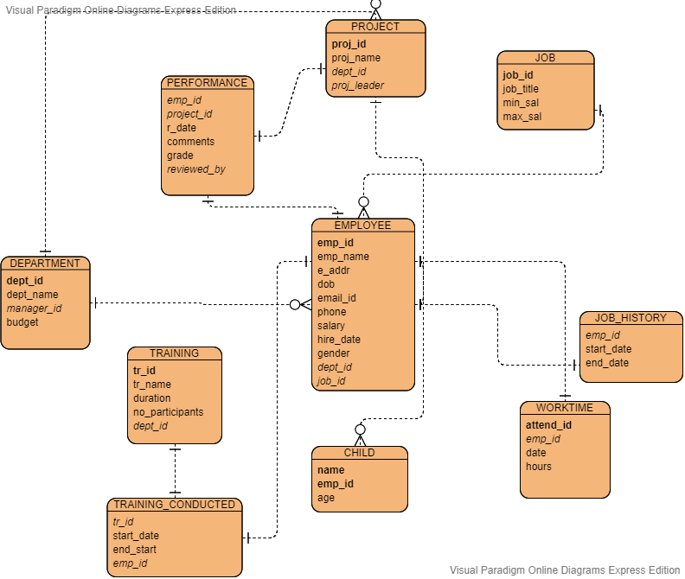

SCHEMA

create table EMPLOYEE

(

emp_id number(5) primary key,

emp_name varchar2(20),

emp_addr varchar2(20),

dob date,

email_id varchar2(25),

phone varchar2(20),

salary number(8,2),

hire_date date,

gender varchar2(10),

dept_id number(5),

job_id number(5));,

create table DEPARTMENT

(

dept_id number(5) primary key,

dept_name varchar2(20),

manager_id number(5),

budget number(10),

constraint fk_manager_id foreign key(manager_id) references EMPLOYEE(emp_id)

);

create table JOB

(

job_id number(5) primary key,

job_title varchar2(20),

min_sal number(8,2),

max_sal number(8,2)

);

alter table employee add constraint fk_dept_id foreign key(dept_id) references DEPARTMENT(dept_id);

alter table employee add constraint fk_job_id foreign key(job_id) references JOB(job_id);

create table JOB_HISTORY

(

emp_id number(5),

start_date date,

end_date date,

constraint fk_emp_id1 foreign key(emp_id) references employee(emp_id)

);

create table TRAINING

(

tr_id number(5) primary key,

tr_name varchar2(20),

duration number(5),

no_participants number(5)

);

create table TRAINING_CONDUCTED

(

tr_id number(5),

dept_id number(5),

start_date date,

end_date date,

constraint fk_tr_id foreign key(tr_id) references TRAINING(tr_id),

constraint fk_dept_id1 foreign key(dept_id) references DEPARTMENT(dept_id)

);

create table PROJECT

(

proj_id number(5) primary key,

proj_name varchar2(20),

dept_id number(5),

proj_leader number(5),

constraint fk_dept_id2 foreign key(dept_id) references DEPARTMENT(dept_id),

constraint fk_proj_leader foreign key(proj_leader) references EMPLOYEE(emp_id)

);

create table PERFORMANCE

(

emp_id number(5),

proj_id number(5),

r_date date,

comments varchar2(50),

grade varchar2(5),

reviewed_by number(5),

constraint fk_emp_id2 foreign key(emp_id) references EMPLOYEE(emp_id),

constraint fk_proj_id foreign key(proj_id) references PROJECT(proj_id),

constraint fk_emp_id4 foreign key(reviewed_by) references EMPLOYEE(emp_id)

);

create table CHILD

(

c_name varchar2(20),

emp_id number(5),

age number(5),

constraint fk_emp_id3 foreign key(emp_id) references EMPLOYEE(emp_id)

);

create table WORKTIME

(

attend_id number(5),

emp_id number(5),

w_date date,

hours number(5),

constraint fk_emp_id5 foreign key(emp_id) references EMPLOYEE(emp_id)

);