First-Time Supabase Setup for Team Member
# 1. Clone the repository and switch to your own branch

# 2. Go to the REPOSITORY ROOT
cd C:\path\to\R26-DS-010-Intelligent-Care-Support

# 3. Install frontend dependencies
cd frontend
npm install

# 4. Return to repository root
cd ..

# 5. Login to Supabase CLI
supabase login

# 6. Link to our SAME shared Supabase project
supabase link --project-ref mxxpfvxpbktlturlrrae

# 7. Create your component migration SQL files inside:
# supabase/migrations/

# 8. Apply migrations when ready ()root
supabase db push

# 9. Run frontend
cd frontend
npm run dev

Adding your own database tables," placed after the existing "Getting Started"

Add a new section to the root README.md, titled "Adding your own
database tables," placed after the existing "Getting Started"
section. Content:

## Adding your own database tables

Each component owns its own tables. Follow this exact pattern —
skipping any step causes real, hard-to-diagnose errors.

1. Create your migration file in supabase/migrations/, numbered
after the last existing one (e.g. PULSE_yourwork.sql). Never
edit an already-pushed migration file — create a new one instead.

2. Enable RLS on every table you create:
alter table your_table_name enable row level security;

3. Write at least one RLS policy — without one, the table exists but
nobody (not even you) can read/write any rows, even with correct
grants. Example: authenticated users can read everything in your
own component's tables, or restrict by role as needed.

4. Explicitly grant privileges to the roles that need them. This
project has "Automatically expose new tables" disabled by design
(see [link/note about why] — nothing gets API access until you
grant it), so this step is required, not optional:
grant select, insert, update, delete on your_table_name to authenticated;
grant select, insert, update, delete on your_table_name to service_role;
(Adjust which privileges/roles based on what your table actually
needs — e.g. a read-only public table might only need select.)

5. Test locally before pushing: supabase db push --dry-run if
available, or review the CLI's diff preview carefully when it
asks for confirmation.

6. Run supabase db push from the REPO ROOT, never from inside
frontend/ — running it from the wrong directory silently creates
a stray, disconnected supabase/ folder instead of using the
linked project.

7. After pushing, verify in the Supabase dashboard (Table Editor)
that the table actually appears with the columns you expect —
don't just trust the CLI's success message.

Common error and what it actually means: "permission denied for
table X" looks like an RLS problem but is almost always a missing
GRANT (step 4) — RLS and table-level grants are two separate
permission layers in Postgres, and both are required.

Show me the updated README section after adding this.

Supabase tables and their purpose
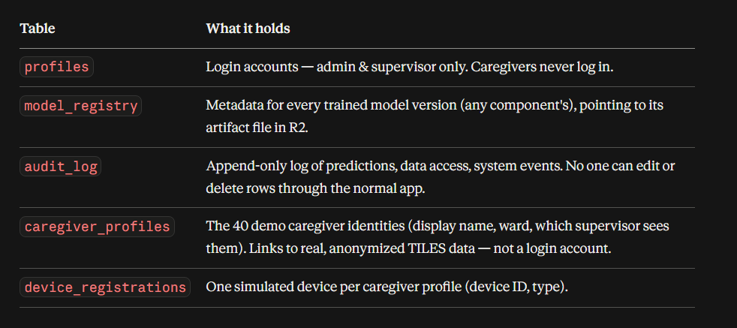

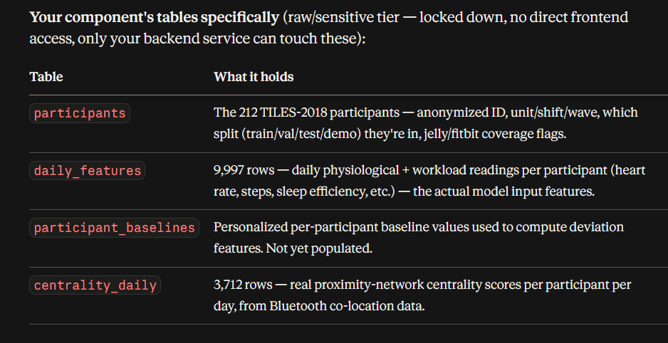

FOR TOP BAR CODE – REPLACE YOUR COMPONENT DETAILS
In modules/[YOUR-MODULE-FOLDER]/, replace the placeholder page
content with a tab-based module page. No page title or subtitle —
the sidebar already labels this section, don't repeat it here.

Structure:
- A horizontal tab row at the very top of the content area. Use these
exact tabs (icon + label), replace with your own module's real
sections: [ICON] "[Tab 1]", [ICON] "[Tab 2]", [ICON] "[Tab 3]",
[ICON] "[Tab 4]" — pick lucide-react icons that fit your module
- Tabs styled EXACTLY as follows, do not adjust these values (this
keeps every module's tabs visually identical across the app):
44px height, 16px horizontal padding per tab, 14px font-size,
medium font-weight, 4px gap between icon and label, 24px gap
between tabs, bottom border 2px solid transparent becoming 2px
solid var(--brand-blue) on the active tab, active tab text in
var(--brand-blue), inactive tabs in var(--text-secondary)
- Below the tab row, 24px top margin, then the active tab's content
in a card: background var(--surface), border-radius
var(--radius-lg), padding 24px, box-shadow var(--shadow-sm)
- Use local useState for tab switching, no routing needed
- Each tab shows a simple placeholder card for now, clearly labeled
which tab is active

Only edit files inside your own modules/[YOUR-MODULE-FOLDER]/ — do
not touch app/, shared/, or any other module's folder.

Show me the result.

CLOUDFLARE R2
