Write two programs to chat. Each program is playing the role of a client and a server. Name one of them MyServer.java and the other MyClient.java. This is how these programs should work:
1. Run MyServer. The program is waiting for the client. After the client is connected the program send: Hello !!
2. Run MyClient. This program receives the word: Hello !!.
The following steps are repeated until the client enters: bye.
Step I) Enter a message on the client’s console (Like: How are you server?) This message should appear on the server’s console (like: How are you server?)
Step II) Enter a message on the server’s console (like: I am good. Do you have any question client?). This message should appear on the client’s console (like: I am good. Do you have any question client?)

These two steps should be repeated until the client enters: bye.

Note: For the sake of simplicity both sides alternate in sending messages. In other words, the both sides repeat:
- Side 1 sends a message
- Side 2 sends a message

Sample dialog:

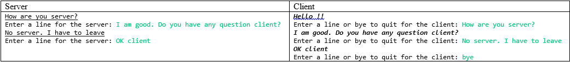

In this sample dialog:
Green lines are what the user enters.
Underlined sentences are what the client sends to the server.
Boldfaced italic sentences are what the server sends.
Other lines are the prompts for the user to enter.

