## **User Evaluation Report**

## **The Accessibilator**

## **By**

## **ByteTheBarrier**

Joel Felix Quadras (D22125093 - DS)

Cheril Mariam John (D22124272 - ASD)

Mountdenyraj Chelladurai Nadar (D22124430 - ASD)

David Ayang (D21127639 - ASD)

1. Introduction 2
2. Proposed Hypothesis 3

User Survey for understanding user needs 3

Comprehensive User Evaluation 5

1. Experimental Method 9

Overview 9

Data Collection 10

Selected Subjects 11

Data Analysis 11

Practical Setup 22

1. Conclusions 23
2. References 24

## Introduction

Accessibilator is a pioneering web application designed to enhance document readability for individuals with dyslexia. It focuses on accessibility, employing advanced algorithms and customizable features to optimize documents for its target users, which include people with dyslexia, those seeking knowledge about dyslexia, and individuals aiming to create dyslexia-friendly documents (Caldwell et al., 2008).

User evaluation of such an application is essential. According to research (Kous & Polancic, 2019), it indicates that customizable websites significantly increase usability and accessibility for people with disabilities, including dyslexia. Customization options like font size, type, and text-background contrast are crucial for improving the effectiveness, efficiency, satisfaction, and overall suitability of websites for users with dyslexia.

In this report, we initially outline the various user evaluations conducted on our system, detailing the distinct methodologies employed in each instance. We then delve into the design of our user evaluation experiments, explaining the setup process, data collection methods, participant selection, and data analysis techniques. Subsequently, we present the outcomes of these evaluations, highlighting both quantitative and qualitative data and interpreting key findings. The report culminates with a conclusion summarizing our main insights and reflecting on potential improvements for future user evaluations.

## Proposed Hypothesis

The primary hypothesis of this study is to evaluate the effectiveness, usability, and accessibility of a website designed to enhance document accessibility for individuals with disabilities, particularly dyslexia.

We have used various methodologies to conduct our user evaluation. We have conducted two surveys that users have filled out to give us a better understanding of the functionalities we have built as well as their experience in using our experience. Along with the surveys, we have had calls with experts in dyslexia who have given us inputs and valuation feedback to build a more robust application. Furthermore, we have implemented a feedback form in the application which general users can fill out about their experience while using the application.

* Explain the questions you are asking in your experiment and why they are important.
* How does the user rate the overall usability of the website in terms of navigation, interface design, and clarity of instructions?
* Are the document upload and processing features easily accessible and efficient from the user's perspective?
* How effective are the formatting changes recommended by the website in improving the readability of documents for users with dyslexia?
* Do the editing features (e.g., font size, colour, line spacing adjustment) intuitively cater to the needs of the user?
* Will users consider this tool beneficial enough to use repeatedly in the future?
* How informative and helpful are the tooltips in enhancing understanding of dyslexia-related issues?
* Are there any significant gaps in the website’s features as expected by the users?

Each question in the survey is designed to extract specific information about various aspects of the website, such as usability, accessibility, functionality, and educational value. Understanding these aspects is crucial for creating a tool that is not only technically proficient but also user-friendly and accessible to a diverse range of users, including those with disabilities.

### User Survey for understanding user needs

We had initially conducted a user survey to gather valuable insights, preferences, and experiences from individuals with dyslexia and those who support and interact with them to collect diverse perspectives and experiences, enabling the development of a more inclusive and user-friendly approach to document accessibility for individuals with dyslexia. This was an especially important survey for this project as the team had very little knowledge of dyslexia and the survey was improved over multiple iterations with inputs and feedback from professors and experts.

Following are the questions that were asked in the first survey.

* Section 1 – General Information
  + Respondent Email
  + Date Submitted
  + Age Group
  + Gender
  + Highest Level of Education
  + Are you a person with Dyslexia?
* Section 2 – A user who has Dyslexia
  + When were you diagnosed with dyslexia?
  + Have you received any formal training or therapy for dyslexia?
  + Which of the following areas of your life were influenced by your dyslexia diagnosis?
  + How has being diagnosed with dyslexia impacted your life?
  + Are you left-handed or right-handed?
  + Do you read documents (e.g., books, articles, reports) daily?
  + Do you prefer reading digital documents or printed ones?
  + Which digital device(s) do you most frequently use for reading or accessing content?
  + How would you rate your level of expertise with technology?
  + Do you use any of the following assistive technologies or tools to help you read?
  + Do you use any specialized glasses or lenses designed specifically to assist with dyslexia or related reading challenges?
  + Do you use colour-tinted glasses or overlays to help with reading or dyslexia-related challenges?
  + Which challenges do you commonly face while reading documents?
  + What strategies or techniques have you developed or used to help with reading?
  + Which elements in a document design make reading easier for you?
  + Would you be interested in a built-in feedback mechanism within the system to continuously share your insights and suggestions?
  + What advice would you give to someone trying to make a document more dyslexia-friendly?
  + Have you come across any documents or platforms that you felt were particularly dyslexia-friendly?
* Section 3 - A user who cares for a person with dyslexia
  + How would you describe your relationship to the person with dyslexia you support?
  + Have you received any formal training or education about dyslexia?
  + What challenges do you experience in supporting a person with dyslexia and how has it impacted your everyday life?
  + What methods or tools do you employ to support the person with dyslexia?
  + What challenges do you commonly encounter when supporting a person with dyslexia?
  + What suggestions or resources would be beneficial for you as a supporter or caregiver of someone with dyslexia?
  + Before this survey, were you aware of any systems or tools designed to make documents more accessible for people with dyslexia?
  + What features would you prioritize in a system designed to make documents more accessible for individuals with dyslexia?
* Section 4 - A user who knows a person with dyslexia
  + How would you describe your association with a person with dyslexia?  
    Before knowing this person, how familiar were you with dyslexia and its challenges?
  + Based on your interactions, what challenges have you noticed the person with dyslexia facing?
  + Are you aware of any tools or systems that can help make reading more accessible for individuals with dyslexia? If yes, kindly specify the name of the tool or system.
  + How do you believe society can be more inclusive and understanding of the challenges faced by people with dyslexia?
  + If you were to recommend a system designed to help individuals with dyslexia to someone you know, what features or qualities would you consider important?
  + How familiar are you with the term "dyslexia" and its implications?
  + Are you aware of any tools, technologies, or systems that support individuals with dyslexia in reading or comprehending text? If yes, kindly specify the name of the tool or system.
* Section 5 – General Population
  + Which of the following statements do you believe are true about dyslexia?
  + In your opinion, how inclusive is our society for people with dyslexia?
  + Have you observed or witnessed instances of individuals with dyslexia facing challenges or discrimination? If so, can you describe the situation?
  + How do you think awareness and understanding of dyslexia can be improved in society?
* Section 6 – The user does not know if he has dyslexia or not and would like to know.
  + Based on the result, do you think you might be a person with dyslexic conditions?

The questions in this survey are designed to gather comprehensive insights from different perspectives to inform the development of the Accessibilator. By addressing various user groups, including those with dyslexia, caregivers, acquaintances of dyslexic individuals, and the general population, the survey seeks to understand the diverse experiences, challenges, and needs related to dyslexia. This approach ensures that the Accessibilator is developed with a holistic view, incorporating feedback from those directly affected by dyslexia and those who support them. Understanding the technological proficiency of users, their preferences in document formats, and the specific challenges they face allows for a more targeted and effective design of the Accessibilator, making it a valuable resource for improving reading accessibility and inclusivity.

The survey was carefully crafted to be dyslexia-friendly, ensuring that individuals with dyslexia could participate without facing undue challenges. This was achieved by transforming long, wordy texts into multiple-choice questions with concise, plain language with dyslexic-friendly font and font size. This approach not only facilitated easier participation for dyslexic respondents but also provided valuable insights into their experiences and preferences. The feedback gathered through these questions played a crucial role in finalizing the features of the Accessibilator. By understanding the specific needs and challenges faced by those with dyslexia, as well as the perspectives of their caregivers and acquaintances, the research contributed significantly to a deeper understanding of dyslexia. This knowledge was instrumental in the development of the Accessibilator, ensuring that it is a user-centred tool that effectively addresses the needs of its target audience, making document accessibility more inclusive and effective.

### Comprehensive User Evaluation

**Cognitive Walkthrough**

In the evaluation process, users were given a clear set of tasks that they needed to perform on the website. Each user was accompanied by an observer, who had a predefined set of questions to record during the user's interaction with the website. The assessments occurred in an environment characterized by minimal interaction, with observers conducting the sessions their own homes.

The tasks assigned to the user are as follows:

Task 1: Select a Document for processing

Goal: Successfully upload a Word document.

Steps:

* Navigate to the Select a document' section.
* Drag and drop a Word document or use the 'Select Document' button to upload.
* Confirm the upload by viewing the file name and size displayed.

Task 2: Format a Document for Dyslexia-Friendly Reading

Goal: Apply formatting changes to improve document readability.

Steps:

* After uploading, select 'Continue to review'.
* Review the list of suggested changes (e.g., font style, size, spacing).
* Toggle the switches to apply the recommended formatting adjustments.
* Select 'Continue' to confirm the changes.

Task 3: Refine the Document Content formatting

Goal: Modify the document text to be more accessible.

Steps:

* Select the 'Refine' option on the document preview page.
* Use the text customization options to change font type
* Use the text customization options to change font size
* Use the text customization options to change font style
* Use the text customization options to change alignment
* Use the text customization options to remove italics from document
* Use the text customization options to generate Table of contents
* Save the changes and review the updated document.

Task 4: Download the Optimized Document

Goal: Save the changes and download the optimized document.

Steps:

* After editing, navigate to the 'Download' button.
* Choose the desired format and download the document to the local machine.
* Verify the document has been downloaded and the changes are reflected.

Task 5: Provide Feedback on the Application

Goal: Submit feedback about the user's experience with the application.

Steps:

* Navigate to the 'Send Feedback' button.
* Enter feedback on what was liked, what could be better, and any desired new features.
* Submit the feedback form.
* For each task assigned to the user, the observer was instructed to collect answers to the below questions. Any additional comments made by the user were also recorded during the process.
* Was the user able to able to perform the task without assistance?
* If the user completes the task independently, it is considered a success. If assistance from the observer is required, the task is considered a failure.
* Amount of time taken for the user to complete the task.

Each task is assigned a preset time in seconds. If the user exceeds this time in completing the task, it will be considered a failure. Otherwise, it would be taken as successful.

**Questionnaire**

Following the conclusion of the cognitive walkthrough, participants were presented with a survey featuring a combination of both qualitative and quantitative questions for them to respond to. These questions collectively cover a broad spectrum of user experience aspects, allowing for a thorough assessment of usability, accessibility, performance, feature effectiveness, user preferences, and areas for improvement. The combination of quantitative and qualitative responses helps in understanding both the overall satisfaction and specific pain points or strengths of the user experience.

**Below are the initial Quantitative Questions**

* How would you rate the overall usability of the website?
* How easy was it to find the document upload feature? (1 - Very difficult, 5 - Very easy)
* How would you rate the speed of the document processing? (1 - Very slow, 5 - Very fast)
* On a scale of 1-5, how effective were the formatting changes in improving document readability?
* How intuitive were the editing features (e.g., changing font size, colour, line spacing)? (1 - Not intuitive, 5 - Very intuitive)
* How likely are you to use this website again? (1 - Very unlikely, 5 - Very likely)
* On a scale of 1 to 5, how beneficial were the tooltips in facilitating your understanding of various issues related to dyslexia?

**Qualitative Questions**

* What is the intended use of this application for you?
* What did you like most about the website?
* What was the most challenging part of using the website?
* Were there any features you expected to find but didn't?
* Please provide any additional comments or suggestions you have for the website.

In a similar vein to the initial survey, we refined the questions through various iterations, guided by input from our mentor and subject matter experts. This collaborative process led to the reengineering of the questions to enhance user-friendliness and ease of use.

The following is the latest copy of our questionnaire, and the following questions were asked in our second survey.

**Questionnaire**

|  |  |  |  |  |
| --- | --- | --- | --- | --- |
| Which digital device(s) would you use this application on | | | | |
| Laptop/ computer | Mobile | Tablet | E-reader | Gaming console |
| Are you a person living with Dyslexia? * | | | | |
| Yes | No, but I care for somebody with dyslexia | No, but I know somebody with dyslexia | I don't know if I have dyslexia or not. | No |
| How comfortable are you with technology? | | | | |
| Expert | Intermediate | Beginner |  |  |
| How easy was the site to use? | | | | |
| Very easy | Easy | Medium | Hard | Very Hard |
| How easy was it to find the document upload feature? | | | | |
| Very easy | Easy | Medium | Hard | Very Hard |
| How would you score the speed at which the document was processed? | | | | |
| Fast | Medium | Slow |  |  |
| How effective were the formatting changes in improving document readability? | | | | |
| Highly effective | Moderately effective | Slightly effective | Not effective at all |  |
| How easy was it for you to use the editing features like changing font size, colour, and line spacing? | | | | |
| Highly effective | Highly effective | Highly effective | Highly effective | Highly effective |
| Will you use this website again? Please choose from: | | | | |
| Very likely | likely | Neutral | Unlikely | Very Unlikely |
| How much did the tooltips help you understand dyslexia-related issues? Choose one: | | | | |
| Very beneficial | Somewhat beneficial | Neutral | Not very beneficial | Not beneficial at all |
| How will you use this website in future? | | | | |
| What did you like most about the website? | | | | |
| What was the most challenging part of using the website? | | | | |
| Were there any features you expected to find but didn't? | | | | |
| Please provide any additional comments or suggestions you have for the website. | | | | |

The second survey focused on evaluating the usability and effectiveness of a web application designed to assist individuals with dyslexia. Questions were asked to gather feedback on various aspects of the user experience, such as the ease of using the site, finding specific features like document upload, and the effectiveness of formatting changes in enhancing readability. The survey also sought to understand user comfort with technology and their preferences for digital devices when using the application. Respondents were asked to rate the processing speed of documents, the helpfulness of tooltips in understanding dyslexia-related issues, and their likelihood of using the website again. Additionally, the survey aimed to gather insights on the most liked features, any challenges faced while using the website, and any expected features that were missing. This feedback is crucial for refining the website, ensuring it meets the needs of its users, particularly those living with dyslexia, and enhancing the overall user experience.

**Expert Review**

After receiving positive feedback and constructive suggestions from two experts in dyslexia research, the team promptly integrated the recommendations into the system, resulting in significant improvements. To continuously refine and evolve the system's capabilities, the team has resolved to maintain weekly engagements with these experts. This consistent collaboration is aimed at harnessing their insights to further inform the development and ensure the system remains at the forefront of user-centric design and functionality.

**Feedback Form**

The feedback form in the web application is a concise tool designed to collect user impressions and suggestions. It offers fields for optional email input, likes, areas for improvement, and requests for new features, allowing users to share their experiences and insights. With a clear and user-friendly layout, it invites users to contribute to the app's development, ensuring that their voices are heard and considered in future updates. The form is completed with the 'Cancel' and 'Send' buttons, making the process of submitting feedback straightforward and efficient.

## Experimental Method

### Overview

The evaluation process is incorporated with a user survey to understand and comprehend user needs in the initial phase of the project. Later, a cognitive walkthrough was conducted with users from various target groups, accompanied by a questionnaire that included both quantitative and qualitative elements. Additionally, the evaluation encompassed a heuristic evaluation conducted by expert reviewers from diverse technical fields. This team of experts consisted of individuals with expertise in linguistics, technology, and user design, ensuring a comprehensive assessment from multiple perspectives.

The entire process of user experience evaluation can in broken down into various activities.

* **Initial survey to understand user needs**

The initial survey was sent through a variety of channels, including personal contacts, the learning disability association affiliated with our college, and the Dyslexic Association of Ireland. These groups generously agreed to circulate our survey, significantly broadening our reach and enriching the data we collected. This approach ensured a diverse range of insights, which were critical in informing the development of our application.

* **Cognitive walkthrough**

A cognitive walkthrough was performed involving participants from the diverse target groups identified through the initial survey. Participants were provided with a document outlining the steps of specific tasks, and their ability to complete these tasks, along with the time taken, was meticulously documented. This methodical approach allowed for a detailed assessment of the user experience and the system's intuitiveness, informing further refinements.

* **Questionnaire after the cognitive walkthrough**

Users engaged with a concise questionnaire featuring both quantitative and qualitative questions designed to gather in-depth insights into their experience. This blend of structured and open-ended queries provided a robust understanding of user interaction and satisfaction, which is crucial for enhancing the user experience.

* **Expert Review**

The team conducts weekly consultations with dyslexia experts, whose recommendations have been instrumental in shaping and refining the project's objectives and functionalities. These ongoing discussions ensure that the development is guided by specialized knowledge, enhancing the project's relevance and effectiveness.

* **Feedback form**

A feedback form is integrated within the web application to enable users to provide their input on the user experience. This feature is an essential component for continuous improvement, allowing users to report on their interaction with the application and offer suggestions for enhancements.

### Data Collection

* Initial survey to understand user needs  
  It helped us to identify what exactly the user needs and what are their preferences.  
  The study will incorporate subjective data like enquires if the user has dyslexia or not, user satisfaction ratings, qualitative feedback with open dialogue, etc.
* Cognitive walkthrough  
  Through the cognitive walkthrough approach, we were able to gain insights into the application's usability and navigational ease. The study incorporates objective data like task completion time, error rates, and the ability to perform a certain task without assistance.
* Questionnaire after the cognitive walkthrough  
  The user questionnaire was designed to get the users to offer detailed feedback on specific functionalities and user experience of the application.
* Expert review  
  We are conducting ongoing expert reviews every week to accumulate professional insights into accessibility and design effectiveness.

This combination of subjective and objective data provides us with a comprehensive understanding of the user experience and the website's functionality. It also offers us insights into the usability perspective of the Accessibilator.

### Selected Subjects

The subjects will include a diverse group of users, with a focus on individuals with dyslexia, educators, and general users who frequently interact with document processing tools.This mix ensures a representative sample by including those directly affected by the tool's accessibility features (individuals with dyslexia), experts in the field of education, and typical users who can provide a broad perspective on usability and functionality.  
 Subjects will be sourced through educational institutions, online forums and communities focused on dyslexia, and general user groups interested in technology and accessibility. This approach ensures a diverse and relevant participant pool for the study.

### Data Analysis

**Initial Survey Analysis**

From the initial survey, we received a lot of information about the user's general information, various other things about people with dyslexia and users' knowledge about dyslexia. Below are a few screenshots from the survey. The full results can be viewed here

[https://docs.google.com/forms/d/1vyEGiM8LwzExw8351rFpqgt_MiTE0mxqxPY4TFxe3d8/edit#responses](https://docs.google.com/forms/d/1vyEGiM8LwzExw8351rFpqgt_MiTE0mxqxPY4TFxe3d8/edit" \l "responses)

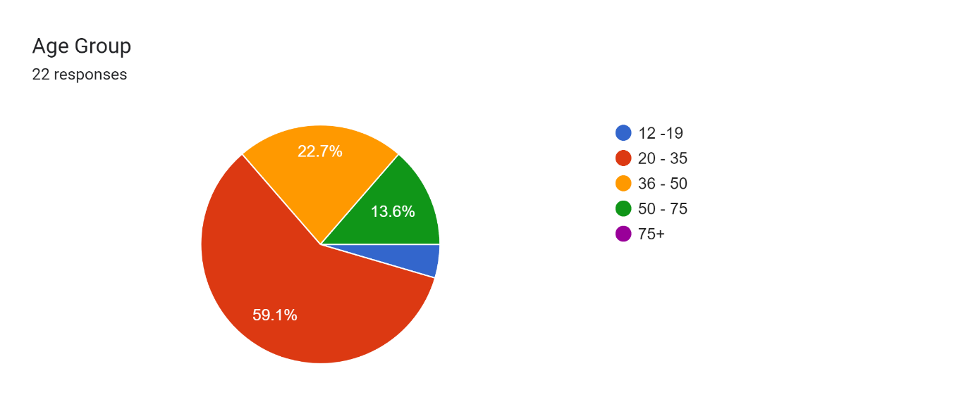

Forms response chart. Question title: Highest Level of Education:
. Number of responses: 22 responses.

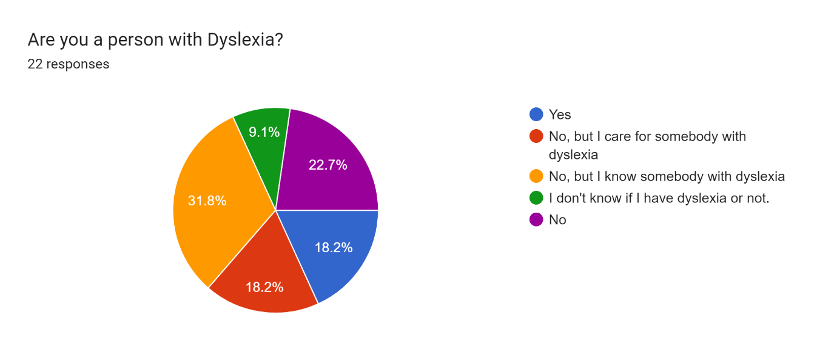

Forms response chart. Question title: When were you diagnosed with dyslexia?
. Number of responses: 5 responses.

Forms response chart. Question title: Which of the following areas of your life were influenced by your dyslexia diagnosis?
. Number of responses: 5 responses.

Forms response chart. Question title: How often do you read documents (e.g., books, articles, reports) on a daily basis?
. Number of responses: 5 responses.

Forms response chart. Question title: Do you prefer reading digital documents or printed ones?
. Number of responses: 5 responses.

Forms response chart. Question title: Which digital device(s) do you most frequently use for reading or accessing content?
. Number of responses: 5 responses.

Forms response chart. Question title: How would you rate your level of expertise with technology?
. Number of responses: 5 responses.

Forms response chart. Question title: Do you use any of the following assistive technologies or tools to help you read?
. Number of responses: 5 responses.

Forms response chart. Question title: Which challenges do you commonly face while reading documents?
. Number of responses: 5 responses.

Forms response chart. Question title: How would you describe your relationship to the person with dyslexia you support?
. Number of responses: 4 responses.

Forms response chart. Question title: What methods or tools do you employ to support the person with dyslexia?
. Number of responses: 4 responses.

Forms response chart. Question title: What challenges do you commonly encounter when supporting the person with dyslexia?
. Number of responses: 4 responses.

Forms response chart. Question title: What features would you prioritize in a system designed to make documents more accessible for individuals with dyslexia?
. Number of responses: 4 responses.

Forms response chart. Question title: How would you describe your association with the person with dyslexia?
. Number of responses: 7 responses.

Forms response chart. Question title: Based on your interactions, what challenges have you noticed the person with dyslexia facing?
. Number of responses: 7 responses.

Forms response chart. Question title: If you were to recommend a system designed to help individuals with dyslexia to someone you know, what features or qualities would you consider important?
. Number of responses: 7 responses.

Forms response chart. Question title: How familiar are you with the term "dyslexia" and its implications?
. Number of responses: 6 responses.

Forms response chart. Question title: Which of the following statements do you believe are true about dyslexia?
. Number of responses: 6 responses.

Forms response chart. Question title: In your opinion, how inclusive is our society for people with dyslexia?
. Number of responses: 6 responses.

**Findings from the survey**

* The general population had very limited knowledge about dyslexia and the challenges faced by people with dyslexia. Therefore, the team decided that they would use this application to educate people about dyslexia and its varied symptoms
* A lot of users resonated with the functionalities that this system was proposing and helped the team research other functionalities that the users were suggesting
* This survey helped us also decide on the different users' personas for this application. A person with dyslexia, a person who wants to learn more about dyslexia and general users who would like to create dyslexic-friendly documents.
* Also, upon a lot of extensive research and survey, we realised that there wasn’t a tool that automated all the changes to a document to make it more dyslexic-friendly.
* As laptops, computers and mobile devices were the most used devices by users with dyslexia building a web application was the most novel approach.
* The survey helped us scrutinize various other similar existing tools that we could analyse and help build the functionalities in our system.
* Survey participants could test themselves for dyslexia using the questionnaire by the International Association for Dyslexia and this helped a survey participant realise that he has dyslexia.
* Dyslexic users use a lot of other assistive technologies such as text-to-speech software and screen reader which will be implemented by the team in the word document editor screen.
* People who care for people with dyslexia feel that there is very less awareness and support for people with dyslexia.

**Cognitive Walkthrough**

In the Cognitive Walkthrough, the quantitative data is collected by focusing on the time taken by users to complete tasks and whether they could do so without assistance. This data is analysed using two primary metrics: Task Completion by the user and Time Taken  
In addition to the qualitative data, we are also recording user inputs while they perform the task which becomes the qualitative data.

|  |  |  |  |  |  |
| --- | --- | --- | --- | --- | --- |
|  | User 1 | User 2 | User 3 | User 4 | User 5 |
| Task 1 | Y/Y/Y/5s | Y/Y/Y/7s | y/y/y/4s | y/y/y/3s | y/y/y/4s |
| Task 2 | Y/Y/Y/5s | Y/Y/Y/3s | y/y/y/5s | y/y/y/6s | y/y/y/5s |
| Task 3 | Y/Y/Y/Y/Y/Y/Y/Y 75s | Y/Y/Y/Y/Y/Y/Y/Y 50s | y/y/y/y/y/y/y/f 90s | y/y/y/y/y/y/y/f 85s | y/y/y/y/y/y/f 100 s |
| Task 4 | Y/Y/Y/5s | Y/Y/Y/3s | y/y/y/ 3s | y/y/y/4s | y/y/y/5s |
| Task 5 | Y/Y/Y/10s | Y/Y/Y/10s | y/y/y/ 30s | y/y/y/ 45 s | y/y/y/6s |

A task was deemed successful if all or most users (at least four out of the total) completed it within a reasonable timeframe, determined specifically for each task. Such an outcome indicated that only minor changes might be needed in the user interface. Conversely, if three or more users failed to complete a task, it was classified as a failure, signalling a need for significant modifications to the user interface to enhance usability.

**Questionnaire**

The analysis of the questionnaire data focused on identifying recurring feedback, which helped in evaluating user satisfaction and pinpointing areas requiring enhancement.

Below are a few screenshots from the survey. The full results can be viewed here  
<https://docs.google.com/spreadsheets/d/1qLQbOnWMBVnWWONY6ZWbzU8mxRsQAV-8H7HQmvaZPrw/edit?resourcekey#gid=1876138850>

Forms response chart. Question title: Are you a person living with Dyslexia?*

. Number of responses: 3 responses.

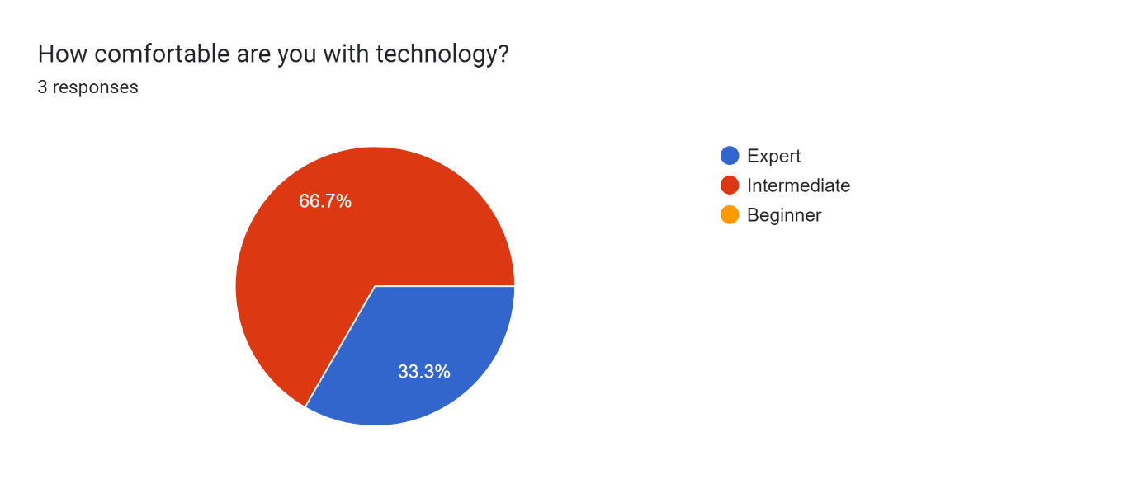

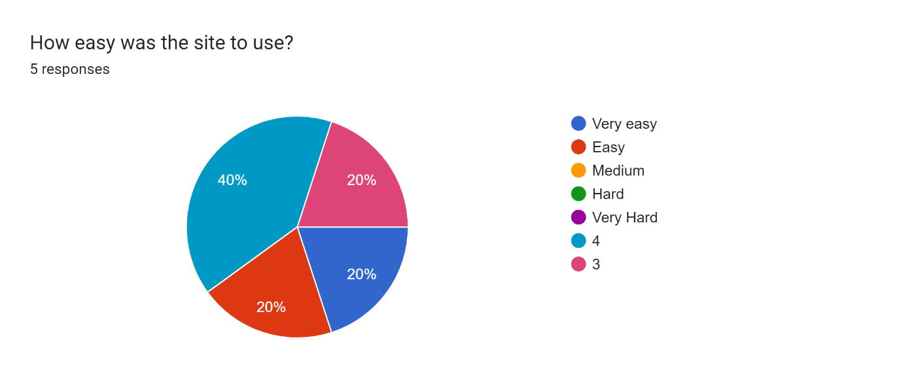

Forms response chart. Question title: How easy was it to find the document upload feature? 
. Number of responses: 5 responses.

Forms response chart. Question title: How easy was it for you to use the editing features like changing font size, alignment, removing italics, line spacing , character spacing, generating table of contents?
. Number of responses: 5 responses.

**Feedback Form**

The application itself has a feedback form which the users can make use of to give valuable feedback on the usability of the application. Below are a couple of responses that we obtained from the same.

The user evaluation revealed several areas for improvement in the application:

* Confusing Language: Users found the application's language to be unclear, leading to difficulties in understanding and using it effectively.
* Ambiguous Screen Reader: The screen reader interface caused confusion among users, indicating a need for a more intuitive design.
* Ineffective Tooltips: The tooltips provided in the application were not found to be helpful, suggesting a need for more informative or clearer tooltip content.
* Difficulty Locating TOC: Finding the Table of Contents (TOC) was challenging for users, suggesting the need for a more prominent or accessible placement.
* Screen Reader size: The size of the screen reader was not proportionate to the webpage, affecting usability and readability.
* Information on data storage: Some users wanted to know how their data was getting stored.

### Practical Setup

The experiment was conducted online, allowing participants to access the Accessibilator application from their preferred environment, ensuring a natural usage context. We also conducted in-person interviews which helped us in collecting more fine-grained feedback.

Participants will be provided with detailed instructions on the tasks to perform and how to provide feedback. This setup of the experiment makes sure that the relevance of its real-world application usage is conveyable. Participants will receive clear instructions on the tasks they need to perform, including uploading and editing documents. They will also be informed about the data collection process and assured of their privacy and confidentiality.

Allowing the environment to be online enables the possibility for more diverse participation, thereby making the study more inclusive and representative of the application’s actual user base. Digital Questionnaires would be provided for easier data collection and analysis.

## Conclusions

The evaluation study of the website will yield conclusions about its usability, accessibility, and effectiveness in making documents more accessible for individuals with dyslexia. It will offer insights into user interactions, highlighting the website's strengths and areas needing enhancement. The study will specifically reveal the intuitiveness and efficiency of the website's interface and features, and their alignment with the needs of dyslexic users. This feedback is essential for further refining the website to more effectively cater to its target audience.  
 The survey for Accessibilator was designed to be dyslexia-friendly, using concise, multiple-choice questions with dyslexic-friendly font and size, facilitating participation for individuals with dyslexia. This approach provided crucial insights into the experiences and preferences of those with dyslexia, their caregivers, and acquaintances, significantly informing the development of the Accessibilator. This user-centric approach ensured that the tool effectively met the needs of its target audience, enhancing document accessibility inclusively.

## References

Brooke, J. (1996). SUS: A "quick and dirty" usability scale. In P. W. Jordan, B. Thomas, B. A. Weerdmeester, & A. L. McClelland (Eds.), Usability Evaluation in Industry (pp. 189-194). Taylor & Francis.

Caldwell, B., Cooper, M., Reid, L. G., & Vanderheiden, G. (2008). Web Content Accessibility Guidelines (WCAG) 2.0. W3C Recommendation. World Wide Web Consortium (W3C).

Dow, S., Mehta, M., Lausier, A., MacIntyre, B., & Mateas, M. (2005). Presence and usability in interactive virtual environments. Virtual Reality, 8(2), 130-140.

Hartson, H. R., Andre, T. S., & Williges, R. C. (2001). Criteria for evaluating usability evaluation methods. International Journal of Human-Computer Interaction, 13(4), 373-410.

Ivory, M. Y., & Hearst, M. A. (2001). The state of the art in automating usability evaluation of user interfaces. ACM Computing Surveys (CSUR), 33(4), 470-516.

Joyce, G., & Lilley, M. (2014). The effectiveness of mobile applications in teaching dyslexic students. In Proceedings of the 16th International Conference on Human-Computer Interaction with Mobile Devices & Services (pp. 473-478). ACM.

Lewis, C. (1994). Critical issues in evaluating the impact of advanced user interfaces on productivity. In Proceedings of the Workshop on Advanced Visual Interfaces (pp. 85-89). ACM.

Nielsen, J. (1994). Usability engineering. Academic Press.

Paz, F., & Pow-Sang, J. A. (2016). A Systematic Mapping Review of Usability Evaluation Methods for Software Development Process. International Journal of Software Engineering and Its Applications, 10(1), 165–178. <https://doi.org/10.14257/ijseia.2016.10.1.16>

Vatankhah, N., Wei, K. T., & Letchmunan, S. (2014). Usability Measurement of Malaysian Online Tourism Websites. International Journal of Software Engineering and Its Applications, 8(12), 1–18. <https://www.earticle.net/Article/A239306>

Kous, K., & Polančič, G. (2019). Empirical Insights of Individual Website Adjustments for People with Dyslexia. Sensors, 19(10), 2235. <https://doi.org/10.3390/s19102235>