XianFire Activity 2
Postman CRUD API Testing Screenshots
This document contains the five Postman screenshots for the Products CRUD REST API: Create, Read All, Read One, Update, and Delete.

1. CREATE — POST /products
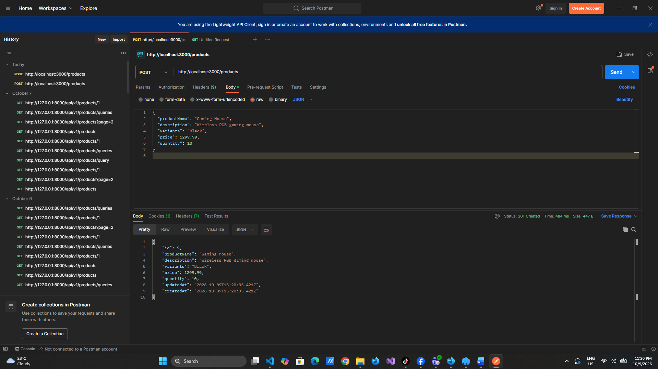

2. READ ALL — GET /products
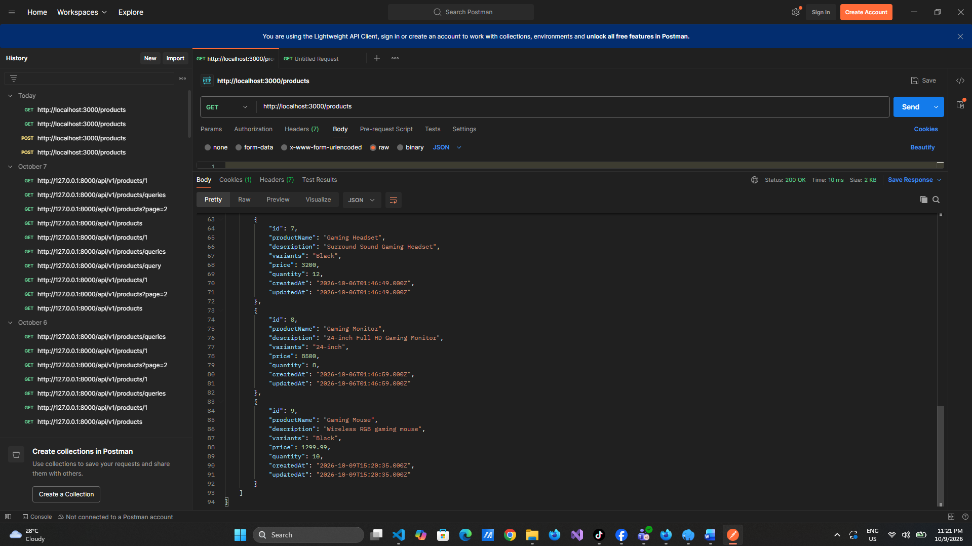

3. READ ONE — GET /products/9
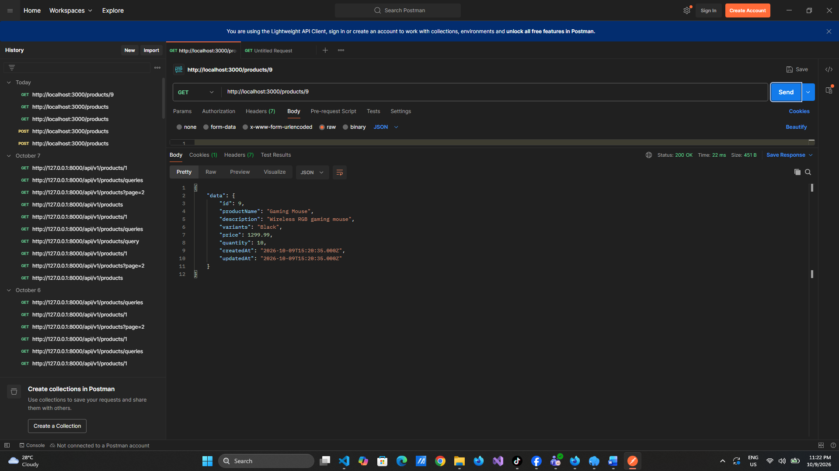

4. UPDATE — PUT /products/9
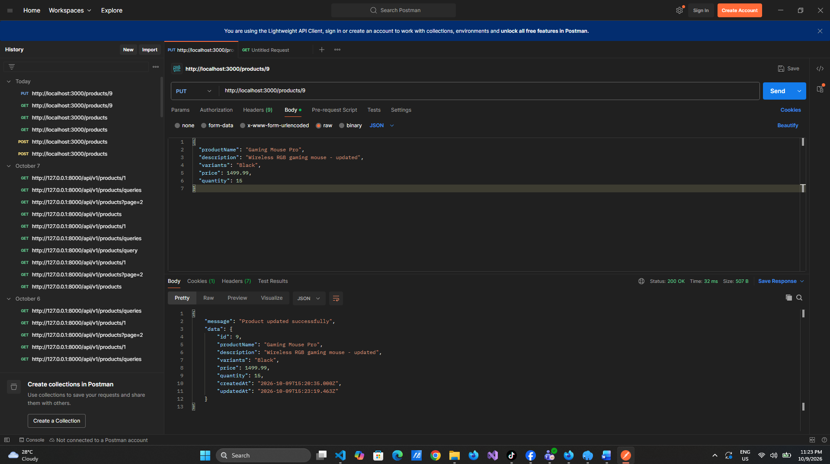

5. DELETE — DELETE /products/9
