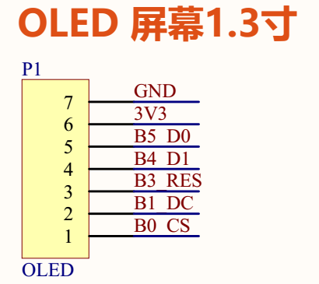

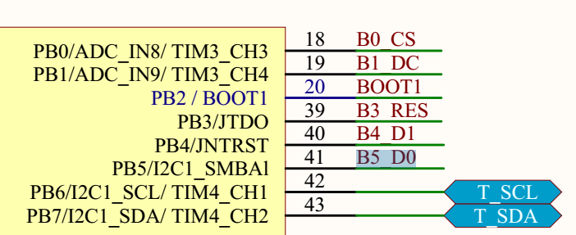

void OLED_Init(void)

{

GPIO_InitTypeDef GPIO_InitStructure;

**RCC_APB2PeriphClockCmd(RCC_APB2Periph_AFIO, ENABLE);**

上面RCC_APB2PeriphClockCmd(RCC_APB2Periph_AFIO, ENABLE);的操作：

#define RCC_APB2Periph_AFIO ((uint32_t)0x00000001)

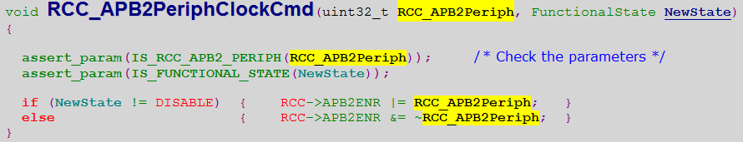

就是说，外设时钟使能寄存器(RCC_APB2ENR)的最低位设置成1，也就是辅助功能IO始终开启。

4.3.7 APB2 外设时钟使能寄存器(RCC_APB2ENR)

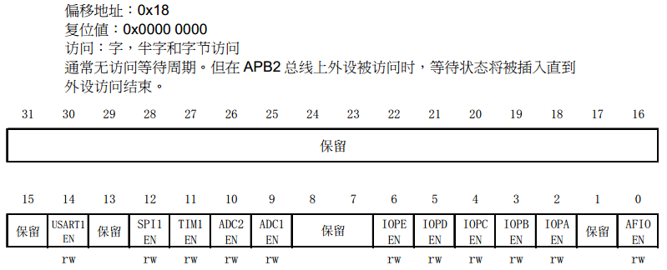

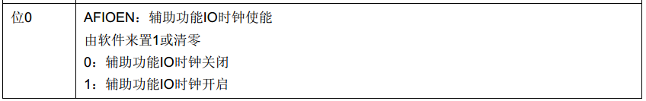

~~~~~~~~~~~~~~~~~~~~~~~~~~~~~~~~~~~~~~~~~~~~~~~~~~~~~~~~~~~~~~~~~~~~~~~~~~~~~~~~~~~~~~~~~~

**GPIO_PinRemapConfig(GPIO_Remap_SWJ_JTAGDisable, ENABLE);**

#define GPIO_Remap_SWJ_JTAGDisable ((uint32_t)0x00300200) /*!< JTAG-DP Disabled and SW-DP Enabled */

简单来说，应该是讲该引脚设置成JTAG-DP disable而SW-DP enable.

这里涉及到“引脚重定义remap”，类似的知识点找到：

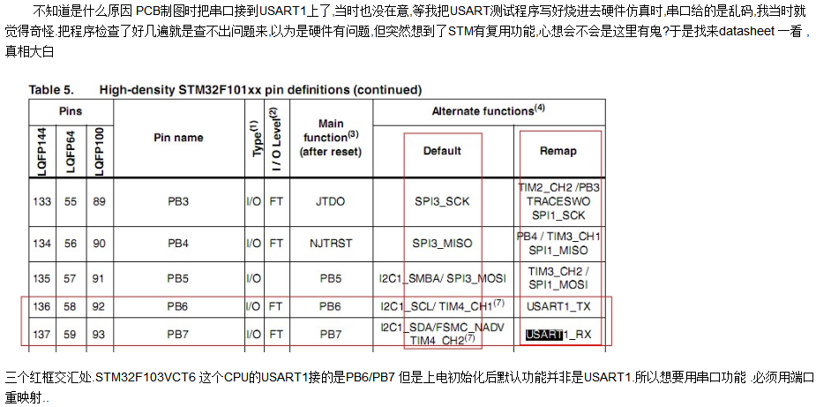

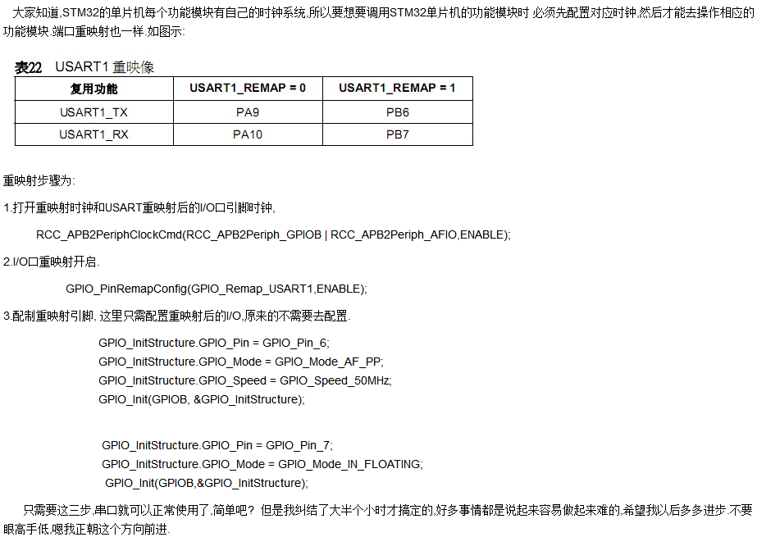

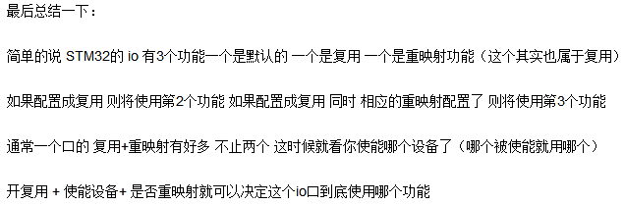

~~~~~~~~~~~~~~~~~~~~~~~~~~~~~~~~~~~~~~~~~~~~~~~~~~~~~~~~~~~~~~~~~~~~~~~~~~~~~~~~~~~~~~~~

**RCC_APB2PeriphClockCmd**(RCC_APB2Periph_GPIOB, ENABLE); //使能PD端口时钟

又使用RCC_APB2PeriphClockCmd()调用。

#define RCC_APB2Periph_GPIOB ((uint32_t)0x00000008) // APB2 bit3置1

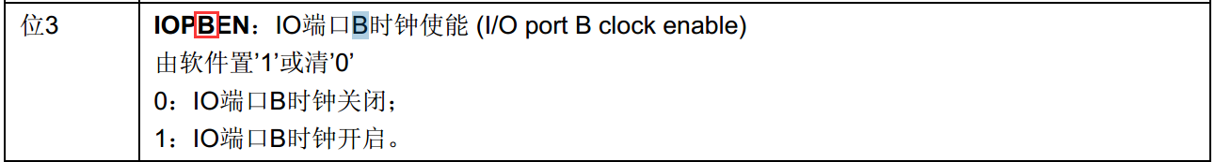

~~~~~~~~~~~~~~~~~~~~~~~~~~~~~~~~~~~~~~~~~~~~~~~~~~~~~~~~~~~~~~~~~~~~~~~~~~~~~~~~~~~~~~~~

GPIO_InitStructure.GPIO_Pin = GPIO_Pin_3|GPIO_Pin_4|GPIO_Pin_5|GPIO_Pin_0|GPIO_Pin_1; // 用到了PB_0/1/3/4/5这几个引脚

GPIO_InitStructure.GPIO_Mode = GPIO_Mode_Out_PP; //推挽输出

GPIO_InitStructure.GPIO_Speed = GPIO_Speed_50MHz; //速度50MHz

GPIO_Init(GPIOB, &GPIO_InitStructure); // 初始化GPIOD3,6

#define GPIOB ((GPIO_TypeDef *) GPIOB_BASE) // (uint32_t)0x40000000 + 0x10000 + 0x0C00 = 0x40010C00

#define GPIOB_BASE (APB2PERIPH_BASE + 0x0C00)

#define APB2PERIPH_BASE (PERIPH_BASE + 0x10000)

#define PERIPH_BASE ((uint32_t)0x40000000) /*!< Peripheral base address in the alias region */

#define GPIO_Pin_0 ((uint16_t)0x0001) /*!< Pin 0 selected */ bit0

#define GPIO_Pin_1 ((uint16_t)0x0002) /*!< Pin 1 selected */ bit1

#define GPIO_Pin_2 ((uint16_t)0x0004) /*!< Pin 2 selected */ bit2

#define GPIO_Pin_3 ((uint16_t)0x0008) /*!< Pin 3 selected */ bit3

#define GPIO_Pin_4 ((uint16_t)0x0010) /*!< Pin 4 selected */ bit4

#define GPIO_Pin_5 ((uint16_t)0x0020) /*!< Pin 5 selected */ bit5

#define GPIO_Pin_6 ((uint16_t)0x0040) /*!< Pin 6 selected */ bit6

~~~~~~~~~~~~~~~~~~~~~~~~~~~~~~~~~~~~~~~~~~~~~~~~~~~~~~~~~~~~~~~~~~~~~~~~~~~~~~~~~~~~~~~~

GPIO_SetBits(GPIOB,GPIO_Pin_3|GPIO_Pin_4|GPIO_Pin_5|GPIO_Pin_0|GPIO_Pin_1); // **这个函数设置寄存器干什么？？？？？**

该函数会调用GPIOx->BSRR = GPIO_Pin; /* 端口位设置/清除寄存器(GPIOx_BSRR) (x=A..E) */

其中BSRR寄存器是端口位设置/清除寄存器

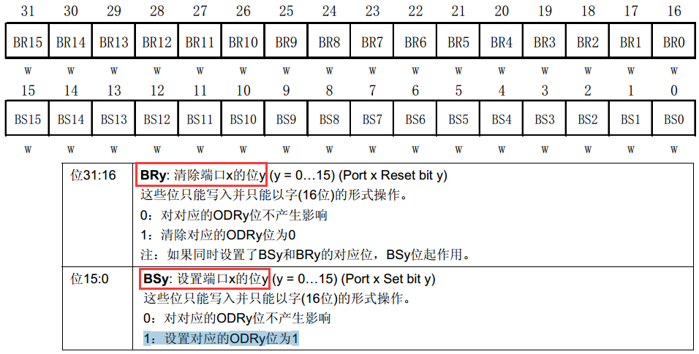

~~~~~~~~~~~~~~~~~~~~~~~~~~~~~~~~~~~~~~~~~~~~~~~~~~~~~~~~~~~~~~~~~~~~~~~~~~~~~~~~~~~~~~~~

OLED_RST_Set(); // #define OLED_RST_Set() **GPIO_SetBits**(GPIOB,GPIO_Pin_3) // **这样就拉高了GPIO_Pin_3？？？？**

delay_ms(100);

OLED_RST_Clr(); // #define OLED_RST_Clr() **GPIO_ResetBits**(GPIOB,GPIO_Pin_3) //RES

delay_ms(100);

OLED_RST_Set();

~~~~~~~~~~~~~~~~~~~~~~~~~~~~~~~~~~~~~~~~~~~~~~~~~~~~~~~~~~~~~~~~~~~~~~~~~~~~~~~~~~~~~~~~

关于OLED的写时序：(分3线SPI和4线SPI)

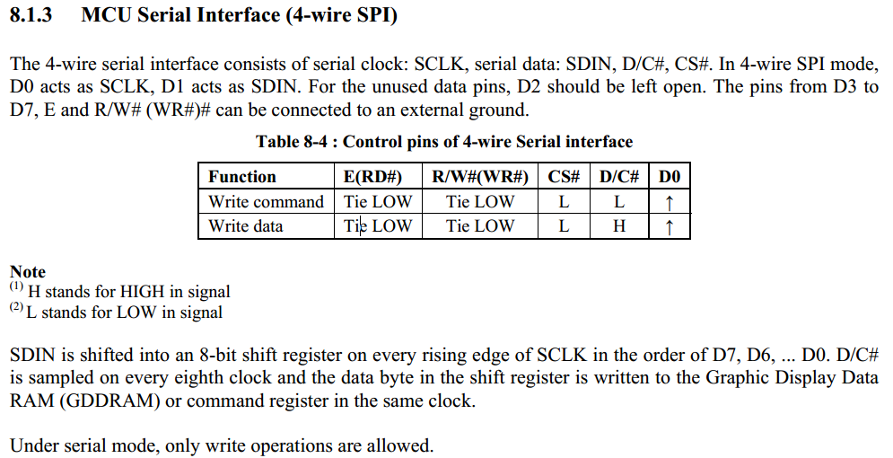

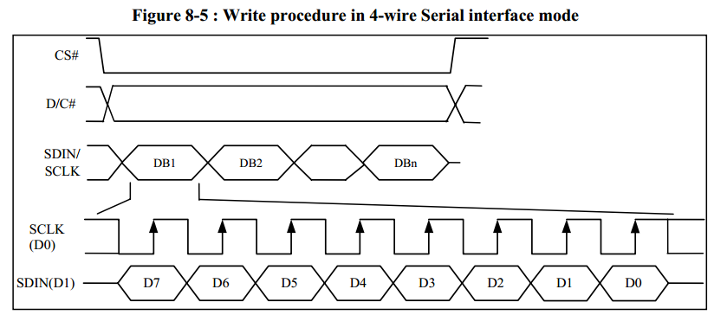

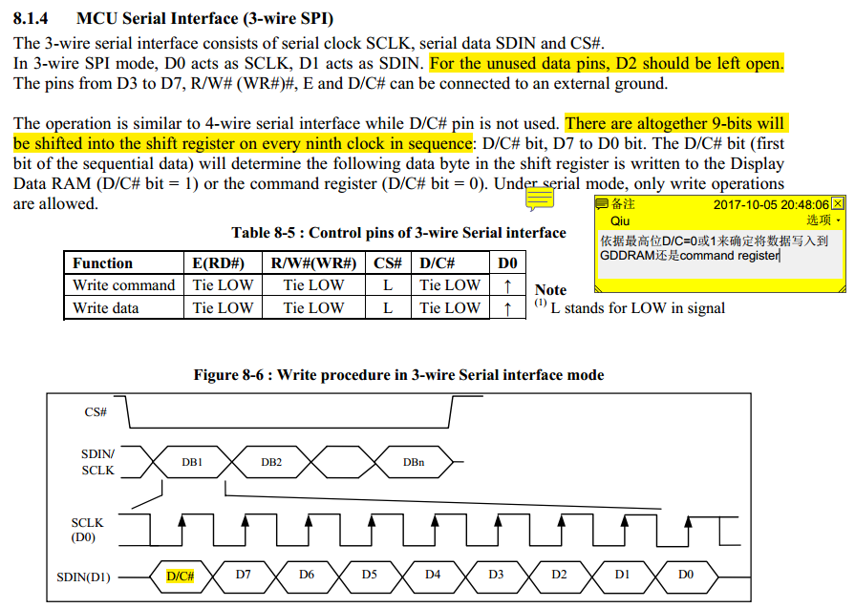

=============================按键keypad=========================================================

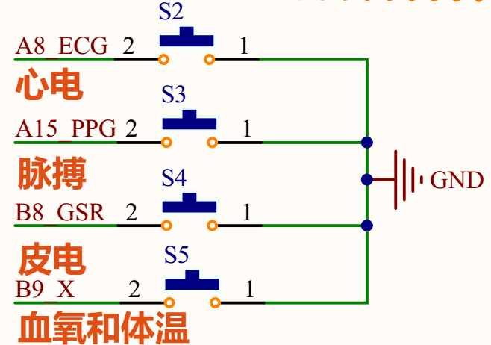





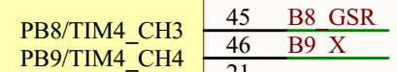

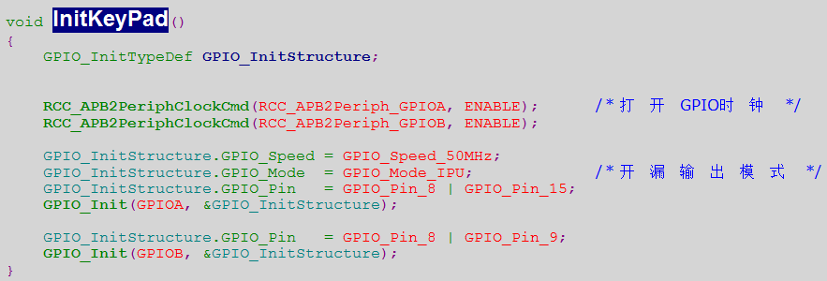

#define RCC_APB2Periph_GPIOA ((uint32_t)0x00000004) // bit2

#define RCC_APB2Periph_GPIOB ((uint32_t)0x00000008) // bit3

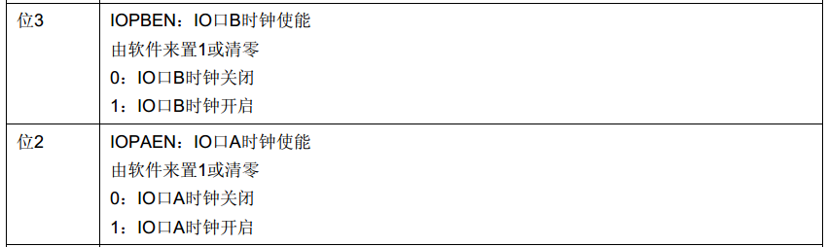

GPIO_InitStructure.GPIO_Mode = GPIO_Mode_IPU; 看注释说GPIO_Mode_IPU; /*上拉输入 */

=============================蜂鸣器beep=========================================================

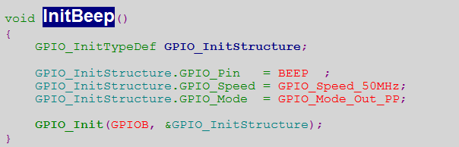

为什么不这么做：RCC_APB2PeriphClockCmd(RCC_APB2Periph_GPIOB, ENABLE); /* 打开GPIO时钟 */

因为上面键盘初始化已经做过。我觉得应该再做一下更好。

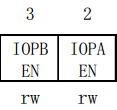

这2位是可读可写的。只是目前不清楚读的函数。

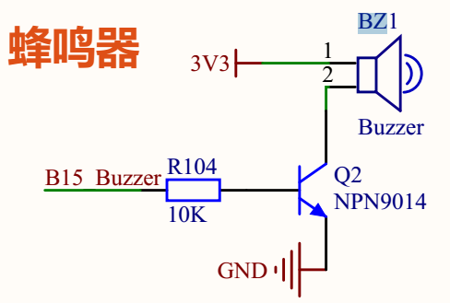



GPIO_Mode_Out_PP是 推挽输出，代码中还有GPIO_Mode_Out_OD是开漏输出

=============================定时器timer=========================================================

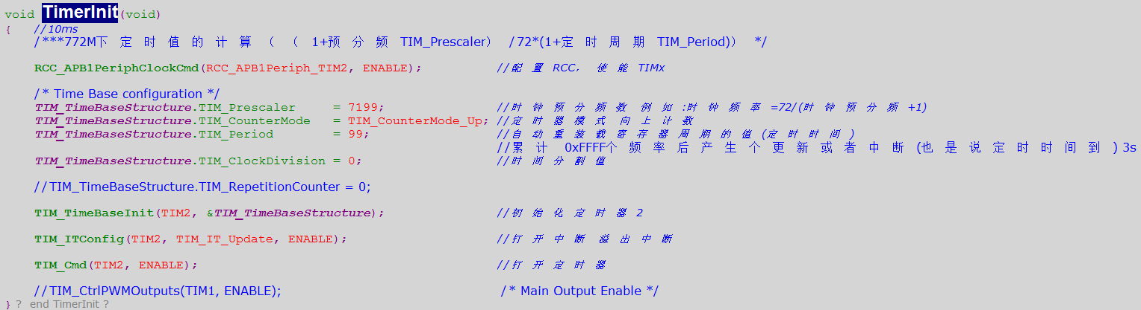

#define RCC_APB1Periph_TIM2 ((uint32_t)0x00000001)

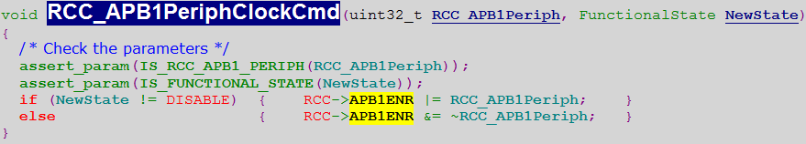

**APB1 外设时钟使能寄存器(RCC_APB1ENR)**

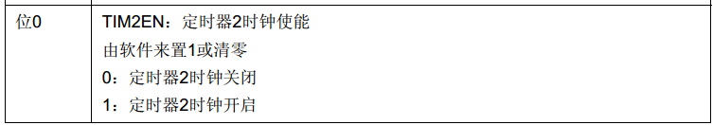

**TIM_TimeBaseInit(TIM2, &TIM_TimeBaseStructure); //初始化定时器2**

#define TIM2 ((TIM_TypeDef *) TIM2_BASE) // 0x40000000 + 0x0000 = 0x40000000

#define TIM2_BASE (APB1PERIPH_BASE + 0x0000)

#define APB1PERIPH_BASE PERIPH_BASE

#define PERIPH_BASE ((uint32_t)0x40000000) /*!< Peripheral base address in the alias region */

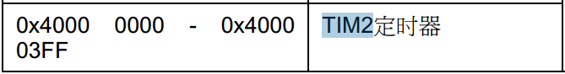

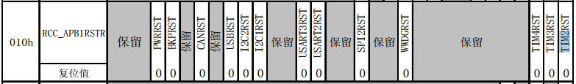

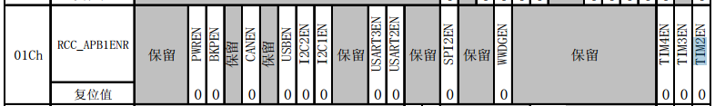

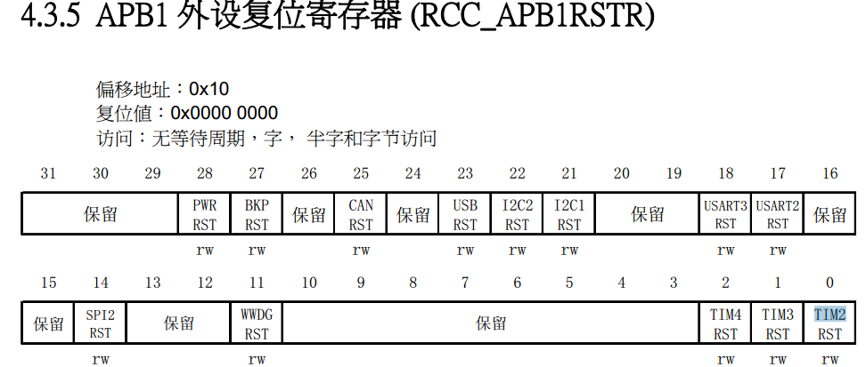

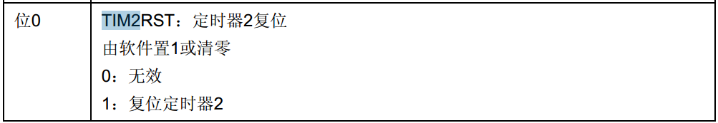

手册上还看到相关寄存器：

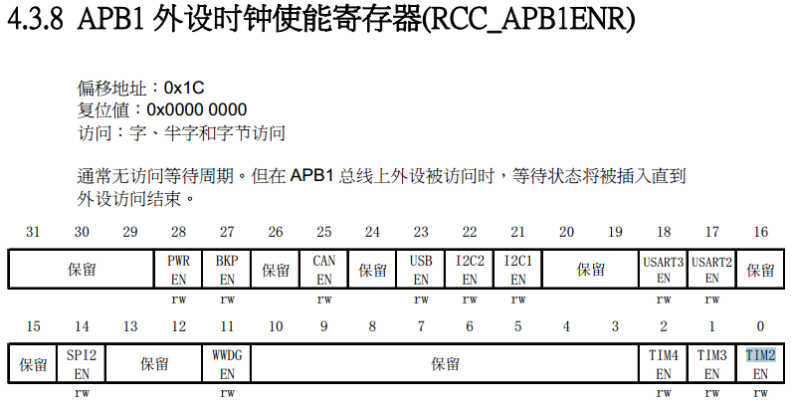

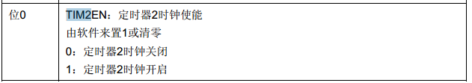

**TIM_ITConfig(TIM2, TIM_IT_Update, ENABLE);**  //打开中断溢出中断

#define TIM_IT_Update ((uint16_t)0x0001)

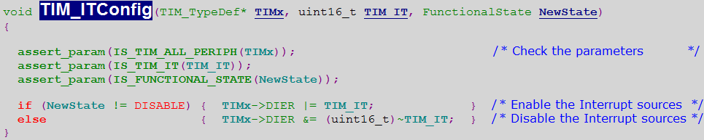

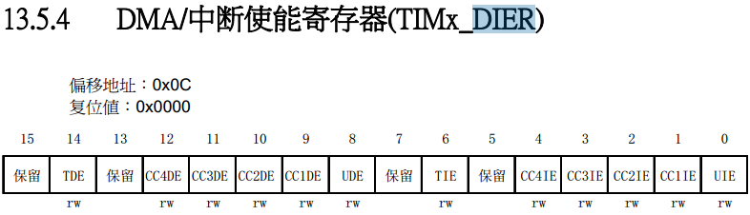

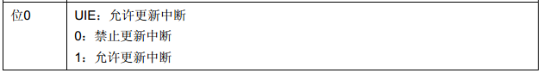

**TIM_Cmd(TIM2, ENABLE);**  //打开定时器

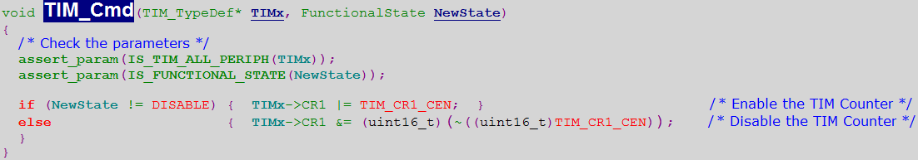

#define TIM_CR1_CEN ((uint16_t)0x0001) /*!< Counter enable */

