Tutorial # 1: Variables, Primitive Data Types and Operators
Name: Puri Sangnawakit Nickname: Day ID:
The use of \n is called a New Line. Wherever it appears, it will start a new line.
- What is the output of the following code (copy the code and place it in the main method)?

System.out.print("Hello World \nMy Name is Pikul \nI'm lecturer");

Output (Example):
Hello World
My Name is Pikul
I'm lecturer

- If you want to output the values using the System.out.print command (without using println)?
사건은 다가와, ah-oh, ayy
거세게 커져가, ah-oh, ayy
That tick, that tick, tick bomb
That tick, that tick, tick bomb
감히 건드리지 못할 걸 (누구도 말이야)
지금 내 안에선 (su-su-su-supernova)

Code:
public static void main(String[] args){
System.out.print("사건은 다가와, ah-oh, ayy\n");
System.out.print("거세게 커져가, ah-oh, ayy\n");
System.out.print("That tick, that tick, tick bomb\n");
System.out.print("That tick, that tick, tick bomb\n");
System.out.print("감히 건드리지 못할 걸 (누구도 말이야)\n");
System.out.print("지금 내 안에선 (su-su-su-supernova)\n");
}

- What is the output of the following code?
Code | System.out.println("1");  //System.out.println("2");  System.out.println("3");  //System.out.println("4"); | /* System.out.println("1"); System.out.println("2"); System.out.println("3"); System.out.println("4");  */ | /**  *System.out.println("1");  *System.out.println("2");  *System.out.println("3");  *System.out.println("4");  */
Output | 1  3
☝We called it as comment In Java are non-executable statements that are used to describe the code, making it more readable and maintainable. They are ignored by the Java compiler during execution.

If you want the output to be as follows, how should the code be modified?
1
2

Please edit the following code: (Please write the modifications below)
System.out.println("1");
System.out.println("2");
/*
System.out.println("3");
System.out.println("4");
*/

- Calculate the value of the given mathematical expression:
A + B * C / (D * E) – (F + G) – H
Assign the following values to the variables: A = 5, B = 11, C = 99, D = 29, E = 8, F = 1, G = 5.5, H = 3 Write the code and display the result.
Expected Output: 0.193965517241379
public static void main(String[] args) {
double a = 5, b = 11, c = 99, d = 29, e = 8, g = 5.5, f = 1, h = 3;
double result = a + b * c / (d * e) - (f + g) - h;
System.out.println(result);

}

Result = 0.193965517241379

- Math Class
Code  (Using System.out.println(X) ) | Output | Data Type | Description
Math.PI | 3.141592653589793 | double | PI value
Math.E | 2.718281828459045 | double | Natural log value
Math.sqrt(36) | 6.0 | double | Square Root
Math.pow(10,2) | 100 | double | Power
Math.ceil (3.5) | 4.0 | double | Rounding up to nearest integer
Math.abs(-3) | 3 | int | Absolute
Math.round(3.5) | 4 | int | Rounding up if decimal is .5 or greater than
Math.floor(3.5) | 3.0 | double | Rounding down to nearest integer
Math.max( 3, 4) | 4 | int | Finding max number
Math.random( ) | 0.04765321602246397 | double | Random Number
Math.min(3, 4) | 3 | int | Finding min number
Math.log(3) | 1.0986122886681098 | double | Logarithm
Math.exp(10) | 22026.465794806718 | double | e to the power of 10
Hint: https://docs.oracle.com/javase/8/docs/api/java/lang/Math.html

- Temperature Converter (Celsius to Fahrenheit)
- declare celsius for example (now temp is 32)
- convert to Fahrenheit
- display the output

(Celsius to Fahrenheit)
  - Formula : C x 9/5 + 32 = °F
  - °F = C x 9/5 + 32
Code:

public static void main(String[] args) {
double c = 32;
double formula = (c * 9/5) + 32;
System.out.println(formula);
}

Output = 89.6

- Temperature Converter (Fahrenheit to Celsius)
- declare fahrenheit
- convert to celsius
- display the output
  - Formula : (°F - 32) x 5/9 = °C

Code:
public static void main(String[] args) {
double f = 89.6;
double formula = (f - 32) * 5/9;
System.out.println(formula);
}
Output = 32.0

- With a = 1, b = 3, and c = –4 write Java code to evaluate Quadratic Equation. Expected outputs are -4 and 1
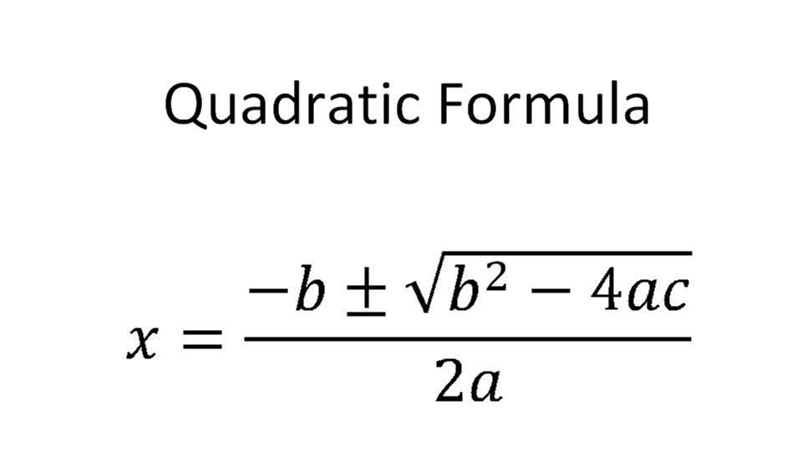
Code:
public static void main(String[] args) {
double a = 1, b = 3, c = -4;
double determinant = (Math.pow(b, 2) - (4 * a * c));

if (determinant >= 0) {
double root1 = ((-b - Math.sqrt(determinant)) / 2 * a);
double root2 = ((-b + Math.sqrt(determinant)) / 2 * a);
System.out.print(root1 + ", " + root2);
} else {
System.out.println("Try again");
}
}

Output = -4.0, 1.0

- BMI Calculator
- declare variable weight and assign value (in KGs)
- declare variable height and assign value (in meters)
- Calculate BMI using BMI formula
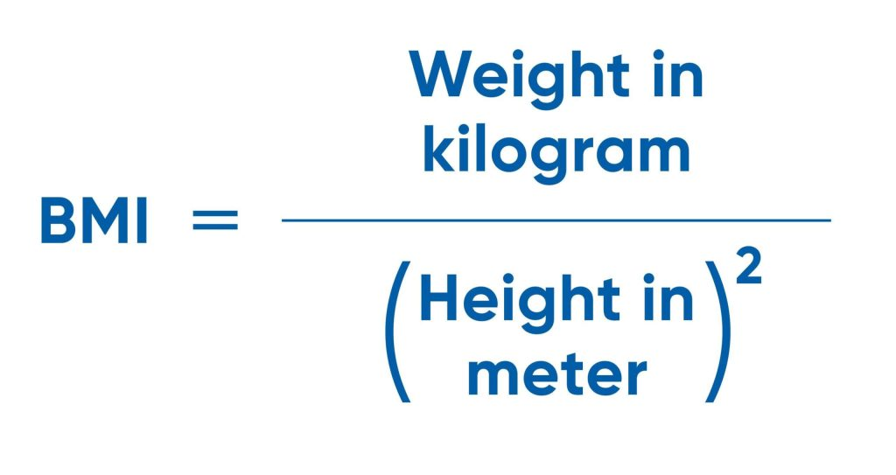

Display the result

Code:
public static void main(String[] args) {
double kg = 120.0;
double height = (2.0);
double bmi = kg / Math.pow(height, 2);
System.out.println(bmi);
}

Output = 30.0

