David Aydin

Professor Krueger

Database Management Systems

19 November, 2019

Final Project

Description:

A very rugged and elementary database for processing orders and payments of sneakers with respect to their manufacturer and each individual customer. All potential types of users for the database would include but are not limited to customers looking to purchase new sneakers and an administrator user to view the order details and payments for each individual customer with respect to the pair of sneakers they desire. Expected queries would invoke perhaps a list of orders or rather those waiting for payments to be fulfilled as well as the various types of sneakers in each set colorway and quantity in stock. Data will be accessed using the primary keys when made during the sql creation and population of each table.

ERD Model:

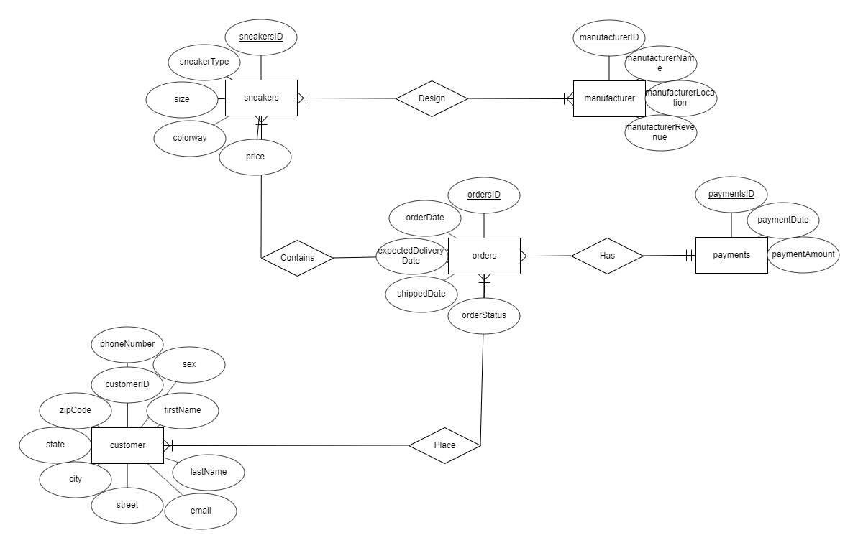

Relational Schema:

