# CSC415 HW1

Name: Cheng Li

SFSU ID: 916422876

Host OS: Windows 7

Guest OS: Linux (Ubuntu 14) on VirtualBox

## Programming in Windows

**Requirement:**

* Prints out the following string on the shell command line: Hello 415, I am <your name>!
* <your name> is #Define’d
* Use GetStdHandle() to get a handle to the standard output stream,
* Use the snprintf() function to format your output into a buffer prior to printing
* Use cl to compile

**Code Segment:**

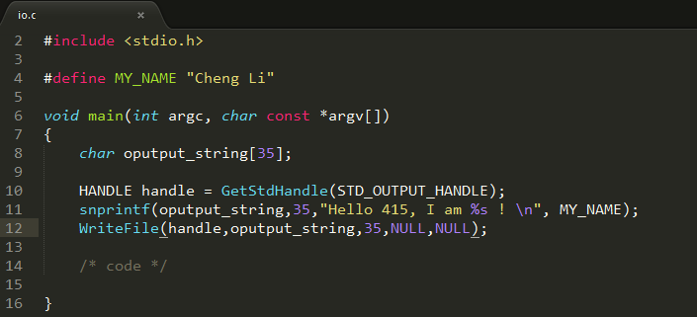

**Compile and run using Visual Studio cl compiler:**

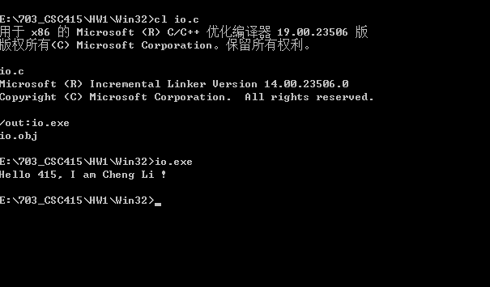

## Programming in Linux (in VirtualBox)

**Requirement:**

* Prints out the following string on the shell command line: Hello 415, I am <your name>!
* <your name> is #Define’d
* Use write() function, and 1 for the file descriptor.
* Use the snprintf() function to format your output into a buffer prior to printing
* Use cc to compile, with –Wall option

**Code Segment:**

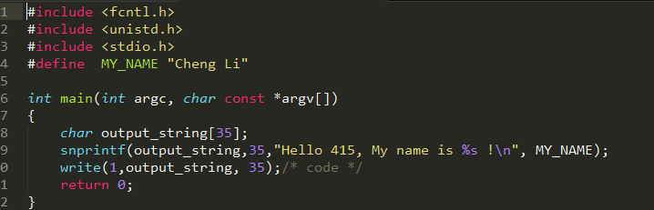

**Compile and run:**

