# CSC415 HW2

Name: Cheng Li

SFSU ID: 916422876

Host OS: Windows 7

Guest OS: Linux (Ubuntu 14) on VirtualBox

## Programming in Linux (in VirtualBox)

**Requirement:**

* Make a copy program and output the total bytes read

**Code Segment:**

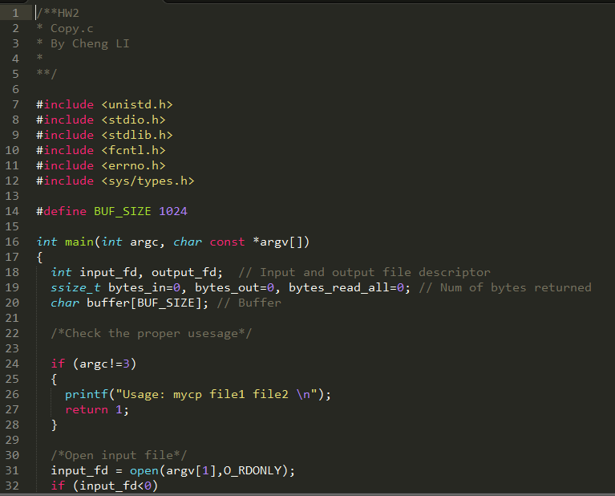

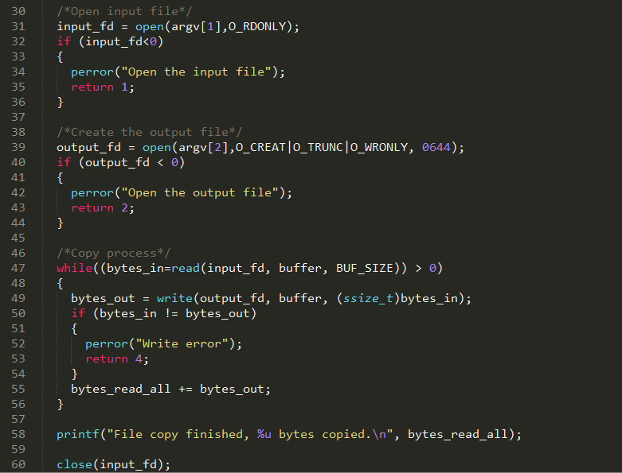

**Compile and run:**

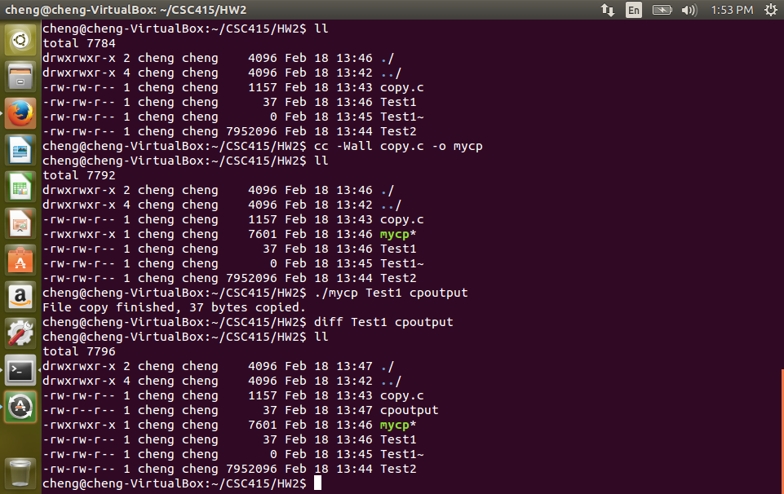

**Copy ASCII file**

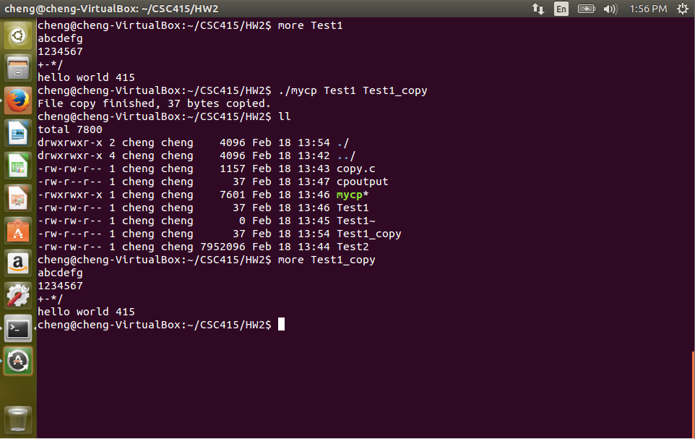

**Copy a binary file (The Test2 in the folder)**

