# CSC415 HW3

Name: Cheng Li

SFSU ID: 916422876

Host OS: Windows 7

Guest OS: Linux (Ubuntu 14) on VirtualBox

## Programming in Linux (in VirtualBox)

**Requirement:**

* A simple shell program that can accept the user input and execute the corresponding build-in program
* **Input requirement**
  + Maximum length of input is 1024 bytes. Extra input beyond that will be omit, only the truncated input will be used.
  + Maximum arguments accepted is 5 (in the program it is set to be modifiable)
  + Empty input (return or space) is acceptable.

**Code structure:**

* The lcsh include 3 funcs, prompt_and_read, parse, and lcsh
* prompt_and_read prompts and read the user input,
* parse parses the input
* lcsh do the fork, execvp and wait work

**Compile and run:**

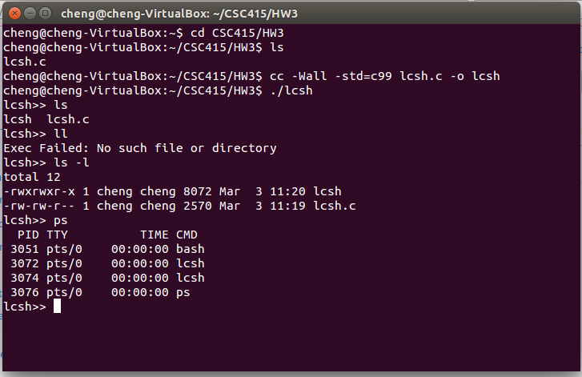

**Compile and run:**

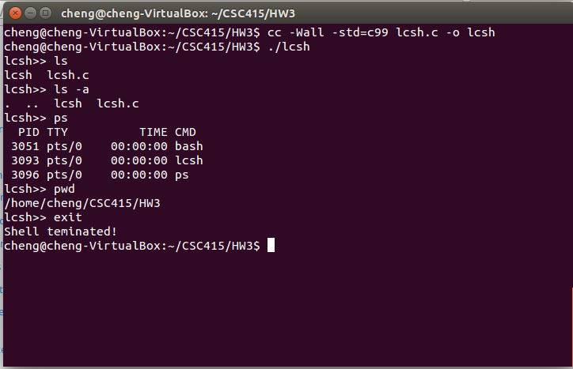

**Error Handling:**

