# Requirement

Create 1/2/4/8 thread to track the total number of distinct characters within a large file.

# Compile and Run

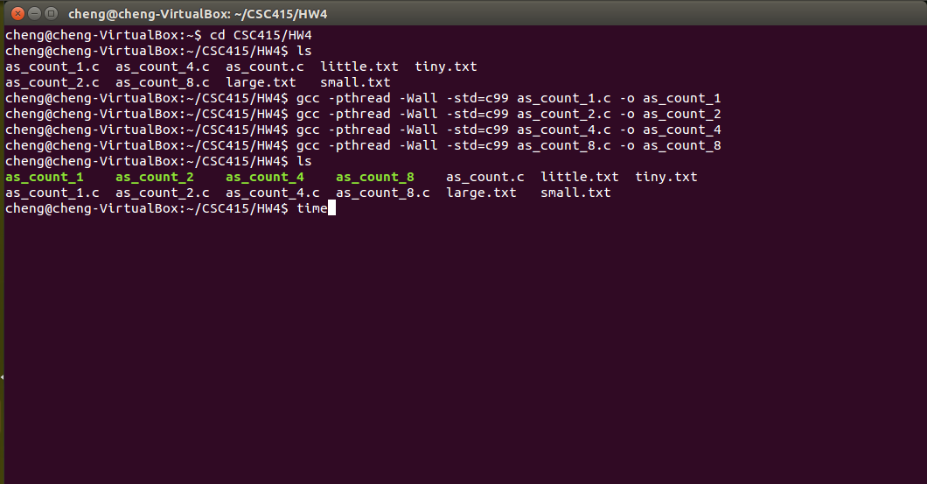

# THREAD Performance

|  |  |  |  |  |
| --- | --- | --- | --- | --- |
|  | Thread_1 | Thread_2 | Thread_4 | Thread_8 |
| Real Time (s) | 0.744 | 0.720 | 0.886 | 0.856 |
| User Time (s) | 0.276 | 0.244 | 0.248 | 0.276 |
| Sys Time (s) | 0.260 | 0.272 | 0.288 | 0.304 |

