|  |  |
| --- | --- |
| Name: Dayem Mujahid | EE-272L Digital Systems Design |
| Reg. No.: 2023-EE-072 | Marks Obtained: ____________ |

**Lab Manual**

**Combinational Circuits: Structural Modeling using Vivado**

**LAB3**

|  |  |  |  |  |  |
| --- | --- | --- | --- | --- | --- |
| **DSD Lab Manual Evaluation Rubrics** | | | | | |
|  |  |  |  |  |  |
| **Assessment** | **Total Marks** | **Marks Obtained** | **0-30%** | **30-60%** | **70-100%** |
| Code Organization (CLO1) | 3 |  | No Proper Indentation and descriptive naming, no code organization.  Zero to Some understanding but not working | Proper Indentation or descriptive naming or code organization.  Mild to Complete understanding but not working | Proper Indentation and descriptive naming, code organization.  Complete understanding, and proper working |
| Simulation (CLO2) | 5 |  | Simulation not done or incorrect, without any understanding of waveforms | Working simulation with errors, don't cares's(x) and high impedance(z), partial understanding of waveforms | Working simulation without any errors, etc and complete understanding of waveforms |
| FPGA (CLO2) | 2 |  | Not implemented on FPGA and questions related to synthesis and implementation not answered. | Correctly Implemented on FPGA or questions related to synthesis and implementation answered. | Correctly Implemented on FPGA and questions related to synthesis and implementation answered. |

**Truth Table :**

|  |  |  |  |  |
| --- | --- | --- | --- | --- |
| **A** | **B** | **C** | **x** | **y** |
| 0 | 0 | 0 | 1 | 0 |
| 0 | 0 | 1 | 0 | 0 |
| 0 | 1 | 0 | 0 | 0 |
| 0 | 1 | 1 | 1 | 0 |
| 1 | 0 | 0 | 0 | 0 |
| 1 | 0 | 1 | 1 | 0 |
| 1 | 1 | 0 | 0 | 1 |
| 1 | 1 | 1 | 1 | 1 |

**Max combinational delay**



Max combinational delay is from path b to y which is 6.771

**Synthesis report:**

**1 LUT out of 63400 was used in LUT as Logic**

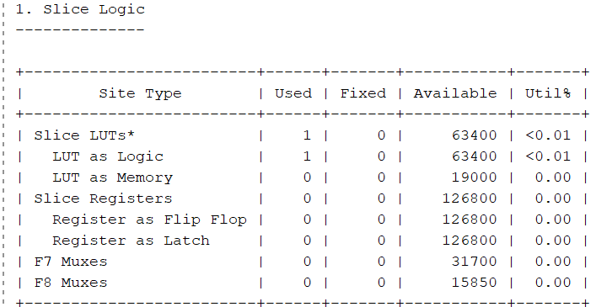

**5/240 Bonded IOb were used in input/output blocks of FGPA.**

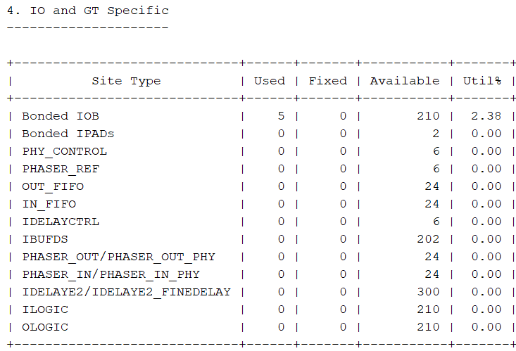

**From primitives 3 input buffers, 2 output buffers,1 3-input LUT, and 1 2-input LUT were used**

