Title: Emergency alert button for women's safety

Problem:

Women’s safety is a major concern, especially in situations like harassment, stalking, or sudden threats. In many cases, victims cannot reach out for help in time due to fear or lack of quick access to communication. There is a need for a *quick, discreet, and reliable way to alert family or authorities* during emergencies

Solution:

The project introduces a *portable emergency alert button* that a woman can press in a dangerous situation. Upon pressing:

* It *sends an instant alert* (SMS or notification) to pre-registered emergency contacts.

* It can *share real-time location (GPS)* for easy tracking.

* It may *activate a buzzer or flash* to attract public attention if needed.

* It ensures *fast communication* without needing to unlock a phone or open an app.

This system provides *speed, simplicity, and safety* during emergencies, allowing women to respond without panic.

Technology/Stack used:

| **Layer** | **Tool** |
| --- | --- |
| UI | Streamlit |
| AI Engine | Hugging Face |
| Logic Dev | Python on Google Colab |
| Location | Streamlit Map |
| SMS (demo) | Simulated |
| Deployment | Hugging Face Spaces |
| High level diagram |  |

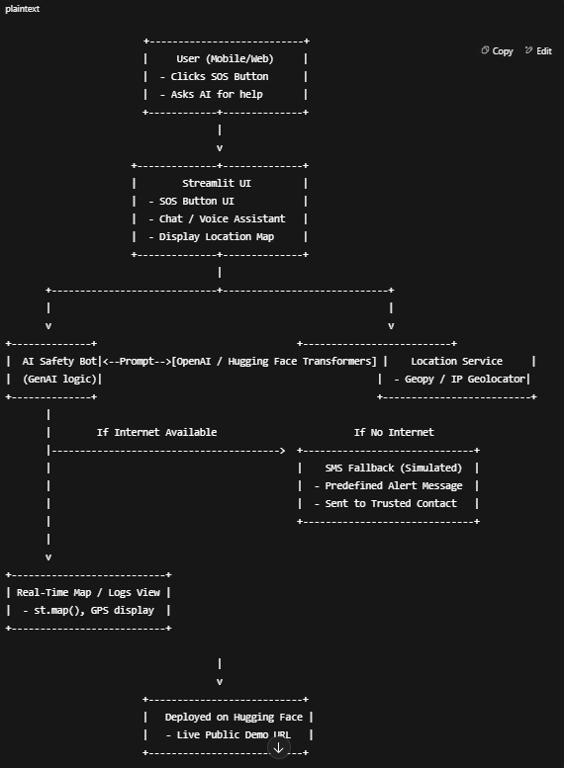

Features of app:

**One-Tap SOS Button (This can be triggered by physical contact)**

* Sends instant alert to pre-saved trusted contact(s)
* Message includes **live GPS location**

### ****Location Tracking****

* Live map (using st.map() in Streamlit or Map APIs)
* Continues updating user location every few seconds until marked safe

### ****Offline Support****

* If no internet:
  + Use SMS fallback (Demo or practical )
  + **SMS fallback** is your Plan B: If the app can't use internet to send an alert, it sends an **SMS message instead**, ensuring the emergency alert always goes through .Vonage API can be used.
  + Alert with approximate last known GPS location to the trusted contact

### ****Voice Activation****

* Say “Help me” or “Emergency” → app triggers SOS
* Use Whisper (OpenAI) or integrate browser mic input in Streamlit

### ****Panic Mode Timer****

* If user presses and holds the button for 3 seconds → triggers emergency
* 10s silent countdown before alerting to contacts