Testable Methods

Test case clarify scenarios

Constructor Chaining minimize repeated codes

Avoid putting too much code in constructor

Namespace organize in logical hierarchy

Static class can only have static members

Static class cannot be instantiated

Static class cannot implement inheritance

Static class cannot be extended

Static class cannot have constructor

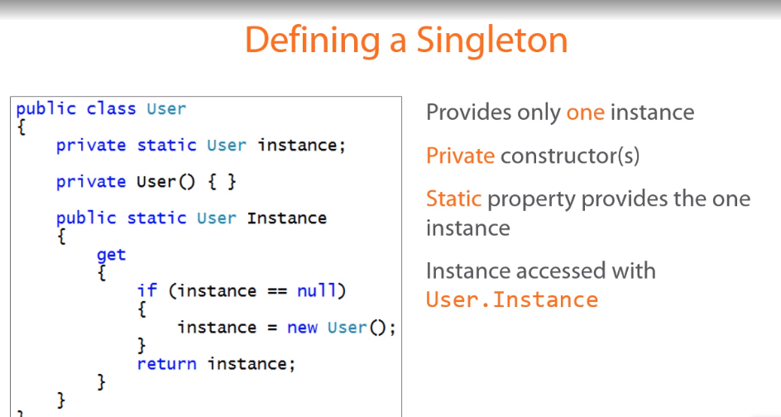

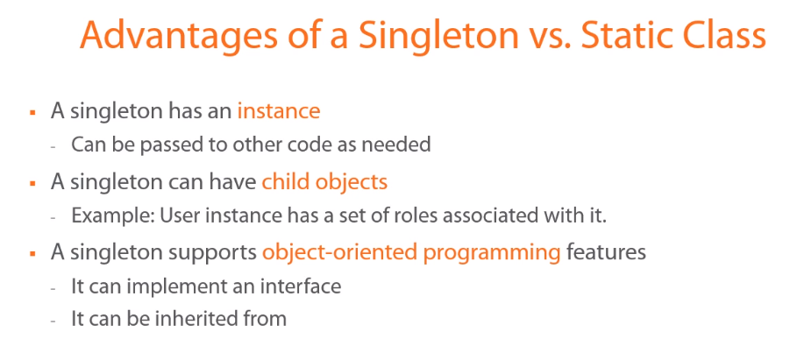

Using object initializers, we can assign values to any properties without the parameterized constructor

**Lazy Loading**

Instantiating related objects when they are need and not before

This often involves creating the instance in the property getter of the related object

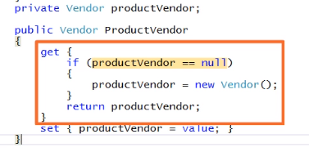

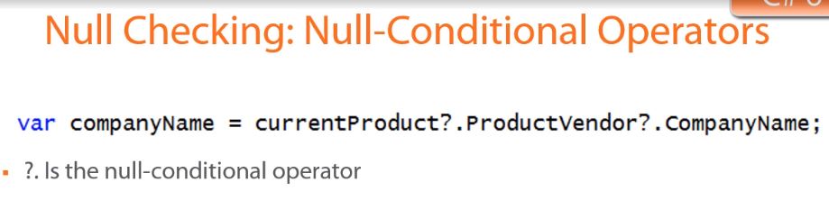

Backing fields are normally private

Null able types defined using “?”.

Constants are evaluated at compile-time. Constants are static and can be used by class name.

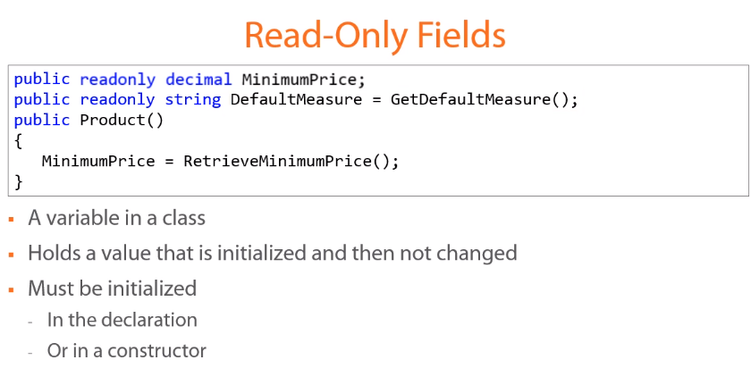

Read-only fields are runtime constant