Janine's Final Thoughts and Advice:

.gitignore:

* Set up first, don't forget it
* Do not block all .json files, you WILL lose important info (like appsettings.json)
* Where this project is set up as MVC vs blazor, it is a bit more difficult to get things working initially, but once they work, it's fairly easy to manage

Leaderboard Page:

* Dynamically populated
* Need to add a leaderboard table in the database
* We were working with code to database approaches and using the given migration tools for MVC projects
* <https://learn.microsoft.com/en-us/aspnet/mvc/overview/getting-started/getting-started-with-ef-using-mvc/migrations-and-deployment-with-the-entity-framework-in-an-asp-net-mvc-application>

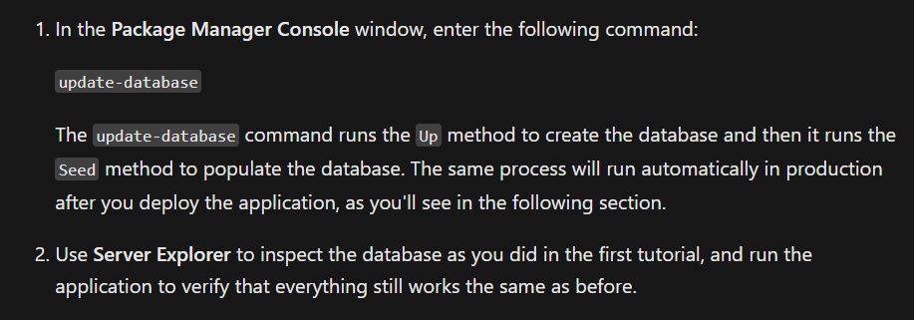

QRCode and Notification Service:

* Admin tools
* Whenever admin console is created, that’s where these should go
* QRCode generator has a link on the home page
* Notification service is just the basic logic in code
  + In order to send texts, you need the provider of the phone number you are trying to text
  + Kinser mentioned figuring out one of the free websites API’s that will find the provider

Task List:

* We initially wanted to only show the location name (Ex: Martin Center) and have a partial view populate when clicked upon, though we ran out of time
* So, each partial view is loaded when a user is validated
* It currently only validates answers, but it does not store any information
* We thought of storing session variables with tasks completed and having a score column in the leaderboard that would track the overall score for everybody

Profile Page:

* This code was never integrated into the final project
* See profile page draft in github

Hunt Controller:

* Loads various partial views (nav bar, task lists)
* Uses session variables to track which user code signed in
  + Just displays their email address, since user table in database does not have first or last name columns
  + Personally, I think they should be added, but only if the migrations from code to database work