Server User/Admin Account Creation and Modification

**Navigate to:**

* Control Panel

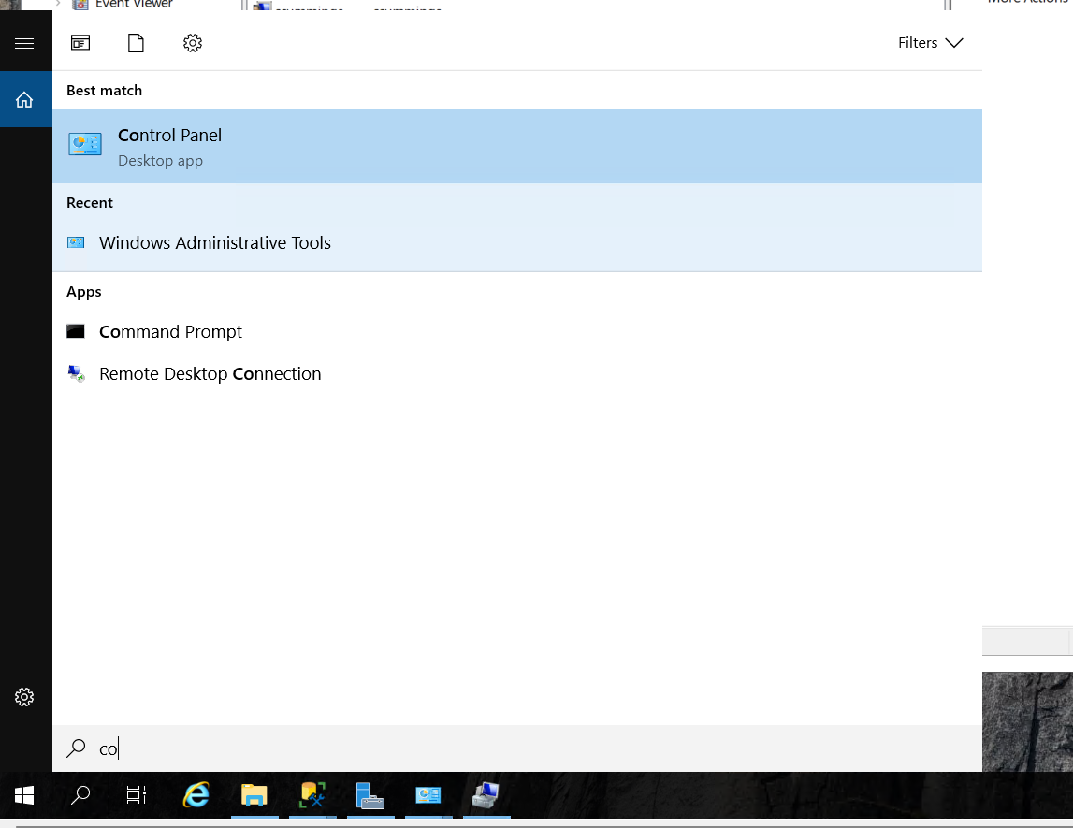

Helpful hint: after opening control panel, set the “view by” drop down in the top right to large icons.

* Administrative tools
* Computer Management
* Local Users and Groups
* Users

You should be here:

**To add a user:**

* + Right click under the current users.
  + Click new user

* + Set a name (first initial followed by last name is a good way to do this)
    - Setting a description is not needed but can be useful if you make an account that is for a specific purpose rather than user (for example, a general “DBAdmin” account)
  + Set a unique password
  + Check the box labeled “password never expired”
    - If the team has a designated administrator keeping up with everyone’s accounts and passwords, the box labeled “user cannot change password” would be good to check also.

* + create

**To Modify a user account:**

* + Right click on the user – This step must be done to all the users

Adding the users to the Remote Desktop Users Group

* + - Properties
    - Members Of
    - Add
    - Advanced
    - Find now
    - Find the Remote Desktop Users group
      * Tip: start typing and it will search

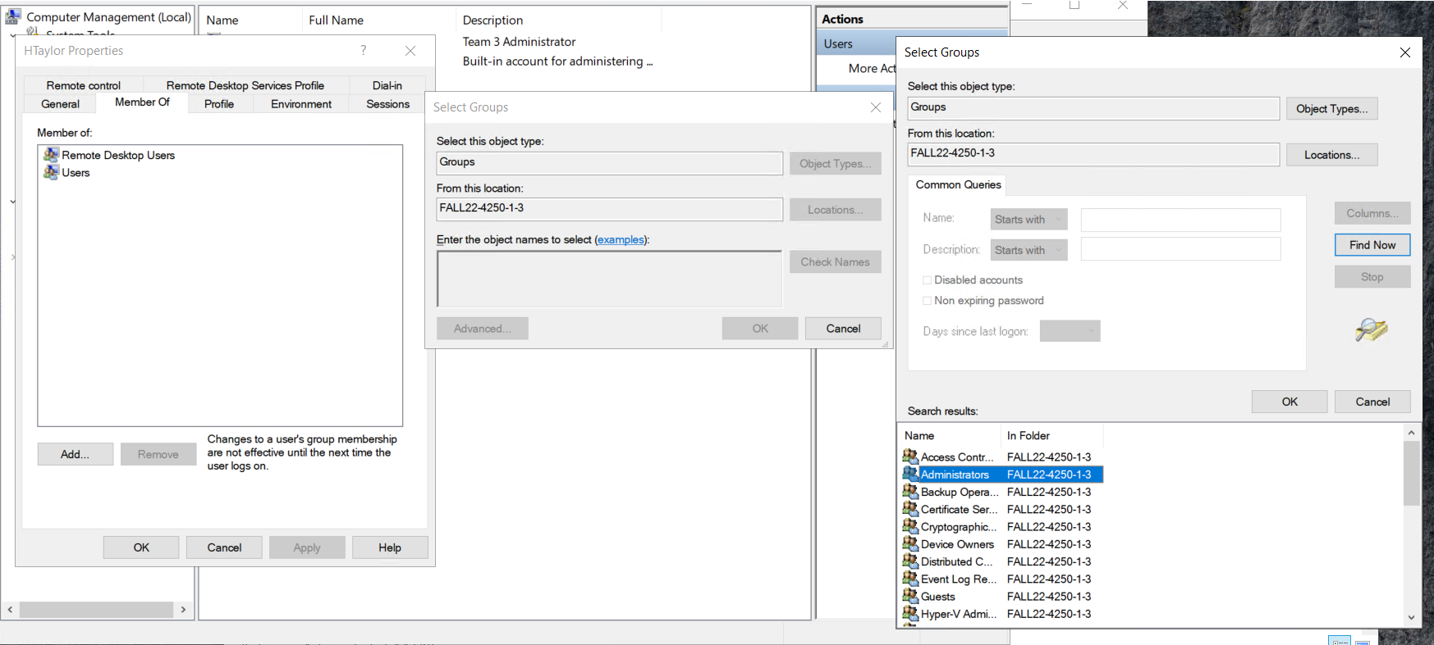

* + - Double click it
    - Okay
    - If the account needs to be an administrator, follow the same steps but add “administrators” – ONLY do this to accounts that need admin right

**If the password needs changed:**

* + - click change password
    - Proceed
    - Type password
    - Ok

**If other account details need changed:**

* + - properties
    - Make necessary changes
    - Apply/ok

**At the end of the semester, the team administrator(s) must:**

* Delete all student user accounts
  + Before doing so, make sure that all data saved under those accounts is backed up in a folder the admin account (this is in case any important project files were accidentally saved under a user account)
* If there are any accounts that need to remain on the server (there shouldn’t be), the accounts need to be disabled.
  + After right clicking on the account, click “disable account”
  + Be sure you don’t do this to the admin account
* The admin account password needs to be given to the professor