Refactoring of class Screenshot.cs located in the ScreenShotLib Library of ShareX.

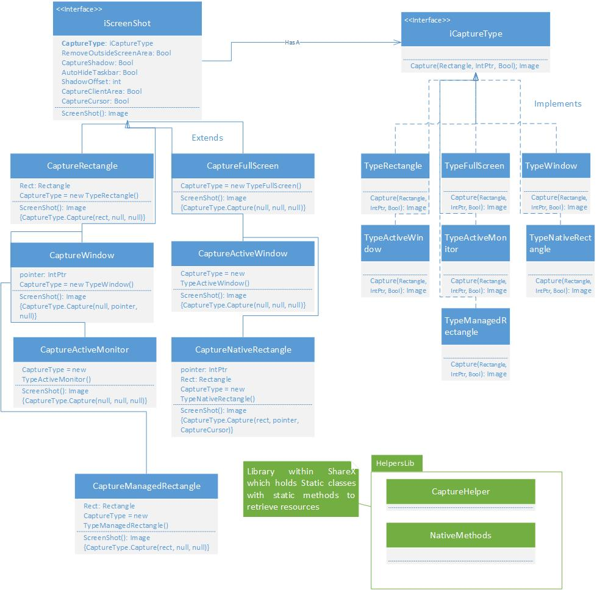

Without any refactoring, the Screenshot.cs class is responsible for capturing screenshot that are defined by the user (full screen, window, region and more). In order to capture the images, ShareX has a library called the HelpersLib, which contains a static class called CaptureHelper and NativeMethods. These class have the appropriate logic to access the screen resource to capture it. The Screenshot class would then have methods, with some extra configuration settings set by the user, where these methods would access the CaptureHelper in order to get the final screenshot. Thus we see that Screenshot has increased cohesion with CaptureHelper and NativeMethods from another library. To reduce this coupling, we are suggesting to implement a Strategy Pattern for the Screenshot class. In order to do so, we need to create a new interface that we will call *iCaptureType* which will have a single method to capture the screenshot using the HelperLib classes. We will then turn the Screenshot class into an interface as well and have a wrap on the iCaptureType. Finally we will have classes which extend the iScreenshot interface to specific captures (region, full screen, window and more). These specific extensions of iScreenshot will then access the appropriate method of capturing using the various strategies located in the iCaptureType interface. Furthermore, by adding this pattern it is easy to add a new capture type to the system, or make changes to the current capture processes.