LockedMe Prototype

Developer: Davina Pinto, BNP trainee

# Introduction

## Purpose

Company Lockers Pvt. Ltd. Aims to digitize their product and LockedMe is the first prototype application. This application handles files in a directory and permits users to add, delete and search for files through the command line.

# Overall Description

## Product Perspective

Application handles manipulation of files in the Root Directory. User can view available files, add a file, delete a file or search for a file. The file could be of any format (word,txt.,etc. ).

## Product Flow

* Application main window has the application name followed by the a main menu containing the following:
  + Display Files in directory: This Option displays all files of the directory.
  + Options to manipulate files: This option further leads to a second menu.
  + EXIT : This option helps exit from application
* Options to manipulate files leads to a menu which contains :
  + Add a file to List: This option adds a file in one of two ways
    - Create a file : User has the option to create a new file
    - Add file : User has the option to add a file from any directory on machine
  + Delete file from List: This options allows user to delete a file from directory if the file exists.
  + Search for file in List: This options allows user to search for a file in directory, if file doesn’t exist, it shows an appropriate response.
  + Return to main menu: This option allows user to return to main menu

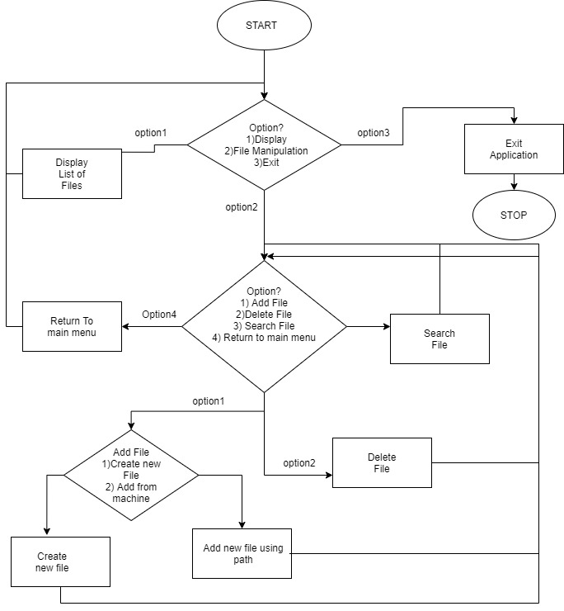

## Core Java concepts used

* Abstract Interface
* Comparator Interface
* Collections framework
* File handling
* Inheritance
* Exception handling

## Requirements

* JDK 1.8 installed
* Eclipse or Spring Tool Suite or IntelliJ IDE
* Maven for dependency management

# GitHub Repository

The Application folder has been uploaded to GitHub to the following repository link: <https://github.com/daylinda/BNP_training_projects>

# Sprint Planning

Duration of project: 15 working days (3 weeks)

Number of sprints: 3

* Sprint 1: week 1
  + Goal: Understand objectives of project and create layout.
  + Tasks:
    - Plan the features of the project
    - Divide the different features into respective classes
    - Decide the flow of the application
    - Decide the Main application window appearance
    - Create abstract interface for file operations
* Sprint 2 : week 2
  + Goal: Develop the application using core java concepts.
  + Tasks:
    - Create class for Display of files
    - Implement File operations interface and the specified features
    - Implement main class to call the application
* Sprint 3: week3
  + Goal: Test the application for exceptions and faults
  + Tasks:
    - Test the application for IO exceptions
    - Test the application for the specified featured and their working

Weekly sprint meeting will be 2 hours, which will give a total of 6 hours.

Sprint review will be taken at the end of each sprint.

At the end of each day, updates will be pushed to the GitHub repository.