**Final Report**

15/12/17

**Online Teaching**

**Presented By:**

Mickey Corriveau

Table of Contents

Project Definition 3

Use Case Diagram 4

Textual use cases 5

Activity Diagrams 13

Consult Content 13

Pass Quiz 13

Post New Content 14

Post Quiz 15

Remove Content 15

Remove Quiz 16

Upload Media 17

View Result 18

Database Schema 19

Class Diagram 20

User Guide 21

Sign Up 22

Authentification 23

Course Creation 24

Add Media to Course 28

Add Quiz to Course 29

Removing components of a course 32

Updating components of a course 33

Supported Media Formats 33

View a course 34

Pass a quiz 35

Creation on same level of structure 37

Search 39

# Project Definition

The project consists of an online teaching website where it will be possible to post publicly content of a subject and you will have the possibility to pass a quiz for that content.

The main functionalities of the system are:

* Post online content
* upload media for students to be able to view them
* create quiz
* Save state of learning

This project will be a free online teaching solution which will not receive funds for this reason the project feels the need to use tools that will be costless.

This project will be presented and approved by my stage supervisor before being developed by myself.

The technologies used for this website are:

* HTML
* CSS
* JavaScript
* JQuery
* PHP
* MYSQL
* AJAX
* BootStrap
* Awesome Fonts
* Eclipse
* PHPMyAdmin
* XAMPP

# Use Case Diagram

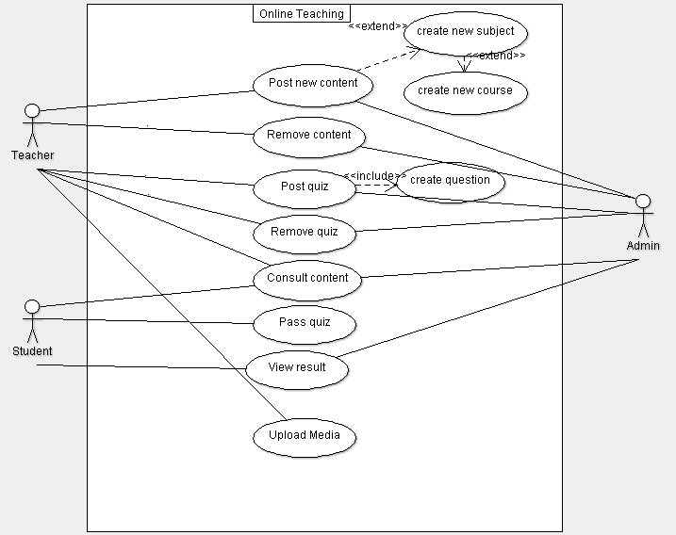

# Textual use cases

















# Activity Diagrams

## Consult Content

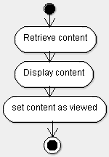

## Pass Quiz

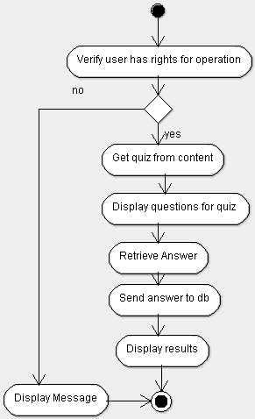

## Post New Content

## Post Quiz

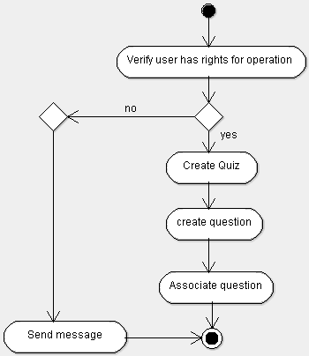

## Remove Content

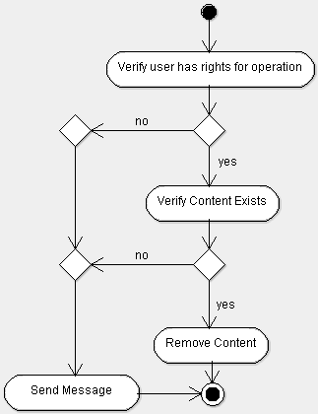

## Remove Quiz

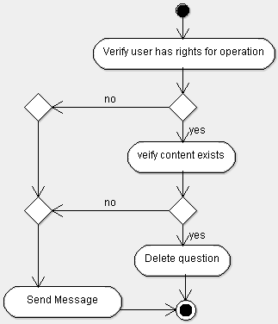

## Upload Media

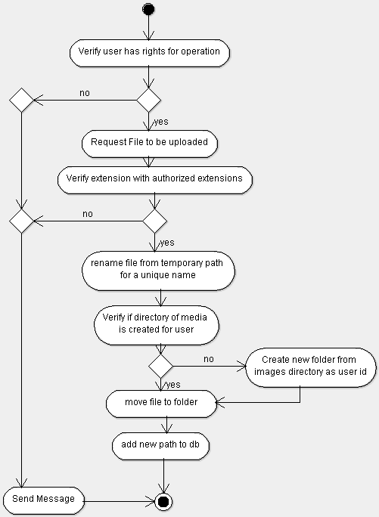

## View Result

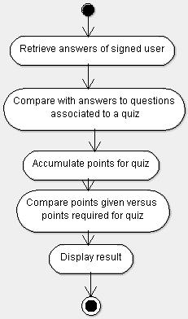

# Database Schema

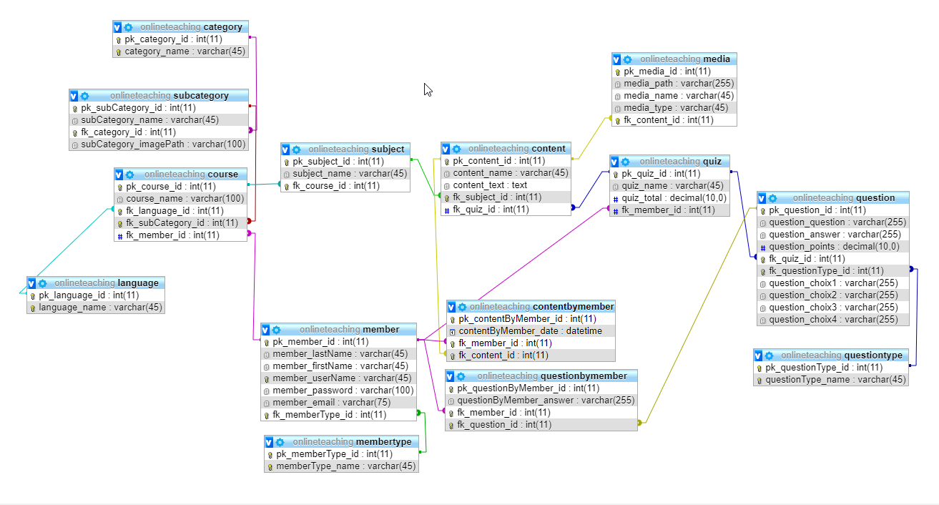

# Class Diagram

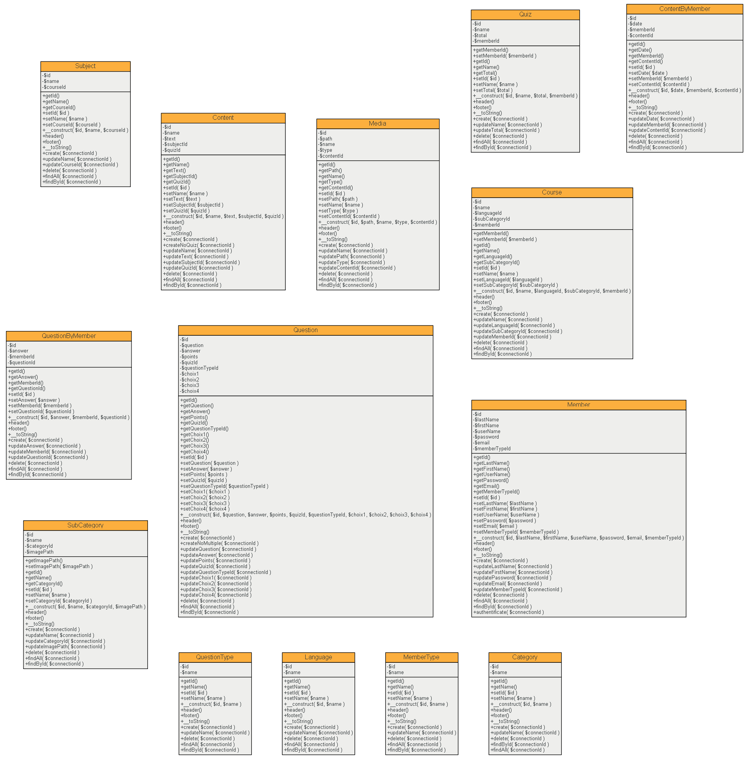



# User Guide

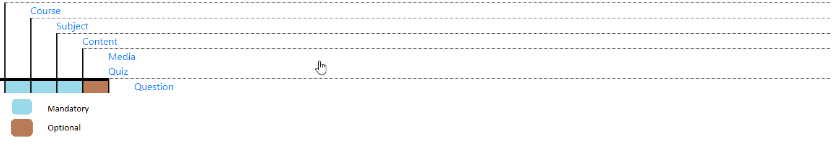

## Sign Up

To sign up no users must be logged in the interface, if it is the case please refer to (disconnect).

1.

On navigation bar click sign up

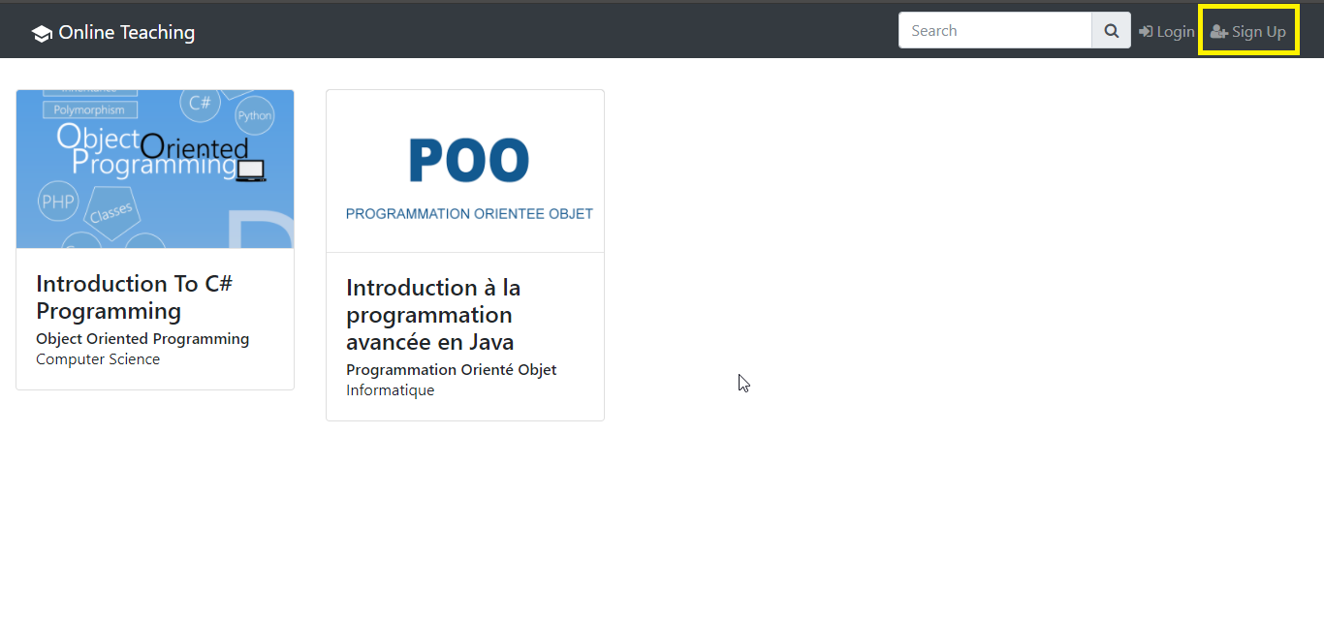

2.

Fill sign up form (<http://localhost/OnlineTeaching/signUp.php>)

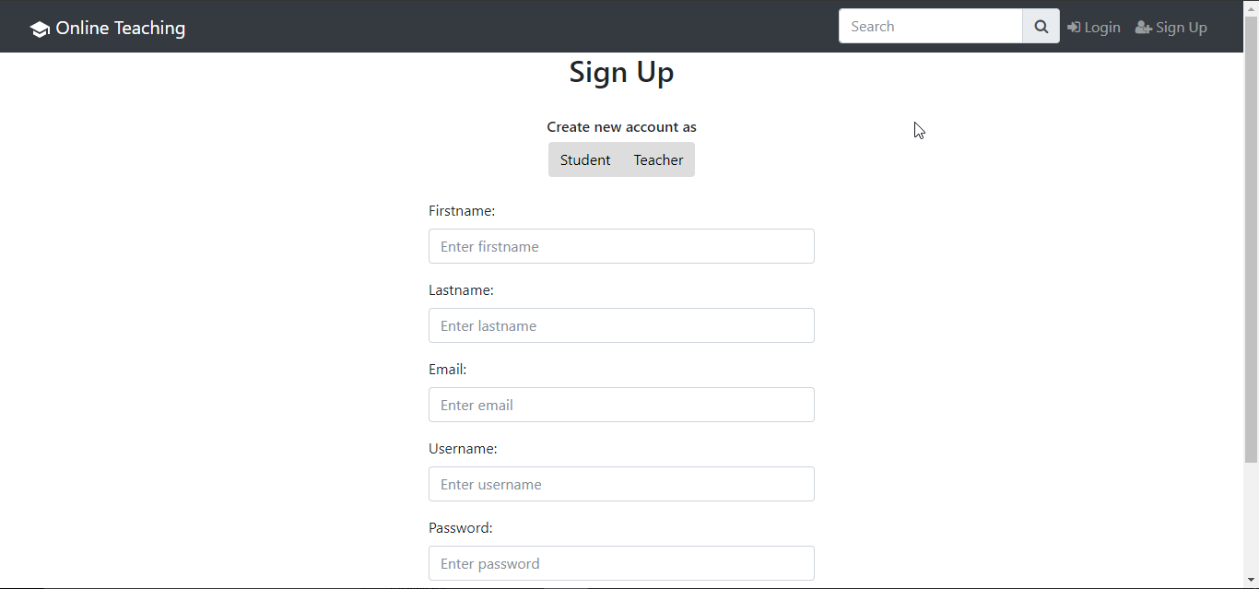

## Authentification

Description:

To authentificate user needs to have signed up and there must be no users logged into the interface , if it is the case please refer to (disconnect).

1.

On navigation bar click Login

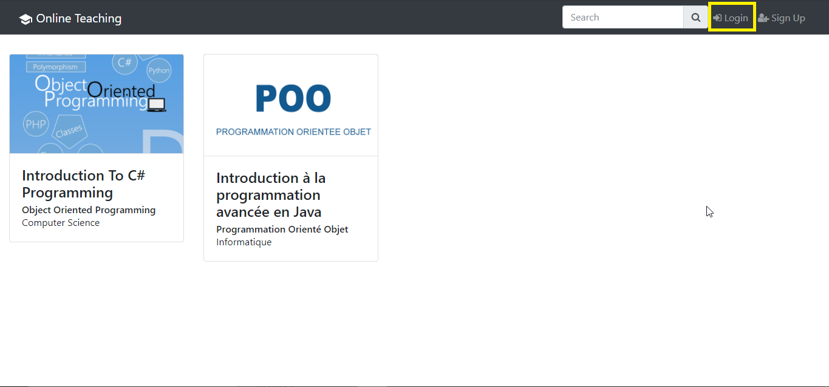

2.

Fill in login form

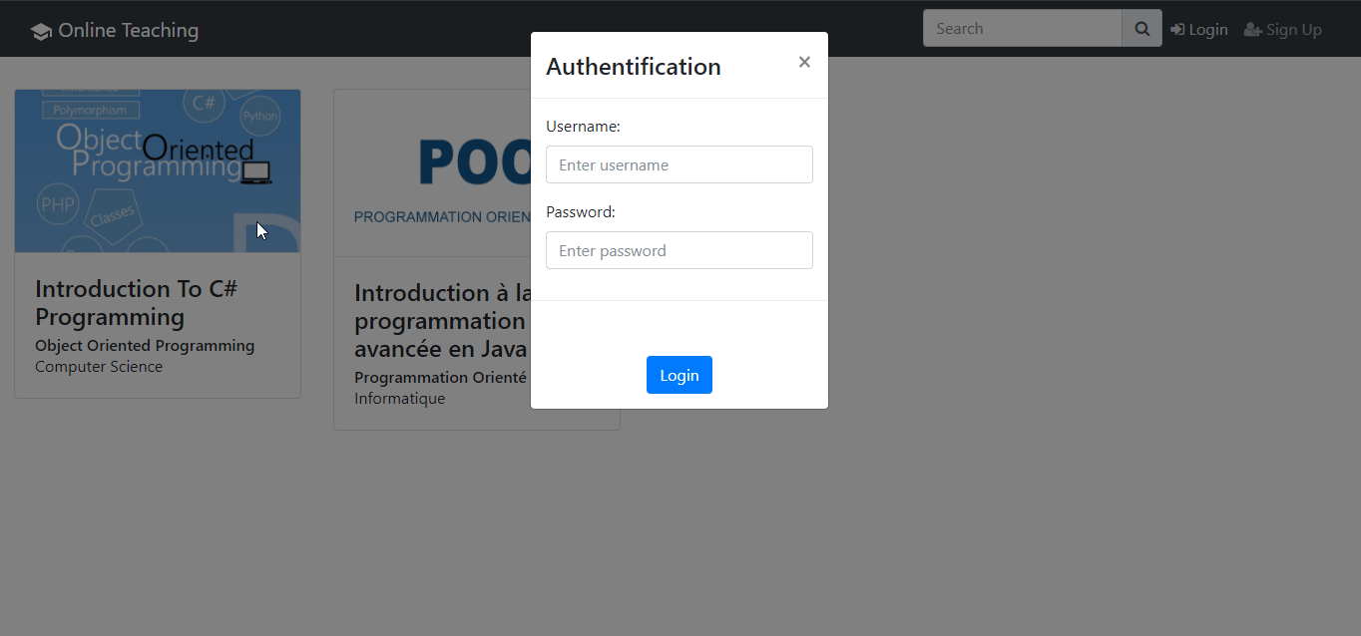

## Course Creation

Description :

The course creation needs to have 3 main objects created to be displayed on the dashboard. (<http://localhost/OnlineTeaching/index.php>)

Objects are creatable if signed in as teacher(Authentification), on Course Management Interface

1.

Login , Please refer to (Authentification).

2.

Click on Manage Courses, in the navigation bar on the profile icon.

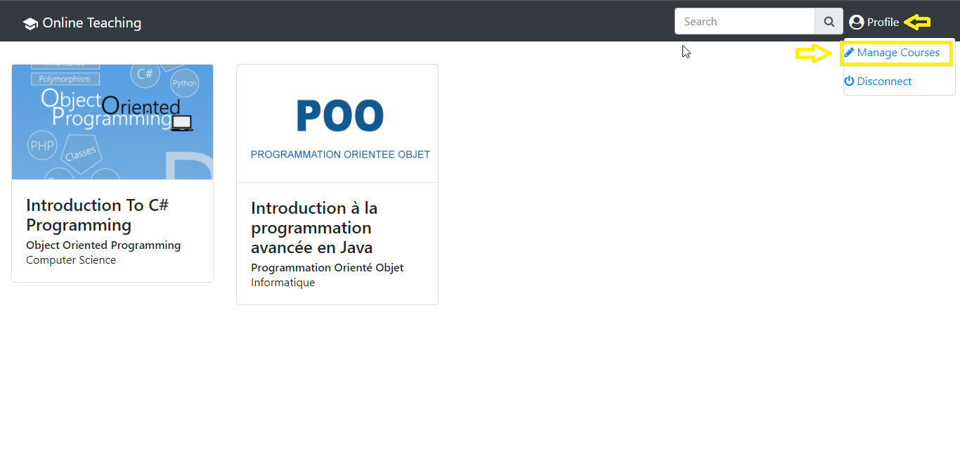

3.

Create a course

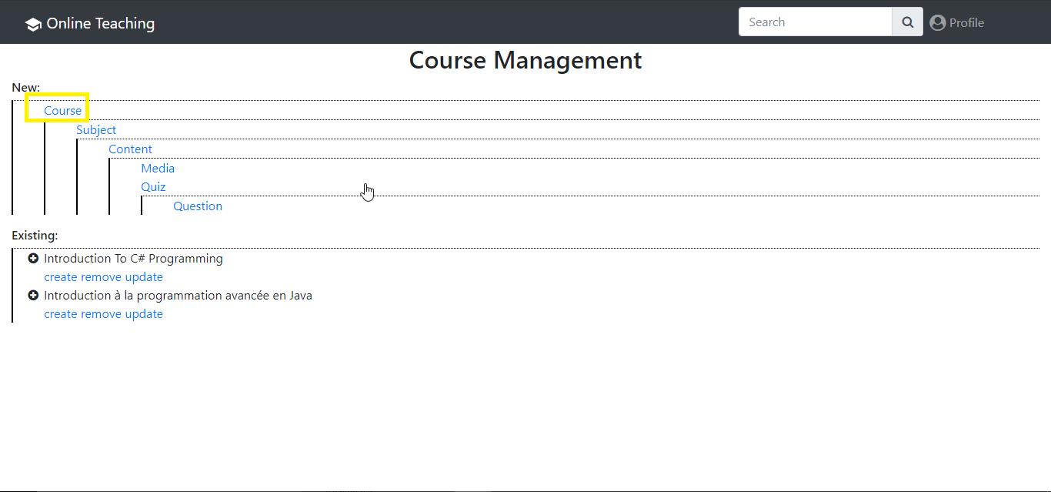

4.

Fill course creation form information

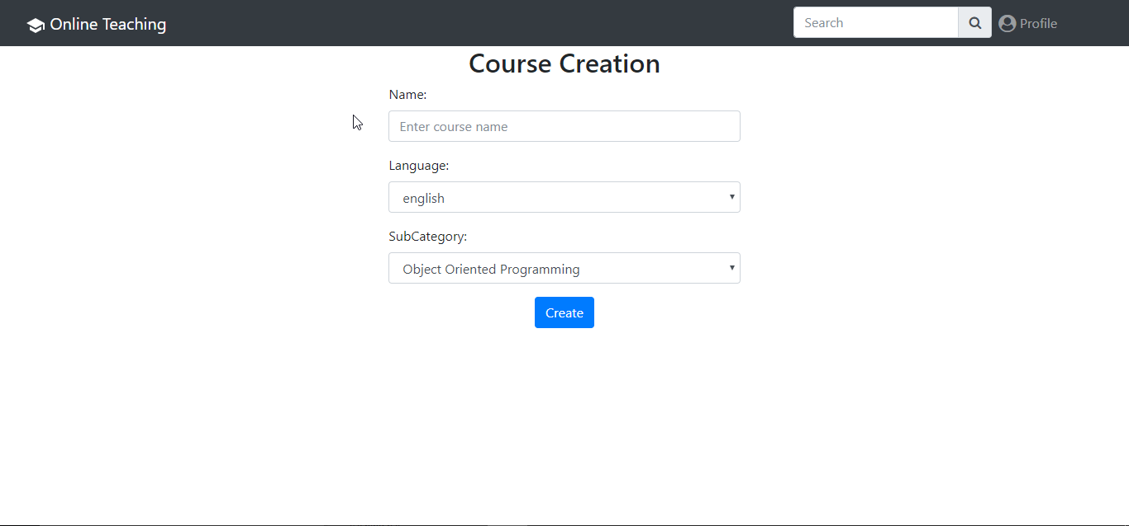

5.

Create a Subject

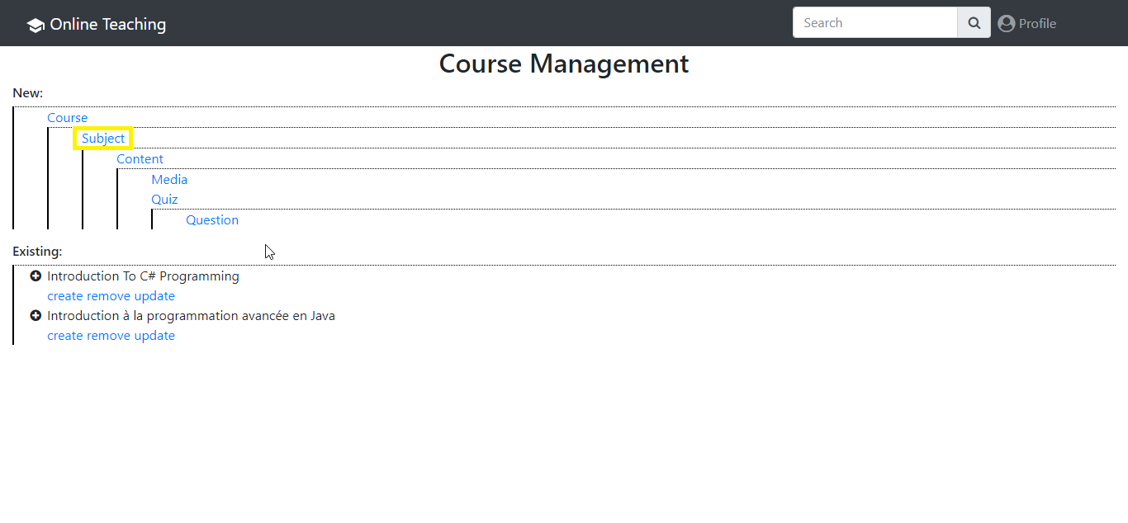

6.

Fill subject creation form

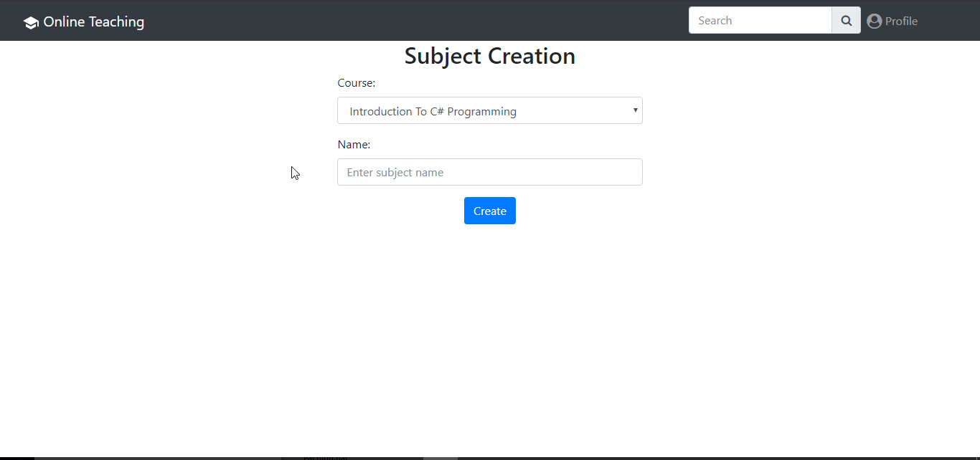

7.

Create new content

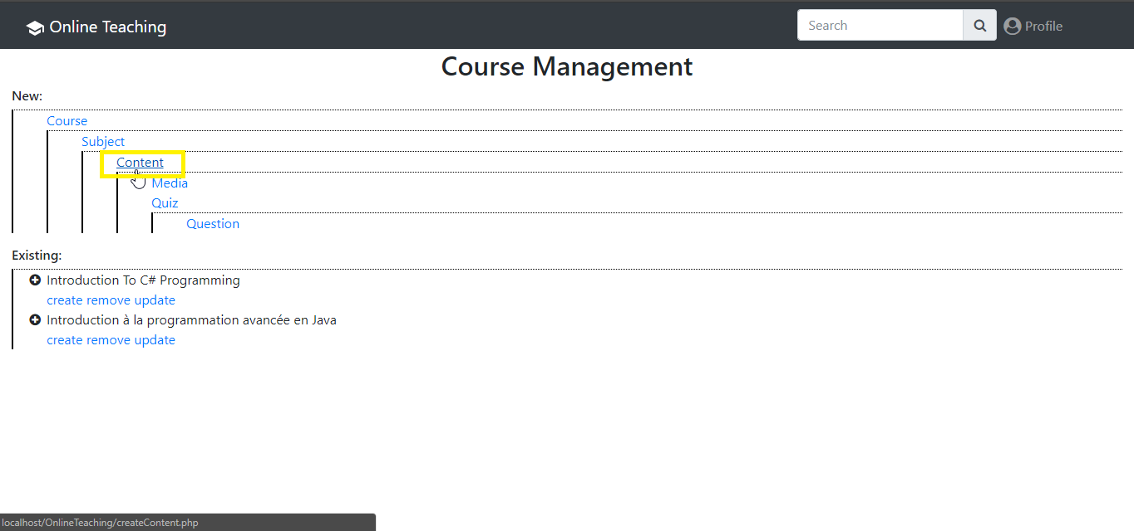

8.

Fill content creation form

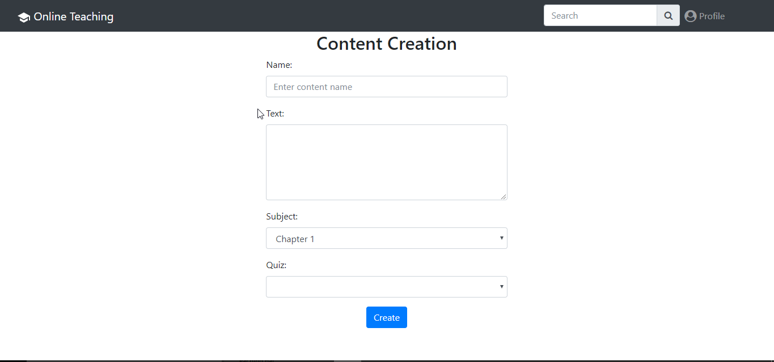

## Add Media to Course

Description:

The content of a course must have been created to add media to a course if it is not done please refer to Course Creation , the same media cannot be applied to multiple content, if this is the case you need to create multiple times the same media, their can be many media on a content.

1.

Inside Course Management interface, Create Media

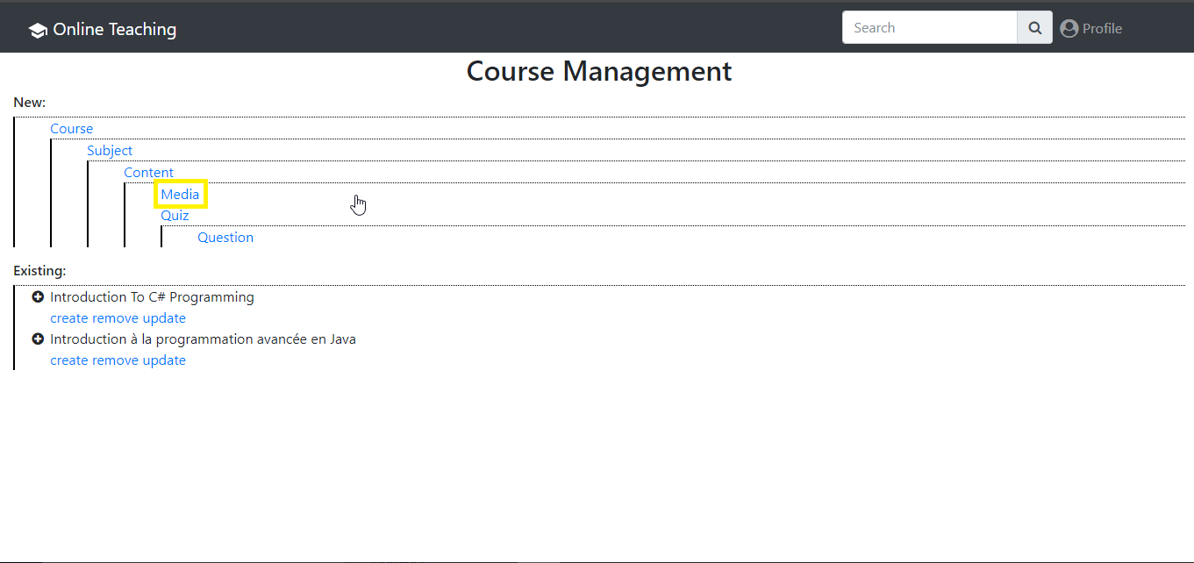

2.

Fill media creation form

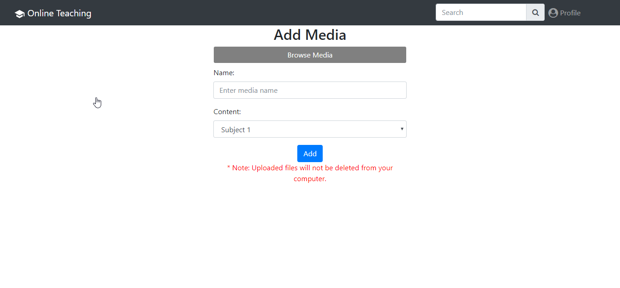

## Add Quiz to Course

Description:

A quiz can be created without having created any content but it will not be displayed until a content is linked to it, also the same quiz can be applied to multiple content, their can be only 1 quiz by content, a quiz is composed of 2 parts quiz and questions

1.

Inside the Course Management interface Create Quiz

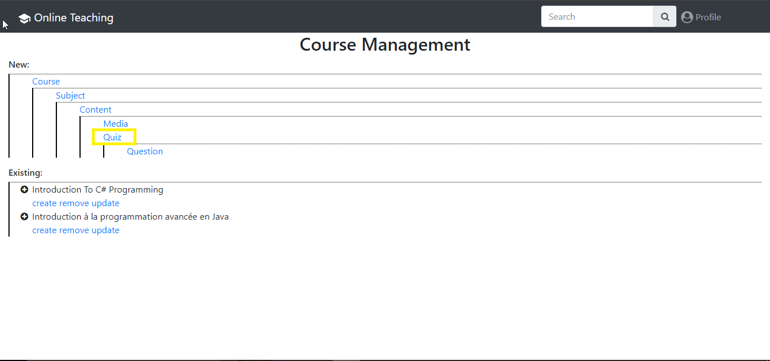

2.

Fill quiz creation form

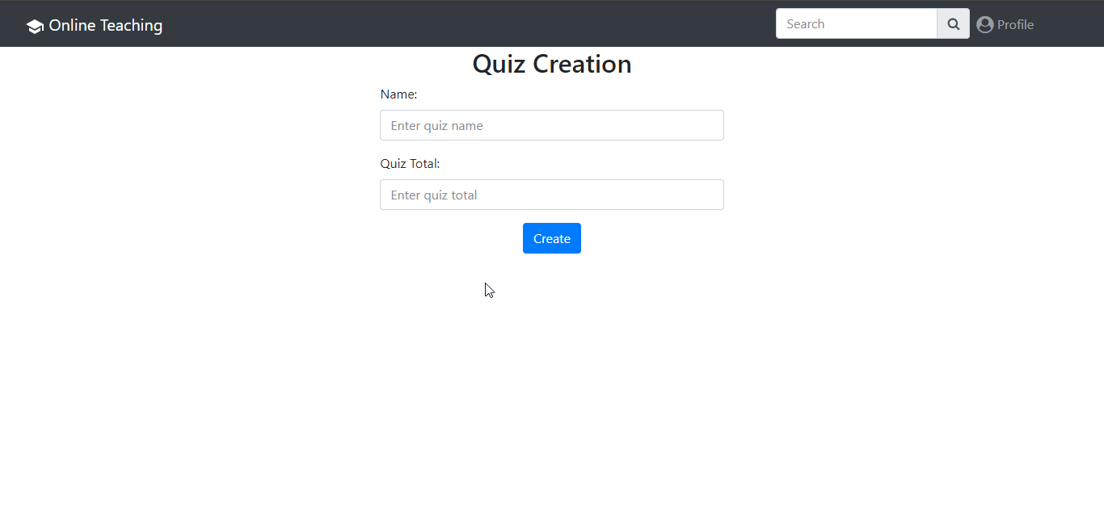

3.

Create Question

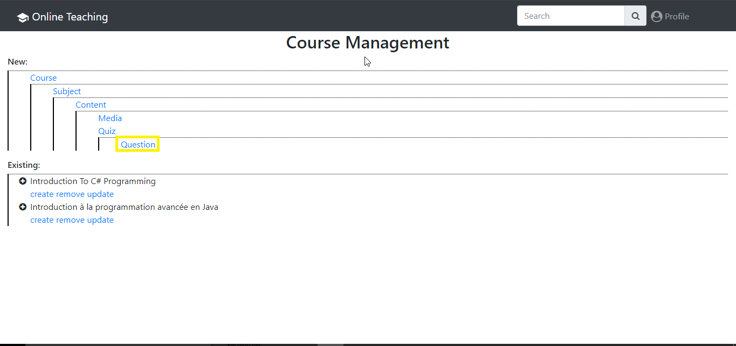

4.

Fill question creation form

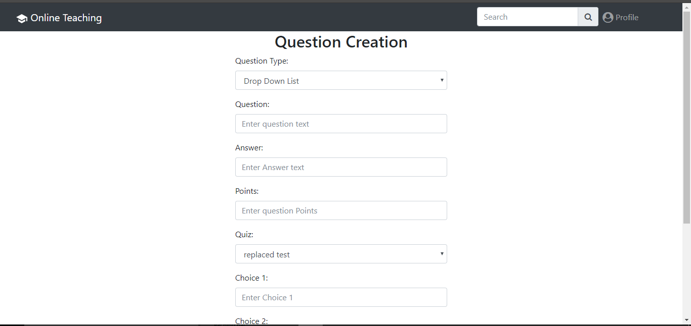

5.

Link quiz to content, select update of an existing content, if there is no existing content, it must be created , if it is the case please refer to Course Creation

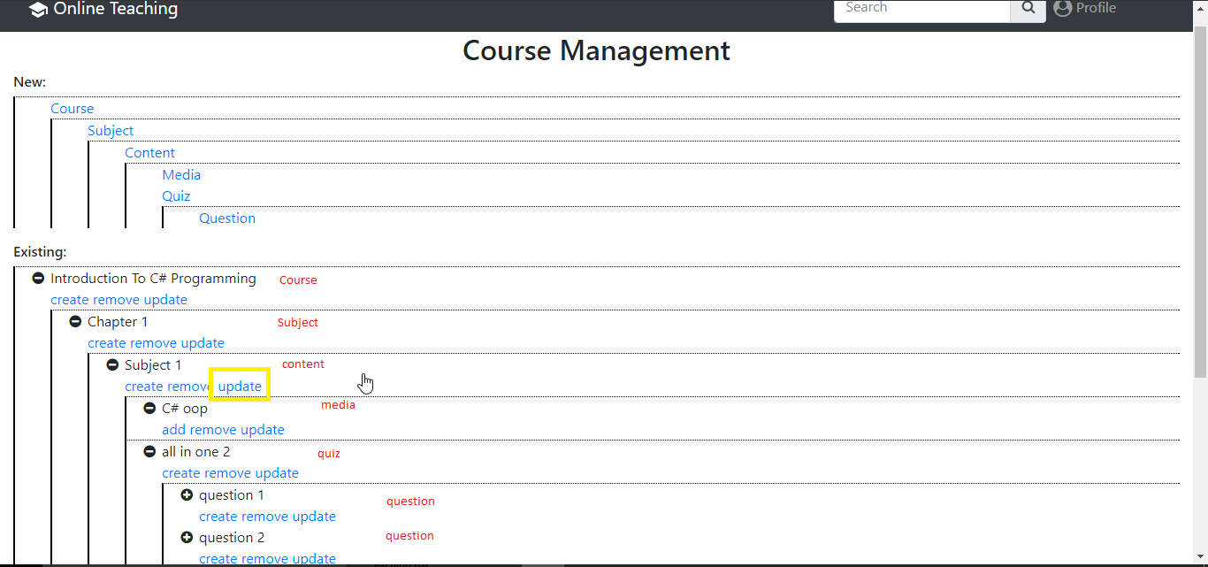

6.

Change the quiz from blank to newly created quiz name

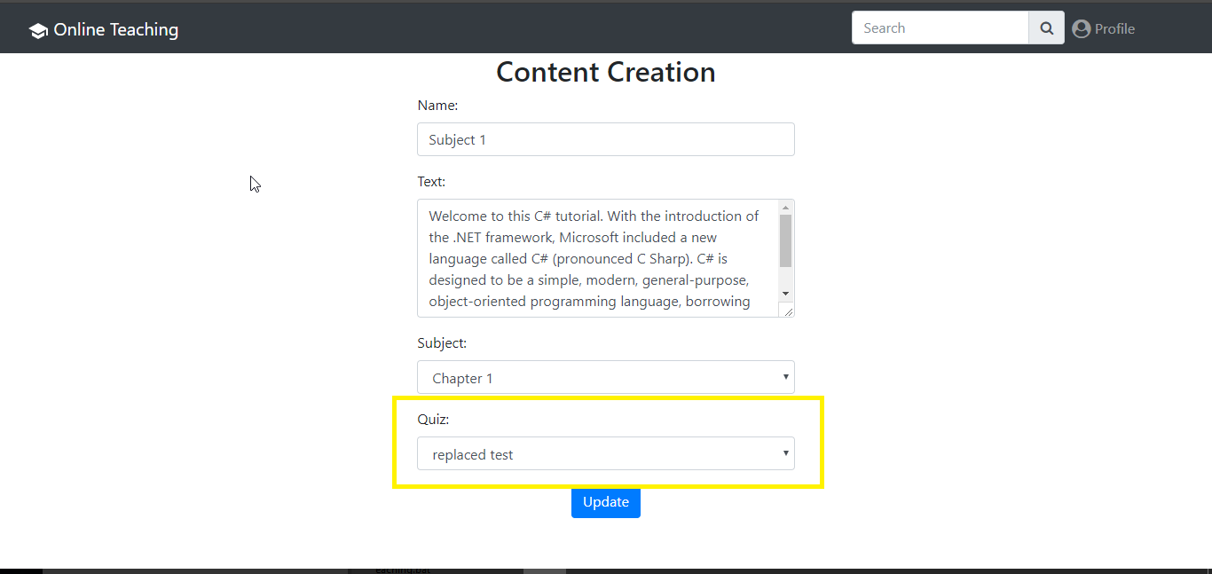

## Removing components of a course

Description:

To remove any parts of a created course it must be done from inner out , if a quiz is removed it will also remove its questions ,if a content is removed and it had media and/or quiz related to it that were not removed first they still exist are not viewable until they are reassociated to an other content.

1.

Inside the course management interface, click remove on the desired item to be removed

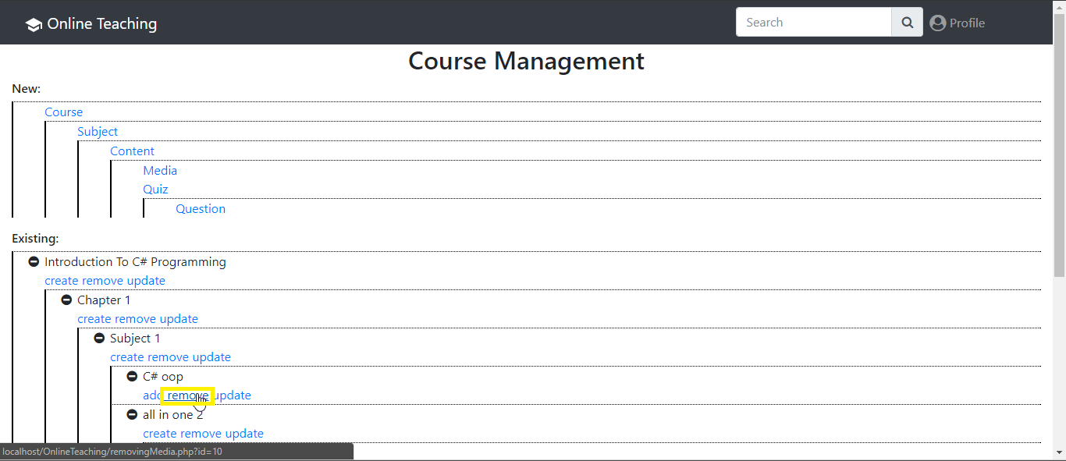

Note: if you are trying to delete an item from outter in and this item should not be kept you will receive this error “course removal failed! Make sure there is no associated subElements”, just delete its inner elements before, you can link an image or quiz to another content instead of removing it by updating it

## Updating components of a course

Description

Updating is used to change links of our element and its contents

1.

Inside the course management interface click update on the desired item to be updated

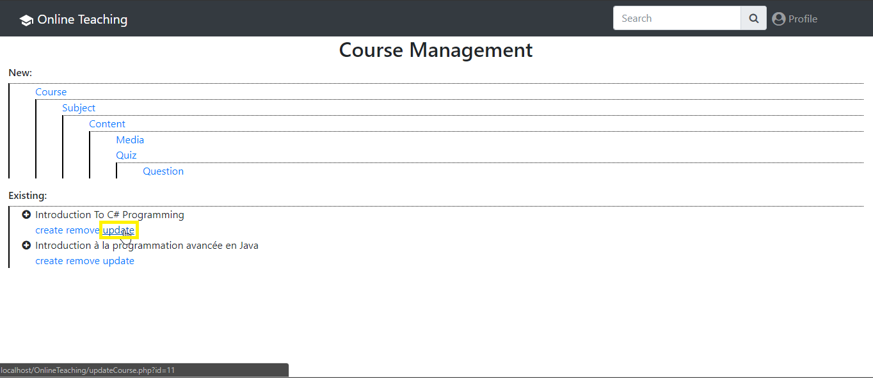

## Supported Media Formats

Image: ‘.gif’,’.jpg’,’.png’,’.svg’

Sound: ‘.mp3’,’.wav’

Video: ‘.mp4’,’.webm’,’.ogg’

## View a course

Description:

To view a course it is not necessary to be logged in, but if you are logged in it will track which courses you have done up to now.

1.

In the dashboard click on the course desired to be viewed

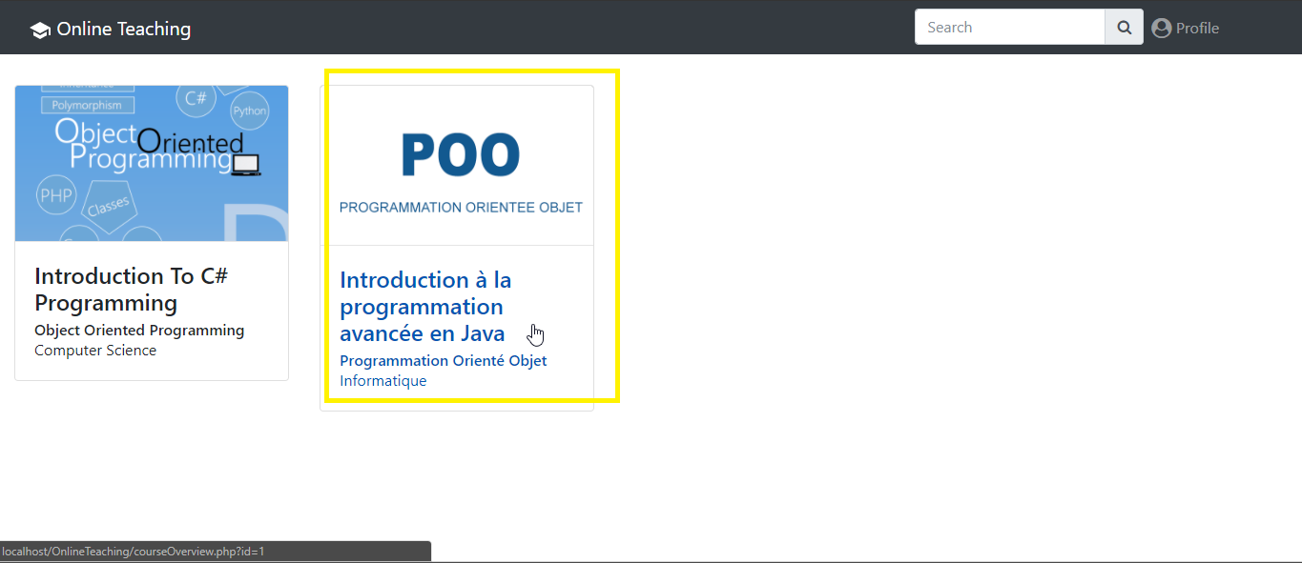

2.

Select at wich part of the course you want to start, the first available option is the beginning of the course

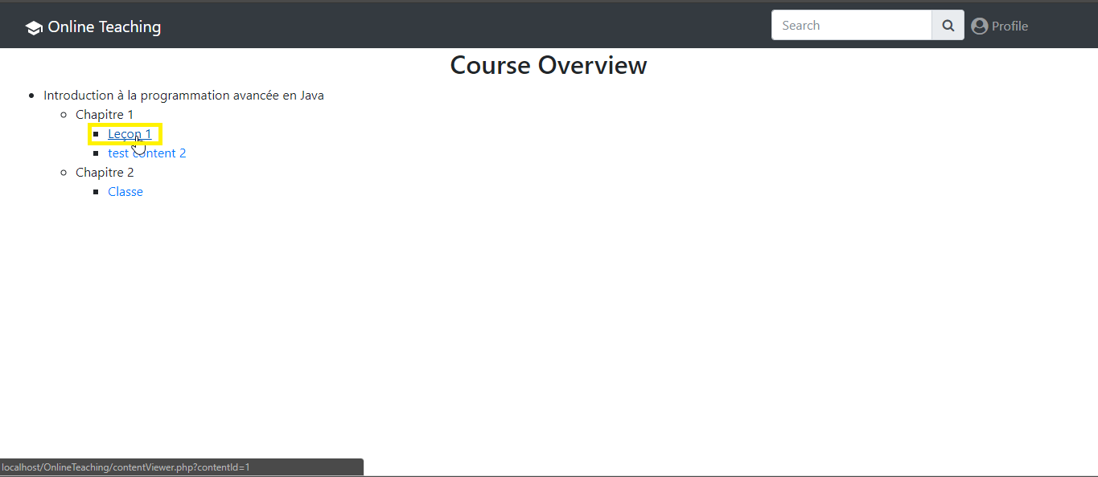

3.

Click next until end of course

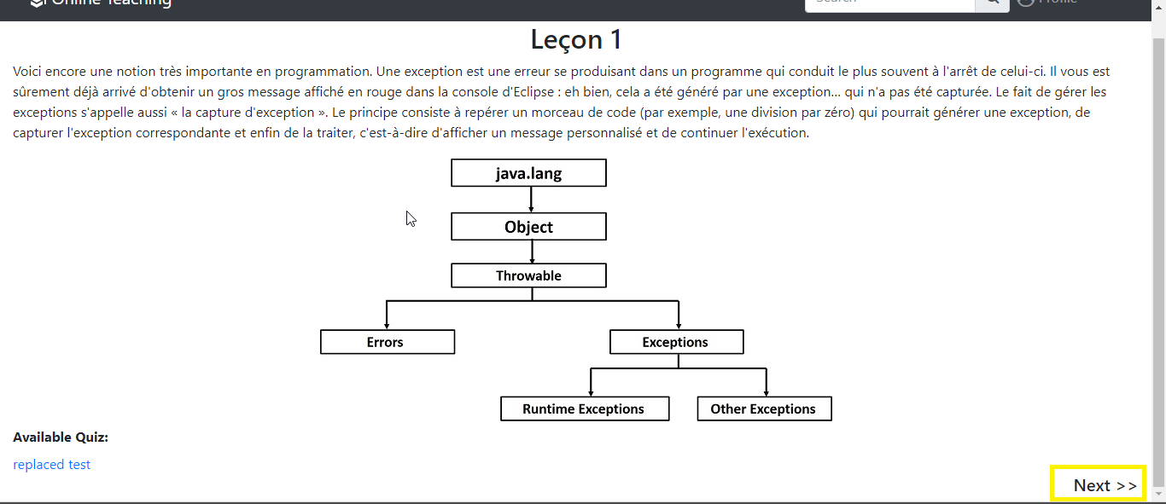

## Pass a quiz

Description:

To pass a quiz it is necessary to be logged in , if not you will receive an error message.

1.

Once started viewing a course if a quiz is available, it will appear under the media, click on it  
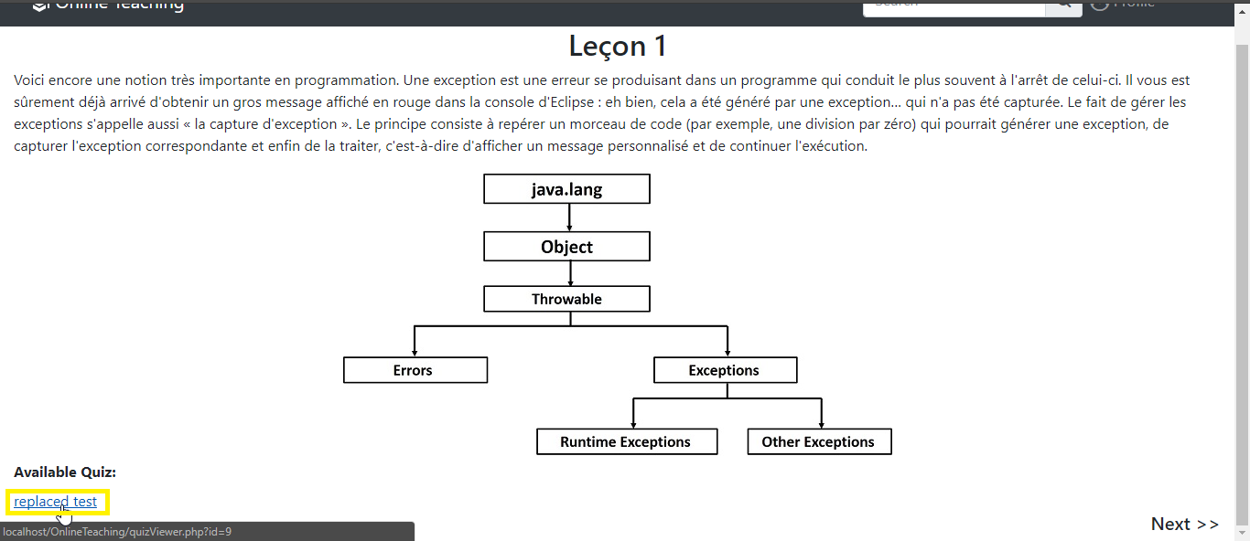

2.

Fill in the quiz form

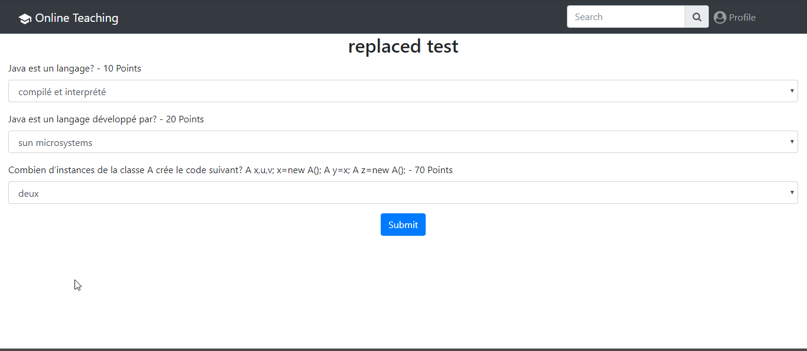

3.

Click next to be brought back where you originally were

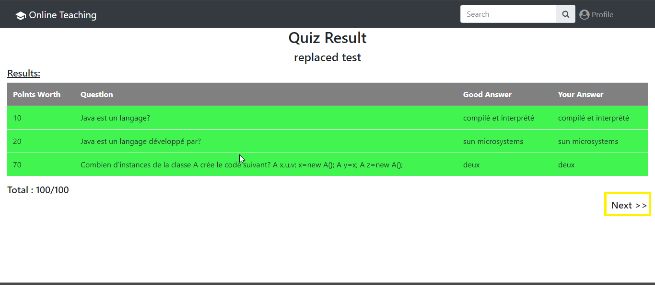

## Creation on same level of structure

Description:

This allows to create elements at the same level of existing elements.

This feature will become more useful the more the teacher adds elements .

If you try to add elements at the course structure you link it to the root structure which just links it to your account and reacts the same way as creating a new course for all sub elements it will link them to parent elements, if at the level you want to use this feature you have never created any element it will not be possible to use it, but by default when creating a new course it will always offer you the last created parent as default link.

Example:

If you create a media on the same level as an existing media (lets say media1 is linked to content1) then media2 will be linked to content1 automatically.

1.

In course management interface click on create of the existing elements

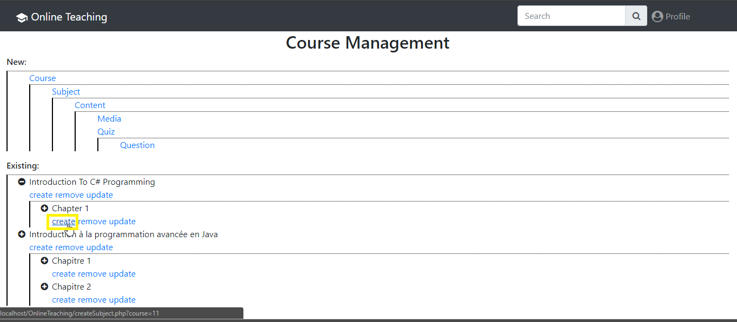

2.

Fill in the form



Disconnect

Description:

If you are logged in and want to connect as someone else you need to disconnect, your session will live as long as the php session lasts or you disconnect.

1.

Click profile icon

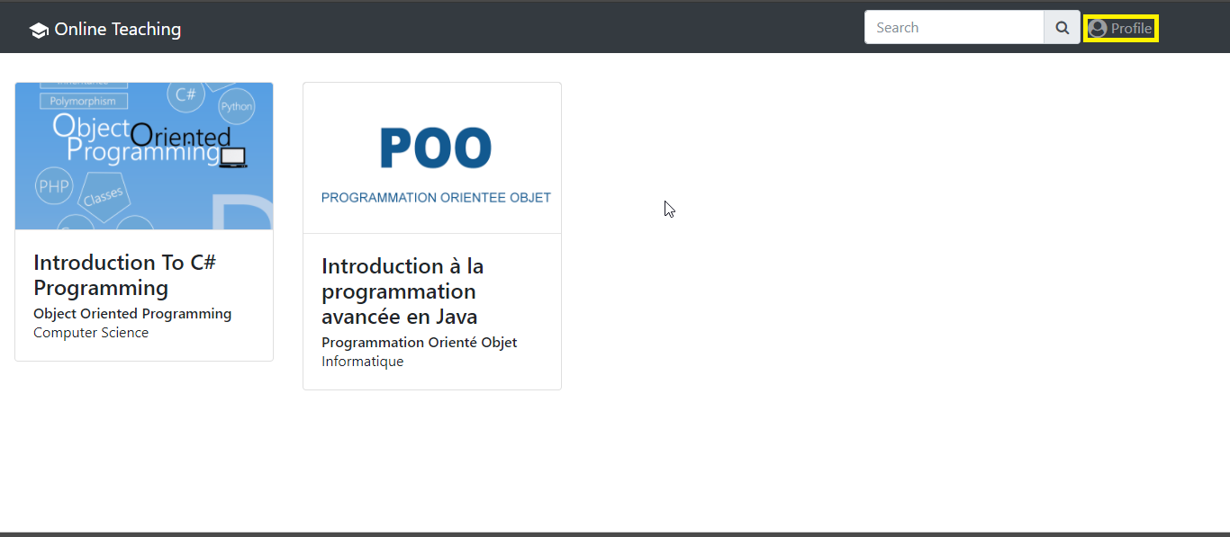

2.

Click disconnect

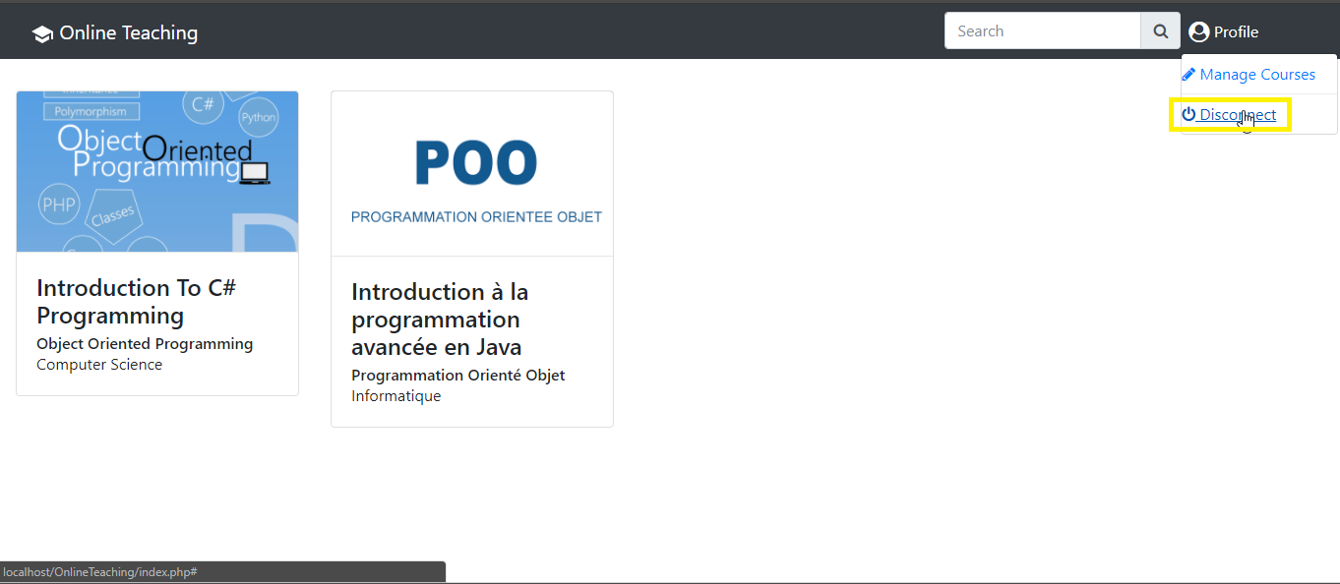

## Search

Description:

Search is available only for bootstrap cards

1.

In the dashboard insert the name or part of the name of the course you want to search for

