Storyboard
2400660
Daynea Chambers
Assignment #2
Tuesday 3pm
Web Programming
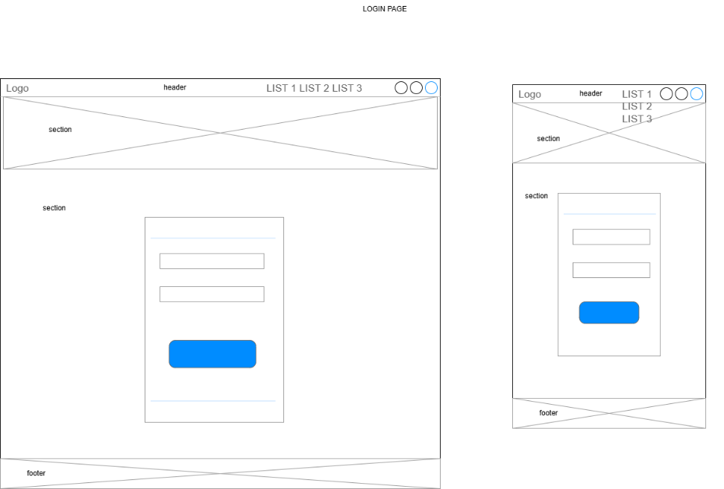
Wireframe
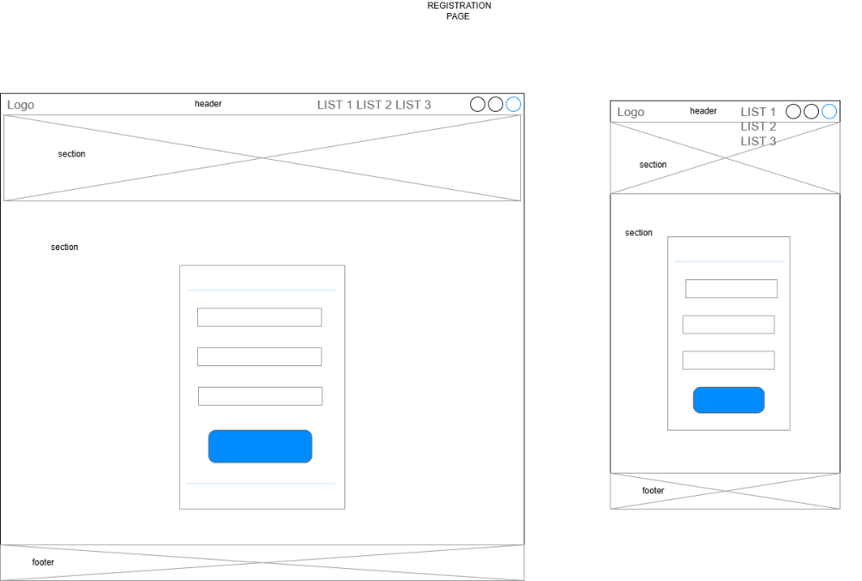
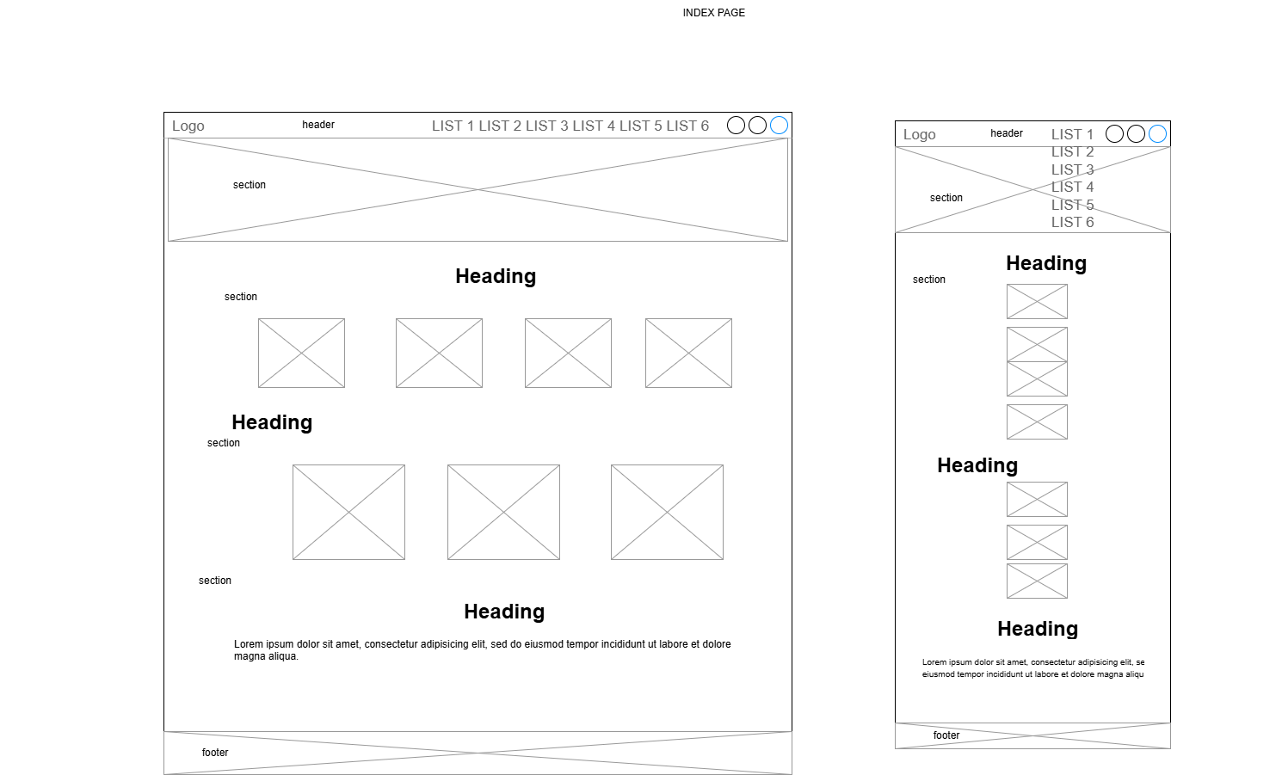
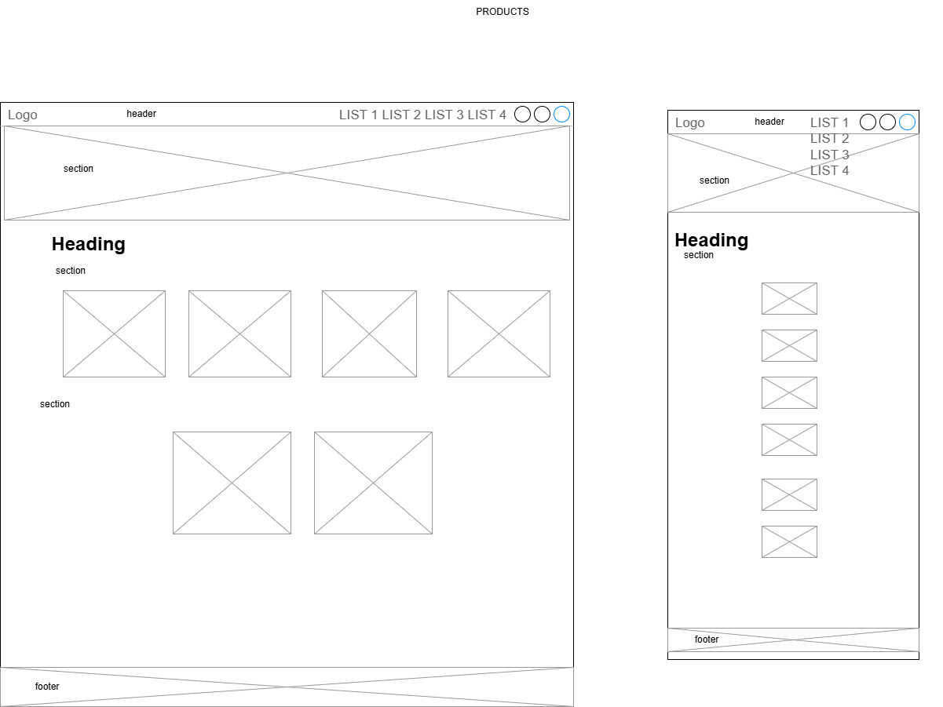
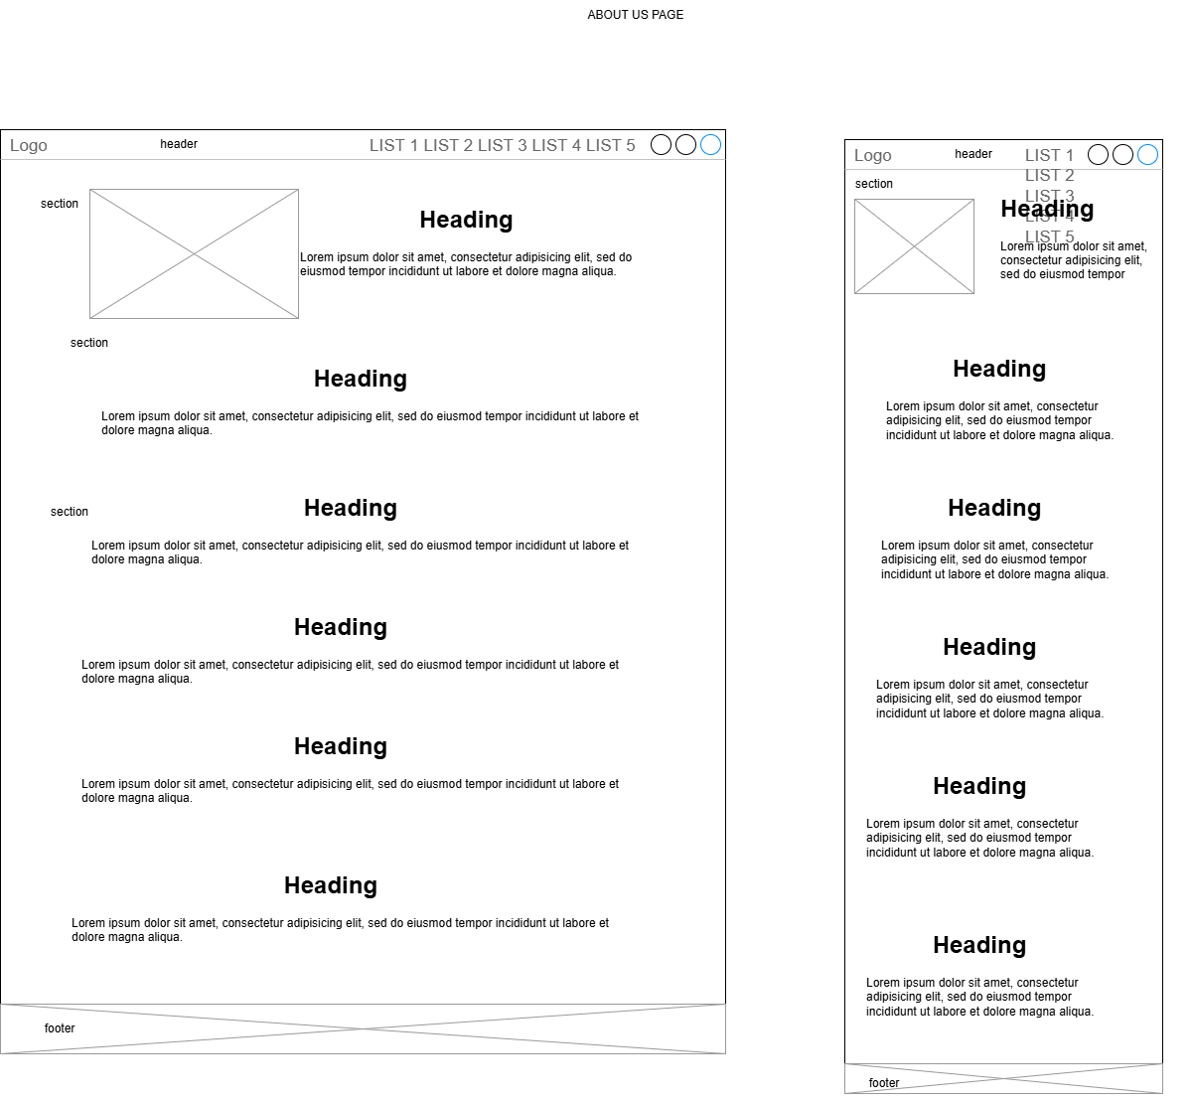
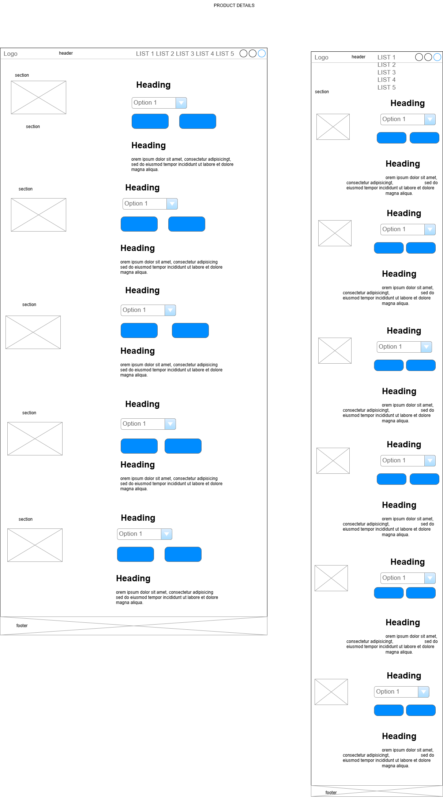
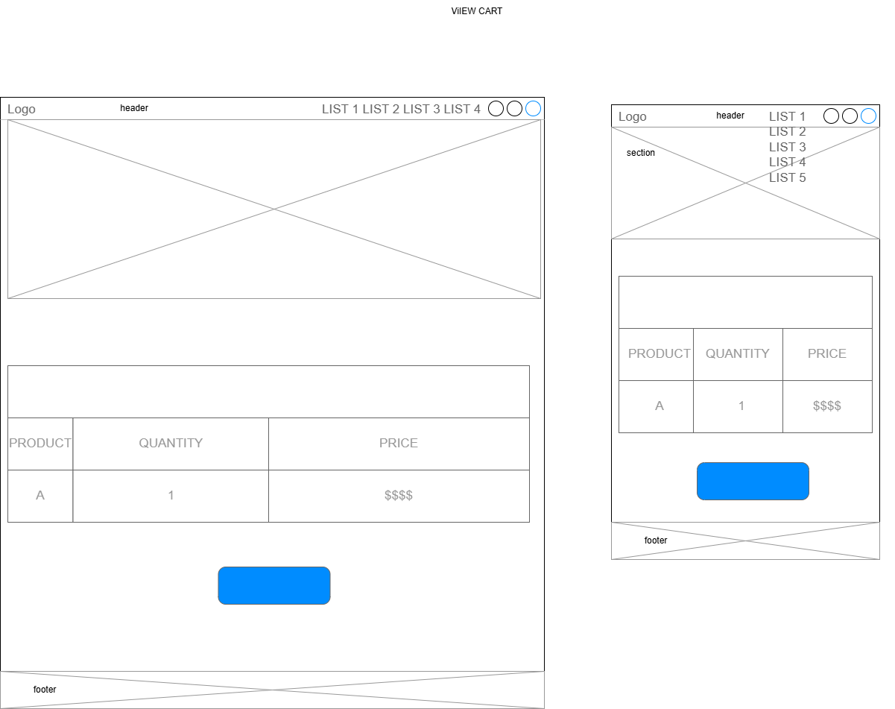
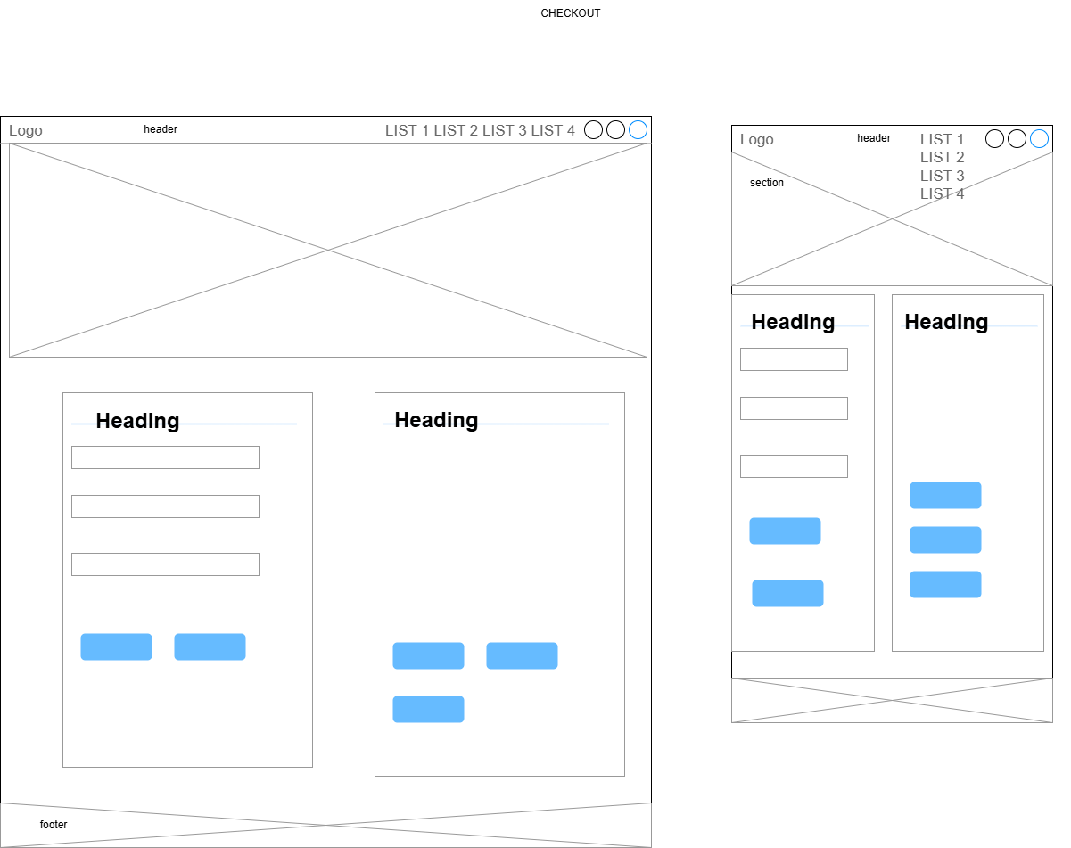
Sitemap
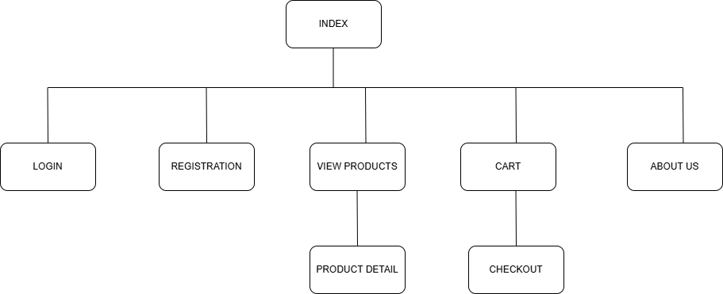
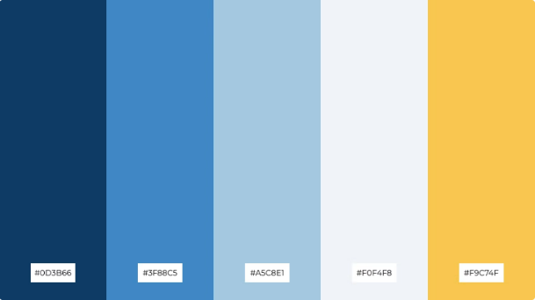
Colour palette

Icons and images used
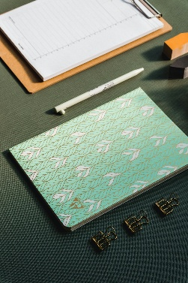  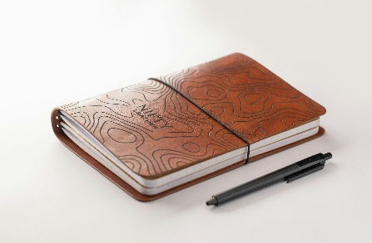    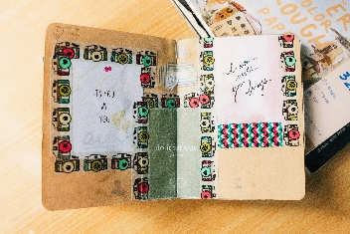  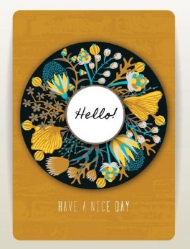  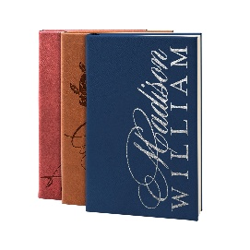           | Dimensions  font-family: "Segoe UI", Tahoma, Geneva, Verdana, sans-serif;  font-size: 1rem;  font-weight: 400;  height: 200px;  Dimensions for images  Height: 50px, 90px, 200px,  Width:500px
Description of my business
Inked Thoughts was crafted to remind people that their thoughts matter. In a society where mental health is often misunderstood or stigmatized, our journals provide a safe space for self-expression where people can write freely, without judgement.
Mission Statement
Our mission is to empower individuals to express their thoughts freely through the art of journaling.
Vision Statement
Our vision is to help reduce suicide rates and inspire a society where people can embrace their mental wellbeing.

Logo
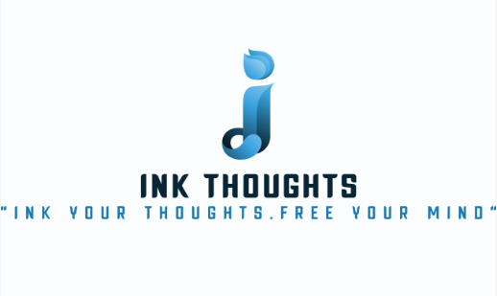
Slogan
“Ink your thoughts. Free your mind”
Justification for the color scheme
I chose this color scheme as it creates a calm and serene atmosphere. The blue is used gives a sense of stability and control, soothing the mind into a state of focus. The yellow creates a creative and innovative atmosphere and white is associated with new beginnings thereby allowing those who are struggling mentally to find hope. Based on the mission of my business, the combination of these colors can achieve the desired outcome.
Intended Audience
Inked Thoughts is for everyone because no matter what we all experience moments of stress and undergo periods of self-reflection.
List of user defined functions
Register-The purpose of this function is for new users to have an account so that they can shop on the website. | Login-This function allows the registered user to access shopping privileges
Add to Cart-This function allows a registered user to add items to their cart. | RemovefromCart-This function allows the user to remove items from their cart
Submit-This allows users to submit their login info and shipping details | Cancel-This function allows the user to cancel shipping details
Checkout-This function allows a user to process payment and enter shipping details | ClearAll-This function allows the user to clear their shopping cart
Confirm-This allows the payment to be submitted | Logout-This function allows the user to log out of the website
RenderCart-This allows the information stored in localStorage to be displayed in the cart | RequireLogin-This function ensures that only users who are registered with Inked Thoughts can shop and access certain features and pages

Link to GitHub repository
daynea-chambers/2400660_IA2_S1AY26
Free hosting link
https://ia22.netlify.app/

References
BrandCrowd. (2025). BrandCrowd. https://www.brandcrowd.com
Flaticon. (2025). Flaticon, The Largest Database of Free Vector Icons. Flaticon.
https://www.flaticon.com/
Hennigan, L. (2023, September 8). 15 Mission Statement Examples For Your Business – Forbes Advisor. Www.forbes.com. https://www.forbes.com/advisor/business/mission-statement-examples/
James, W. (2023, March 22). 601 Fun and Creative Craft Business Names To Try in 2025. Niche Pursuits. https://www.nichepursuits.com/craft-business-names/
Martins, J. (2022, July 26). 7 steps to write the perfect vision statement. Asana. https://asana.com/resources/vision-statement
‌‌ The Best 15 Indigo Blue Color Palette Combinations. (2024). Piktochart.com. https://piktochart.com/tips/indigo-blue-color-palette
Unsplash. (2025). Beautiful Free Images & Pictures. Unsplash; Unsplash. https://unsplash.com/

