

|  |
| --- |
| PROG6211 POE - Documentation |
|  |
| June 4  18002054  Developed by: Dayne Mare` |

# CONTENTS

|  |
| --- |
| DATABASE DESIGN ERD 3  **USE CASE DIAGRAMS 4**  Main Application 4  Web Application 5  **CLASS DIAGRAMS MAIN APPLICATION 6**  LoginPage 6  MainMenu 7  NewEntry(&CityPreferences) 8  GenerateReport(&EditResults) 10  **CLASS DIAGRAMS WEB APPLICATION 11**  GeneralUserLogin 11  LatestWeatherForecasts 11  **Application Demonstration 12** |
|  |

# DATABASE DESIGN ERD

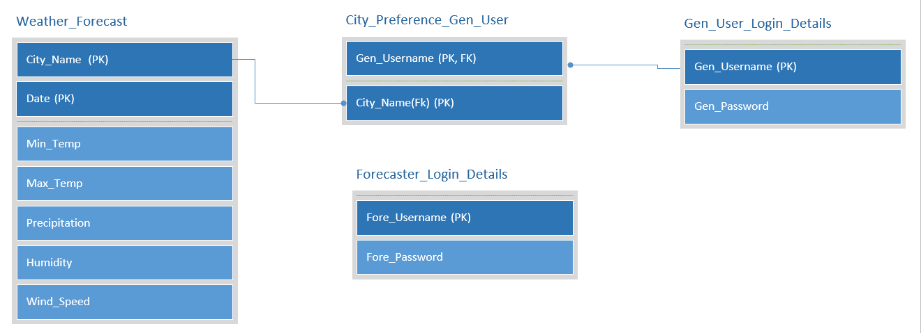

USE CASE DIAGRAMS

MAIN APPLICATION:

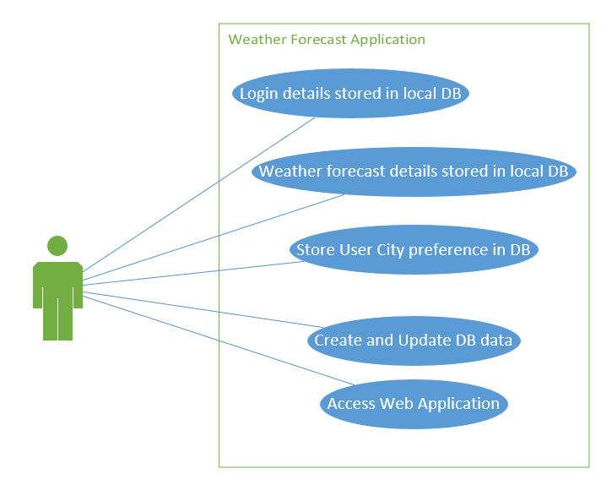

WEB APPLICATION:

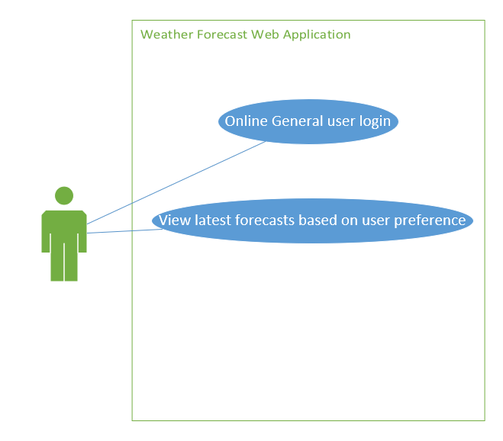

# CLASS DIAGRAMS MAIN APPLICATION

NOTE: To view the full document for improved association detail please view the “CLASS DIAGRAM” Visio Doc inside the “DOCUMENTATION FILES”.

1.) LoginPage

Associations:

1. MainMenu
2. GeneralUserLogin

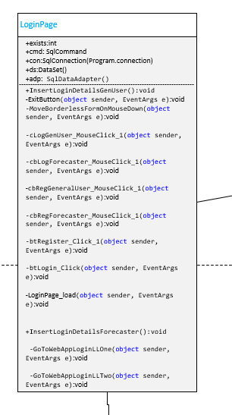

2.) MainMenu:

Associations:

1. NewEntry(&CityPreferences)
2. GenerateReport(&EditResults)

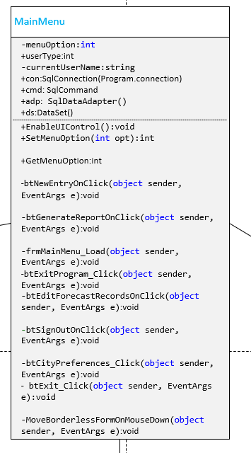

3.)NewEntry(&CityPreferences)

Associations:

1. MainMenu

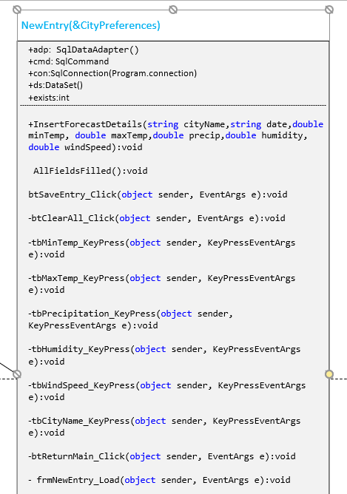

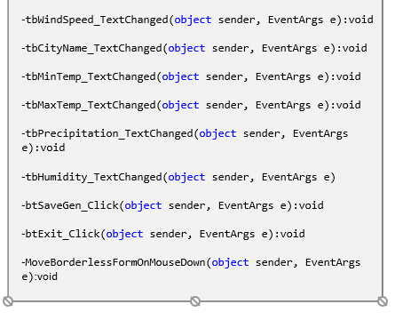

4.)GenerateReport(&EditResults)

Associations:

1. MainMenu

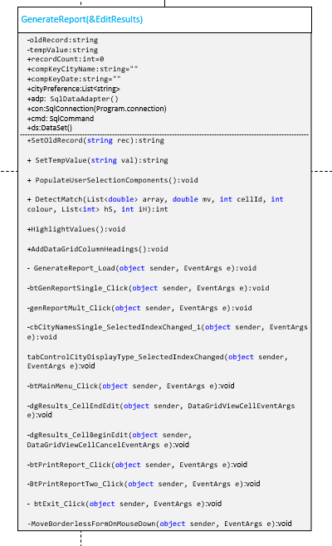

# CLASS DIAGRAMS WEB APPLICATION

1. GeneralUserLogin (WEB APP):

Associations:

1. LoginPage
2. LatestWeatherForecasts

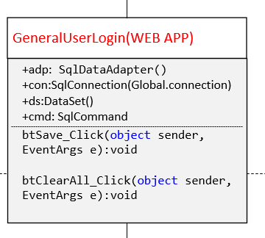

1. LatestWeatherForecasts (WEB APP):

Associations:

1. GeneralUserLogin

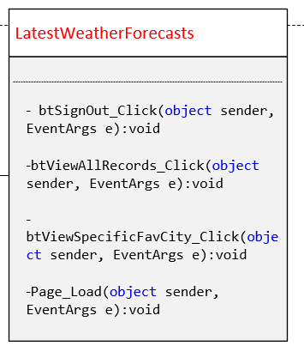

# APPLICATION DEMONSTRATION

After the splash screen has loaded the user is presented with a form where they may either choose to log in with an existing account created by the database administrator or gain the rights on their workstation to register a new account manually.

To register a new account (if granted) the user must:

* click on a user type
* input a valid username in the username field
* input a valid password in the password field
* click the Register button to confirm

An example is shown below in Figure 1:

Figure 1: Login/registration form

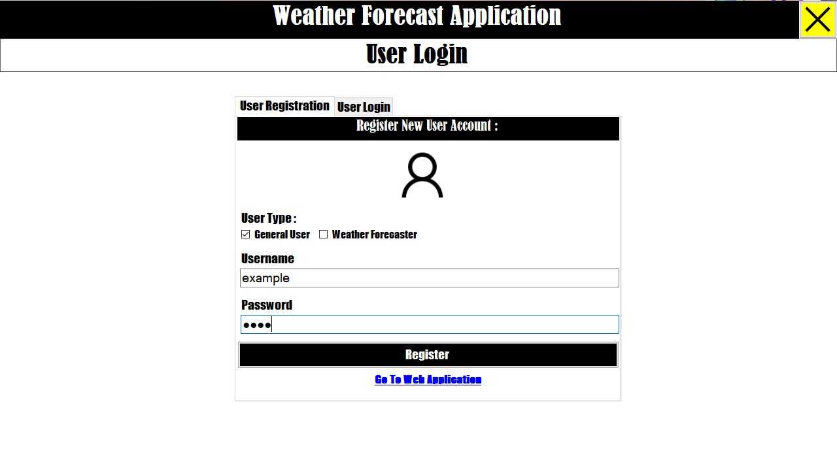

If all input is correct the user may then click the Register button - NOTE: There may be a brief pause after clicking Register or Submit but this is just the application connecting to the database.

If all input is valid after clicking the Register button the user is presented with a popup dialog form (Seen in Figure 2 below) stating that registration was successful. Once the user clicks on ‘OK’ it will automatically take them to the login tab.

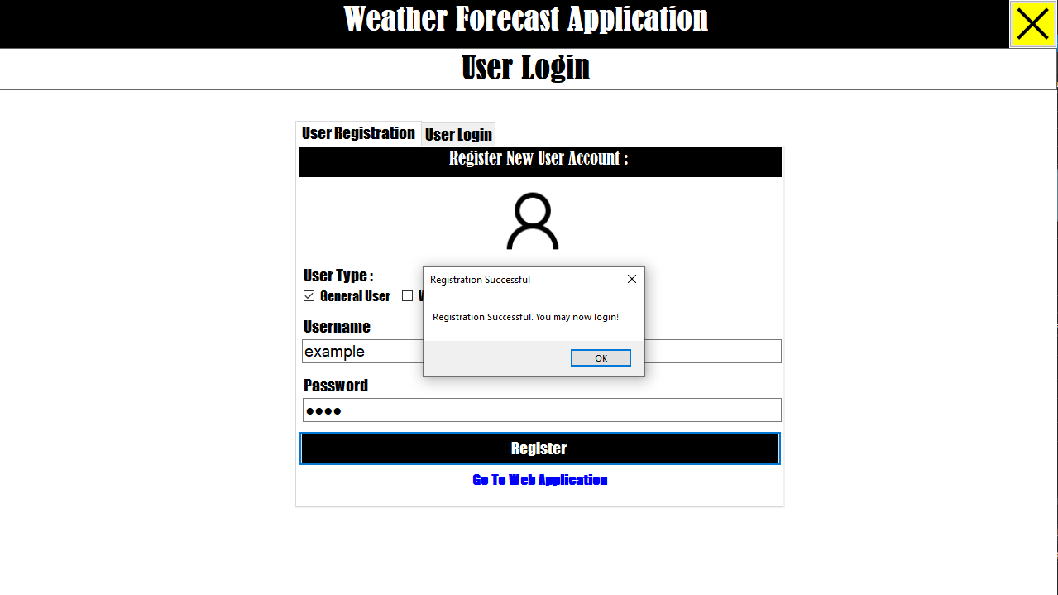Figure 2: Registration Successful

However, if the username already exists in the applications database the application will display the error message shown below in Figure 3. After closing the message box by clicking “OK” the user can then attempt to try creating an account that does not exist.

Figure 3: Registration unsuccessful

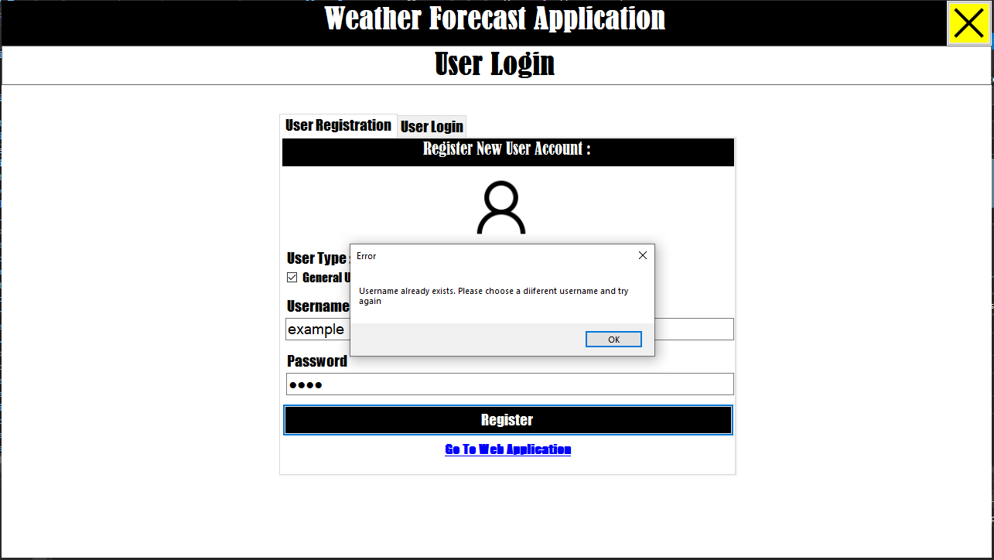

Once Registration is successful, the user can now use their details to login as seen in Figure 4.

To login the user must:

* Click on a User type
* input a valid username in the username field
* input a valid password in the password field
* click the Submit button to confirm

Figure 4: Login tab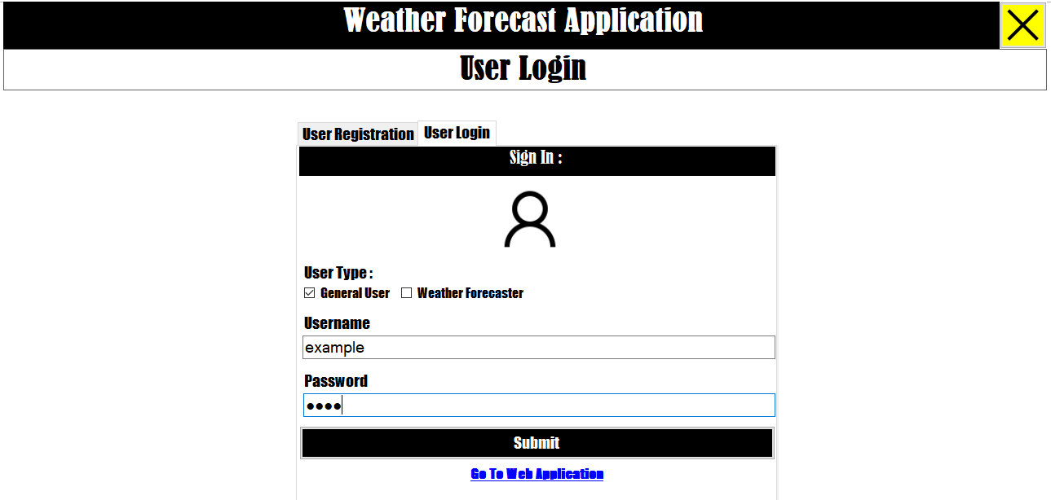

If the user logs in as a General User they will be presented with a general user main menu that present the following functions to the user (See Figure 5):

-City Preferences: Allows a user to select which city records they want to view in the View Weather Forecast menu.

- View Weather Forecast: Allows the user to view weather forecast records based on their favorite cities set in the City Preferences menu.

-Exit To Windows: Allows the user to shut down the application once they have finished using it.

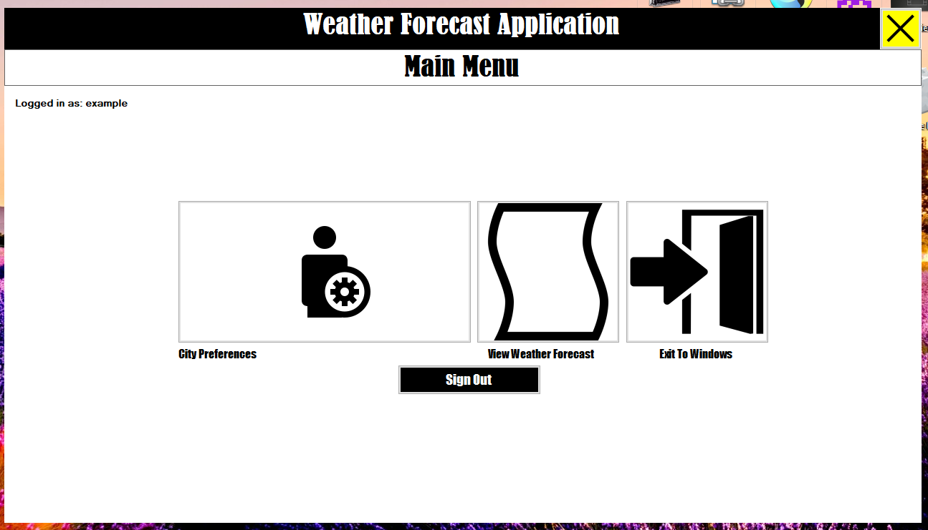Figure 5: General User Main Menu

General User City Preferences menu

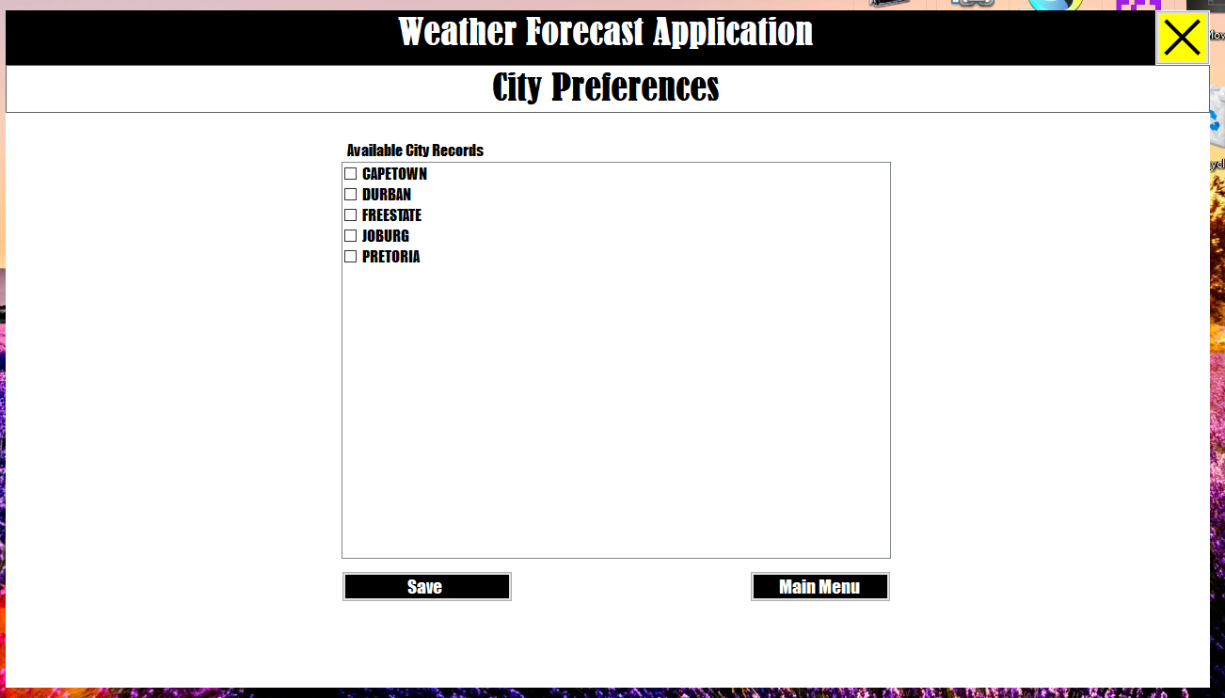Figure 6: General User City Preferences menu

The following Figures demonstrate how a user can set their favorite city choices for weather forecast record viewing:

STEP 1: General Users must first select which city or cities or they would like to view records for by selecting one or more check boxes from the available city records list.

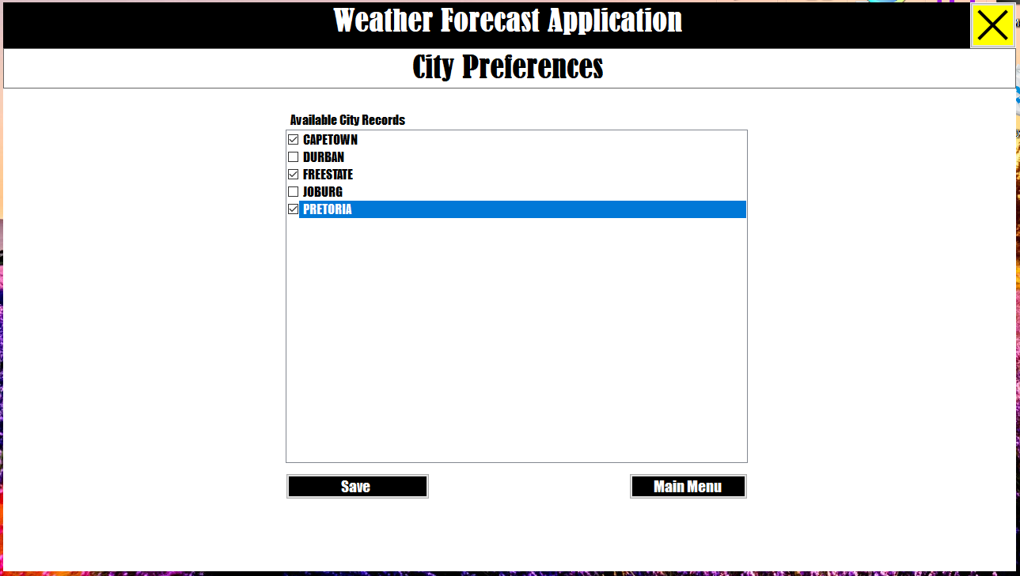

STEP 2:Once the user is happy with their selection they can click the SAVE button to store their city preference data .The user should be presented with a message box to state that the records were saved successfully to let them know their operation was done successfully.

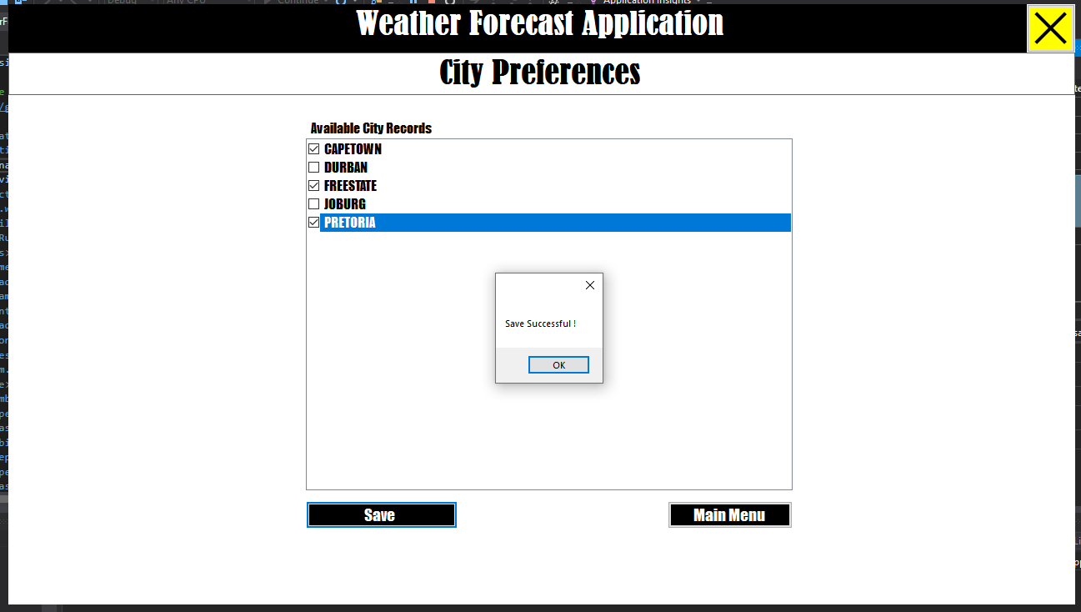To leave the CITY PREFERENCES menu the user can now click on the MAIN MENU button once they have finished the operation.

View weather forecast menu

The following Figures demonstrate how a user can view a Single City Report :

STEP 1: First the user must select a date range and which city they want to see records for out of a list of their saved city preferences from the drop-down menu and date picker controls shown below. Once this is done the user can view the record specified by clicking the GENERATE REPORT button that becomes enabled once the above steps have been completed.

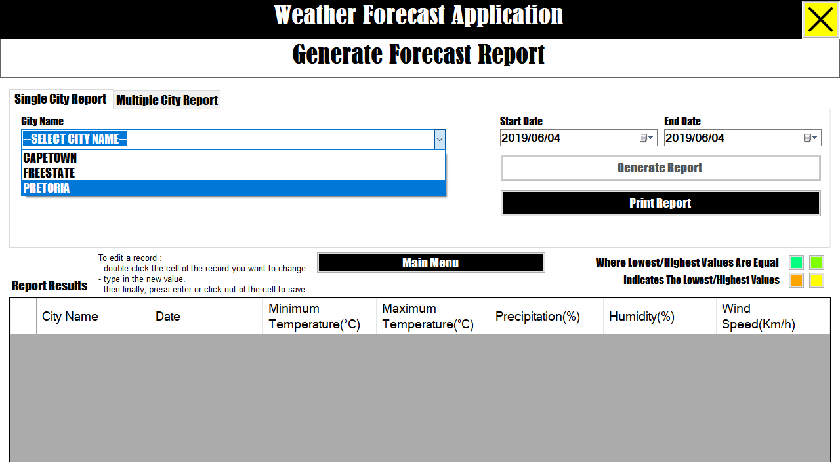 (Therefore, it is important that new general users set their city preferences before accessing this menu because the drop down will present no city names to select otherwise.)

STEP 2: Once the GENERATE REPORT BUTTON has been clicked the records defined should appear in the grid view below.

