

BERZIET UNIVERSITY

FACULTY OF ENGINEERING AND TECHNOLOGY

DEPARTMENT OF ELECTRICAL AND COMPUTER ENGINEERING

**User Association and Load Balancing In 5G Network**

Prepared by:

|  |  |
| --- | --- |
| Rajaie Imseeh | 1140302 |
| Mousa Mousa | 1141026 |
| Osama Muhammad | 1140136 |

Supervised by: Dr. Aziz Qaroush

Graduation Project submitted to the Department of Electrical

and Computer Engineering in partial fulfillment of the requirements

for the degree of B.Sc. in Computer Engineering

BIRZEIT

May - 2018

Abstract:

Table of Contents

Chapter 1 General Introduction 1

1.1. Introduction 2

1.2. Motivation and problem statement 3

1.3. Report outline 4

Chapter 2 Background and Related Work: 5

2.1. Scope 6

2.1.1. Heterogeneous networks (HetNets) 6

2.1.2. Other 5G Candidate Technologies 7

2.1.2.1. Massive MIMO Networks 7

2.1.2.2. MmWave Networks 8

2.1.2.3. Energy Harvesting Networks 8

2.1.2.4. Device to Device communication (D2D) 9

2.1.2.5. Full Duplex communication 9

2.1.2.6. Cloud radio access network(C-RAN) 10

2.1.2.7. Self-organizing networks(SONs) 10

2.1.3. Summary 11

2.2. Optimization techniques 12

2.2.1. Game Theory 12

2.2.1.1. Non-Cooperative 12

2.2.1.2. Cooperative 13

2.2.1.3. Challenge 13

2.2.2. Evolutionary algorithm 14

2.2.2.1. Encoding of Chromosomes 14

2.2.2.2. Fitness measures 14

2.2.2.3. Crossover Process 15

2.2.2.4. Mutation Process 15

2.2.3. Combinatorial optimization 15

2.2.4. Other techniques for solving multi-objective problems 16

2.3. Metrics 16

2.3.1. Energy efficiency 17

2.3.1.1. User Association in HETNETS Network 17

2.3.2. Spectrum Efficiency: 18

2.3.2.1. User Association in HETNETS Network: 18

2.3.3. outage/coverage probability 19

2.3.3.1. User association in heterogeneous cellular networks 20

2.3.4. Other metrics used for determining the user association 21

Chapter 3 Proposed Method and Analyses 22

3.1. Problem definition: 23

3.2. System model: 23

3.2.1. Power Calculation: 25

3.2.2. SINR Calculation: 26

3.2.3. Throughput: 27

3.3. Problem formulation and optimal solution: 29

3.4. Overall Algorithm: 29

3.5. Solving Problem Using Evolutionary algorithm: 30

3.5.1. Chromosome and Genes Formalization: 31

3.5.1.1. Chromosome Formalization: 31

3.5.1.2. : Genes Formalization: 31

3.5.1. Cross-Over Algorithm: 32

3.5.1.1. Generating population: 33

3.5.1.2. Probability of matting: 33

3.5.1.3. Probability of mutation: 33

3.5. Fitness Function: 34

3.5.1. Single Objective Fitness function: 34

3.5.1.1. Using SINR only: 34

3.5.1.2. Using Power only: 34

3.5.1.3. Using Power and SINR without load balancing: 34

3.5.1.4. Using Power, SINR and Load balancing: 35

3.5.2. Multi objective NSGA-III: 36

3.6. Solving Problem Using Game Theory: 36

3.6.1. Game Theory approaches: 36

3.6.1.1. Cooperative approach: 36

3.6.1.2. Non-Cooperative approach: 36

3.6.2. Formalization: 37

3.6.2.1. Players: 37

3.6.2.2. Strategy: 37

3.6.2.3. Normalizing SINR and PR: 38

3.6.2.4. Load Balancing Objective: 38

3.6.2.5. Utility function: 39

Chapter 4 Used Tool and Results 40

4.1. Tool: 41

4.2. Experiments setup: 41

4.2.1. Building topology: 41

4.2.2. Simulation Parameters: 41

4.3. Results: 41

4.4. Metrics we Will Compare to Other Methods: 41

Chapter 5 Conclusion 42

References: 44

List of Figures

Figure ‎2‑1 Interference Using Massive MIMO 8

Figure ‎2‑2 5G MmWave Bandwidth 8

Figure ‎2‑3 Energy Harvested from renewable energies 9

Figure ‎2‑4 Device to device connection 9

Figure ‎2‑5 Full-Duplex Technology 10

Figure ‎2‑6 C-RAN Technology 10

Figure ‎2‑7 SONs technology 11

Figure ‎2‑8 Genetics format 14

Figure ‎2‑9 Combinatorial optimization process 15

Figure ‎2‑10 Received power curve 21

Figure ‎3‑1 Network Architecture 24

Figure ‎3‑2 Our Chromosome for NSGA-III Algorithm 31

Figure ‎3‑3 Our Genes for NSGA-III and genetics Algorithms 32

List of Tables

Table ‎2‑1 Comparison between Macro and small cells 6

Table ‎2‑2 Network topology summary 12

# General Introduction

## Introduction

Nowadays, the total number of devices that are manufactured around the world are increasing dramatically, and it is predicted that the data traffic density will increase enormously than the current data traffic and all previous technologies cannot handle this massive rise in users and data rate.

The fourth generation of mobile networks for example have some limitations, such as no support for Heterogeneous networks (HetNets), which provides a flexible and more economic infrastructure compared with tower-mounted (macro-only) systems. Moreover, there is no sufficient utilization of processing power of base stations, it gives the same power to an area independently of the load upon it. Furthermore, In the current cellular networks, there is no support for zero latency property, in which a user equipment needs hundreds of milliseconds to find the appropriate or best base station to connect to. Moreover, the defect of the current network is that the communication between a user device and an outdoor base station is not efficient in terms of spectrum efficiency, energy efficiency and data rate transfer, due to the environment attenuation on the communication signals.

Most of above problems will be solved in synchronism with the launch of the fifth generation of mobile networks (5G). At the beginning, 5G networks support HetNets which will be our mainly scope in this report. Moreover, 5G networks can give each area its need of power based on the capacity assigned to each base station. On the other hand, for the latency problem, 5G networks are planned to support real time services with optimal quality of service. Furthermore, another requirement is that 5G should support the ubiquitous connectivity and support massive number of connected devices. The requirements of 5G networks we mentioned before may have several challenges:

* **Scalability and flexibility:** 5G must be powerful enough to work with massive number of users with their unlimited demands on the network.
* **channel for upload and download link:** We need to manage the channel that is used to transmit and receive data, the time and frequency of it should be controlled very well to accomplish the best possible performance.
* **Environmentally friendly:** Wireless technologies consumes a lot of energy that emits CO2 which defects the environment, so a big challenge is to develop a technology that is friend to the environment.
* **Performance:** 5G is required to reach a big coverage area and serve many devices, with all that it needs to have an excellent performance, and that is a big challenge.
* **Security issues:** 5G shouldn't ignore the privacy wise of users, the capability of making users connect indirectly to the base station by connecting through other users’ needs to take the privacy of users into consideration.

## Motivation and problem statement

Energy sustainability is the key for future networks due to their foreseen capacity upsurge. The most important factor for building a sustainable cellular network is to achieve a high spectral and energy efficiency, so in this report we are trying to get the maximum value of these metrics using multi-objectives techniques by balancing the tradeoff between them. The architecture we are going to make our experiments on consists of two-tier cellular networks, the first tier is the macro cell tier, this cell has a big coverage area in other words, it uses small frequency ranges. Moreover, it has more transmit power than the other tier. The second tier is the femto cell tier, this tier has a less coverage area in other words, it uses high frequency ranges. Also, it transmits power less than the macro cell tier. Here is a list of objectives that we will work on and described in this report:

* Building the environment using the MATLAB.
* Making a tradeoff between energy and spectrum efficiency and maximizing their values under the spectrum efficiency constrain.
* Getting the maximum benefit from the customer and company point of view.
* Associating the users using many techniques as greedy algorithm, single objective genetics algorithm and multi-objective genetics algorithm NSGA-III (Non-Dominant-Sort-Genetics-Algorithm).

## Report outline

In chapter 2, section 1 introduce the different types of scopes that can be used in the network, the section describes each type, how it works and why to use them. The section that follow describes the different models used in networks. Section 3 explain the metrics we can work on in our project and describe the calculation of each one.

Chapter 3 defines the problem we are working on very well, with the architecture we used, and all calculation needed to solve the problem, in addition it formulates the problem in different ways as in greedy and genetics algorithm describing the ways we used for solving the problem (associating the users in our topology)

Chapter 4 gives some information about the tool we use, and why did we use it, how it helps us to get the solution and list all parameters we define as inputs. Describe the main directories, classes and scripts we used to solve the problem. Discussion of results and compare it with results of other people.

The last chapter gives a conclusion of the whole work in the paper and how well was our work compared with others work.

# Background and Related Work:

This chapter gives a briefly summary about the topology, models and metrics of the 5G network architecture, on other hand we will analyze and expand some related works on the user association to multi-objective metrics.

## **Scope**

### Heterogeneous networks (HetNets)

A heterogeneous network is a network the connects different types of devices such as computers, mobiles and other devices even if they have different protocols or operating systems.

HetNets is an effective approach to provide the coverage and capacity needed for cellular networks. This type of networks uses small cells in its structure, which will provide more capacity since there will be more users sharing the same spectrum. So, this network reduces the coverage of the cell to decrease the capacity shared by users leading to a high capacity and faster data speed. And to know more about the small cells Table ‎2‑1 is a comparison between the macro cells and the small cells.

Table ‎2‑1 Comparison between Macro and small cells

|  |  |  |
| --- | --- | --- |
| Features | MACRO CELLS | SMALL CELLS |
| Max User Per Cell | 2000 | 200 |
| Max range | 25Km | 200m |
| Max Transmit Power | 50W | 5W |
| Typical usage | Fast moving and rural coverage | Stationary / slow moving and urban / in-building coverage |

The high capacity is not only the advantage of the small cells used by the HetNets, from Table ‎2‑1 we can see that the small cells transmit at low power, that will decrease the cost and by reusing the spectrum across a geographical area which results in spectral and energy efficiency.

Using a dedicated carrier for the small cell layer is the simplest deployment to use. By using it, the interference with the macro cell will be reduced to the lowest level and avoid tight coordination or synchronization. On the other hand, there are disadvantages when using dedicated carrier, since there are multiple frequency bands which might not be used most efficiently. In addition, there will be time and power consuming inter-frequency handover needed by the mobility between the frequencies. There will be some drawbacks even if we use another way, like carrier aggregation, in which there will be centralization and complexity problems.

As users increase the demand of lower costs and improved performance, the challenges for operators increases requiring a new and wide technologies to ensure the success of the operation of their networks in a variety of scenarios.

### Other 5G Candidate Technologies

There are some other technologies that may enter the race of the evolution in the 5G, and those technologies are:

#### Massive MIMO Networks

Massive MIMO (Multiple-Input-Multiple-Output) is a technology that utilizes the active antenna elements that exists in each Base Station to communicate over the same time and frequency band with single antenna terminals. By doing that it can serve many users at the same time and this is an advantage over the conventional MIMO that can serve only a very limited number of users. The interference exists between adjacent subsectors of the same site as shown in Figure ‎2‑1 more likely than between overlapping subsectors at different sites. Thus, backhaul overhead can be reduced due to the less need of cooperation between sites. The main disadvantage of Massive MIMO is its complexity, so it is used mostly for cellular tower.

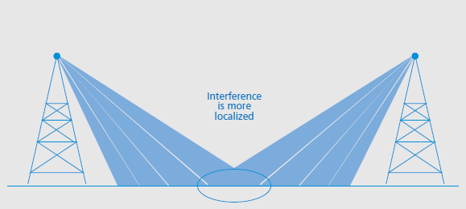

Figure ‎2‑1 Interference Using Massive MIMO

#### MmWave Networks

MmWave is the next generation wireless technology that its data rate is expected to reach 100 times of today's technology. Millimeter wave spectrum ( between 30 [GHz](http://searchnetworking.techtarget.com/definition/gigahertz) and 300 GHz) wavelength (10mm-1mm) as shown in Figure ‎2‑2, this spectrum is used for high speed wireless communication, by allocating more bandwidth to speed transmission of files especially high quality video and multimedia content.

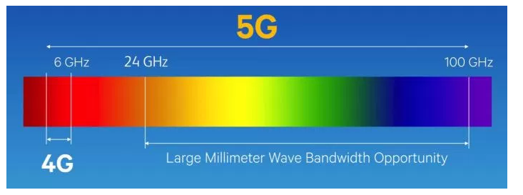

Figure ‎2‑2 5G MmWave Bandwidth

#### Energy Harvesting Networks

Energy harvesting is the process of extracting energy from energy sources such as wind energy, solar energy and thermal energy. But, these energies are not stable, they vary over time according to the weather, time and location so we cannot depend on this way of harvesting. Figure ‎2‑3 shows how the energy is harvested from renewable energies.

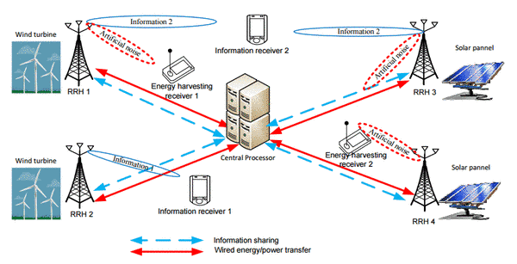

Figure ‎2‑3 Energy Harvested from renewable energies

#### Device to Device communication (D2D)

A technology that enables devices that are close to each other to communicate directly to improve the energy and spectrum efficiency as shown in Figure ‎2‑4.

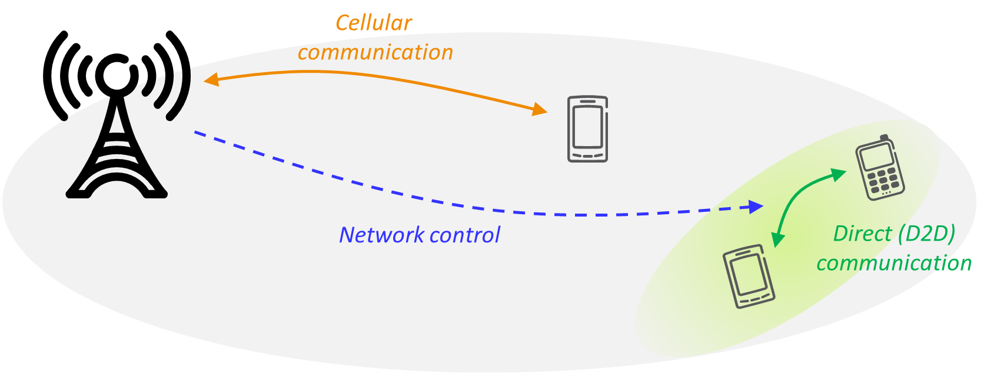

Figure ‎2‑4 Device to device connection

#### Full Duplex communication

It is a technology that allow the data to transfer in the two ways (Bi-directional), an example of a full duplex device is the telephone in which you can talk and listen in the same time. This technology shown in Figure ‎2‑5 improves the spectrum efficiency.

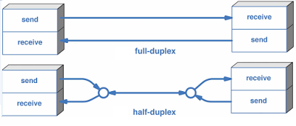

Figure ‎2‑5 Full-Duplex Technology

#### Cloud radio access network(C-RAN)

The cloud contains the baseband unit, so it can coordinate between cells which improves the performance and reduce the cost. As in Figure ‎2‑6.

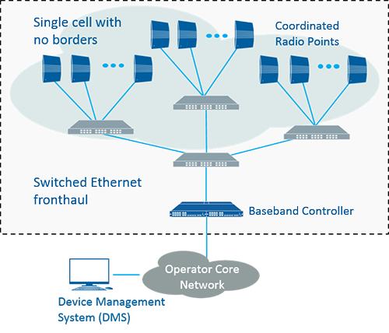

Figure ‎2‑6 C-RAN Technology

#### Self-organizing networks(SONs)

It is an automatic technology that performs planning, healing, configuration and optimizing so that the manual work is reduced. Shown in Figure ‎2‑7.

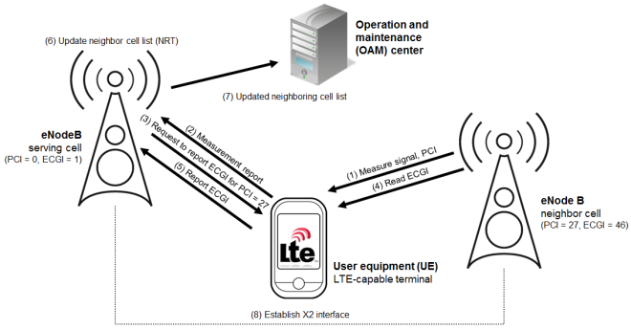

Figure ‎2‑7 SONs technology

### Summary

From Table ‎2‑2 we notice that each technology has its own benefits, small cells for example that are used in HetNets increase the data transfer and network capacity and it is efficient in terms of energy, in addition that it doesn't need a high cost to be used. Massive MIMO, MMWave, D2D and C-RANS all of them support massive devices. Massive MIMO also has low latency, but it is not costly efficient. CRN increase the capacity of the network and it is costly efficient. MMWave has the same advantages of Massive MIMO but each one of them has its own applications. For device to device(D2D) it is good in economic, energy, data transfer and sportiness of massive devices terms. Energy harvesting networks are efficient in energy and economic terms. SONS have two good domains, data transfer and network capacity increase. At last, we choose to use HetNets because it collects most of the previous benefits.

Table ‎2‑2 Network topology summary

|  |  |  |  |  |  |  |
| --- | --- | --- | --- | --- | --- | --- |
| Mythologies/Technologies | Increase data transfer | Increase  network capacity | Support massive devices | Energy efficient | Low latency | Economic |
| Small cells (HetNets) | X | X |  | X |  | X |
| Massive MIMO | X | X | X | X | X |  |
| CRN |  | X |  |  |  | X |
| D2D | X |  | X | X |  | X |
| mmWave | X | X | X | X | X |  |
| C-RANS | X | X | X | X |  | X |
| Full duplex |  | X |  |  |  |  |
| DUD |  | X |  |  | X |  |
| VLC | X |  |  | X | X | X |
| Energy harvesting |  |  |  | X |  | X |
| SONs | X | X |  |  |  |  |

## Optimization techniques

This means using the Utility in widely range to solve the user association problem, where the utility depending on the metric adopted, may be relied on spectrum efficiency, energy efficiency, QoS, etc.

### Game Theory

"Game theory is a mathematical modeling tool, which has distinct advantages in investigating the interaction of multiple players(Users)". In game theory there is a point called "equilibrium point" occur when the combination of plans incorporating the best strategy for each user in the system. Game Theory can follow one of following methods:

#### Non-Cooperative

Covers competitive social interactions where there will be some winners and some losers between users. The solution of the game achieves Nash Equilibrium (when all users make the choice that better off and no matter what their opponents decide to do).

When the user competitive with others, it makes sense to choose the course of action that benefits himself the most and no matter what everyone else decides to do.

#### Cooperative

where every user(player) has agreed to work together toward a common goal. A method of dividing up gains or costs among players according to the value of their individual contributions called "Shapley Value" where:

* The contribution of each user is determined by what is gained or lost by removing them from the game and this is called (marginal contribution).
* If 2 parties bring the same things to the coalition they should have to contribute the same amount and should be rewarded for their contributions equally.
* DUMMY players have zero value: where if a member (user) of a coalition contribute nothing then it should receive nothing.
* In some cases, the user may be can’t contribute at this moment, in this case the coalition might want to pay something out to them anyway.
* If a game has multiple parts, Cost or Payment should be decomposed across those parts.

We need to mention that the game theory is a good way to design distributed algorithms with flexible self-configuration features but may imposing a low communication overhead. Moreover, game theory operates under the assumption of rationality, where in 5G networks, players — BSs or users — may cannot be act in a rational manner all the time.

#### Challenge

Enhance the NE efficiency, bargaining ensures the highest level of fairness among the users. In addition, the distributed method that finds a NE nearer from the social-optimum point is the repeated game but can have two practical drawbacks: unacceptable latency due to high number of repetitions and not find the social-optimum solution due to incomplete system information.

### Evolutionary algorithm

Genetic Algorithm is an optimization method inspired by the process of natural selection that belongs to the evolutionary algorithms, the genetic algorithm (GA) begins by generating an initial population which will be used for crossover and mutation, this initial population must have diversity to generate a new population and to reach a global maximum solution rather than being stuck in local maximum solution. Each chromosome represents a solution to the problem, and the fitness value which is calculated from the fitness function indicates how good is this solution from other solutions. To search a global maxima or minima (depending on the problem itself), the generic operations such as crossover, mutation and selection can be performed during each iteration which in this way will generate a new generation with new fitness values that is desired to be better than the old generations. Where the crossover operation is a matting between a selected two chromosomes (parents) that may generate a new two chromosomes (children) that can have better characteristics than the parents’ chromosomes. The mutation operation is an unnatural changing in the genes of the chromosomes while being mated, this unnatural change may produce better solutions or may produce worst solutions this may get a new combination of genes. This helps to make diversity in the genes if there no diversity and to get out of local minima or maxima.

#### Encoding of Chromosomes

When encoding process, each chromosome should be represented in such a way that it provides complete information about the solution of problem represented in the form of a binary as shown in Figure ‎2‑8.

|  |  |  |  |  |  |  |  |  |  |  |  |  |  |  |  |  |
| --- | --- | --- | --- | --- | --- | --- | --- | --- | --- | --- | --- | --- | --- | --- | --- | --- |
| Gene 1 | | | | |  | Gene 2 | | | | | …… | Gene N | | | | |
| 0 | 1 | 0 | 0 | 1 | 1 | 0 | 0 | 1 | 0 | 1 | 1 | 1 | 0 | 1 |

Figure ‎2‑8 Genetics format

#### Fitness measures

In this step we will evaluate the fitness value for each chromosome by using the fitness function. The fitness measure determines how well an individual chromosome from a population. The fitness function is generally a real number, where as its value increase the chromosome will be closer to the optimal solution.

#### Crossover Process

A pair of parent chromosomes is selected from this pool and mated using the crossover procedure discussed in the next section. After that perform the crossover on randomly selected chromosomes by exchange parent chromosomes with each other to get a new child chromosome, which each crossover generates two child chromosomes.

#### Mutation Process

In the Mutation process, the child chromosomes reflect a bit from 0 to 1 or vice versa. The number of chromosomes that apply the mutation process is specified by the mutation rate (such as 1%).

### Combinatorial optimization

Combinatorial optimization is the process of searching for maxima or minima of an objective function whose domain is a discrete but large configuration space. Simplified models are often used to formalize real life problems such as finding shortest/cheapest round trips (TSP), finding models of propositional formulae (SAT), coloring graphs (GCP), finding variable assignment which satisfy constraints (CSP) as shown in Figure ‎2‑9.

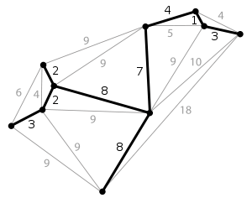

Figure ‎2‑9 Combinatorial optimization process

Combinatorial optimization is already part of mathematical optimization related to algorithm theory, and computational complexity theory, the importance of this process comes from having numerous applications such as artificial intelligence, machine learning, and software engineering.

Utility maximization under resource constraints constitutes a general modeling approach for user association in 5G networks, which is formulated as in *Equation (‎2‑1)* and *Equation (‎2‑2)*.

|  |  |  |
| --- | --- | --- |
|  |  | *Equation (‎2‑1)* |
|  |  | *Equation (‎2‑2)* |

where X = Xmn is the user association matrix (Xmn = 1, if user n around BS m, Xmn = 0) and U represent the total network utility µ mn is the utility of user n. fi (x) ≤ Ci represents the resource constraints.

The challenge of combinatorial optimization that we assume that a user can only be associated with a one BS at any time. We can overcome this issue by relaxing the user association matrix from Xmn = (1-4, 6-20) to Xmn = (0, 1) then invoke the classic Lagrangian dual analysis, followed by recovering the primal user association matrix x from the optimal dual problem.

### Other techniques for solving multi-objective problems

* Stochastic geometry.
* Rpsilon-constraint method.
* The two-phase method.
* Barzilai and Borwein multi-objective optimization (BBMO) method.

## Metrics

In this section we will introduce to some common metrics and the related works that users and companies work on to optimize for optimal user association in 5G network architecture for some main topology.

### Energy efficiency

Through the last years, mobile users and data transmission has been grown dramatically, that caused in increasing exponentially in the energy consumption, this has become a critical issue for the mobile companies to preserve to carry on ability growth to meet their new loads, also to achieve to decrease their electric bill and to decrease the environmental pollution.

The energy efficiency metric is one of the most significant metrics in user association algorithms, as governments nowadays are being more concerned about environments and environmental pollution, that’s why many industrially and academically institutions are thinking about saving energy and also changing their viewpoint for switching from solar energy into green energy that is friendly for the environment, also these industrially and academically institutions ;and for a chosen algorithm for user association in a certain scope, they have many choices for an energy efficiency metrics that provides a study for the power saving possible. Two of the main metrics for an energy efficiency are:

* The ratio between the total data rate of all users and the total energy consumption (bits/joule).
* The direct presentation of the power/energy saving achieved by means of a certain algorithm. As the percentage of power saving for a certain algorithm.

Now we will discuss the HetNets scope how the energy efficiency can affect the user association:

#### User Association in HETNETS Network

In the HetNets networks, maximizing the energy efficiency can be shown as Minimizing the total energy consumption while satisfying the associated traffic demands. Maximizing the overall energy efficiency; which is defined as the ratio between the total data rate of all users and the total energy consumption of the network.

In HetNets connecting to macrocells will consume more power than connecting to a small cell also when associating to a macrocell will dramatically need larger transmit rate comparing with the small cells. Many researches aimed for maximizing the downlink and the throughput for user association by associating each mobile with a base station that outcomes in minimizing the transmit power consumption. Also, only a small number of existing researches have considered the joint uplink and downlink user association in HetNets, a user organization plan was projected, and the goal function was prepared as the subjective difference between the total number of established user equipment’s and total summation of uplink transmit power. Also, we want to maximize the sum of log-scale uplink and downlink power efficiencies along with all user equipment’s. In this class of network, the most consuming part is the base station, so one of the most important solutions which is a efficient way to reduce power consumption was by shutting down the base station if no users are connecting to it. So, the user association and the base station sleep mode are the best in maximizing the energy efficiency or minimizing the total power consumption.

### Spectrum Efficiency:

The spectrum efficiency is defined by the maximum data that can be transmitted in a defined bandwidth in the communication system network (wired or wireless), for 5G networks a high spectrum efficiency is needed to decrease the traffic of data and the limited resources used for spectrum. Since in 5G networks need to be very fast then this means that a low interference between the base stations and large spectrum bandwidth need to be defined. 5G networks operate on high frequency bands in above 24 GHz which gives it more and more bands to transmit data through and as a result it makes it much faster for transmitting data.

Also, the user allocation algorithm plays a role in the spectrum efficiency, since huge number of mobiles (users) are connecting to the same base-station then this base-station must have a big spectrum to transmit data in an efficient way. It is measured in the number of bits traveled from one place to another on a network at a given carrier frequency and have a unit of (bits/second)/Hz. We will compare for different scopes of network how to allocate the users based on the spectrum efficiency.

#### User Association in HETNETS Network:

In this type of network the spectrum allocation is one of the most important metrics, since there is a macro-cell and other small cells and the interference between the cells is high enough which may result in working on a good algorithm to allocate the users on the perfect base-station to minimize the sum of data rate and number of channels, also in this type of network it is known that the number of users allocated on a small cell is much larger than the number of users allocated on a macro-cell so this means we need much number of frequencies to transmit the data on in the small cells, although we need to be careful when associating the users such that minimizing the data rate of all users may result in an inequitable (unfair) data rate allocation.

Users who are allocated to the macro-cell will achieve higher data rate from users allocated in a small cell this because the users who are allocated to the small cells are much larger than users allocated to the macro-cell.

There are many algorithms to allocate the users on the base stations, such algorithm is low complexity distributed user association that maximize the data rate for all users, by giving more resources to the users who has low data rates achieving load balancing and more fairness between users.

Another algorithm used to associate the users is Game theory where the base-station is like a player challenging to serve the users to maximize the data rate based value, while promising a certain minimal data rate for all users, and at the same time giving fairness for all users as well as balancing the traffic load of the cells in different tiers.

### outage/coverage probability

Coverage probability is the probability that shows if a specific device is in the coverage area of at least one base station or not, it determines that by comparing the signal to interference plus noise ratio with a certain threshold, if the SINR was greater than the threshold then the device is in the coverage area, but if it was below the threshold then the device can't connect to the base station. Mathematically, the outage probability is given by *Equation (‎2‑3)*.

|  |  |  |
| --- | --- | --- |
|  |  | *Equation (‎2‑3)* |

A lot of people performed studies on deriving the outage probability, at * they proposed an expression of the multi-cellular systems for finding the outage probability, they mentioned that the frequency and the mean duration of outage events are important to characterize a system. So, we can modify *Equation (‎2‑3)* and add the outage duration, as in *Equation (‎2‑4)*.

|  |  |  |
| --- | --- | --- |
|  |  | *Equation (‎2‑4)* |

In which is the minimum outage duration. is the outage duration.

But still the frequency is not involved directly in *Equation (‎2‑4)*, so subsequent studies approximated the outage probability to *Equation (‎2‑5)*.

|  |  |  |
| --- | --- | --- |
|  |  | *Equation (‎2‑5)* |

is average rate of the outage events.

#### User association in heterogeneous cellular networks

Our HetNets consists of N-tier, each tier may contain different base stations in which the transmitted power and the data rate are different, let say that we have a base station named BS1 in the tier number x, a device can communicate with this base station if and only if its downlink SINR is greater than the BS1 SINR.

Every tier has its own transmission power amount, signal to interference noise ratio and its own density, all these attributes make each tier differs from any other tier, so we can say that these attributes make the tier unique.

To find the SINR expression that result when the device connects to the base station is given by the *Equation (‎2‑6)* as illustrated in *.

|  |  |  |
| --- | --- | --- |
|  |  | *Equation (‎2‑6)* |

Where:

is the fading power between the Base station and the device.

The standard path loss function is given by , where a > 2

is the constant additive noise power.

The numerator of *Equation (‎2‑6)* is the received power.

Figure ‎2‑10 shows the received power curve of micro and femto cells.

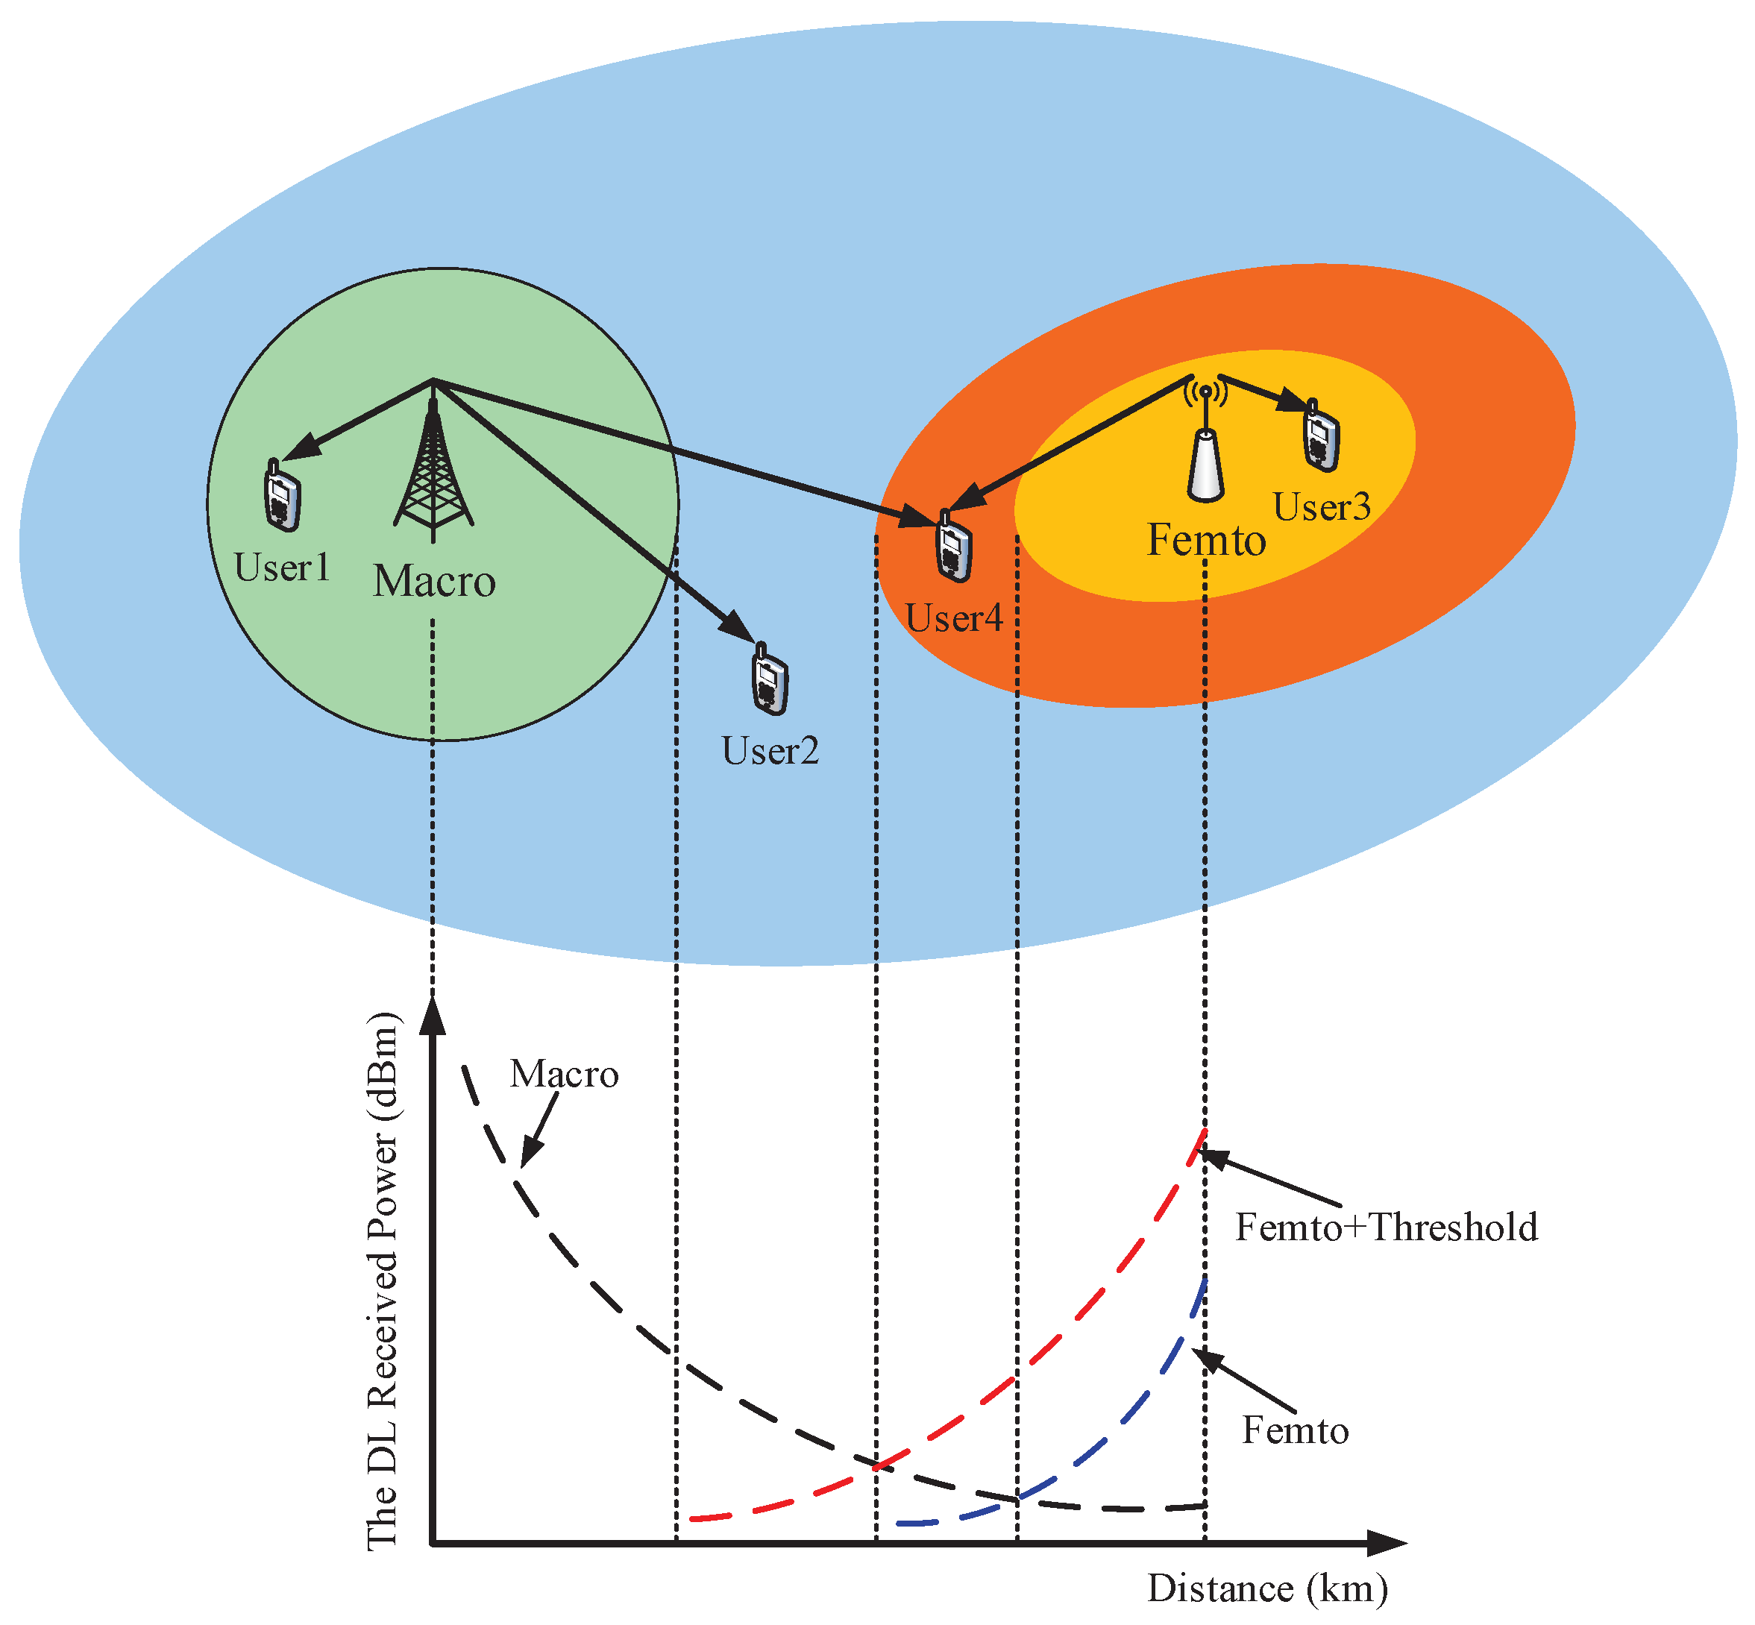

Figure ‎2‑10 Received power curve

There are a lot of equations that are proposed by other people, at they discussed the outage probability of lot of systems such that Multi cellular SISO systems and for an Mrt Comp transmission.

Based on this metric, we can improve the performance of the network in which the data loss will be reduced which also reduces the number of retransmissions, we can do that because the transmitter now can control the size of data he transmits based on the condition of the network, so that the transmitted data will reach its destination without any loss.

A good case to mention is that if we see Figure ‎2‑10 and imagine that we have a car that it is moving from left to right (towards the Femto cell), how does the device deal with the received power and which cell it will deal with?

Well, at first when the car is travelling from left to right, it will communicate with the Macro cell, but when it reaches the area that the two cells cover, a handover starts happening and the device will slowly turn its communication to the femto cell.

### Other metrics used for determining the user association

* **Quality of service (QOS)**
* **Channel Access Control Management**
* **data traffic**

# Proposed Method and Analyses

## Problem definition:

In the last few years the number of users has grown dramatically, which resulted the main big companies to start thinking how to maintain this huge capacity growth, this significantly growth in users resulted in more and more energy consumption and on the other hand the shortage of spectrum channels, these two factors pressured the need for energy and spectral efficiency solutions. So, our problem will be focused on associating the users to the base station based on the spectrum and energy factors tacking into account the load balancing for the uses on the base stations in mobile network, where to assign the user to achieve less power consumption from the user side and maximum network capacity from the company side by achieving maximum spectrum efficiency, since these are the main two factors companies are looking forward to maximizing the number of users connecting in a mobile network and saving as much as we can energy and spectrum for the next generation of mobile networks (5G) Heterogenous Mobile Network (HMN).

## System model:

Our model design is based on Heterogenous Mobile Network which consists of multi-tiers, a main Macro cell tier and other small cell tier (Pico-cell, Femto-cell, …), our analysis will be on a Heterogenous () two tiers network, a first tier Macro cell tier that contains of other femto-cells a secondary tier. Also, the frequency deployment is a Co-channel deployment, where the small cells operate on the same frequency band of the macro cells, each macro cell contains of channels called (resources block (RB)), whereas the femto cells also contains a resources block, some of the resources blocks are fixed as only a single base station uses these channels in the resources blocks, on the other hand, some of the channels are allocated dynamic and controlled by a Channel Allocation Center (CAC) that contains a pool of unused channels where the base stations that has shortage in its channel can borrow some channels from the Channel Allocation Center. Besides, the small cells (Femto-cells) communicate wirelessly with the macro cell assuming they are on the same line-of-sight. The mobile stations (MS/user) can connect to a macro-cell or a femto-cell where the femto cell is connected to the macro cell directly (Single-hop). The macro cell is separated into three sectors that work on the same channels to increase the network capacity and they are operator deployed planned, also the femto cells are an operator deployed plan. Each tier (macro -tier1- or femto -tier2-) has a transmission power where the power of the macro cells are much more than the power of a femto cell (radius of the macro cell is larger than the radius of a femto cell. The distance between every two nodes is calculated based on the Euclidian distance calculation, and the path loss model is a free space path loss. Figure ‎3‑1shows the architecture of our network.

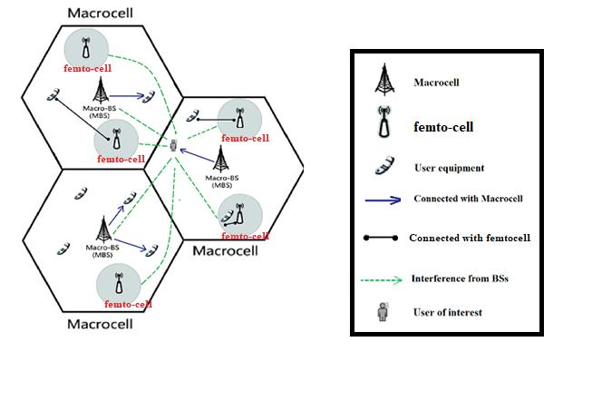

Figure ‎3‑1 Network Architecture

To determine the total Channels available in the spectrum, we assume an equal bandwidth per Channel, therefore we calculate the total Channels by using *Equation (‎3‑1)*.

|  |  |  |
| --- | --- | --- |
|  |  | *Equation (‎3‑1)* |

After that we combine a group of channels to form a Resource Block, the number of resources blocks is determined from the Cluster (Combine a group of macro Cells) size and the number of femto cells in each macro cell ( without reusing the resources blocks and the size of the resource block is determined from number of channels used for static allocation (calculated from the number of channels used for dynamic allocation and the total available channels) and the total w here the number of Resources Block and size are calculated based on *Equation (‎3‑2)* and *Equation (‎3‑3)*.

|  |  |  |
| --- | --- | --- |
|  |  | *Equation (‎3‑2)* |
|  |  | *Equation (‎3‑3)* |

### Power Calculation:

The range for each cell should be calculated to know that the user can connect to the BS or not and it is calculated by *Equation (‎3‑4)*.

|  |  |  |
| --- | --- | --- |
|  | [3] | *Equation (‎3‑4)* |

Where the constant calculated using the frequency as in *Equation (‎3‑5)*.

|  |  |  |
| --- | --- | --- |
|  | [3] | *Equation (‎3‑5)* |

Where:

:Path loss

The power consumed by each user is differ than the transmitted power from the BS that the user connected with, and it can be calculated in different ways like in [4], *Equation (‎3‑9)* was used because it is the best equation that fit our topology where the Gains, the transmitted power and the wavelength are parameters and the distance is calculated.

Formally, for a given BS x and a desired MS y, the desired signal power received at y is expressed as in *Equation (‎3‑9)*:

|  |  |  |
| --- | --- | --- |
|  | [1] | *Equation (‎3‑6)* |
|  | [2] | *Equation (‎3‑7)* |
|  | [2] | *Equation (‎3‑8)* |
|  | [2] | *Equation (‎3‑9)* |

Where

* and are the receive and transmit antenna gains.
* is the wavelength
* is the distance between x and y.(Euclidean)
* where d>d0
  + Typical value for :
    - Indoor:1m
    - Outdoor: 100m to 1 km
* is the transmitted power
* is the received power
* and are in same units
* and are dimensionless quantities.

### SINR Calculation:

The distribution of the base stations is based on a homogenous Poisson Point Process (PPP), . where the location for the Cell is given by . And also, the distribution of the BSs in multitier HMNs is governed by a Poisson point process where the .

The PPP model is also used for the distribution of users, each user (MU) has an independent PPP denoted by for MUs associated with the Kth tier, is the location of the user in the cell and served with the nearest with a distance between them.

The noise we are considering here is the thermal noise denoting by , thermal noise is modeled here as an additive white Gaussian noise (AWGN). The variance is denoted by , and a mean of zero. We can express the SIR as shown in *Equation (‎3‑10)*.

|  |  |  |
| --- | --- | --- |
|  | [2] | *Equation (‎3‑10)* |

Where are all Base stations that cause Interference without the base station the MS is connected to. To calculate the signal to interference plus Noise ratio as in *Equation (‎3‑11)*.

|  |  |  |
| --- | --- | --- |
|  | [2] | *Equation (‎3‑11)* |

Where N is the terminal noise (additive white gaussian Noise).

### Throughput:

Total throughput is the product of the total number of active users and the average achievable rate of a randomly chosen user when it is under the coverage of the BS as in Equation (‎3‑12).

|  |  |  |
| --- | --- | --- |
|  |  | Equation (‎3‑12) |

Where:

∶ is the density of the randomly chosen user

: is the total area

: is the averaged coverage probability of mBSs over the plane

: is the averaged coverage probability of pBSs over the plane

: is the average achievable rate of the randomly chosen user in the macro tier

: is the average achievable rate of the randomly chosen user in the pico tier

To find the coverage probability, we use *Equation (‎3‑13)*

|  |  |  |
| --- | --- | --- |
|  | [5] | *Equation (‎3‑13)* |

Where:

* : Target SINR
* : the random distance between the tagged MU and its serving mBS
* , such that:
* : path loss exponent
* : Noise variance
* : mBS density

The averaged coverage probability of pBS over the plane is derived as in *Equation (‎3‑14)*.

|  |  |  |
| --- | --- | --- |
|  |  | *Equation (‎3‑14)* |

Where:

Now, the only thing remaining is to find the average achievable rate, the following equations(*Equation (‎3‑15)*, *Equation (‎3‑16)*, *Equation (‎3‑17)*, *Equation (‎3‑18)*and *Equation (‎3‑19)*) shows how to find it.

|  |  |  |
| --- | --- | --- |
|  | [5] | *Equation (‎3‑15)* |
| Where: | * [5] | *Equation (‎3‑16)* |
|  | * [5] | *Equation (‎3‑17)* |
|  | * [5] | *Equation (‎3‑18)* |
|  | * [5] | *Equation (‎3‑19)* |

Where LI1(s) and LI2(s) are the Laplace transform of a random variables 𝐼1 and 𝐼2 which are the aggregate interference power generated by the () at the tagged macro MU.

## Problem formulation and optimal solution:

Our objective here is to find the maximum spectrum and energy efficiency while taking into account the load balancing of users in the network, at first we can define the spectrum efficiency as the total throughput divided by the total bandwidth, and the energy efficiency as the total throughput divided by the total power consumption. Now, we can express the spectrum and energy efficiency according to the definition above as spectrum efficiency in *Equation (‎3‑20)* and energy efficiency in *Equation (‎3‑21)*.

|  |  |  |
| --- | --- | --- |
|  |  | *Equation (‎3‑20)* |
|  |  | *Equation (‎3‑21)* |

Based on the above analysis, we formulate an optimization problem to balance SE and EE, to maximize the SE under the EE constraint. This optimization problem can be formulated as:

With constrains:

## Solving the problem using simple greedy algorithm:

In this method we will associate the users based on the calculated SINR and the received power for each user using a simple greedy algorithm which will associate the user on the maximum combined SINR which is represented by the spectrum efficiency and the power which is represented by the energy efficiency and tacking into account the number of users that are connected to the base station which is represented by the load balancing.

|  |
| --- |
| ***Simple Algorithm*** |
| ***For*** *user*  ***find*** *all possible base-stations that user can connect to.*  ***For*** *each BS of the possible base-stations that user can connect to*  ***Find*** *the total SINR and* ***save*** *it in SINR array*  ***Sort*** *SINR array in descending order*  ***Save*** *SINR array length in n*  ***While*** *true*  ***Get*** *the n SINR*  ***Calculate*** *the total throughput*  ***Calculate*** *SE and EE*  ***If*** *(EE > EE_MIN)*  *Optimal = SE;*  *Break*  ***else***  ***decrement*** *n* |

### Description of the greedy algorithm

We take one user per time, we see all possible base-stations that the user can connect with and take all possible scenario and find the total SINR in every scenario then find the scenario that gives the maximum total SINR for that scenario find the total throughput of the best case and find SE and EE Check if EE is greater than the EE_MIN and take this association if true. If not, then take the scenario that gives the next best SINR and check again.

## Solving Problem Using Evolutionary algorithm:

In this section we will formalize our problem to solve it using Evolutionary algorithm (Genetics algorithm). In which it will give us a possible solution which is as much close to the optimal solution for the topology we formalized.

In the next part we will describe the chromosome we will use, moreover will describe the genes for the chromosome and define our fitness function that will be used in the genetics algorithm and solve the problem as single objective genetics algorithm problem and multi-objective genetics algorithm using Non-dominant Sorting Genetics Algorithm (NSGA-III).

### Chromosome and Genes Formalization:

#### Chromosome Formalization:

As we made the Macro cells, the Femto cells and the users, numbers and locations as random as possible then also the chromosome will be affected by these changes from one topology to another. Which will make it changeable (dynamic) between topology and another.

In the same topology the chromosome will be static which will contain all users in the topology that are inside the area of our system and can connect to a macro cell or a femto cell. The chromosome will be as shown in Figure ‎3‑2. Each user describes a gene of this chromosome and the crossover will be as changing genes of this chromosome.

|  |  |  |  |  |  |  |
| --- | --- | --- | --- | --- | --- | --- |
|  | | | | | | |
| User 1 | User 2 | … | User k | … | User (i-1) | User i |

Figure ‎3‑2 Our Chromosome for NSGA-III Algorithm

#### Genes Formalization:

As we mentioned before the chromosomes will contain the genes which are the number of users that can connect to our network, but each gene will contain all the possible base stations that a user can connect to. As the number of base stations that a user can connect to is changeable from each user to another then in this way the genes also will be changeable in the one chromosome which will affect the crossover, so in order to unify the genes over the chromosome then we will separate the genes into two sub-genes, the first will contains only the Macrocells possible connections and the second will contain the Femto cells possible connection, then we unify these numbers for all the genes and take the maximum number of macro base stations and the maximum number of femto cells a user can connect to and define the genes as the total number of base stations a user can connect to. Figure ‎3‑3 Shows the description of the genes. Each part of the gene will be either a 0 or 1 (Binary) (1: the user is connected to this base station, 0: user isn’t connecting to this base station) and for the one gene at most and at least one of its parts will be 1 which means that the user is only connected to one base station.

Moreover, the genes consist of the cell Id as shown in Figure ‎3‑3 (Cluster Id , Macrocell Id and Femtocell Id (will be described later in the next chapter)).

|  |  |  |  |  |  |  |  |
| --- | --- | --- | --- | --- | --- | --- | --- |
|  | | | | | | | |
| Possible Macro Cell 1 | Possible Macro Cell 2 | … | Possible Macro Cell M | Possible Femto Cell 1 | Possible Femto Cell 1 | … | Possible Femto Cell F |

Figure ‎3‑3 Our Genes for NSGA-III and genetics Algorithms

### Cross-Over Algorithm:

The cross over will happen between any two members of the population where each matting will produce two new members which we will call children that may have a better qualities than their parents, the cross over will be an exchange of genes between the parents, the place of the genes will remain static so if the first gene transfer from the first parent then it must replace the first gene in the second parent and so on for all genes in the chromosomes, the number of genes to be transferred and the place of genes will be chosen randomly.

This process will be repeated for the number of iterations which is an input for the algorithm and if the system falls in some local maxima then a mutation will help us to get out of this solution.

### Generating population:

The generation for a population will be randomly as each gene in the chromosome will be generated separately, where there is a constrain on the generation process, that each bit in the gene that represents a possible connection, although the user cannot be connected to more than one base station and the user must be connected to at least one base station, so there must be at least and at most one bit in the gene that is one to insure that the user is connected to a base station and no more than one. The generation process is randomly so that in the population there must be all possible scenario, and for the base stations that are padded to the gene and the user cannot connect to them, then these must not be ones so to ensure that the user isn’t connected to a base station that he from the first cannot connect to it.

### Probability of matting:

When we choose two chromosomes to be matted then there is a probability that these chromosomes can be matted and produce two new children. This probability must be high enough to make the process faster and to reach the optimal solution. This probability must be greater than 70% and in the best case it can reach to 100% where for each possible choice there is a mating and two new children are created.

### Probability of mutation:

In this section we will describe the mutation process that may occur in the children chromosomes after the cross over happens, where one gene in the chromosome can be changed and this changing also has some constrains, as if a mutation occur then it will change the one to zero and set one of the possible zeros that represents a possible base station the user can connect to, the probability of a mutation is low and it is less than 1%.

### Fitness Function:

Our fitness function was calculated for each chromosome independently, described by *Equation (‎3‑22)*.

|  |  |  |
| --- | --- | --- |
|  |  | *Equation (‎3‑22)* |

Where gene is connecting with the base station or not, is the objective that is used for that base station and the desired user, and N is the number of genes in the chromosome, so we will compare using multi objectives as SINR, Power, and the Load balancing.

#### Single Objective Fitness function:

In this section we will describe how to calculate the fitness function using SINR only, Using Power only, Using Power and SINR, and using Power, SINR and load balancing.

##### Using SINR only:

In this technique we will calculate the SINR for each user and each base station that can connect to, and we will calculate the fitness function for each chromosome by adding the SINR for each user for the base station that is connecting to; according to that chromosome.

##### Using Power only:

In this technique we will calculate the received Power for each user and each base station that can connect to, and we will calculate the fitness function for each chromosome by adding the Power for each user for the base station that is connecting to; according to that chromosome.

##### Using Power and SINR without load balancing:

This technique is different for the above since the SINR and Power may have different means and standard deviation, so adding them may result by one dominate the other which will be dominant for one objective. So, to solve that problem we should change the mean and standard deviation for both the SINR and Power to the same mean and standard deviation to add them.

To make an array named Var distributed between 0 and 1 we will use *Equation (‎3‑23)* and *Equation (‎3‑24)*.

|  |  |  |
| --- | --- | --- |
|  |  | *Equation (‎3‑23)* |

Where the Var is an array of the numbers (SINR or Power) for all possible connection cells for one user.

Normalized.Var is an array of the new normalized Var in the range of where 99.9% of all the Var values in this range, so to make the range from (0,1) with mean 0.5 we used *Equation (‎3‑24)*.

|  |  |  |
| --- | --- | --- |
|  |  | *Equation (‎3‑24)* |

Dividing by 6 will change the range from to ( with zero mean and adding 0.5 to the array will change the mean from 0 to 0.5 and the range from to .

Applying the above equations for the SINR and Power Arrays this will unify the mean and the standard deviation for the SINR and Power, (Mean= 0.5 and Unity Standard deviation). This allows us to add the arrays which will result for a new array distributed between with mean=1 and standard deviation equal 2.

After adding the SINR and Power arrays we will calculate the fitness function for each chromosome by adding the Normalized array (SINR + Power) for each user for the base station that is connecting to (its Bit is 1); according to that chromosome.

##### Using Power, SINR and Load balancing:

Adding the load balancing for our calculation is made by dividing the Normalized Power and SINR by the number of users connecting to that base station. *Equation (‎3‑25)* shows how it is done.

|  |  |  |
| --- | --- | --- |
|  |  | *Equation (‎3‑25)* |

And After adding the load balancing to the SINR + Power arrays we will calculate the fitness function for each chromosome by adding the Normalized array with the balancing () for each user for the base station that is connecting to (its Bit is 1); according to that chromosome.

#### Multi objective NSGA-III:

To solve our problem, we used the proposed algorithm NSGA-III as proposed in (paper) for our chromosome and solved the problem for the main two objectives SINR and received power.

## Solving Problem Using Game Theory:

Game theory is a mathematical modeling tool, which tries to distribute the interest to all interaction players(Users) by reach a point called "equilibrium point". This happens when users take the best strategy to be associated with only one BS.

In HetNets, the process of spectrum and energy-efficiency user association based on the Game Theory can be described as follows.

### Game Theory approaches:

The Game theory has two main approaches:

#### Cooperative approach:

Each player in the game considers the utility of the rest of players when he tries to maximize its own utility. On other words the players on the network agree to work together and divide the gains based on their individual contributions.

#### Non-Cooperative approach:

In this approach there will be some winners and losers between players. Where, each user tries to maximize its own utility no matter what other players (opponents) decides to do.

### Formalization:

#### Players:

Game Theory describes each user or BS as a player and in our topology the users were assumed to be the players.

Each UE in a specific area that is served (by Macro or Femto) is denoted as a player. Assume that M users, each one of them has a selection {… … }. Each UE can choose to be associated with any BS within the range. Therefore, each UE in this range can be modeled as a player of the Game Theory.

#### Strategy:

The strategy in game theory of each user refers to the selection of a BS where, each UE can select any BS to be associated with.

The Probability of each to selects can be denoted as , since ∈ {0,1}, and . That means each user can be associated with only one BS.

Each user can connect with more than one BS needs to determine which BS to connect with by consider multi-objective (SINR, Power-Received, Load balancing).

For the SINR we collect the best SINR for each user, whereas the minimum SINR that allows the user to connect with a BS should be greater than (0.2), otherwise the user will not be considered. Then store the users SINR values in an array and find the mean value of all SINR values for all users. At the same way we find the mean value of power.

Now the distributions for each user () should follow *Equation (‎3‑26)*.

|  |  |  |
| --- | --- | --- |
|  |  | *Equation (‎3‑26)* |

#### Normalizing SINR and PR:

The values of SINR and PR are not in the same range, so we need to scale them to be close to each other. To do that we normalize these quantities using*Equation (‎3‑27)* and *Equation (‎3‑28)*.

|  |  |  |
| --- | --- | --- |
|  |  | *Equation (‎3‑27)* |
|  |  | *Equation (‎3‑28)* |

Where STD means the standard deviation, for both (SINR, PR) calculated as in *Equation (‎3‑29)*:

|  |  |  |
| --- | --- | --- |
|  | σ (STD) | *Equation (‎3‑29)* |

where, for each value, subtract the mean and square the result, then work out the mean of those squared differences and take the square root of that and we are done.

The normalized value for SINR and PR will differ in each run and applied to previous equations.

We should notice that the value of (V) is not enough because it can give us greedy search of BSs that gives the best possible value from the array, so we need to consider the load balancing as the 3rd objective in our decision.

#### Load Balancing Objective:

The load balancing objective is implemented by considering the BS capacity, where the BS should not be full to allow some users to connect with it when necessary, and take into account the number of connected user and the value of V (SINR with the power) as ratio.

Each user ( ) can see more than one BS, the decision is determined by dividing the value of V over the number of connected users for each BS, and the best result we get will determine which BS the user will connect with. See *Equation (‎3‑30)*.

|  |  |  |
| --- | --- | --- |
|  |  | *Equation (‎3‑30)* |

that the user can connect with. So that, our decision takes these 3 objectives to assign any user to a specific BS.

#### Utility function:

The utility function is calculated after assigning each user to a BS, depending on multiple objectives (SINR, Power received, Load-balancing), and it can be calculated in different ways. In our topology the utility for each user was calculated as the ratio of the throughput over the SINR as the equation below. And the payoff (gain) of a player is determined by its net utility.

|  |  |  |
| --- | --- | --- |
|  |  | *Equation (‎3‑31)* |

where i ∈ {UE}. and the total utility can be calculated as in *Equation (‎3‑32)*.

|  |  |  |
| --- | --- | --- |
|  |  | *Equation (‎3‑32)* |

where M number of user connected.

# Used Tool and Results

## Tool:

## Experiments setup:

### Building topology:

### Simulation Parameters:

## Results:

## Metrics we Will Compare to Other Methods:

# Conclusion

# References:

[1-5]

1. Han, T., et al., *Interference minimization in 5g heterogeneous networks.* Mobile Networks and Applications, 2015. **20**(6): p. 756-762.

2. Aldhaibani, J.A., A. Yahya, and R.B. Ahmad, *Coverage extension and balancing the transmitted power of the moving relay node at LTE-A cellular network.* The Scientific World Journal, 2014. **2014**.

3. Arthur, J.K., *DESIGNING A WiMAX COMMUNICATION NETWORK FOR ACCRA FOR BROADBAND WIRELESS ACCESS.*

4. Nasim, I. and S. Kim, *Human Exposure to RF Fields in 5G Downlink.* arXiv preprint arXiv:1711.03683, 2017.

5. Xiang, L., H. Chen, and F. Zhao, *Area Spectral Efficiency and Energy Efficiency Tradeoff in Ultradense Heterogeneous Networks.* Wireless Communications and Mobile Computing, 2017. **2017**.