Portfolio

Dayoung Lee

About me

* Name : Dayoung Lee
* Email : [dayoung5213@gmail.com](mailto:dayoung5213@gmail.com)
* Contact: 647.825.6971
* Used skills :

Java. JSP. MySQL. Tomcat v9.0  
HTML. CSS. JavaScript

* Github : github.com/dayoung-lee

This is my first project that use JSP. It is a simple website that user can sign in, sign up and write in a board.

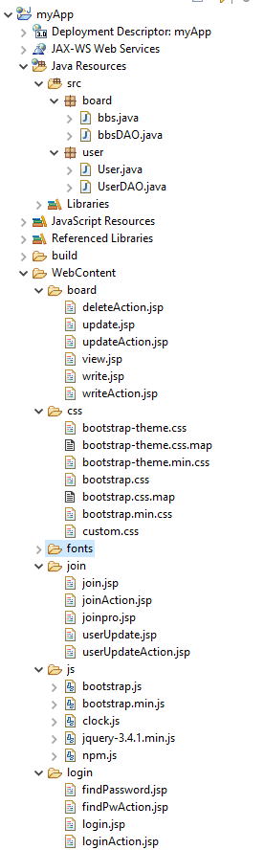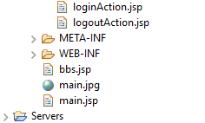Project Structure

Period : 1 week

Participants : 1

Main

Sign in

Sign up

Find

Password

Board

Write

Update

Delete

Insert

MySQL

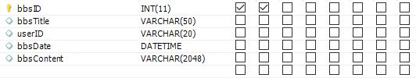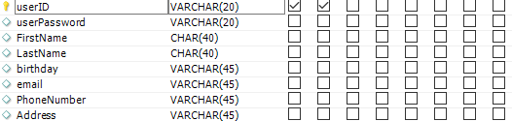

userDAO.java

connection

projectdb/bbs

projectdb/user

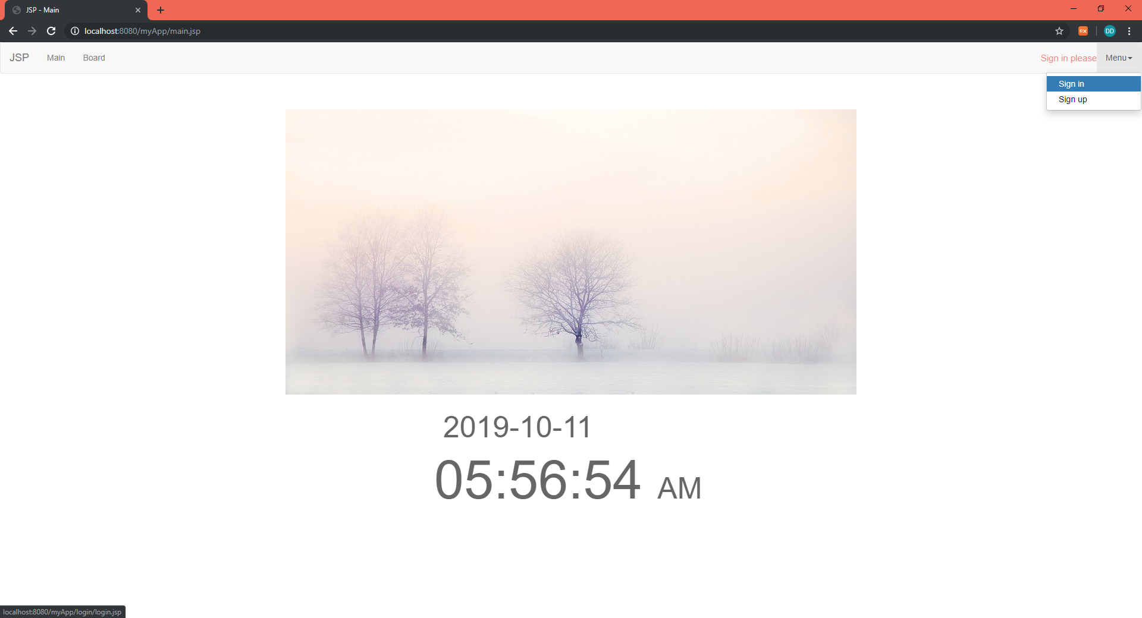Main

Css : bootstrap.css + custom.js

Js : bootstrap.js + jQuery (menu animation) + Clock (date + time)

Main

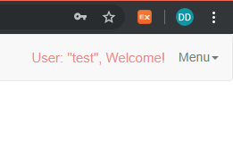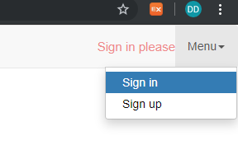

Dropdown menu

(jquery-3.4.1.min.js)

Before sign in,

print “Sign in please”

After sign in,

print “User: (userID), Welcome!”

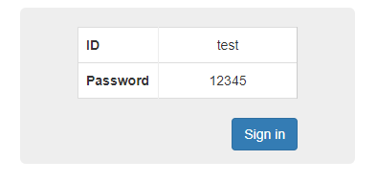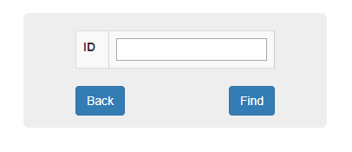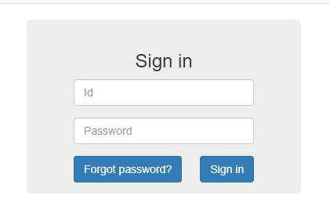Sign In

findPassword.jsp

login.jsp

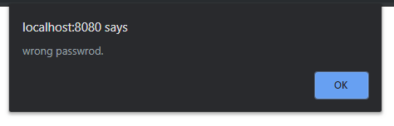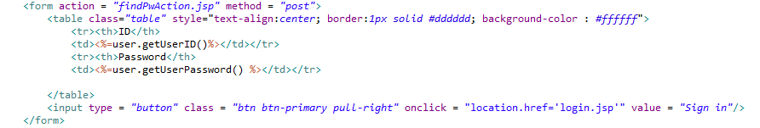

* If user type wrong password, alert message.
* use “post” method.
* use javaBean to get user information.

findPwAction.jsp

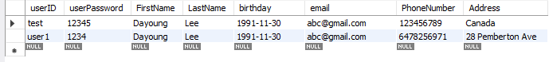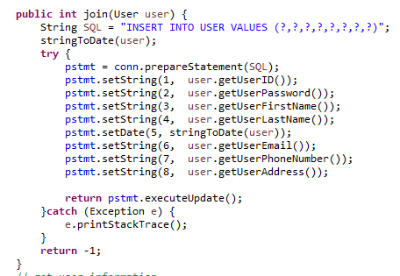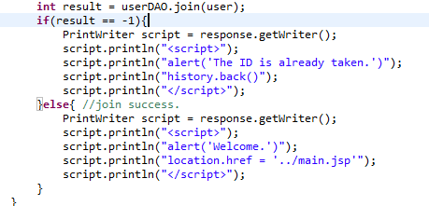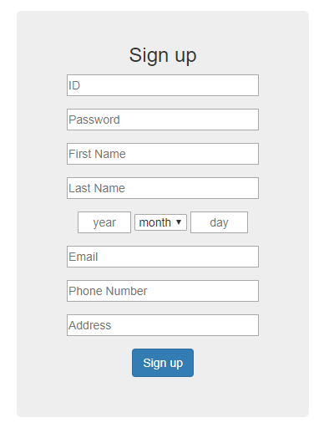Sign Up

User table

userDAO.java

joinAction.jsp

join.jsp

* use “post” method.
* use javaBean to insert user information.

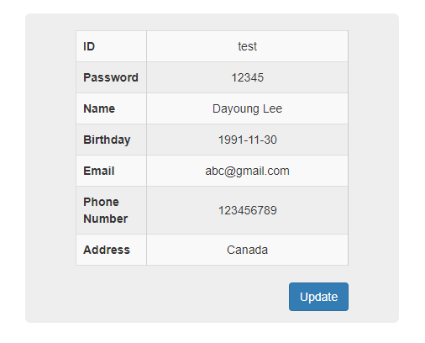My Page

Joinpro.jsp

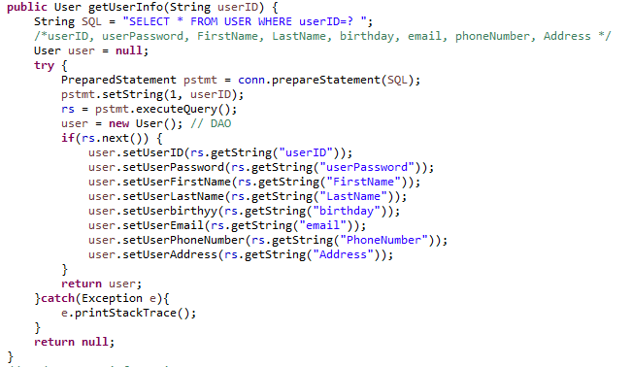

* use “post” method.
* use javaBean to insert user information.

userDAO.java

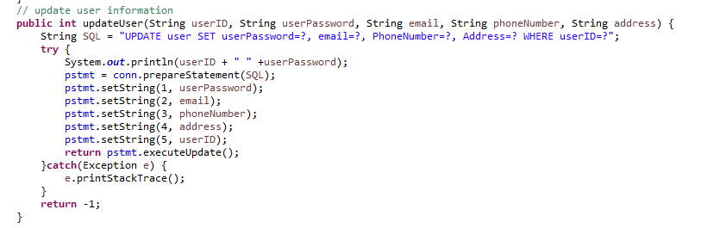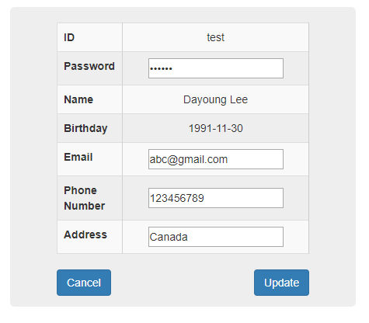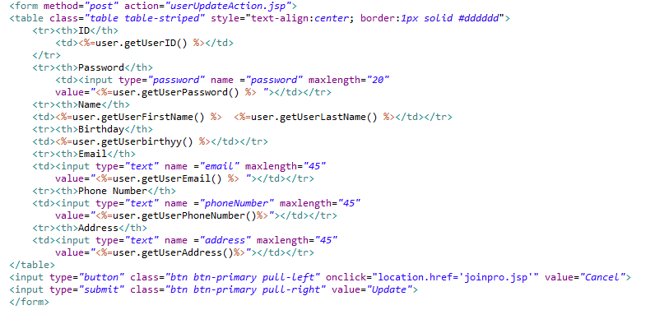My Page – Update

userUpdate.jsp

userDAO.java

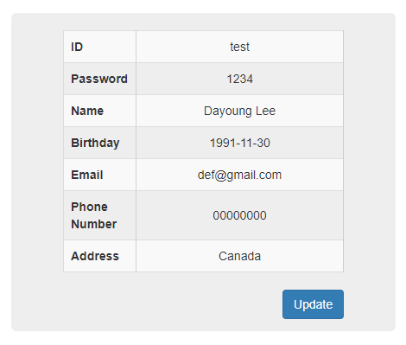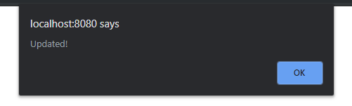My Page – Update

Show if the information is updated.

* Alert(‘Updated’);

javapro.jsp shows information changes.

Sign Out

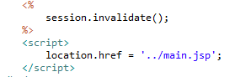

session.invalidate(); to logout.

After user sign out,

* back to main.jsp

Board - List

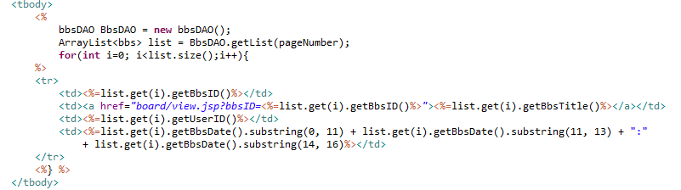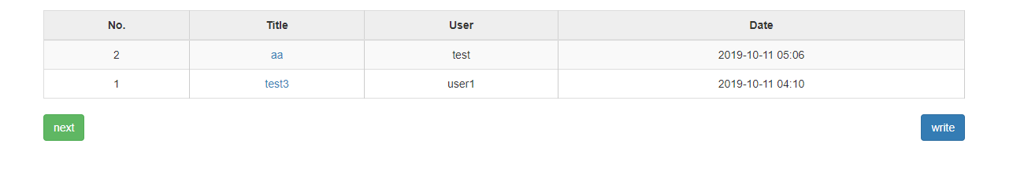

bbs.jsp

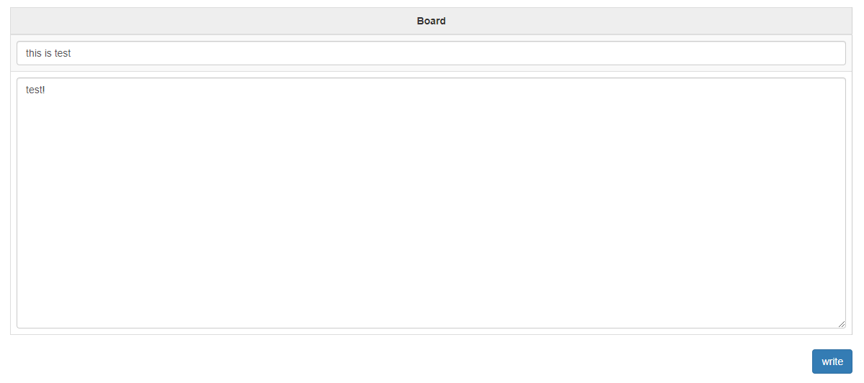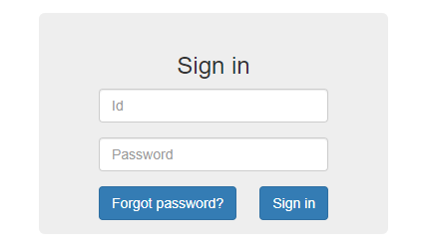Board - Write

write.jsp

If user don’t log in when press “write”

* show sign in

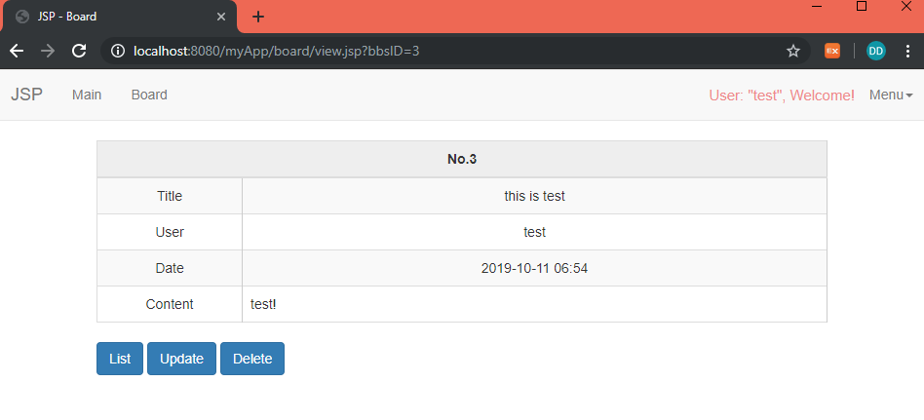Board – View

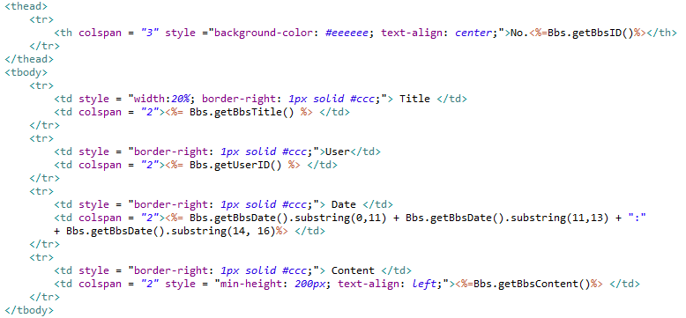

Use board javaBean

to get board objects

Board – Update

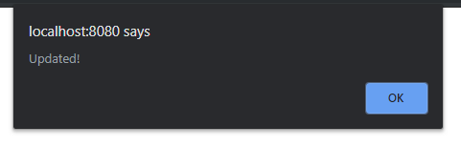

Show message box,

if update succeed.

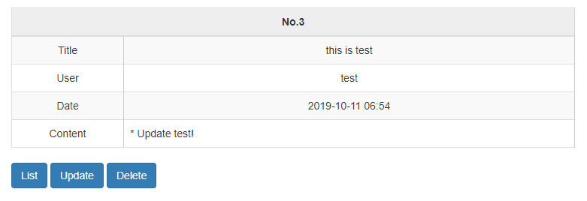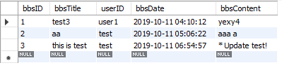

Board table

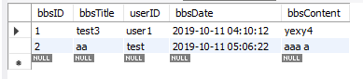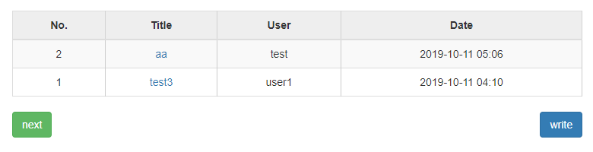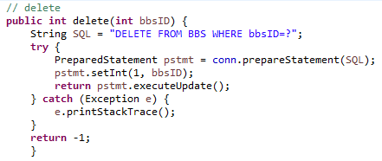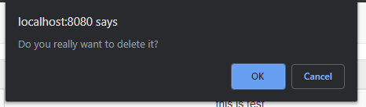Board - Delete

bbsDAO.jsp

After delete the table

Show message box to ask delete.

Summary

This is first project that I use JSP, before I start studying Spring. I have tried to put very simple but important function into the project. It was first time to connect database to JSP. Although the project is simple, it took some days because I have never studied JSP before. However, I really enjoyed and hopefully I can update some function more later. Thank you for watching my portfolio.