Microsoft: map needs to the right layer

Contents
Executive Summary
1. Windows is the PC layer
2. Microsoft 365 is work
3. Azure builds apps
4. Copilot assists workflows
Citations

Executive Summary
Bottom line: Microsoft is a portfolio, not one system; first map the need to Windows, Microsoft 365, Azure or Copilot, then verify entitlements early.
Audience: Executive decision-makers
Decision: Map needs to the right layer and confirm entitlements before committing.

Narration
Bottom line: Microsoft is a portfolio, not one system; first map the need to Windows, Microsoft 365, Azure or Copilot, then verify entitlements early.
Start with Windows when the decision is the PC experience: devices, desktop, apps and user productivity. It anchors the endpoint for users, not every cloud service.
Use Microsoft 365 when the need is everyday work: Office apps, email, files, meetings, sharing and collaboration. It packages work services, not custom infrastructure.
Use Azure when applications need cloud services: compute, storage, data and AI categories. It is the builder layer for apps and managed resources for teams.
Treat Copilot as AI assistance that sits inside selected workflows and licenses. Confirm access, grounding, service availability and subscription before commitments.

1. Windows is the PC layer
Start with Windows when the decision is the PC experience: devices, desktop, apps and user productivity. It anchors the endpoint for users, not every cloud service.

Claims
Windows 11 is the client operating-system layer for PC experience and user productivity.
The selected sources describe separate product layers: Windows, Microsoft 365, Azure and Copilot Chat.

Speaker notes
Evidence: Windows 11 is described as a client operating system with productivity-oriented features. Interpretation: treat it as the endpoint layer before expanding into cloud or AI choices.

Assets and alt text
visual-windows-layer: The decision map starts with the user endpoint, then separates work services, app services and AI assistance. (mermaid diagram)
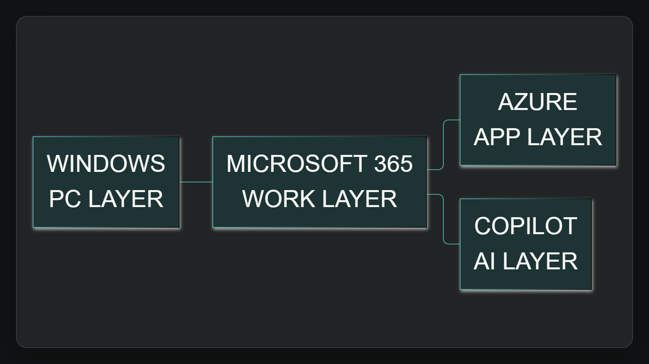

2. Microsoft 365 is work
Use Microsoft 365 when the need is everyday work: Office apps, email, files, meetings, sharing and collaboration. It packages work services, not custom infrastructure.

Claims
Microsoft 365 combines Office apps with online services for email, file storage, collaboration and meetings.
The selected sources describe separate product layers: Windows, Microsoft 365, Azure and Copilot Chat.

Speaker notes
Evidence: Microsoft 365 for enterprise combines Office apps with online services for email, storage, collaboration and meetings. Interpretation: this is the work-productivity layer.

Assets and alt text
visual-work-layer: Microsoft 365 groups common work capabilities into a productivity-services layer. (excalidraw diagram)
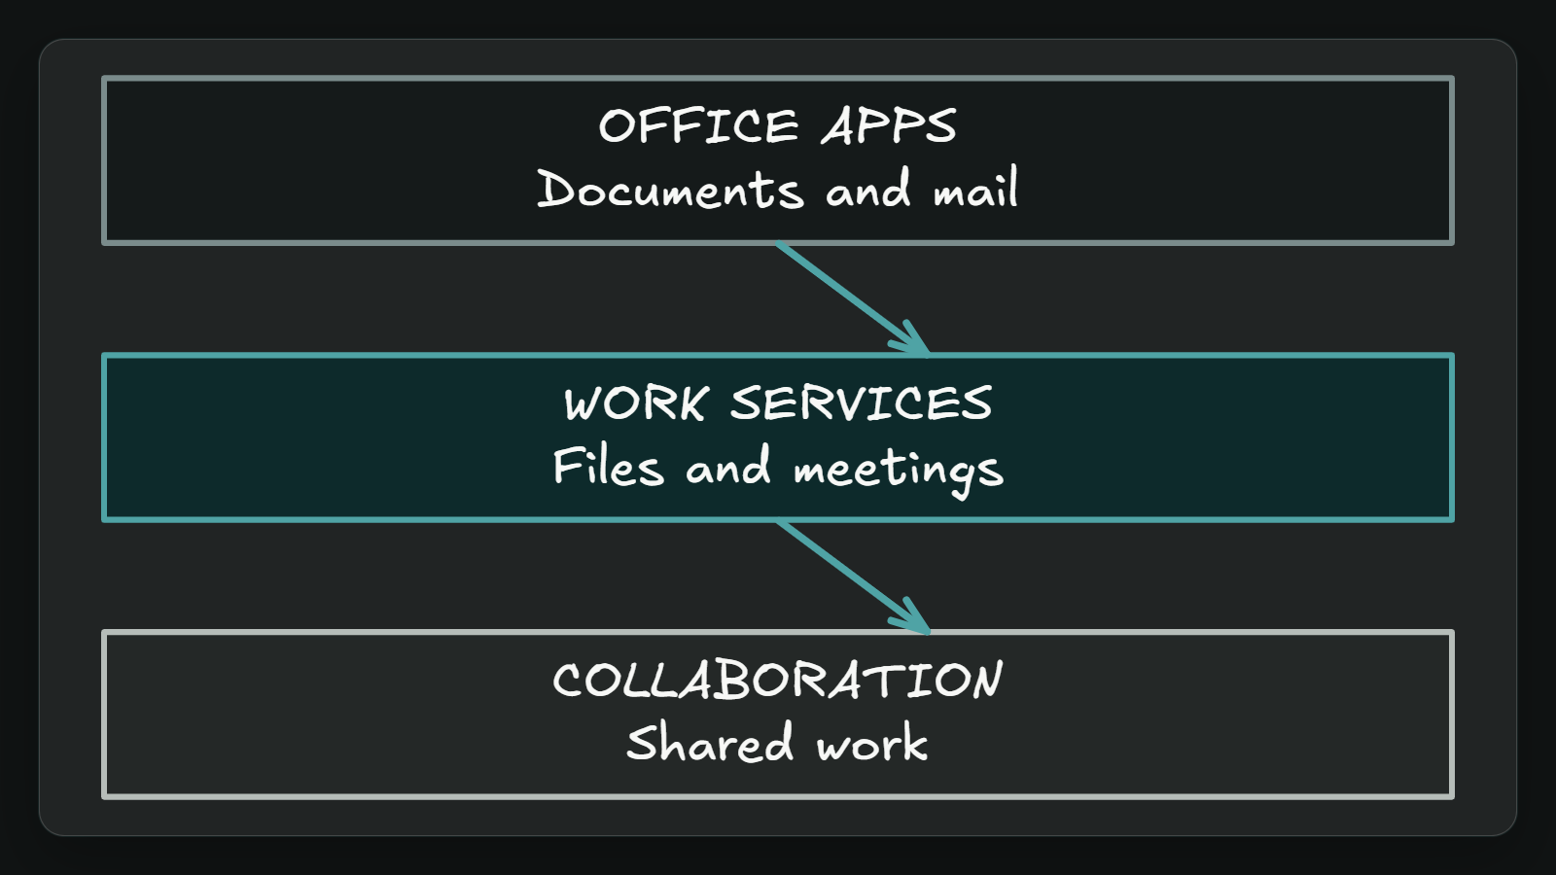

3. Azure builds apps
Use Azure when applications need cloud services: compute, storage, data and AI categories. It is the builder layer for apps and managed resources for teams.

Claims
Azure is the cloud-services layer for building and managing applications, including AI, compute and storage categories.
The selected sources describe separate product layers: Windows, Microsoft 365, Azure and Copilot Chat.

Speaker notes
Evidence: Azure documentation supports building and managing applications and lists AI, compute and storage categories. Interpretation: use Azure for application service needs.

Assets and alt text
visual-azure-layer: Azure is the cloud-services layer for application teams. (marp diagram)
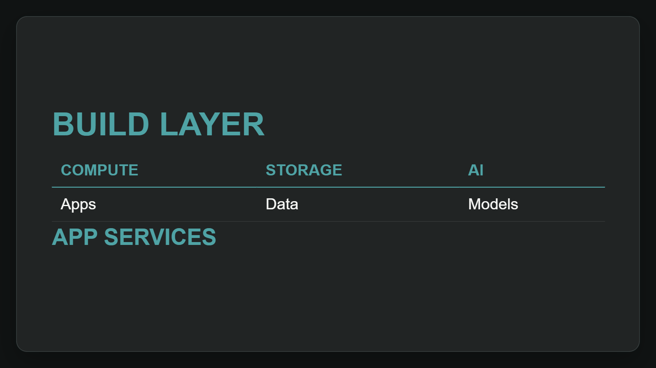

4. Copilot assists workflows
Treat Copilot as AI assistance that sits inside selected workflows and licenses. Confirm access, grounding, service availability and subscription before commitments.

Claims
Copilot Chat provides AI assistance to eligible Microsoft 365 users for information, content and tasks.
Copilot capability and grounding depend on access point, service capacity and Microsoft 365 Copilot licensing.

Speaker notes
Evidence: Copilot Chat helps eligible users find information, create content and complete tasks; grounding depends on access point and licensing. Interpretation: confirm entitlement before rollout.

Assets and alt text
visual-copilot-layer: Copilot decisions need entitlement and grounding checks before commitments. (marp diagram)
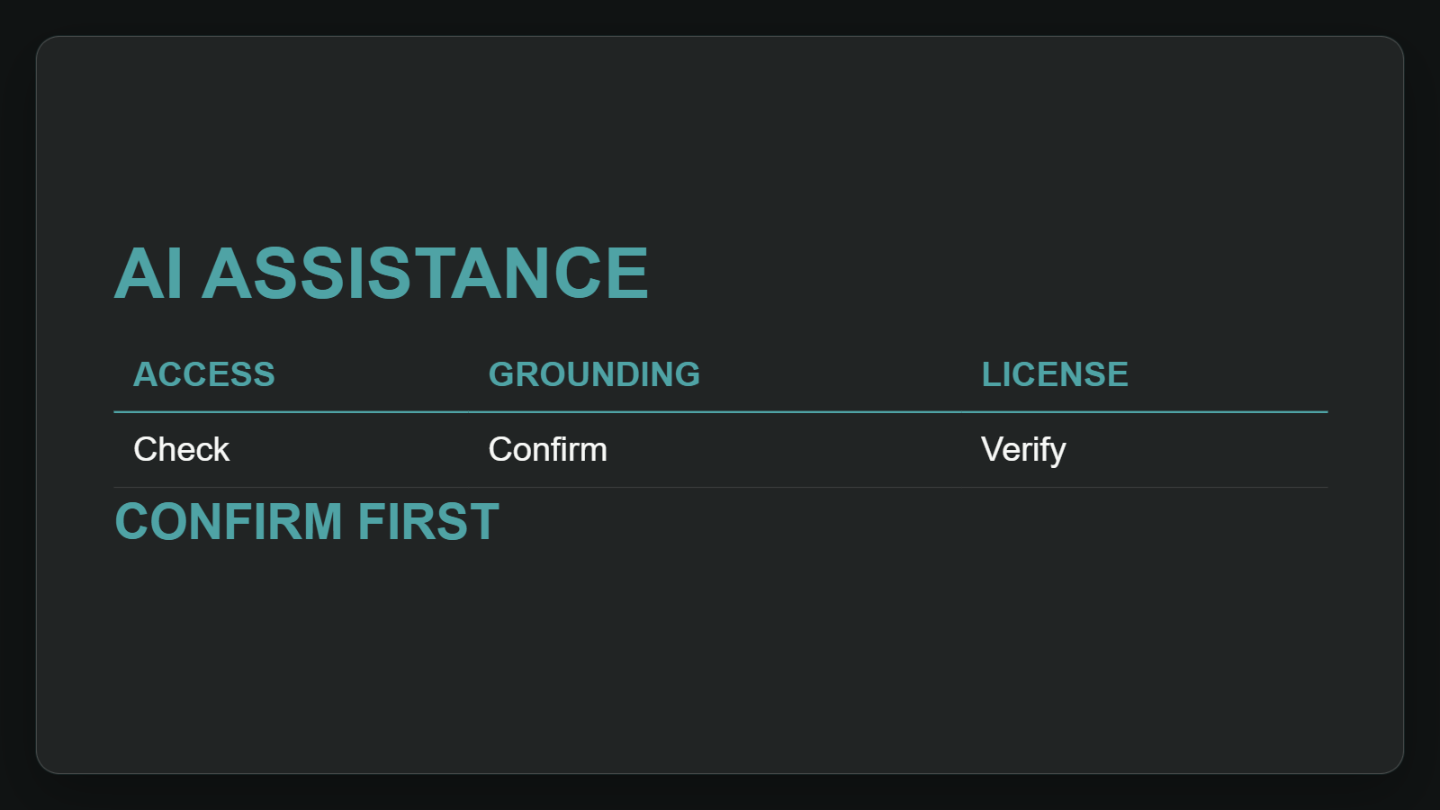

Citations
[ev-01, ev-02] Windows 11 overview for administrators | Microsoft Learn (retrieved 2026-10-06T20:19:06.862Z)
[ev-03, ev-04] Microsoft 365 for enterprise overview - Microsoft 365 Enterprise | Microsoft Learn (retrieved 2026-10-06T20:18:34.313Z)
[ev-05, ev-06] Azure documentation | Microsoft Learn (retrieved 2026-10-06T20:18:00.053Z)
[ev-07, ev-08, ev-09, ev-10] Overview of Microsoft Copilot Chat | Microsoft Learn (retrieved 2026-10-06T20:16:50.269Z)

