Copilot Studio 2026: govern intent-to-action agents

Contents
Executive Summary
1. Managed build surface
2. Orchestrate choices
3. Tools execute work
4. Govern the platform
Citations

Executive Summary
Bottom line: use Copilot Studio as a governed agent platform, moving from business intent to useful action while funding workflows that merit scale, with rigor.
Audience: Executive decision-makers
Decision: Fund governed agent scale where workflows merit managed automation.

Narration
Bottom line: use Copilot Studio as a governed agent platform, moving from business intent to useful action while funding workflows that merit scale, with rigor.
Copilot Studio is a low-code studio for building and managing agents. Teams create agents, workflows and agent flows tied to business data, systems and work channels.
Generative orchestration is the decision layer. It lets an agent choose topics, tools, knowledge or other agents, ask for missing input, and then compose the response.
Tools are where intent turns into action. Govern connectors, agent flows, prompts, REST APIs, MCP and computer use for both modern apps and legacy screens under policy.
Scale only with enterprise controls attached. Data policies, audit logs, Agent 365, Entra identities, spend controls and evaluations keep the platform managed at scale.

1. Managed build surface
Copilot Studio is a low-code studio for building and managing agents. Teams create agents, workflows and agent flows tied to business data, systems and work channels.

Claims
Copilot Studio is a low-code studio for agents, workflows and agent flows that connect to business data and publish to work channels.
Executives should treat Copilot Studio as a managed agent platform with monitoring, governance, evaluations, administration and policy gates.

Speaker notes
Evidence: Microsoft Learn overview retrieved through project intake. Interpretation: frame the executive decision as governed platform adoption, not isolated bot creation.

Assets and alt text
visual-managed-build: The studio connects business data and systems to workplace channels through managed agents and workflows. (mermaid diagram)
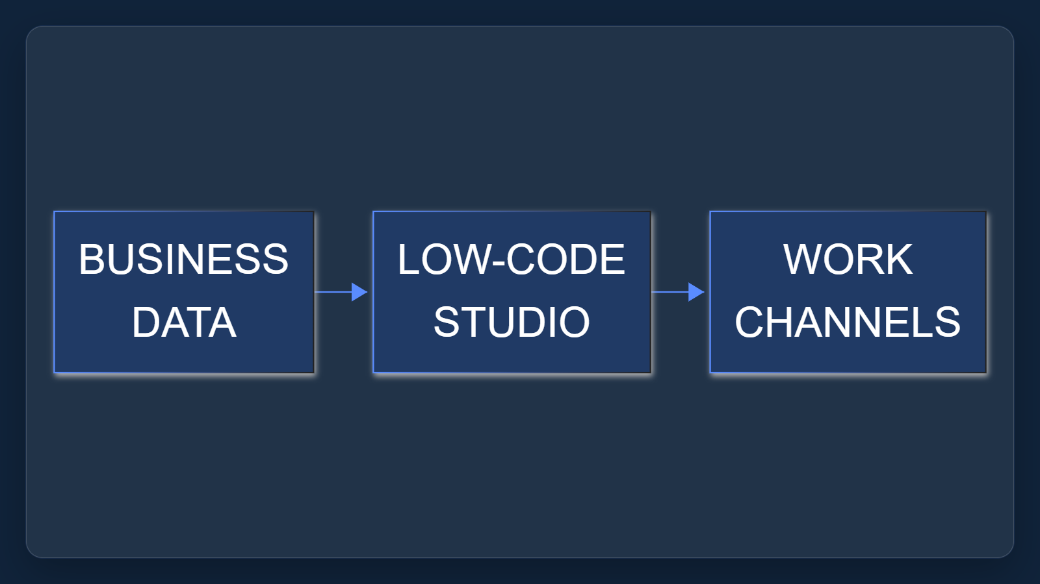

2. Orchestrate choices
Generative orchestration is the decision layer. It lets an agent choose topics, tools, knowledge or other agents, ask for missing input, and then compose the response.

Claims
Generative orchestration lets agents choose tools, knowledge, topics or other agents, ask for missing inputs and compose responses.

Speaker notes
Evidence: orchestration documentation states the default for new standard-harness agents and the selection behavior. Interpretation: descriptions become operating metadata.

Assets and alt text
visual-orchestrate-choices: A readable routing model: one request can route to knowledge, tools, topics or other agents. (excalidraw diagram)
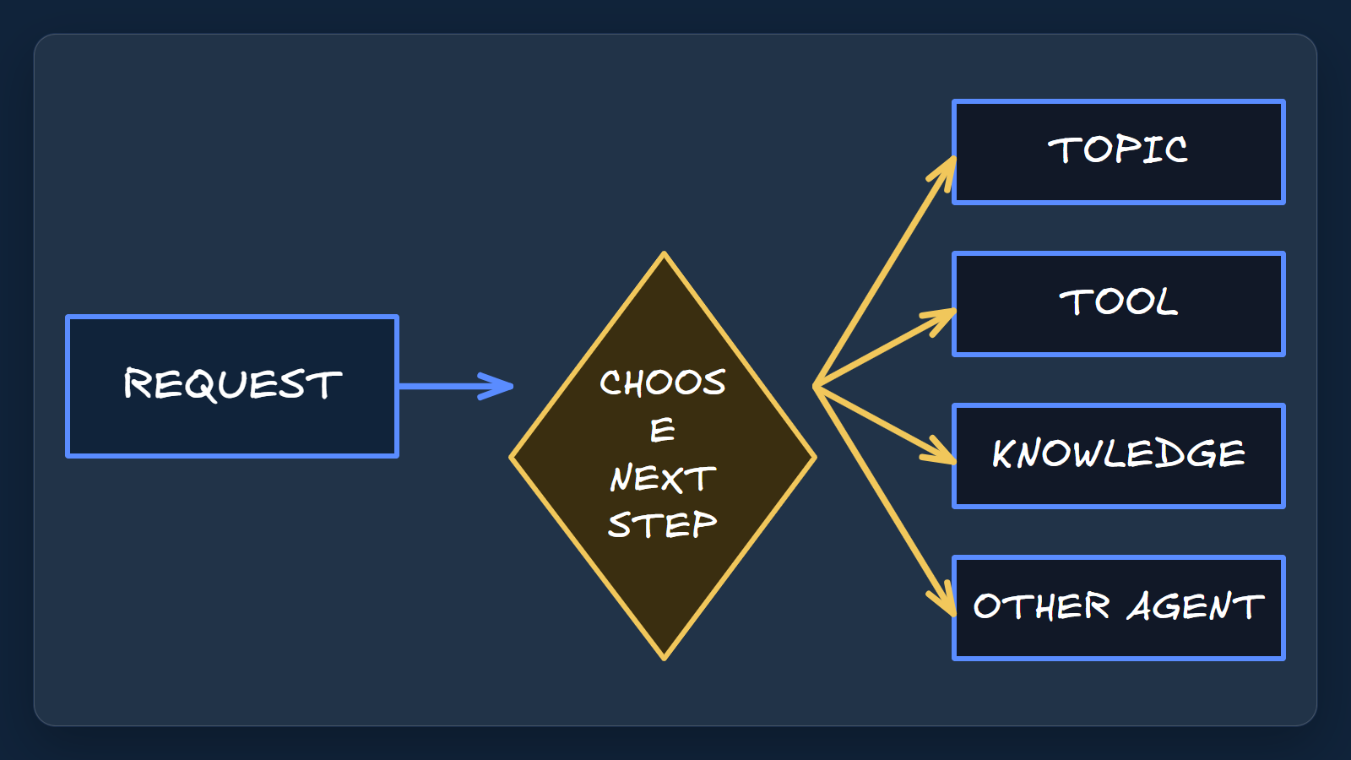

3. Tools execute work
Tools are where intent turns into action. Govern connectors, agent flows, prompts, REST APIs, MCP and computer use for both modern apps and legacy screens under policy.

Claims
Tools move intent to action through connectors, agent flows, prompts, REST APIs, MCP and computer use, with policy restrictions available.

Speaker notes
Evidence: the tools article lists the supported tool mechanisms and notes governance policies can restrict tools and connectors. Interpretation: action reach needs portfolio policy.

Assets and alt text
visual-tools-execute: Tool routes convert intent into action, but each route should be governed before scale. (marp diagram)
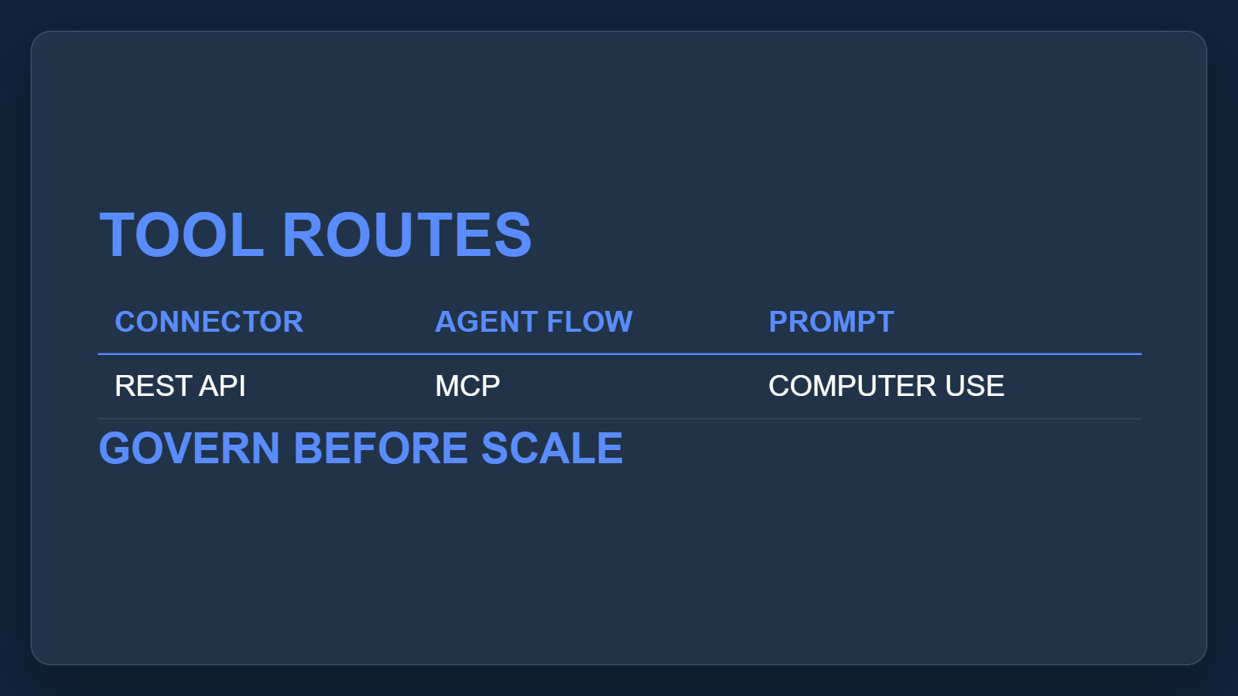

4. Govern the platform
Scale only with enterprise controls attached. Data policies, audit logs, Agent 365, Entra identities, spend controls and evaluations keep the platform managed at scale.

Claims
Enterprise control includes data policies, audit visibility, Agent 365 governance, Entra agent identities and security controls.
Executives should treat Copilot Studio as a managed agent platform with monitoring, governance, evaluations, administration and policy gates.

Speaker notes
Evidence: governance documentation covers data policies, audit visibility, Agent 365 and Entra identities; overview covers evaluations and administration. Interpretation: fund platform operating controls with use-case rollout.

Assets and alt text
visual-govern-platform: A control board keeps scale tied to identity, policy, audit, cost and quality evidence. (marp diagram)
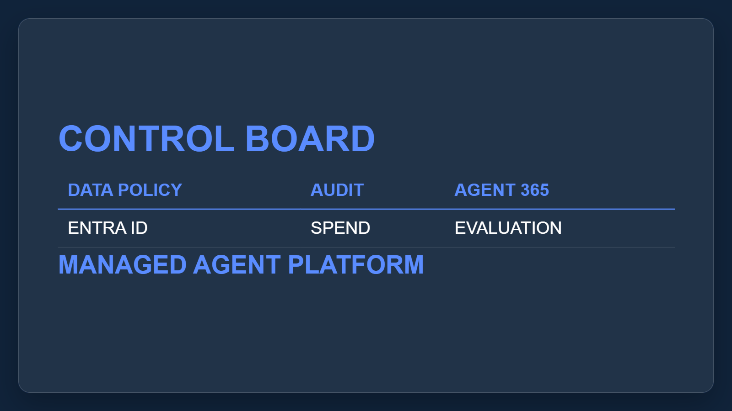

Citations
[ev-01, ev-02, ev-03, ev-14, ev-15] Overview - Microsoft Copilot Studio (retrieved 2026-10-06T20:16:38.547Z)
[ev-04, ev-05, ev-06] Orchestrate agent behavior with generative AI (retrieved 2026-10-06T20:16:38.738Z)
[ev-07, ev-08, ev-09] Add tools to custom agents (retrieved 2026-10-06T20:16:38.897Z)
[ev-10, ev-11, ev-12, ev-13] Security and governance (retrieved 2026-10-06T20:16:39.025Z)

