Power Platform ALM: govern one release path

Contents
Executive Summary
1. One platform
2. Managed artifact
3. Config and data
4. Release gate
Citations

Executive Summary
Bottom line: use one ALM path; ship a managed artifact, set target config, move data apart, and do DLP, test, license and approval checks before final go-live.
Audience: Executive decision-makers
Decision: Fund one governed ALM path; ship managed artifacts and move data separately.

Narration
Bottom line: use one ALM path; ship a managed artifact, set target config, move data apart, and do DLP, test, license and approval checks before final go-live.
Treat the suite as one platform for apps, flows, sites, agents and Dataverse data. Put lifecycle, security, test and release choices in one clear decision frame.
Build change in an unmanaged solution, with source control as the source of truth. Export a managed solution as the build artifact that test and production receive.
Keep configuration and business records on separate tracks. Set connections, references and variables per target, then migrate table rows, because solutions carry no data.
Automate with pipelines, or use Azure DevOps or GitHub when the route needs it. Before final production, check DLP policy, tests, analytics, approvals and licenses.

1. One platform
Treat the suite as one platform for apps, flows, sites, agents and Dataverse data. Put lifecycle, security, test and release choices in one clear decision frame.

Claims
Power Platform ALM spans apps, automation, sites, agents and Dataverse; executives should manage it as one governed delivery path.

Speaker notes
Evidence: ALM scope includes Power Apps, Power Automate, Power Pages, Copilot Studio and Dataverse, with governance, testing and release management as ALM disciplines. Interpretation: executives should avoid treating each workload as an isolated release path.

Assets and alt text
visual-one-platform: The decision frame is one governed ALM path across the Power Platform suite. (mermaid diagram)
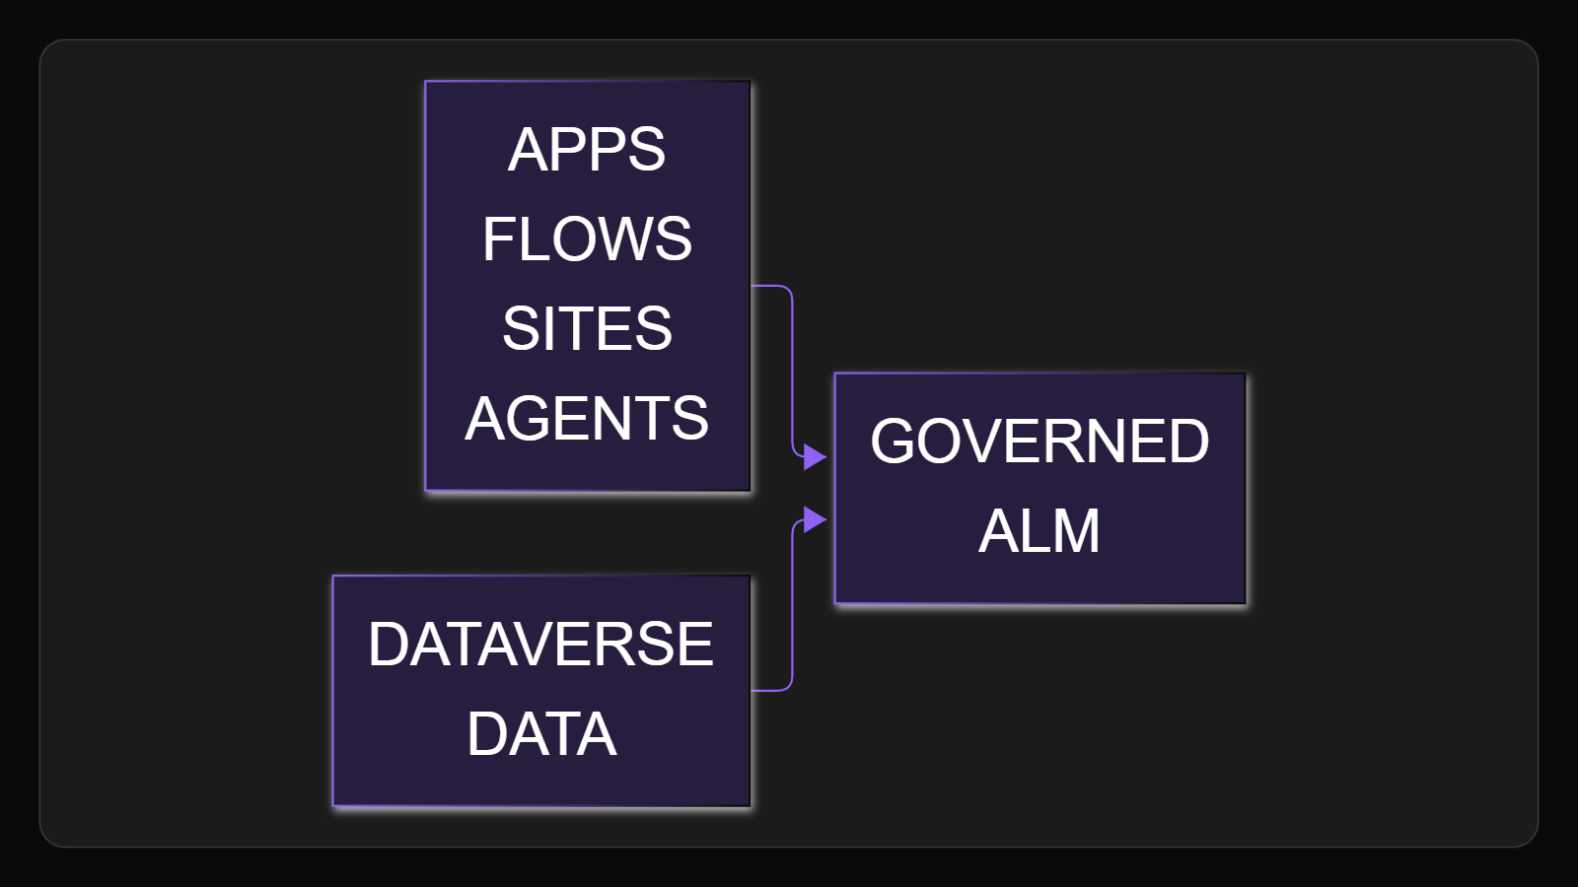

2. Managed artifact
Build change in an unmanaged solution, with source control as the source of truth. Export a managed solution as the build artifact that test and production receive.

Claims
Use source control as truth, build changes in unmanaged solutions, and export managed solutions as downstream build artifacts.

Speaker notes
Evidence: Microsoft Learn states source control should be the source of truth, unmanaged solutions are for development, and managed exports are build artifacts. Interpretation: test and production should receive the managed package, not ad hoc maker changes.

Assets and alt text
visual-managed-artifact: Development remains editable, while the promoted package becomes the controlled artifact. (excalidraw diagram)
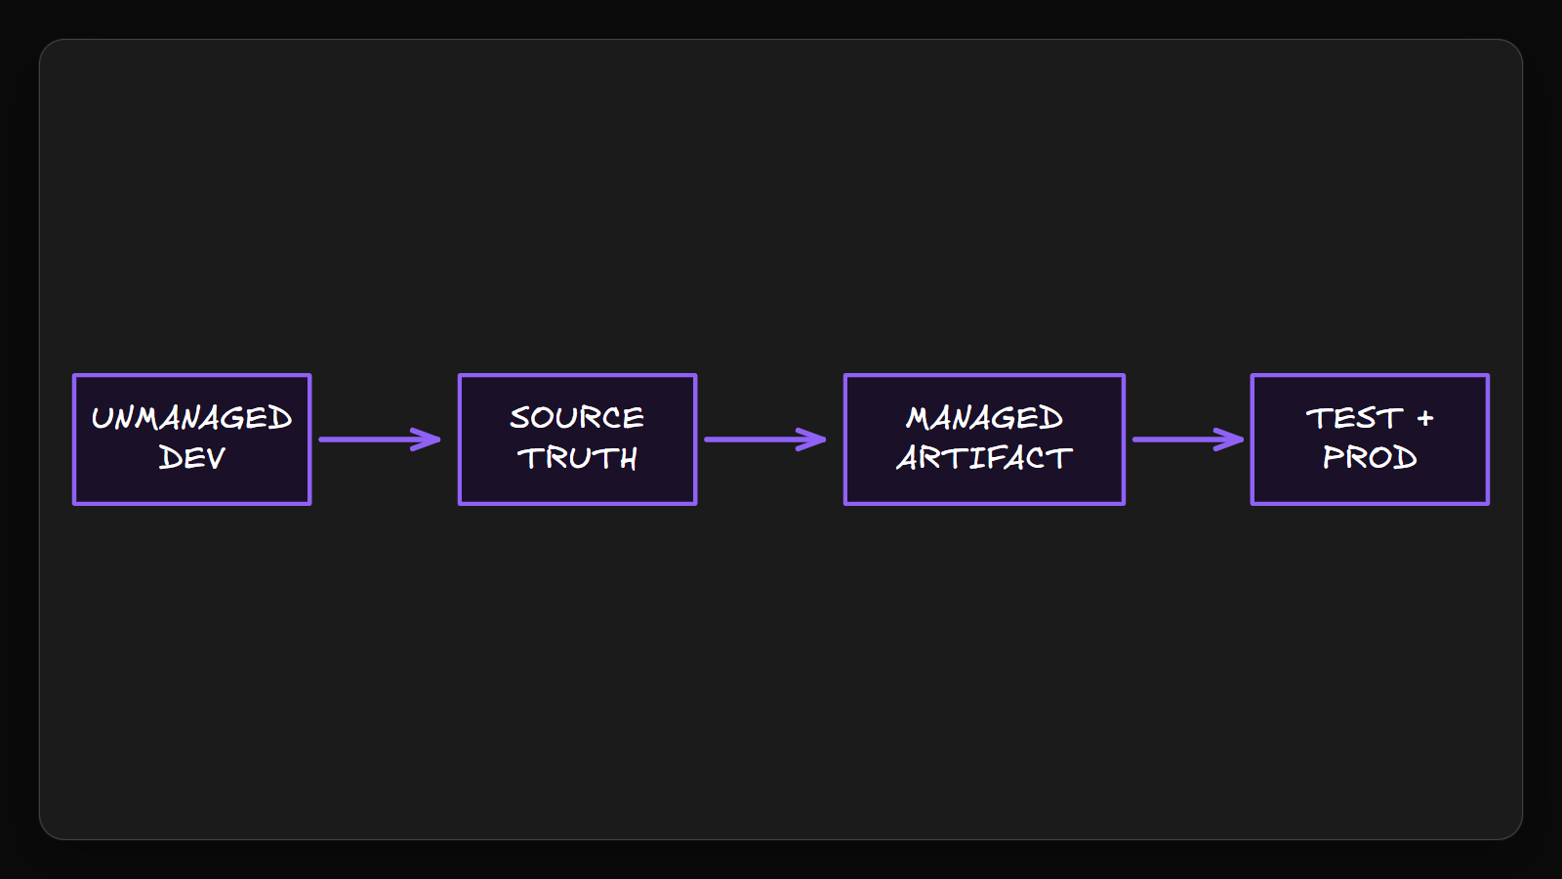

3. Config and data
Keep configuration and business records on separate tracks. Set connections, references and variables per target, then migrate table rows, because solutions carry no data.

Claims
Promote the same artifact through ordered stages; configure each target, and move Dataverse table records separately.

Speaker notes
Evidence: pipelines deploy solution configuration such as connections, connection references and environment variables, while solutions do not contain Dataverse table data. Interpretation: deployment and data migration should be separately planned and validated.

Assets and alt text
visual-config-and-data: Configuration travels with deployment; Dataverse table records need a separate path. (marp diagram)
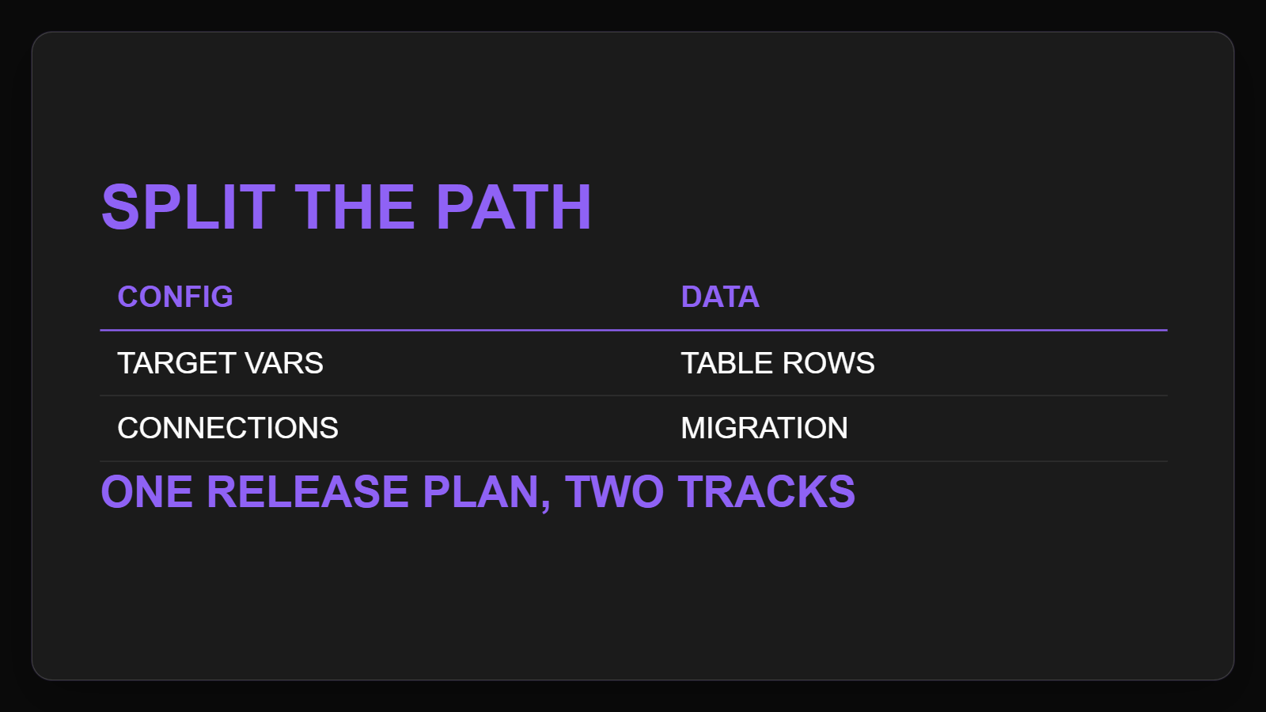

4. Release gate
Automate with pipelines, or use Azure DevOps or GitHub when the route needs it. Before final production, check DLP policy, tests, analytics, approvals and licenses.

Claims
Automate delivery with pipelines and CI/CD; Microsoft documentation points to Azure DevOps or GitHub for some scenarios.
Before production, check DLP connector controls, tests, analytics, approvals and managed-environment licensing.

Speaker notes
Evidence: sources cite automated pipelines, Azure DevOps CI/CD, GitHub for some scenarios, DLP connector controls, pipeline analytics, approval controls and managed-environment licensing. Interpretation: automation speeds promotion but should not bypass release governance.

Assets and alt text
visual-release-gate: Automation accelerates delivery only after the release gate is satisfied. (mermaid diagram)
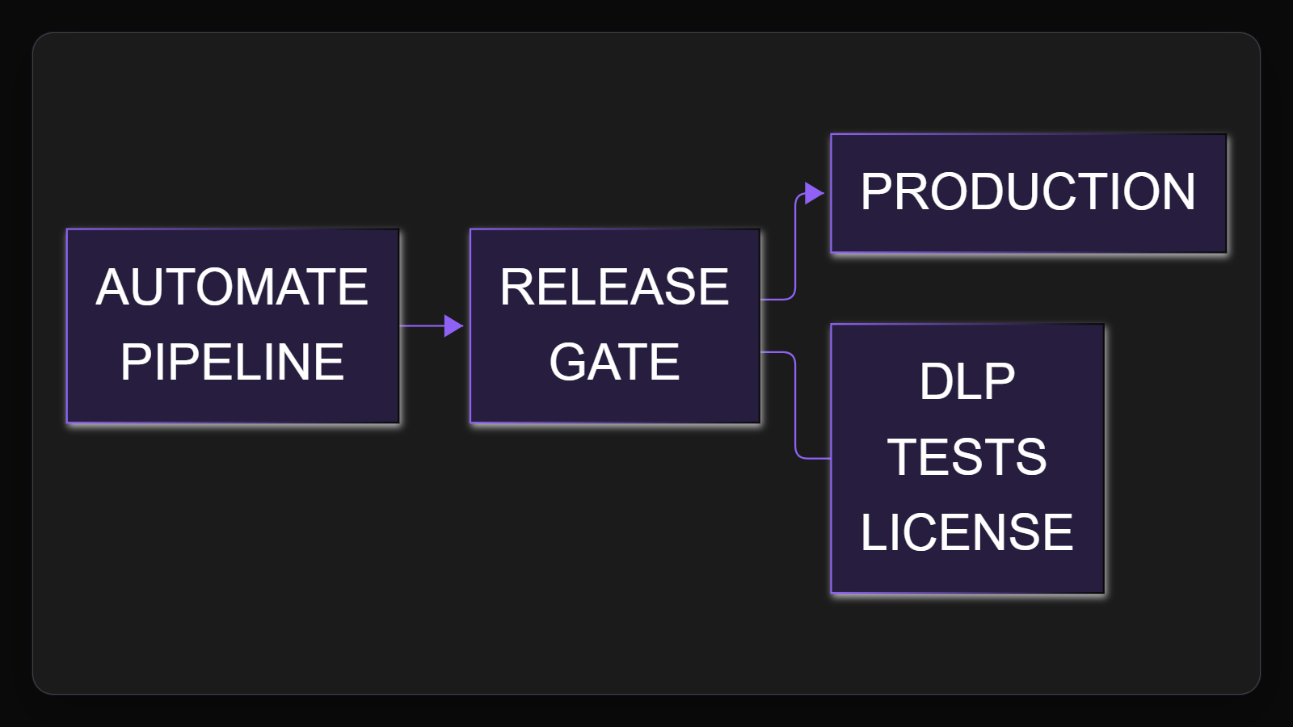

Citations
[ev-01, ev-02, ev-03, ev-04] Overview of application lifecycle management with Microsoft Power Platform (retrieved 2026-10-06T20:16:28.682Z)
[ev-05, ev-06, ev-07] Solution concepts (retrieved 2026-10-06T20:16:28.824Z)
[ev-09, ev-10, ev-11, ev-12, ev-08, ev-13, ev-14, ev-15] Overview of pipelines in Power Platform (retrieved 2026-10-06T20:16:28.991Z)
[ev-16, ev-17] Data policies (retrieved 2026-10-06T20:16:29.158Z)

