Agent 365: pilot the control plane first

Contents
Executive Summary
1. Name the control plane
2. Observe traced work
3. Govern and secure access
4. Pilot before expansion
Citations

Executive Summary
Bottom line: use Agent 365 as the control plane for one accountable pilot; verify ownership, access, action traces, licenses, and preview limits before scaling.
Audience: Executive decision-makers
Decision: Pilot one accountable agent before scaling governance.

Narration
Bottom line: use Agent 365 as the control plane for one accountable pilot; verify ownership, access, action traces, licenses, and preview limits before scaling.
Agent 365 is the control plane for AI agents. Ask who owns each one, where it runs, what it can reach, who it affects, and what risk needs action.
Observe with a registry, activity, and health first. Add telemetry so each request, model step, tool call, and error has a trace for operators, not guesswork.
Govern and secure access as one path. Pair lifecycle review, Entra controls, Purview data checks, and Defender signals for every agent before wider rollout.
Keep the current agent and add only needed SDK pieces. Pilot one owned use case, verify licenses and preview limits, then scale only from evidence and review.

1. Name the control plane
Agent 365 is the control plane for AI agents. Ask who owns each one, where it runs, what it can reach, who it affects, and what risk needs action.

Claims
Agent 365 is a centralized control plane for observing, governing, and securing AI agents.
A pilot must verify prerequisites, licenses, preview limits, and telemetry before scaling.

Speaker notes
Evidence: service description calls Agent 365 a centralized control plane; overview states observe, govern, and secure. Interpretation: ownership and access questions make the pilot accountable.

Assets and alt text
visual-control-plane: Frame the pilot with ownership, access, and traceability before scale. (mermaid diagram)
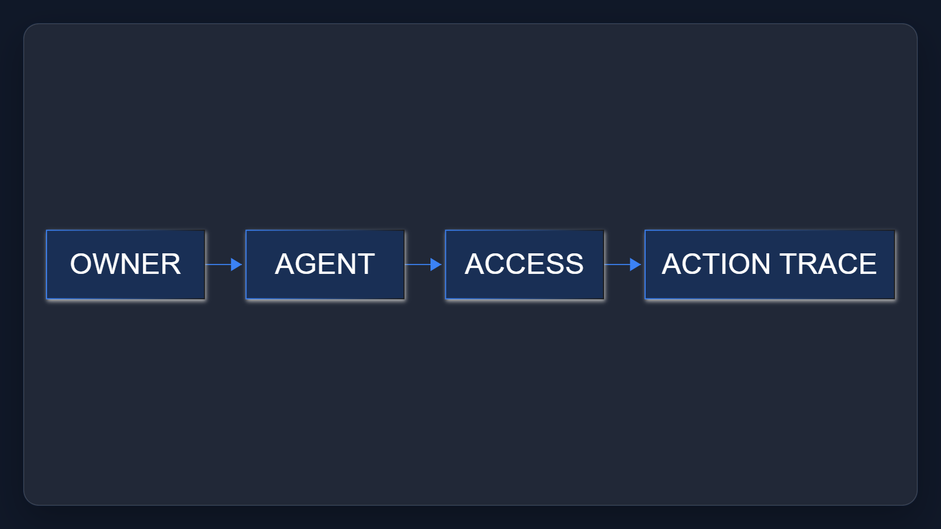

2. Observe traced work
Observe with a registry, activity, and health first. Add telemetry so each request, model step, tool call, and error has a trace for operators, not guesswork.

Claims
Observation should pair agent inventory with audited traces for interactions, inference events, and tool usage.

Speaker notes
Evidence: overview describes real-time visibility into the agentic environment; SDK guidance describes audited, traceable interactions, inference events, and tool usage.

Assets and alt text
visual-observe-traces: Inventory plus telemetry turns agent activity into traceable evidence. (excalidraw diagram)
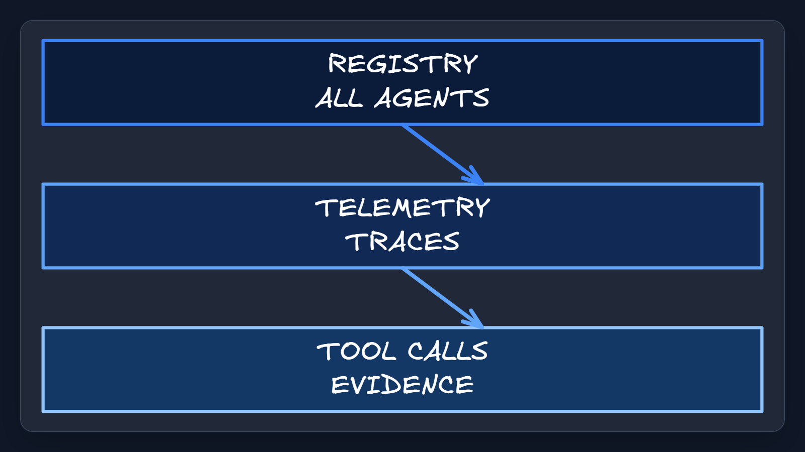

3. Govern and secure access
Govern and secure access as one path. Pair lifecycle review, Entra controls, Purview data checks, and Defender signals for every agent before wider rollout.

Claims
Governance and security connect lifecycle controls, Entra permissions, Purview protection, and Defender detection.

Speaker notes
Evidence: overview connects registry, Microsoft 365 admin center, Entra, and Purview with lifecycle and permissions; the secure section identifies Defender threat detection.

Assets and alt text
visual-govern-secure: Use the Microsoft control stack as one governed access path. (marp diagram)
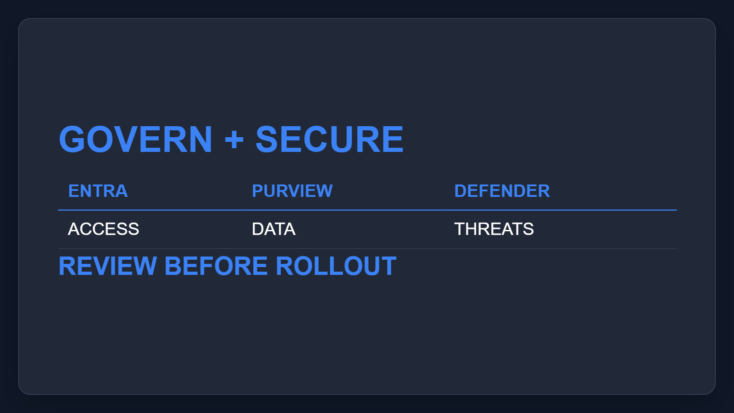

4. Pilot before expansion
Keep the current agent and add only needed SDK pieces. Pilot one owned use case, verify licenses and preview limits, then scale only from evidence and review.

Claims
SDK integration extends existing agents with enterprise capabilities without creating or hosting the agent.
A pilot must verify prerequisites, licenses, preview limits, and telemetry before scaling.

Speaker notes
Evidence: the SDK extends existing agents without creating or hosting them. The quickstart and service description make validation, assigned licenses, preview status, and plan availability explicit checks.

Assets and alt text
visual-accountable-pilot: Start small, prove the controls, and expand only from evidence. (mermaid diagram)
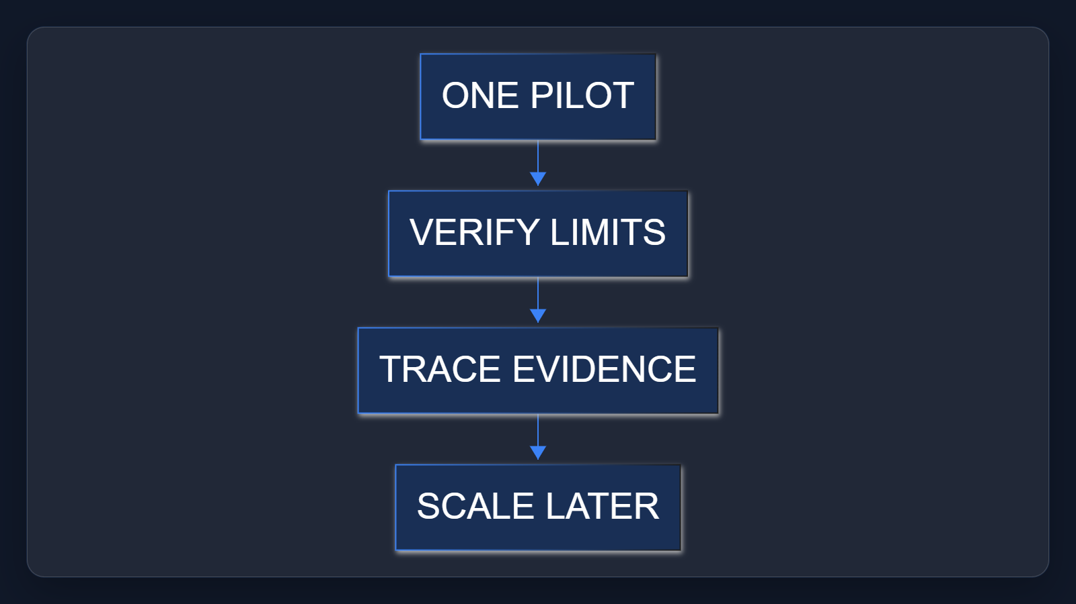

Citations
[ev-01, ev-12] Microsoft Agent 365 - Service Descriptions (retrieved 2026-10-06T20:16:49.112Z)
[ev-02, ev-03, ev-05, ev-06] Microsoft Agent 365 overview (retrieved 2026-10-06T20:16:48.334Z)
[ev-04, ev-07, ev-08] Microsoft Agent 365 SDK and CLI (retrieved 2026-10-06T20:16:48.694Z)
[ev-09, ev-10, ev-11] Quickstart: Connect an Existing Agent to Agent 365 (retrieved 2026-10-06T20:16:49.394Z)

