Datadog for Claude Cowork. Observability by conversation.

Contents
Executive Summary
A bridge. Not a dashboard.
Where it runs. Cowork and Claude Code.
Set up. Pick a site, sign in.
Access. Your permissions still apply.
Control. Choose the toolsets.
Risk. Preview, compliance, site limits.
Citations

Executive Summary
The Datadog plugin and connector let Claude query Datadog logs, metrics, traces, dashboards and monitors through the Datadog MCP Server.
Audience: Platform and SRE engineers
Decision: Pilot the Datadog connector with one team, keep Datadog permissions scoped, and treat the Preview status as a rollout risk.

Narration
Datadog for Claude Cowork. Your telemetry, one question away. Here is what the plugin does, how it connects, and where a team should be careful.
The Datadog Model Context Protocol server bridges your observability data to agents. Logs, metrics, traces, dashboards, and monitors become things you can simply ask about.
For Claude, including Cowork, the official connector is the recommended path, and it adds in-product visualizations. Claude Code installs the same server as a plugin from the official marketplace.
Setup is short. Choose your Datadog site, then sign in with OAuth in the browser. Keys are an alternative, and any older manual server or custom connector should be removed first.
Access is not widened. You still need the Datadog permissions for the data you query, and the plugin states that no Datadog credentials are sent to the model provider.
Tool groups can be switched on or off, so a team can expose only the products it needs. Start with one narrow toolset.
Treat the preview label as a rollout risk. The server is HIPAA eligible, yet you own compliance for the tools you connect, and government sites are not supported. Pilot with one team, keep permissions tight, then expand.

A bridge. Not a dashboard.
The Datadog MCP Server links your observability data to any agent that speaks the Model Context Protocol, so you ask instead of clicking through screens.

Claims
The Datadog MCP Server bridges Datadog observability data to AI agents, so logs, metrics, traces, dashboards and monitors can be queried in natural language.

Speaker notes
Explain that the plugin is a bridge to Datadog data for MCP agents.

Assets and alt text
visual-what-it-is: Datadog data reaches an MCP-capable agent through the Datadog MCP Server. (mermaid diagram)
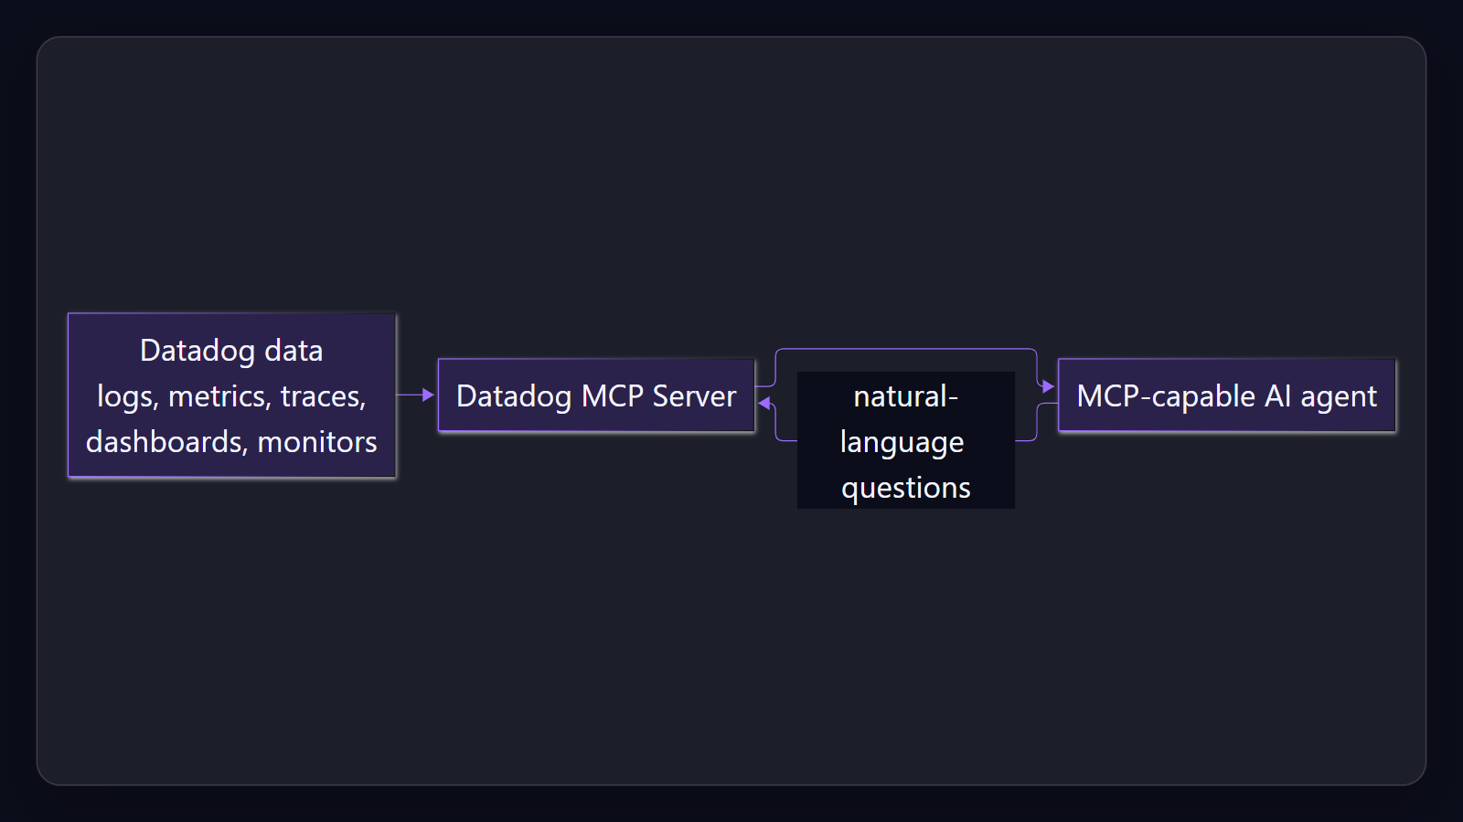

Where it runs. Cowork and Claude Code.
Claude, including Cowork, uses the official connector. Claude Code installs the plugin from the official Anthropic marketplace.

Claims
For Claude, including Claude Cowork, the official Datadog connector is the recommended path and includes MCP Apps for in-product visualizations.
Claude Code installs the Datadog plugin from the official Anthropic Plugin Marketplace; the plugin bundles the MCP Server with skills and auto-updates.

Speaker notes
Show the path from Datadog data to the team through the connector or plugin.

Assets and alt text
mcp-flow: Four-step flow: Datadog data, MCP server, Claude connector or plugin, your team, with existing permissions applying at each step.
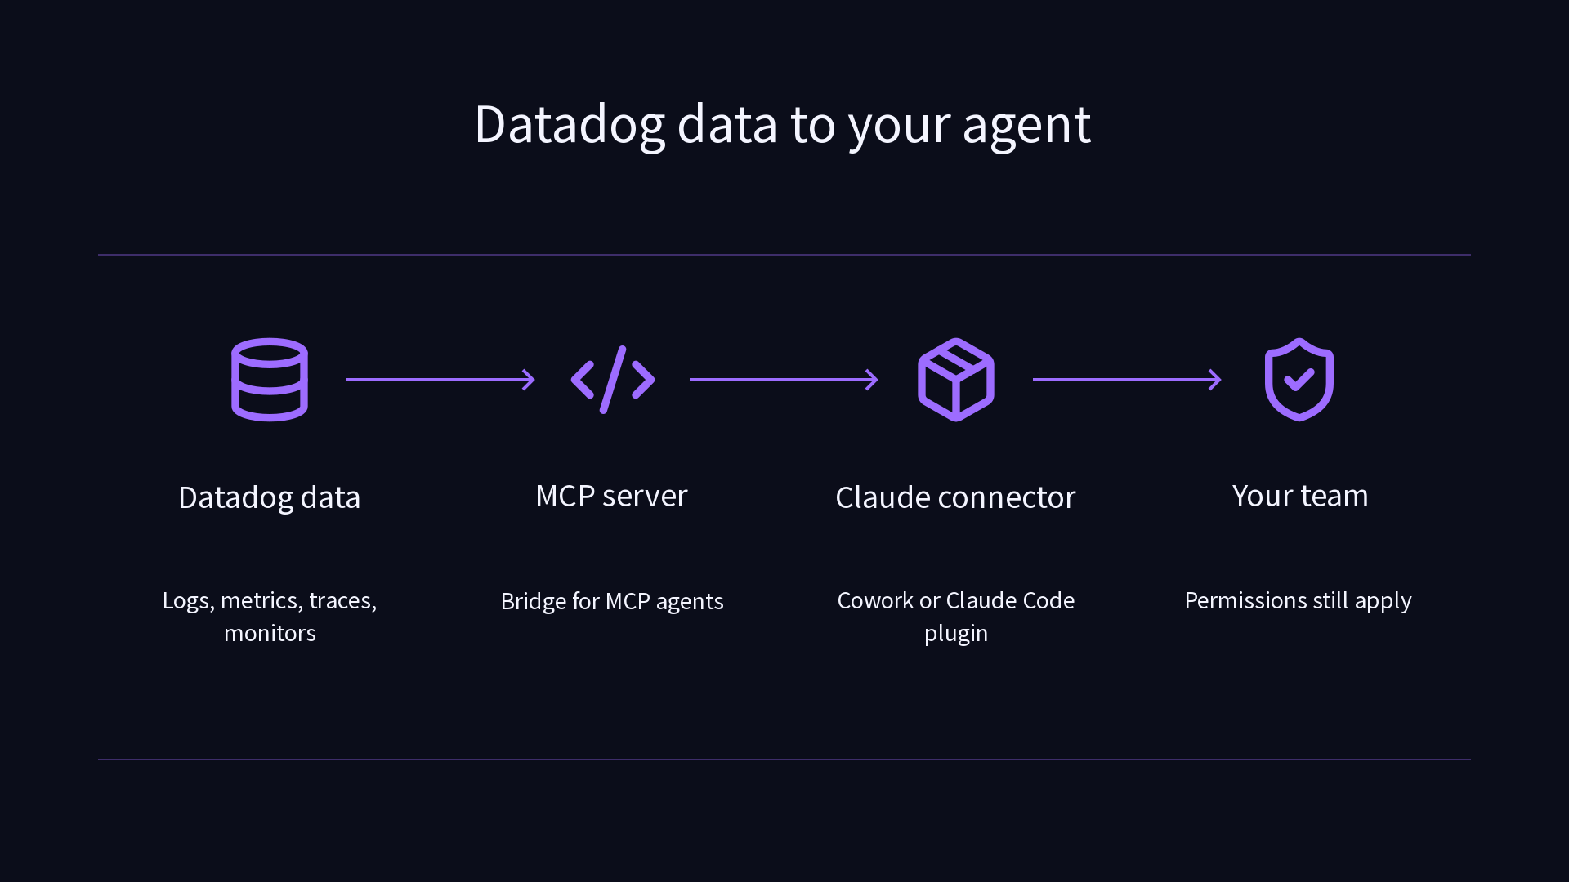

Set up. Pick a site, sign in.
Choose your Datadog site and sign in with OAuth. Keys are supported, and older manual servers or custom connectors should be removed first.

Claims
Setup asks you to choose a Datadog site and sign in with OAuth in the browser; API and application keys are a supported alternative.
Remove any separately registered Datadog MCP server or custom connector first to avoid conflicts.

Speaker notes
Walk through the guided setup and the conflict warning.

Assets and alt text
visual-setup: Setup order: clear conflicts, install, choose a site, sign in. (mermaid diagram)
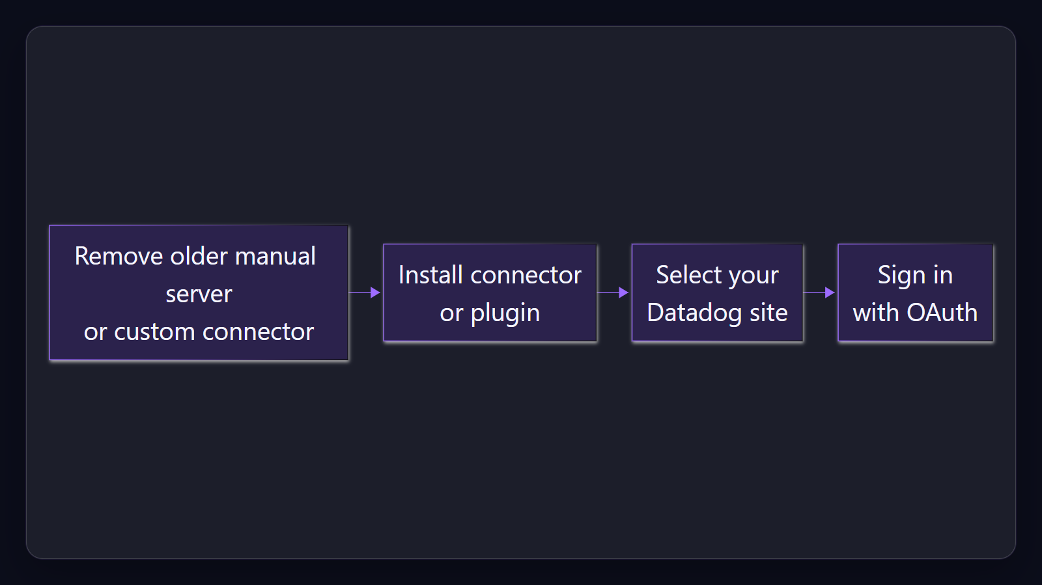

Access. Your permissions still apply.
You need Datadog permissions for the resources you query, and no Datadog credentials are sent to the model provider.

Claims
You need Datadog permissions for the resources you query, and the plugin states that no Datadog credentials are sent to the AI model provider.

Speaker notes
Stress that the plugin does not widen access.

Assets and alt text
visual-access: Your Datadog permissions apply; no Datadog credentials go to the model provider. (excalidraw diagram)
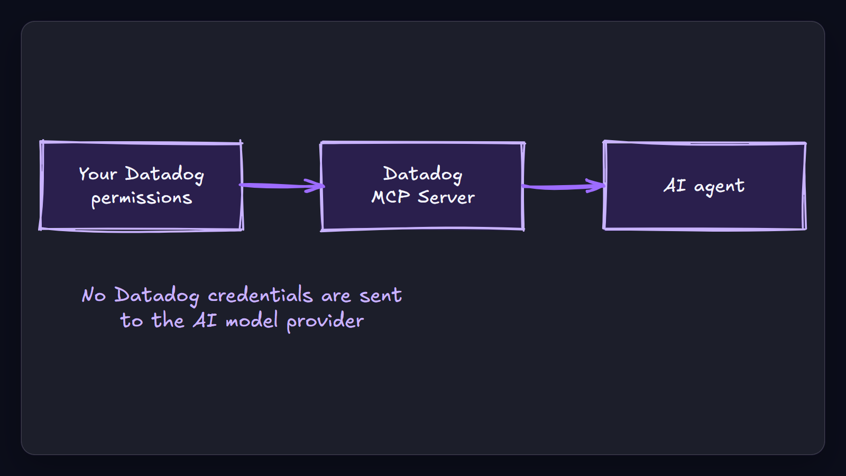

Control. Choose the toolsets.
Enable or disable groups of MCP tools so the agent sees only the Datadog products your team needs.

Claims
Groups of MCP tools can be enabled or disabled with the toolsets command.

Speaker notes
Recommend starting with one narrow toolset.

Risk. Preview, compliance, site limits.
The plugin is in Preview. The server is HIPAA-eligible, but you own compliance for connected tools, and the government sites are unsupported.

Claims
The Datadog plugin and its marketplace listing are in Preview.
The Datadog MCP Server is HIPAA-eligible, customers remain responsible for the compliance of the AI tools they connect, and the server is not supported on the Datadog government sites.

Speaker notes
Close with the pilot recommendation and the preview caveat.

Assets and alt text
visual-risk: Rollout checklist: Preview status, compliance ownership and supported sites. (marp diagram)
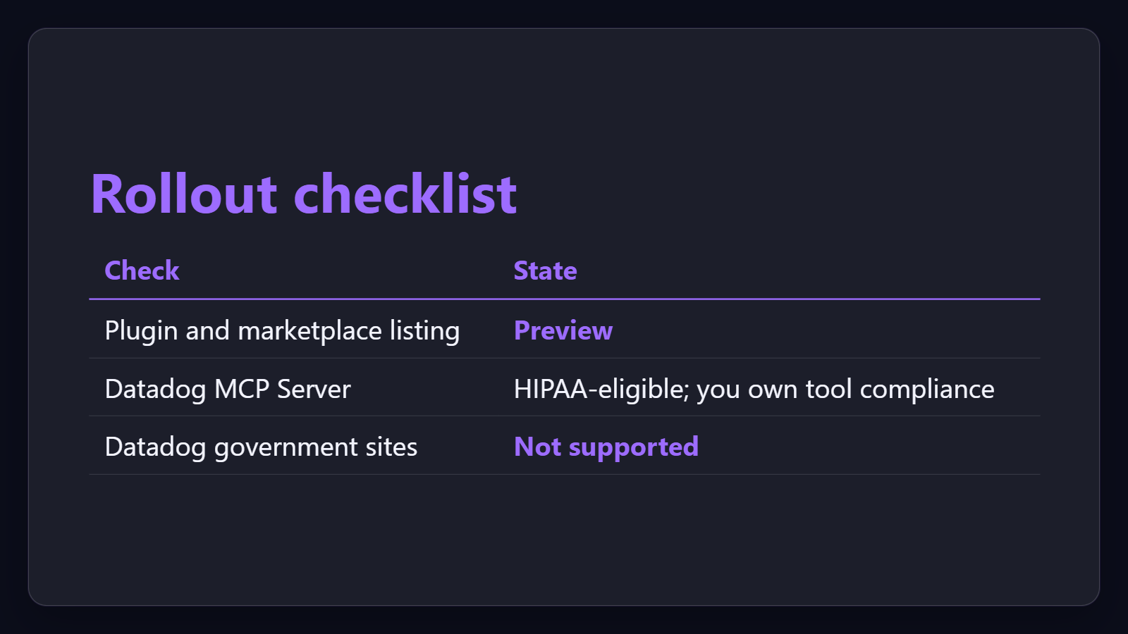

Citations
Datadog MCP Server (2026-09-29T17:00:00Z)
Datadog Claude Code Plugin (2026-09-29T17:00:00Z)
Datadog Claude Code Plugin (2026-09-29T17:00:00Z)
Datadog | Claude by Anthropic (2026-09-29T17:00:00Z)
Set Up the Datadog MCP Server (2026-09-29T17:00:00Z)
Set Up the Datadog MCP Server (2026-09-29T17:00:00Z)
Set Up the Datadog MCP Server (2026-09-29T17:00:00Z)
Datadog Claude Code Plugin (2026-09-29T17:00:00Z)
Datadog Claude Code Plugin (2026-09-29T17:00:00Z)
Set Up the Datadog MCP Server (2026-09-29T17:00:00Z)
Datadog Claude Code Plugin (2026-09-29T17:00:00Z)
Datadog MCP Server (2026-09-29T17:00:00Z)
Set Up the Datadog MCP Server (2026-09-29T17:00:00Z)
Datadog Claude Code Plugin (2026-09-29T17:00:00Z)
Set Up the Datadog MCP Server (2026-09-29T17:00:00Z)

