Copilot: choose the right AI assistant for the job

Contents
Executive Summary
1. Choose by job
2. Govern access
3. Separate builders
4. Run decision checks
Citations

Executive Summary
Bottom line: Copilot is a family, not one tool; choose Chat, Microsoft 365, GitHub, or Studio by job, then verify access, licensing, and grounding.
Audience: Executive decision-makers
Decision: Choose by job; verify access, licensing, grounding, and output scope.

Narration
Bottom line: Copilot is a family, not one tool; choose Chat, Microsoft 365, GitHub, or Studio by job, then verify access, licensing, and grounding.
Copilot Chat fits research and drafting. It can summarize web information, rewrite content, analyze files, create images, use agents, and ask supported work questions.
Microsoft 365 Copilot brings AI into work apps. Grounding, user permissions, compliance controls and license level shape what it can answer for each person.
GitHub Copilot fits coding workflows in developer tools. Copilot Studio builds agents and workflows connected to organizational data, systems, and channels for teams.
Make the decision after the fit is clear. Check permissions, license tier, and grounding so leaders know what each output can and cannot use in practice.

1. Choose by job
Copilot Chat fits research and drafting. It can summarize web information, rewrite content, analyze files, create images, use agents, and ask supported work questions.

Claims
Copilot Chat supports research, content generation, file analysis, images, agents, and supported organizational questions.
The executive choice is job first, then access, licensing, grounding, and output scope.

Speaker notes
Evidence: ev-01 lists Copilot Chat research, generation, file analysis, images, agents, and supported organizational questions. Interpretation: make the task the first routing filter.

Assets and alt text
visual-choose-by-job: Route Copilot choices by the job the leader needs done. (mermaid diagram)
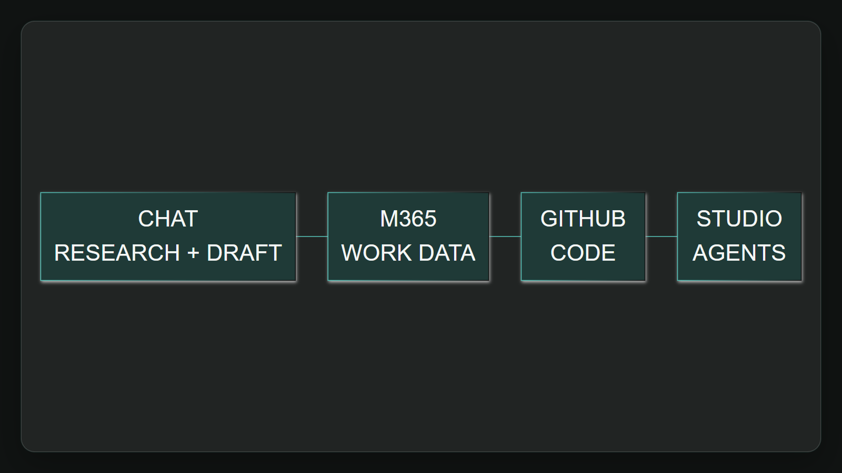

2. Govern access
Microsoft 365 Copilot brings AI into work apps. Grounding, user permissions, compliance controls and license level shape what it can answer for each person.

Claims
Microsoft 365 Copilot is shaped by organizational grounding, user permissions, compliance controls, work-app access, and license level.
The executive choice is job first, then access, licensing, grounding, and output scope.

Speaker notes
Evidence: ev-03 documents grounding, organizational data, user permissions, and compliance; ev-04 ties the full work-app experience to the Microsoft 365 Copilot add-on license.

Assets and alt text
visual-govern-access: Access governance makes the permitted information boundary explicit. (excalidraw diagram)
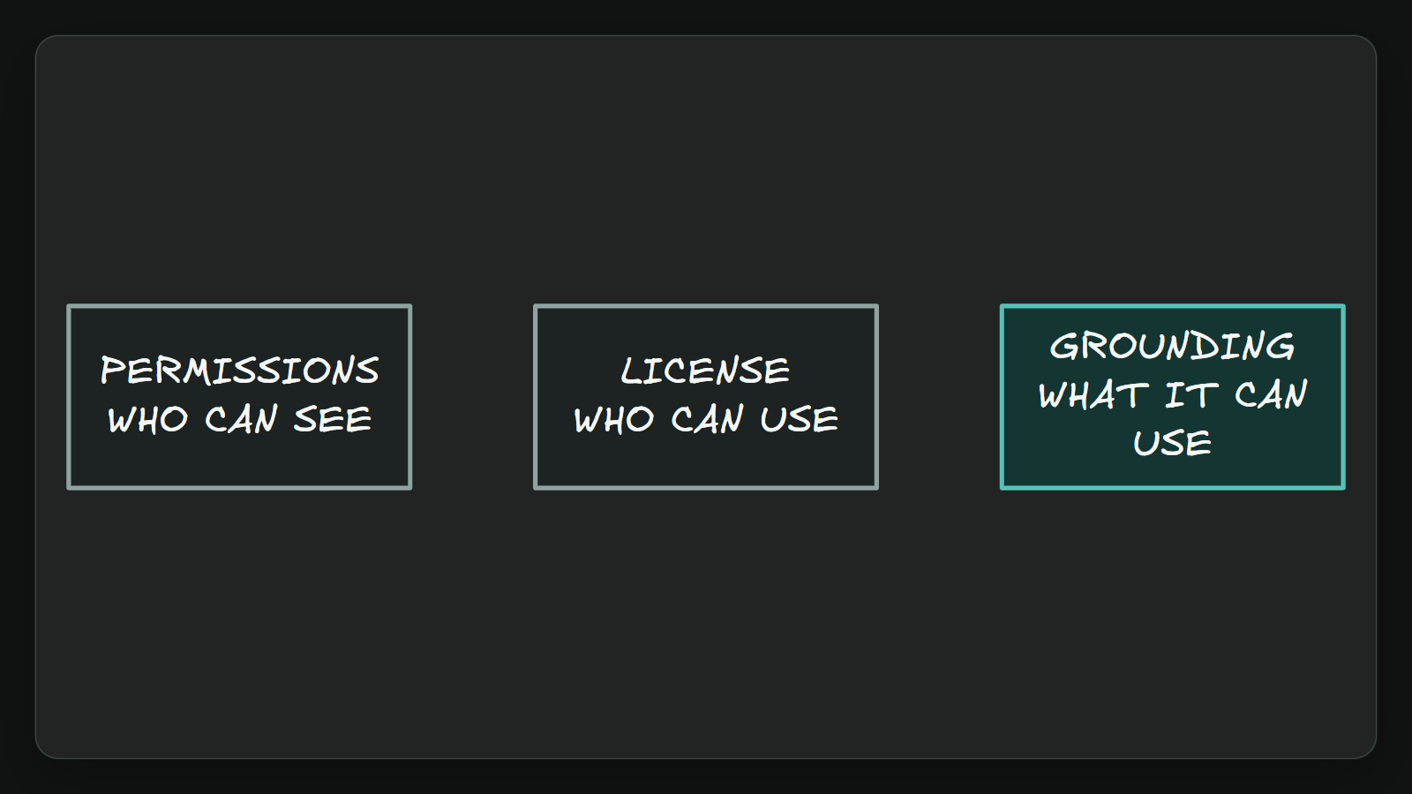

3. Separate builders
GitHub Copilot fits coding workflows in developer tools. Copilot Studio builds agents and workflows connected to organizational data, systems, and channels for teams.

Claims
GitHub Copilot supports coding work in editors, the command line, and GitHub, including completing code, edits, validation, and workflow support.
Copilot Studio is a low-code route for building agents and workflows connected to organizational data, systems, and channels.

Speaker notes
Evidence: ev-05 and ev-06 place GitHub Copilot in coding surfaces; ev-07 and ev-08 define Copilot Studio as a low-code agent and workflow builder connected to organizational systems.

Assets and alt text
visual-builder-routes: Coding assistance and business-agent building are different routes. (marp diagram)
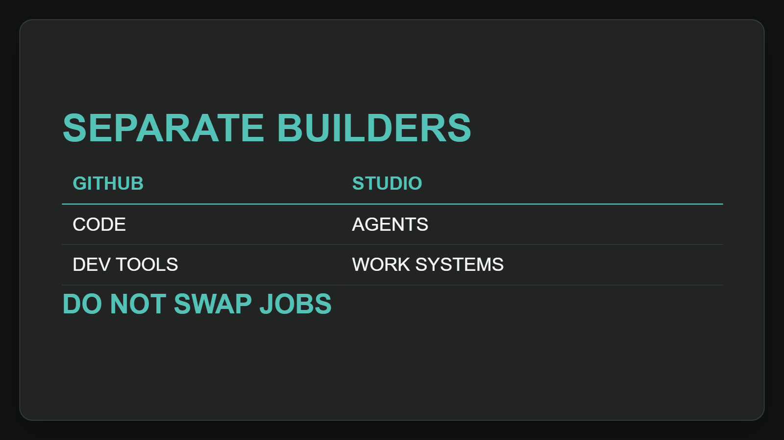

4. Run decision checks
Make the decision after the fit is clear. Check permissions, license tier, and grounding so leaders know what each output can and cannot use in practice.

Claims
Microsoft 365 Copilot is shaped by organizational grounding, user permissions, compliance controls, work-app access, and license level.
The executive choice is job first, then access, licensing, grounding, and output scope.

Speaker notes
Evidence: ev-02 and ev-03 show available information depends on access point, license, grounding, and permissions. Interpretation: output scope should be part of the executive decision gate.

Assets and alt text
visual-decision-checks: The final executive gate checks fit, access, licensing and grounding. (marp diagram)
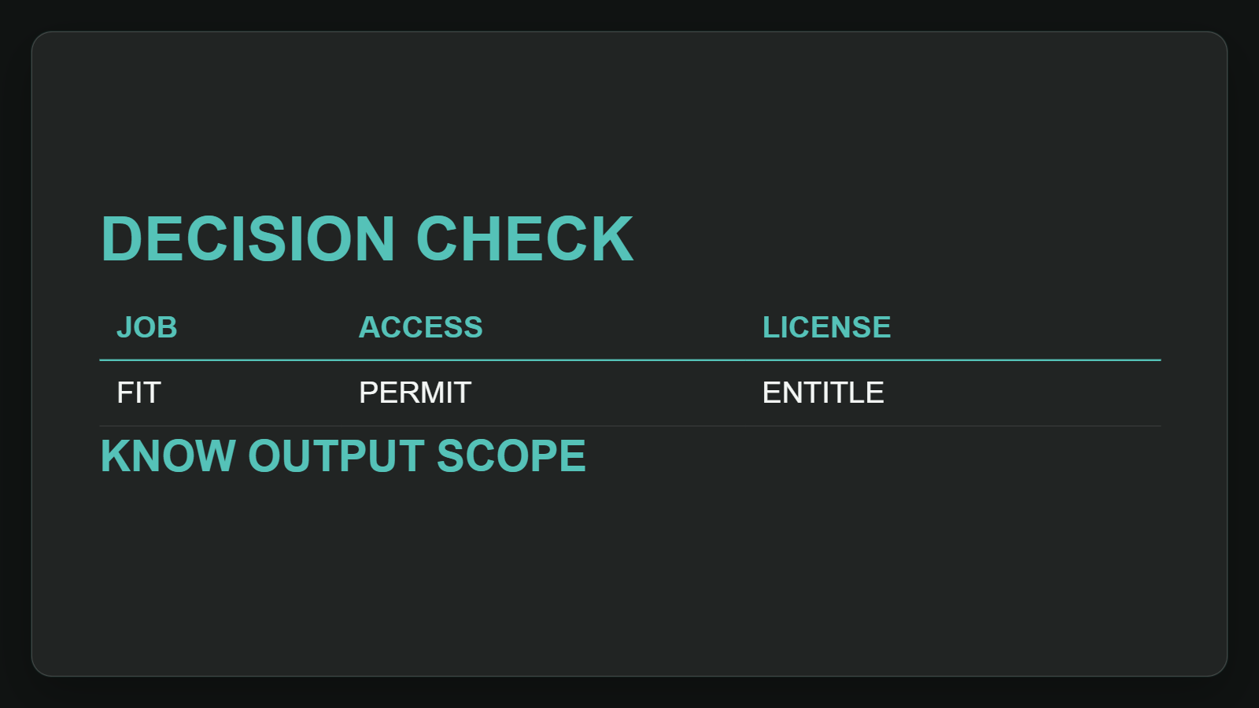

Citations
[ev-01, ev-02] Overview of Microsoft Copilot Chat (retrieved 2026-10-06T20:16:25.109Z)
[ev-03, ev-04] What is Microsoft Copilot? (retrieved 2026-10-06T20:16:25.380Z)
[ev-05, ev-06] GitHub Copilot · Your AI coding agent · GitHub (retrieved 2026-10-06T20:16:25.831Z)
[ev-07, ev-08] Overview - Microsoft Copilot Studio (retrieved 2026-10-06T20:16:25.952Z)

