Autopilot Agents: decide the operating model before the rollout

Contents
Executive Summary
1. Change the unit of delegation
2. Govern identity before capability
3. Pilot the role, not the technology
Citations

Executive Summary
Bottom line: treat Copilot Autopilot as a bounded standing role, not a better chatbot. Approve one private-preview pilot only where a named leader owns the goal, access boundary, cost and outcomes.
Audience: Executive decision-makers
Decision: Approve one narrow private-preview pilot only when a named business leader owns the goal, access boundary, cost guardrail, exception path and outcome review.

Narration
Bottom line: treat Copilot Autopilot as a bounded standing role, not a better chatbot. Approve one private-preview pilot only where a named leader owns the goal, access boundary, cost and outcomes.
The shift is from asking for an answer to assigning a standing role. Autopilot was announced with identity, memory, a computer and workspace; leaders still set objectives and boundaries. That changes governance, not just productivity.
Foundry provides an architectural lens, not proof that every implementation is identical: identity establishes the role, while capability can change. The organization controls interactions, access and actions, and an accountable manager remains essential.
Pilot one recurring workflow with one team and one accountable owner. Reuse a blueprint for logic, but scope each instance to its own permissions and assignment. Because Copilot Autopilot remains private preview, require a stop condition and outcome review before expansion.

1. Change the unit of delegation
The shift is from asking for an answer to assigning a standing role. Autopilot was announced with identity, memory, a computer and workspace; leaders still set objectives and boundaries. That changes governance, not just productivity.

Claims
Copilot Autopilot, previously called Scout, was announced as a persistent digital teammate with its own identity, memory, computer and workspace; people set its objective and boundaries and remain informed and in control.

Speaker notes
Evidence: Microsoft announcement, Autopilot section, retrieved 2026-10-06. Interpretation: a standing role changes the operating model. This is Copilot Autopilot, previously Scout, not Windows Autopilot device provisioning.

Assets and alt text
visual-operating-model: The operating-model shift: from one request to a bounded standing role with human accountability. (mermaid diagram)
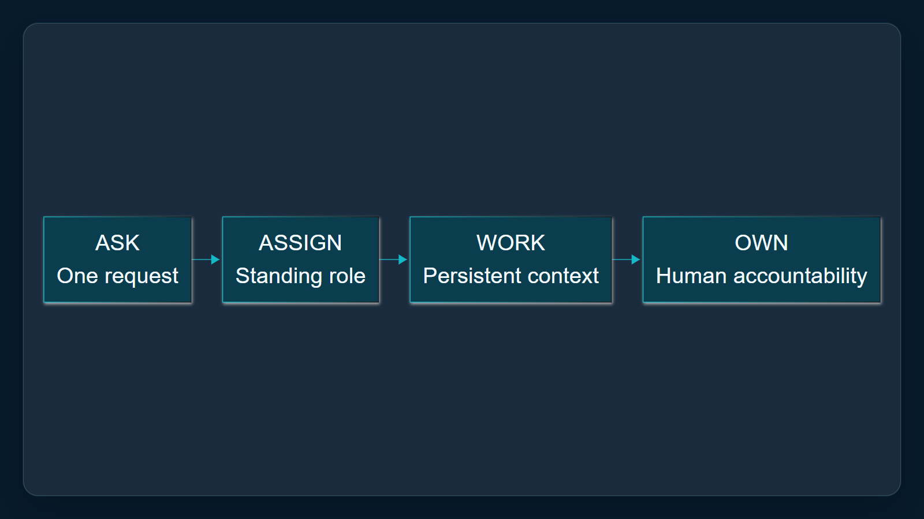

2. Govern identity before capability
Foundry provides an architectural lens, not proof that every implementation is identical: identity establishes the role, while capability can change. The organization controls interactions, access and actions, and an accountable manager remains essential.

Claims
As an architectural lens, Microsoft Foundry defines an autopilot by a persistent standing role and its own identity, security profile and accountable manager, not by a changing feature list.
In the Foundry model, autonomy remains bounded: the organization controls when an autopilot responds, who it interacts with, what it accesses and which actions it can take.

Speaker notes
Evidence: Microsoft Foundry autopilot overview, opening definition and autonomy section, retrieved 2026-10-06. Applicability limit: architectural lens only; do not assert implementation equivalence with Copilot Autopilot.

Assets and alt text
visual-identity-boundaries: Identity anchors the role; goals, access and actions remain bounded by the organization. (excalidraw diagram)
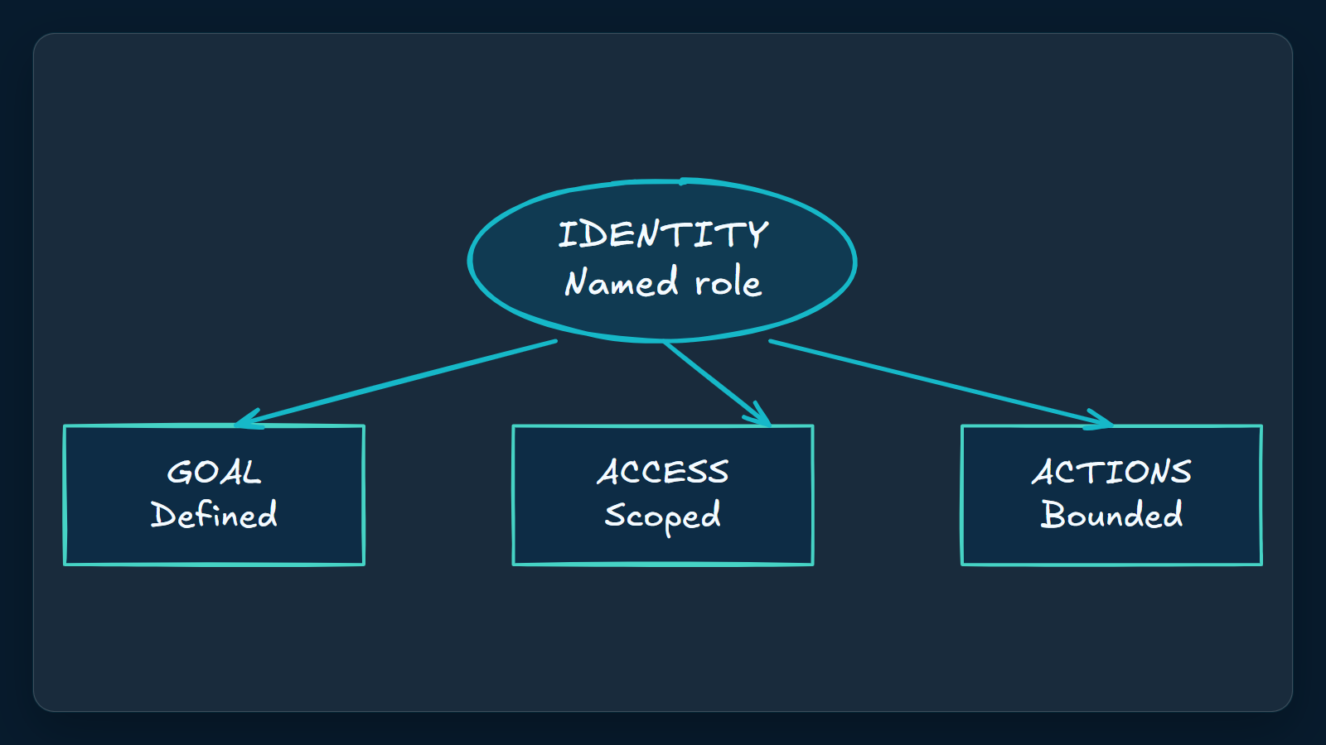

3. Pilot the role, not the technology
Pilot one recurring workflow with one team and one accountable owner. Reuse a blueprint for logic, but scope each instance to its own permissions and assignment. Because Copilot Autopilot remains private preview, require a stop condition and outcome review before expansion.

Claims
Microsoft said Copilot Autopilot was expanding to private preview at the end of September 2026; the announcement does not establish general availability.
The Foundry blueprint model separates reusable agent logic and infrastructure from team-specific business access, with each created instance receiving its own identity, permissions and assignment.

Speaker notes
Evidence: Microsoft announcement private-preview statement and Microsoft Foundry blueprint section, retrieved 2026-10-06. Proposed action: one workflow, one team, one owner, explicit access boundary, cost guardrail, stop condition and review.

Assets and alt text
visual-pilot: A narrow, accountable private-preview pilot with explicit expansion gates. (marp diagram)
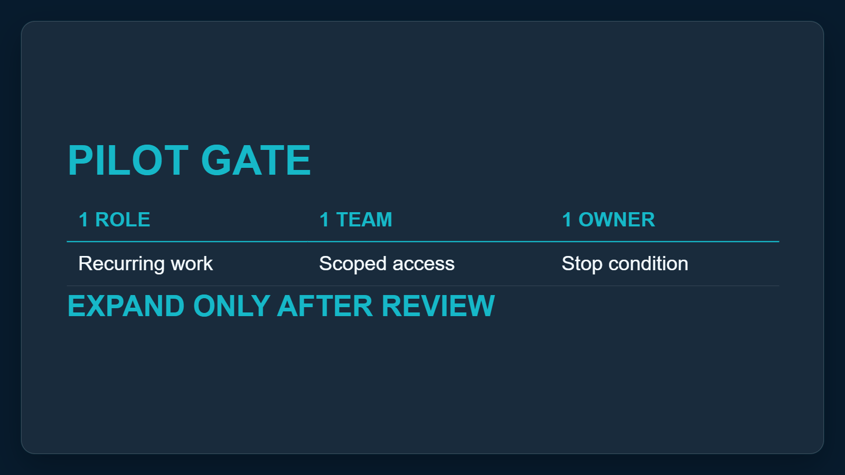

Citations
[ev-01, ev-02, ev-03, ev-04] Introducing the new Copilot with Home, Code and Autopilot (retrieved 2026-10-06T00:22:16.157Z)
[ev-05, ev-06, ev-07, ev-08, ev-09, ev-10] What is an autopilot in Microsoft Foundry? (retrieved 2026-10-06T00:22:16.312Z)

