Autopilot Agents: decide the operating model before the rollout

Contents
Executive Summary
1. Change the unit of delegation
2. Govern identity before capability
3. Pilot the role, not the technology
Citations

Executive Summary
Bottom line: Copilot Autopilot is a bounded standing role, not a chatbot. Pilot privately with one owner, scoped access, cost guardrail and review.
Audience: Executive decision-makers
Decision: Approve one narrow private-preview pilot only when a named business leader owns the goal, access boundary, cost guardrail, exception path and outcome review.

Narration
Bottom line: Copilot Autopilot is a bounded standing role, not a chatbot. Pilot privately with one owner, scoped access, cost guardrail and review.
The shift is from asking for an answer to assigning a standing role. Autopilot brings identity, memory and a workspace; leaders still own objectives and boundaries. Governance changes with the unit of delegation.
Foundry is an architectural lens, not proof of identical implementation. Identity anchors the standing role; the organization still bounds interactions, access and actions, with a manager accountable for the role.
Pilot one recurring workflow with one team and owner. Reuse blueprint logic, but scope each instance to its own permissions and assignment. While Autopilot is private preview, require a stop condition and review before expansion.

1. Change the unit of delegation
The shift is from asking for an answer to assigning a standing role. Autopilot brings identity, memory and a workspace; leaders still own objectives and boundaries. Governance changes with the unit of delegation.

Claims
Copilot Autopilot, previously Scout, was announced as a persistent digital teammate with its own identity, memory, computer and workspace; people set objectives and boundaries and remain in control.

Speaker notes
Evidence: Microsoft announcement, Autopilot section, retrieved 2026-10-06. Interpretation: a standing role changes the operating model. This is Copilot Autopilot, previously Scout, not Windows Autopilot device provisioning.

Assets and alt text
visual-operating-model: The operating-model shift: from one request to a bounded standing role with human accountability. (mermaid diagram)
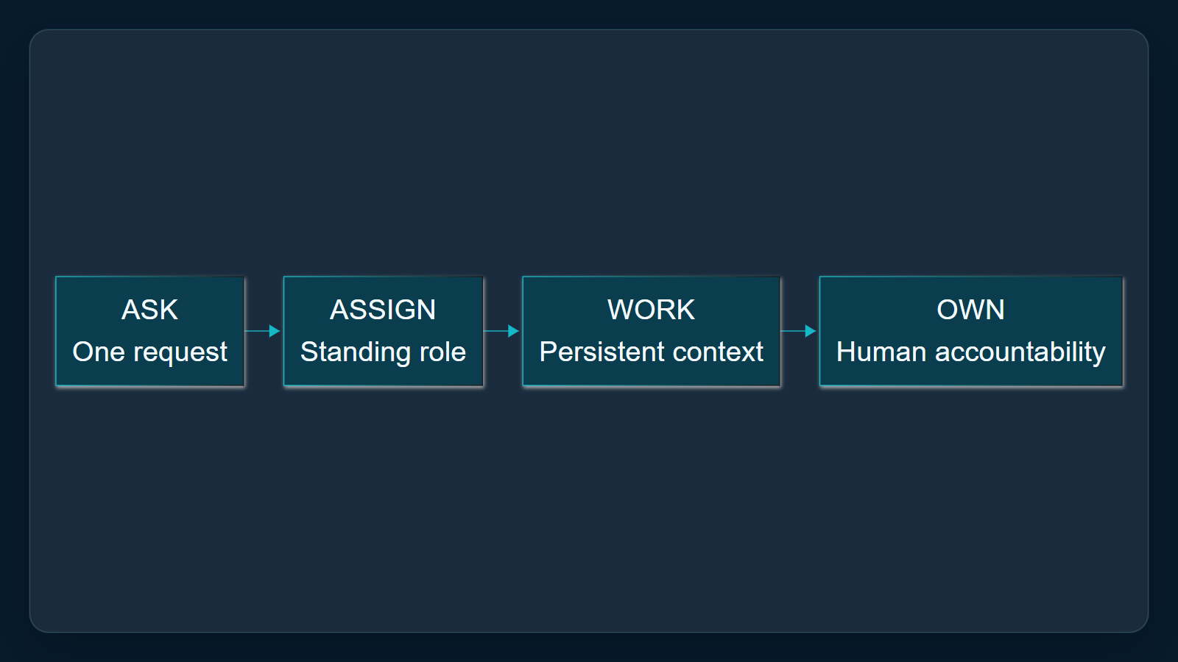

2. Govern identity before capability
Foundry is an architectural lens, not proof of identical implementation. Identity anchors the standing role; the organization still bounds interactions, access and actions, with a manager accountable for the role.

Claims
As an architectural lens, Microsoft Foundry defines an autopilot by its standing role, identity, security profile and accountable manager, not by a changing feature list.
In the Foundry model, autonomy remains bounded: the organization controls when an autopilot responds, who it interacts with, what it accesses and which actions it can take.

Speaker notes
Evidence: Microsoft Foundry autopilot overview, opening definition and autonomy section, retrieved 2026-10-06. Applicability limit: architectural lens only; do not assert implementation equivalence with Copilot Autopilot.

Assets and alt text
visual-identity-boundaries: Identity anchors the role; goals, access and actions remain bounded by the organization. (excalidraw diagram)
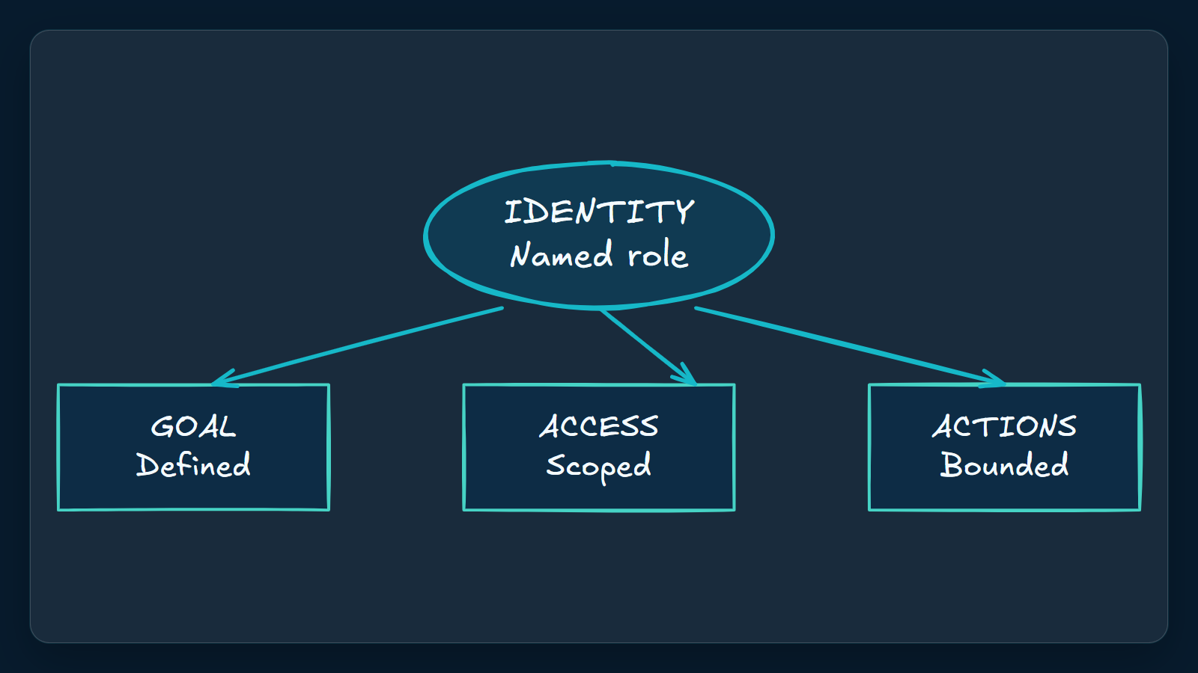

3. Pilot the role, not the technology
Pilot one recurring workflow with one team and owner. Reuse blueprint logic, but scope each instance to its own permissions and assignment. While Autopilot is private preview, require a stop condition and review before expansion.

Claims
Microsoft said Copilot Autopilot was expanding to private preview at the end of September 2026; the announcement does not establish general availability.
The Foundry blueprint model separates reusable logic and infrastructure from team-specific access; each instance receives its own identity, permissions and assignment.

Speaker notes
Evidence: Microsoft announcement private-preview statement and Microsoft Foundry blueprint section, retrieved 2026-10-06. Proposed action: one workflow, one team, one owner, explicit access boundary, cost guardrail, stop condition and review.

Assets and alt text
visual-pilot: A narrow, accountable private-preview pilot with explicit expansion gates. (marp diagram)
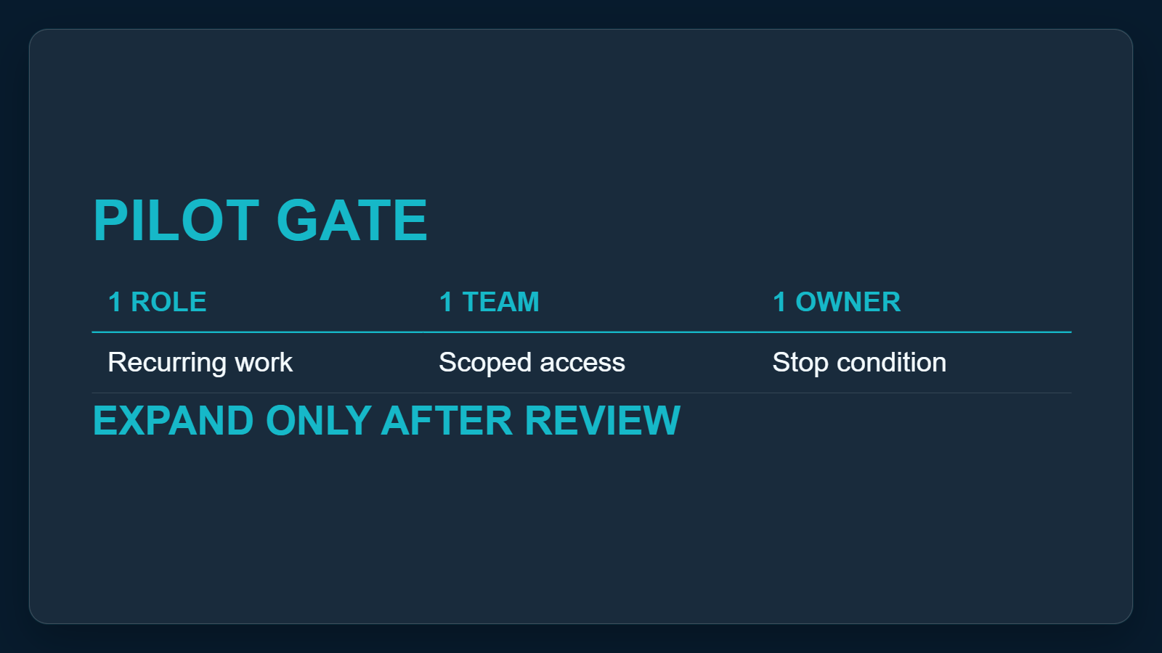

Citations
[ev-01, ev-02, ev-03, ev-04] Introducing the new Copilot with Home, Code and Autopilot (retrieved 2026-10-06T00:22:16.157Z)
[ev-05, ev-06, ev-07, ev-08, ev-09, ev-10] What is an autopilot in Microsoft Foundry? (retrieved 2026-10-06T00:22:16.312Z)

