PPCC 2026: turn conference learning into one governed pilot

Contents
Executive Summary
Bottom line: send a focused team with one pilot objective
Use the full conference week deliberately
Connect innovation ambition to execution controls
Require one pilot charter after the event
Citations

Executive Summary
PPCC 2026 is an upcoming opportunity to connect agents, apps, automation, trusted data, and governance to a concrete executive pilot decision.
Audience: Executive decision-makers
Decision: Recommendation: send a focused team to PPCC 2026 to return with one governed AI, app, and automation pilot charter.

Narration
Bottom line: recommend sending a focused cross-functional team to PPCC 2026 with one objective: return with a governed AI, app, and automation pilot proposal.
This is a recommendation, not a measured outcome. Treat the event as a structured learning sprint for business, platform, data, and risk leaders.
PPCC runs October 27 through 29 at the MGM Grand in Las Vegas. Applied workshops run before and after the main conference.
Microsoft frames PPCC around Copilot, agents, apps, automation, and data. The program connects those capabilities to trusted data, implementation, architecture, and governance. That is the bridge from innovation ambition to execution controls.
After the event, require one pilot charter naming the workflow, owner, trusted data, guardrails, and a testable success measure. Expand only when that evidence supports the next decision.

Bottom line: send a focused team with one pilot objective
Recommendation: send a focused business, platform, data, and risk team with one mandate: return with a governed AI, app, and automation pilot charter.

Claims
Microsoft frames PPCC around Copilot, agents, apps, automation, and data.

Speaker notes
State clearly that this is a recommendation, not a measured outcome.

Assets and alt text
executive-pilot-team: Three-step executive flow from a focused team to one chosen opportunity and one governed pilot.
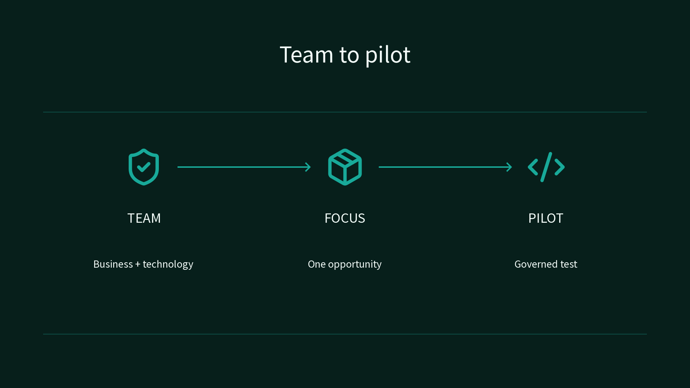

Use the full conference week deliberately
Main conference: October 27-29 at the MGM Grand in Las Vegas. Workshops: October 25-26 and October 30.

Claims
PPCC 2026 runs October 27-29 at the MGM Grand in Las Vegas.
Applied workshops run October 25-26 and October 30, outside the main conference.

Speaker notes
Show the sequence without discussing registration prices.

Assets and alt text
visual-conference-week: Conference-week timeline: applied workshops bracket the October 27-29 main conference. (mermaid diagram)
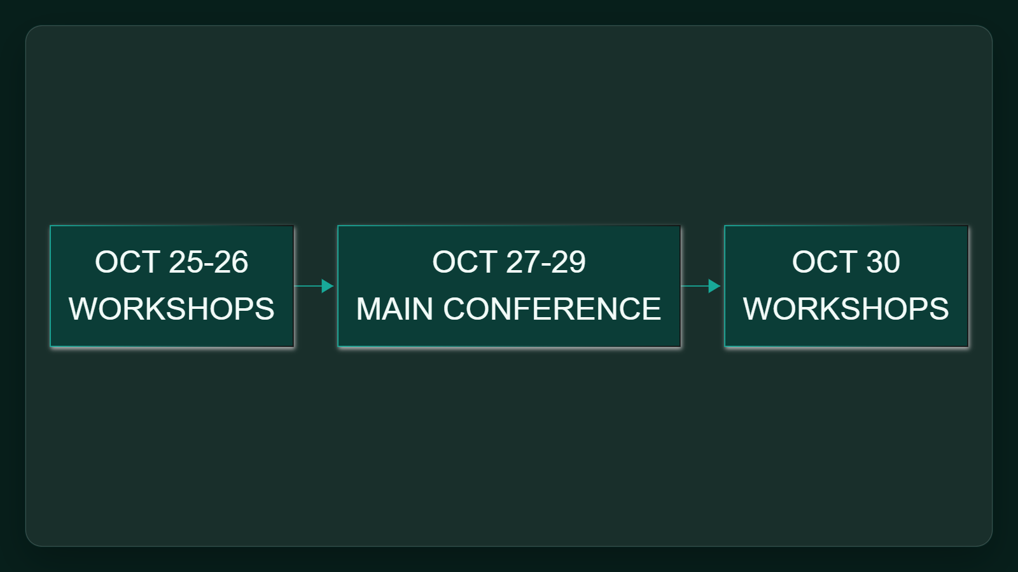

Connect innovation ambition to execution controls
PPCC connects agents, apps, automation, and trusted data with implementation, architecture, governance, and AI-driven scenarios.

Claims
PPCC covers agents, apps, automation, and trusted data as governed business solutions.
The FAQ emphasizes implementation, architecture, governance, and AI-driven scenarios.

Speaker notes
Keep the focus on executive execution rather than a product feature list.

Assets and alt text
visual-execution-value: Learning-to-pilot flow: narrow the opportunity, ground it in trusted data, set controls, then test. (mermaid diagram)
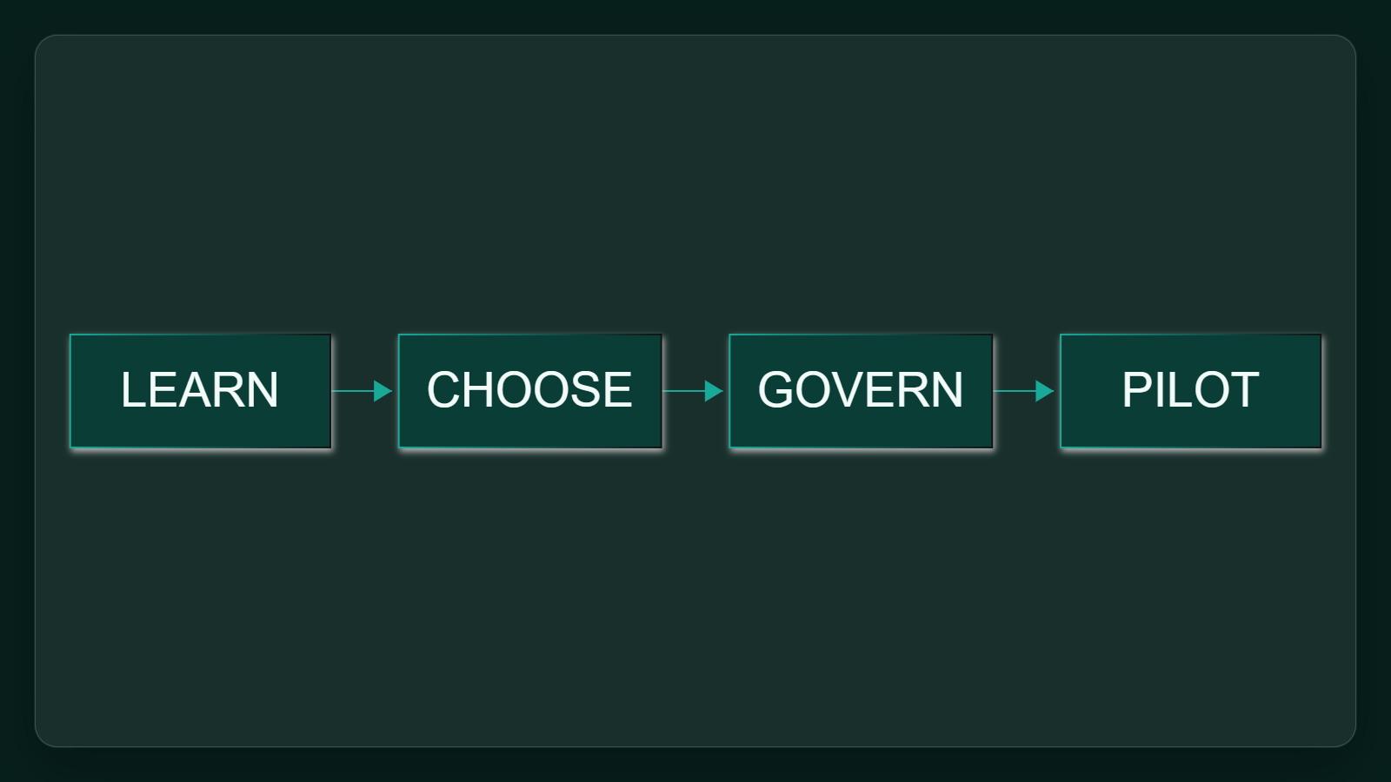

Require one pilot charter after the event
Ask the team to return with the workflow, owner, trusted data, guardrails, and testable success measure for one pilot. Expansion should depend on that evidence, not conference enthusiasm.

Claims
The FAQ emphasizes implementation, architecture, governance, and AI-driven scenarios.

Speaker notes
Close with the proposed deliverable and avoid inventing an owner or deadline.

Citations
[ev-01, ev-02] Register now for PPCC 2026: Come for the learning, stay for the community (retrieved 2026-10-05T23:21:29.581Z)
[ev-03, ev-04, ev-05] FAQ | PPCC26 (retrieved 2026-10-05T23:21:29.710Z)

