Copilot Code: approve a narrow, governed preview pilot

Contents
Executive Summary
1. Shift from answers to small solutions
2. Choose the execution boundary deliberately
3. Configure first, then pilot narrowly
Citations

Executive Summary
Bottom line: pilot Copilot Code for one small purpose-built solution, with IT policy set first, a named owner, scoped data, a spend limit and an explicit stop-or-expand review.
Audience: Executive and IT decision-makers
Decision: Approve one bounded Frontier pilot only after IT sets the execution, permission, data, GitHub and spend policies and names an accountable business owner.

Narration
Bottom line: pilot Copilot Code for one small purpose-built solution, with IT policy set first, a named owner, scoped data, a spend limit and an explicit stop-or-expand review.
Code is for outcome-led builders, not a replacement for developer tools. Describe a dashboard, team tool, site, transform, automation or script; Code builds a live preview, keeps revertible versions and can publish cloud apps to Copilot Managed Runtime for your organization.
Local mode works inside a chosen folder and asks approval by default for network, extensions or MCP, shell commands and outside-folder access. Cloud mode is isolated. Microsoft says existing Microsoft 365 governance applies, with audit visibility into code, commands and file activity.
IT must confirm license and enablement, then set auto-approve, execution location, GitHub, organizational data and spend policies. Recommendation: one low-risk business use case, one owner, least data needed, a budget cap, and a stop-or-expand review before broader access.

1. Shift from answers to small solutions
Code is for outcome-led builders, not a replacement for developer tools. Describe a dashboard, team tool, site, transform, automation or script; Code builds a live preview, keeps revertible versions and can publish cloud apps to Copilot Managed Runtime for your organization.

Claims
Copilot Code is a preview build experience in the Microsoft Copilot app that requires Frontier access; the selected sources do not establish general availability.
Microsoft frames Code as a shift from files alone toward small purpose-built solutions: users describe software in natural language, see a live result, iterate, and can revert to an earlier version.
Cloud projects can publish interactive apps to Copilot Managed Runtime for people in the organization, while local projects work inside a chosen project folder.

Speaker notes
Evidence: Microsoft announcement and Copilot Code overview, retrieved 2026-10-20. Microsoft calls purpose-built solutions a fourth unit of knowledge work; that framing is attributed, not an independent market conclusion. Code remains a Frontier preview and is distinct from GitHub Copilot, its coding agent, Visual Studio Code, Copilot Studio and Copilot Pages.

Assets and alt text
visual-what-code-is: From an outcome description to a previewed, versioned and organization-scoped solution. (mermaid diagram)
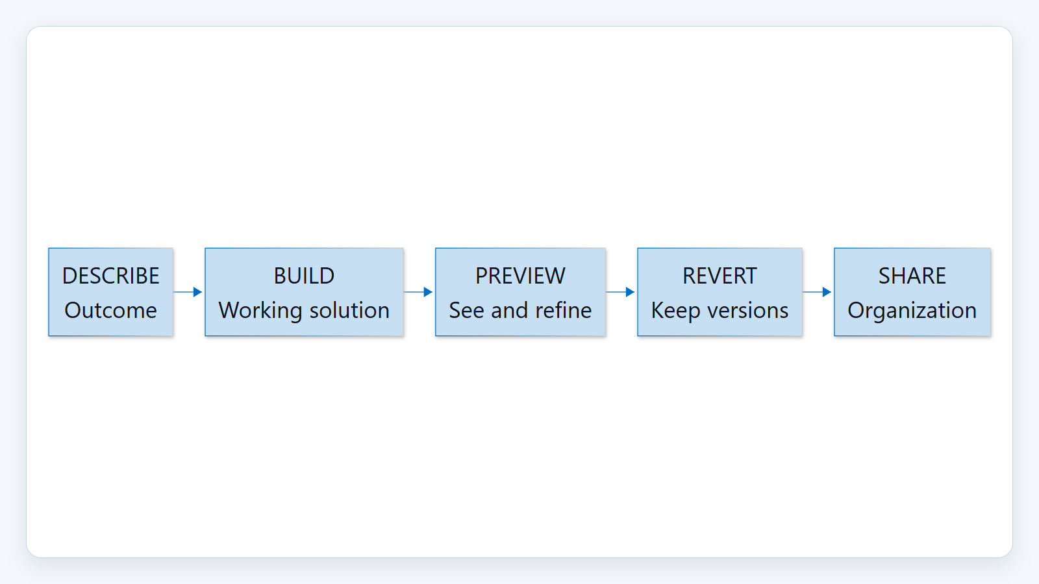

2. Choose the execution boundary deliberately
Local mode works inside a chosen folder and asks approval by default for network, extensions or MCP, shell commands and outside-folder access. Cloud mode is isolated. Microsoft says existing Microsoft 365 governance applies, with audit visibility into code, commands and file activity.

Claims
Local mode asks for approval by default before network calls, extensions or MCP use, shell commands, or file access outside active projects; cloud mode runs in a secure isolated environment.
Copilot Code follows Microsoft 365 governance, security and compliance controls, and administrators can audit generated code, commands run, and files read or written.

Speaker notes
Evidence: Copilot Code overview, build location, Stay in control, and Data protection sections, retrieved 2026-10-20. The permission statement is a documented default, not a guarantee against administrator or user policy changes.

Assets and alt text
visual-safe-operation: Local and cloud have different execution boundaries, joined by governance and audit. (mermaid diagram)
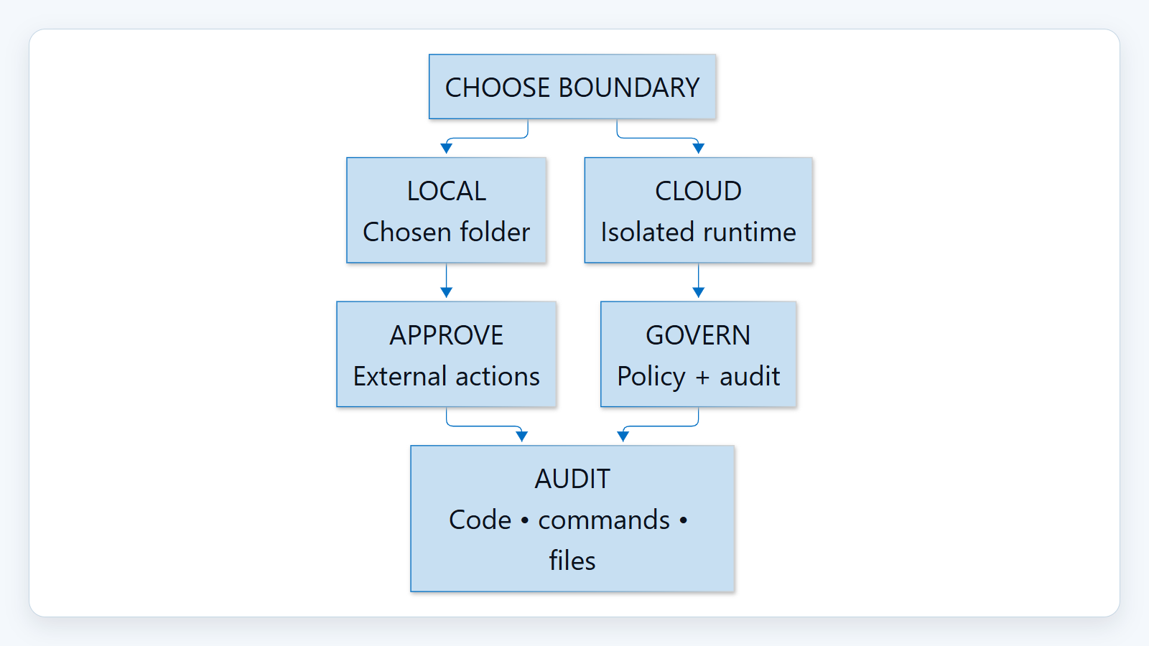

3. Configure first, then pilot narrowly
IT must confirm license and enablement, then set auto-approve, execution location, GitHub, organizational data and spend policies. Recommendation: one low-risk business use case, one owner, least data needed, a budget cap, and a stop-or-expand review before broader access.

Claims
For work accounts, IT must provide a Copilot license and organization-level enablement, and can configure auto-approve, execution location, GitHub connections, organizational data access and spend limits; documented defaults can change during preview.

Speaker notes
Evidence: requirements and admin pages, retrieved 2026-10-20. Documented defaults include auto-approve on, execution location cloud-only on, GitHub off, and organizational data on for cloud and off for local. These are preview documentation states and may change. The pilot guardrails are recommendations, not product guarantees.

Assets and alt text
visual-pilot-gate: A narrow pilot starts with policy and ends with an accountable review. (marp diagram)
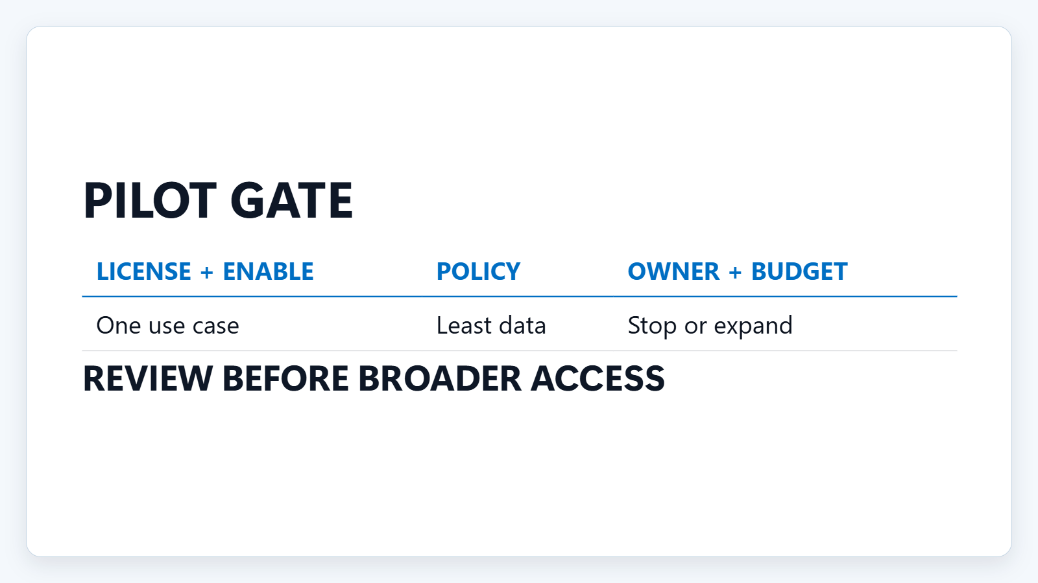

Citations
[ev-preview, ev-frontier, ev-build, ev-versions, ev-publish, ev-local, ev-cloud, ev-approval-default, ev-governance, ev-audit] Copilot Code overview (Frontier) (retrieved 2026-10-20T22:53:14.682Z)
[ev-fourth-unit] Introducing the new Copilot with Home, Code and Autopilot (retrieved 2026-10-20T22:53:14.262Z)
[ev-license-enable, ev-auto-approve, ev-execution, ev-github, ev-org-data] Manage Copilot Code for your organization (Frontier) (retrieved 2026-10-20T22:53:15.003Z)
[ev-spend] Copilot Code (Frontier) requirements (retrieved 2026-10-20T22:53:14.896Z)
[ev-corroboration] New Microsoft Copilot brings Home, Code and Autopilot together (retrieved 2026-10-20T22:53:15.111Z)

