**Control scheme**:

* Left click on "Play" to start the game.
* Close game with ESC or by left clicking on the close window button.

Player Controls:

* Move player with WASD.
* Press Space to use the station module in the ship.

Steering Wheel (ship) Controls:

* Move the player to the steering wheel (in the middle of the ship at the start of the game), press Space to use the steering wheel.
* Move ship with WASD.
* Press Space to gain back controls to player mode.

Cannon Controls:

* Move the player to the cannon station, press Space to use the station.
* Move the mouse around to change the direction the cannon is pointing at.
* Left click to fire a projectile from the cannon (there is a timer on the cannon).
* Press Space to gain back controls to player mode.

**Overview:**

1. Once the program runs, there will be a menu screen with a `Play` button
2. Click on the Play button to begin playing.
3. You should be able to use the 2 modules that are on the ship (1. steering wheel, 2. cannon) simply by standing on their respective tile and pressing the spacebar.
4. If you control the steering wheel, you can move the ship by pressing WASD.
5. If you control the cannon, you can aim using the mouse and left click to shoot projectiles.
6. Module rearrangement:
   1. If you wish to store a module into your inventory, right click on an existing module in the ship.
   2. If you wish to place a module from your inventory, left click on the desired module from the inventory located at the bottom of your screen.
      1. Then left click on where you want to place it on the ship. Only one of each module can be present at any time.
7. If the ship collides with an enemy, the ship and enemy will take damage (enemy will die)
8. If the cannon projectile collides with an enemy, the enemy will die, the projectile will disappear.
9. If the cannon projectile collides with a jailed bunny (there’s one on the top left), the bunny will be saved and board the ship.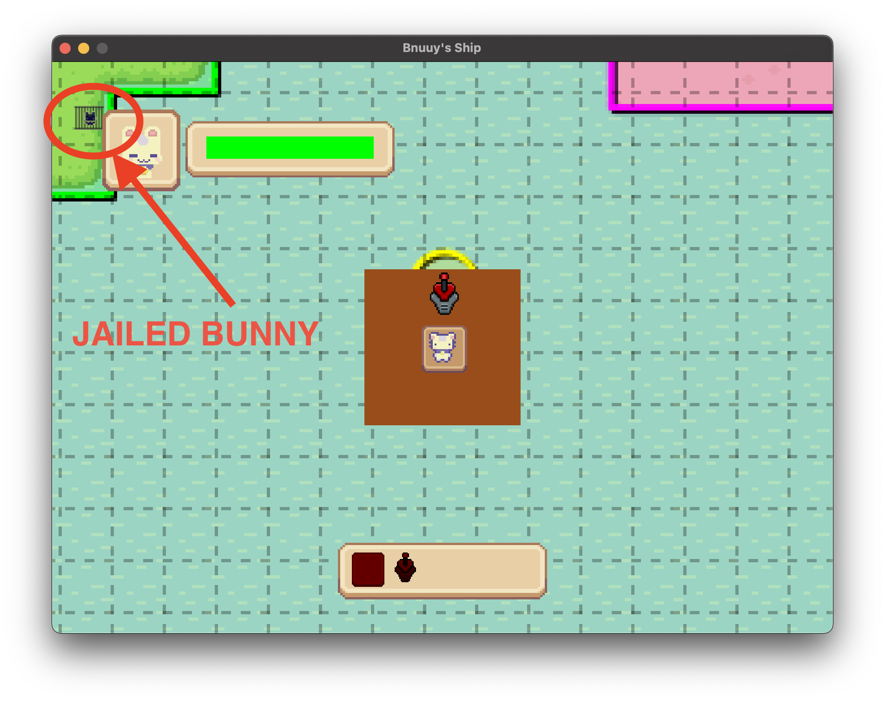
10. If the player attempts to move outside the ship, it will stop moving at the ship’s boundaries.
11. If the ship collides with an island, it will stop moving at the island boundaries.