Running Expanded Lipidomics Panel with SLA

Installation:

1. Download SLA_V1.12 from Github and extract to fold of your choice. If desired, create Exe shortcut to desktop. Run SLA_V1.12.exe.
2. If it does not open properly, or if it collapses while running, try to open it from command prompt to check the error message.
3. To convert wiff file to mzml file, you need to download and isntall MSconvertGUI from Proteowizard. (Note: We have been using version 3.0.19082-ade61137d. Some updated versions may not transfer the data or file name correctly.)
4. A spreadsheet program must be installed on the control computer (Excel or LibreOffice).

Tuning – Instrument Setup:

1. This protocol assumes that users are utilizing a Sciex Lipidyzer with the 100ul sample loop installed in the Shimadzu Autosampler.
2. Prior to Tuning/Sample Run, make sure that the instrument is topped off with appropriate solvents and solutions. The pump system should be supplied with running buffer (50/50% Methanol/Dichloromethane with 10mM ammonium acetate). The autosampler wash should be topped off with 2-propanol. The SelexION should be supplied with 1-propanol as modifier.
3. Tuning solution is prepared by diluting EquiSPLASH™ LIPIDOMIX® (Avanti, 330731-1EA) 1 to 20 with running buffer. The syringe pump should be loaded with .5-1mL of this tuning solution and connected to the electrode (the autosampler output is disconnected from the mass spec for this step).
4. Load a sample vial containing running buffer in Position 1 in sample rack. This will be utilized in the Tuning and Suitability steps.

Tuning – Run:

1. It is recommended that you create a new project or subproject for each experiment in order to avoid confusion in appropriately tuned methods. In Analyst: Tools → Project → Create Project
2. Copy “Neg Infusion COV 3500_SPLASH”, “Pos Infusion COV 3500_SPLASH”, “SST v3”, “Method 1 v3” and “Method 2 v3” from provided method package to the current project “Acquisition Method” folder.
3. “Hardware Config” → Activate “Lipidyzer” profile
4. Acquire → Ready Instrument
5. Purge Modifier and wait 30min for instrument to warm up
6. While waiting, set up batches. Negative and positive infusion batches should each contain three repeats of the same respective method.
7. For Positive Batch: Build Acquisition Batch → add batch name(e.g. “Tune – *Date* – 1”) and add 3 samples named “POS1/2/3” (all drawing from vial position 1) → submit
8. For Negative Batch: Build Acquisition Batch → add batch name(e.g. “Tune – *Date* – 2”) and add 3 samples named “NEG1/2/3” (all drawing from vial position 1) → submit
9. Start syringe pump 3-5min before sample run start

Tuning – Data Analysis:

1. Following the run, find and copy both sets of .WIFF files to a working folder in a location of your choice. Extract to Mzml with MSConvertGUI.
2. Read Tuning data with SLA Tuning tab.
3. Click **Import POS/Import NEG** and choose the corresponding Mzml files. (We recommend using the last one among the 3 replicates.)
4. Click **Import Tune Dict** to import the Tuning_spname_dict_xxx.xlsx file.
5. Choose peak finding method from drop down list. We recommend “Con9”.
6. Hit the “Run” button, the auto selected peak results will be printed to the Result window and plots will pop out. (The **Group** column in the POS and NEG tab in Tuning_spname_dict_xxx.xlsx file are corresponding to the items listed under the **Export** area. You can customize it by editing the **Group** column.)
7. Fill in COV values in the Export area. You can also use your mouse to point at a different peak. The x shown on the bottom right corner is the COV value. Hit ExportResult button. Result will be saved to a xlsx file under the same directory with Mzml files. (The excel file will be open automatically. A command prompt may pop-up. You can close it after the excel file is open.)
8. Copy paste the volt column to the corresponding Analyst method COV column. The “POS” and “NEG” tabs correspond to the respective experiments in “Method 1”. The SST tab contains COV values for both positive and negative experiments in the SST method. Save the respective files after this modification.

|  |  |
| --- | --- |
| Group | Name |
| PC | PC(16:0/12:0) |
| PC | PC(12:0/22:6) |
| PC | PC(15:0/14:1) |
| PC | PC(15:0/16:1) |
| LPC18 | LPC(18:4) |
| LPC18 | LPC(20:0) |
| LPC18 | LPC(20:1) |
| LPC18 | LPC(24:1) |
| LPE16 | dLPEBLANK |
| LPE16 | LPE(12:0) |

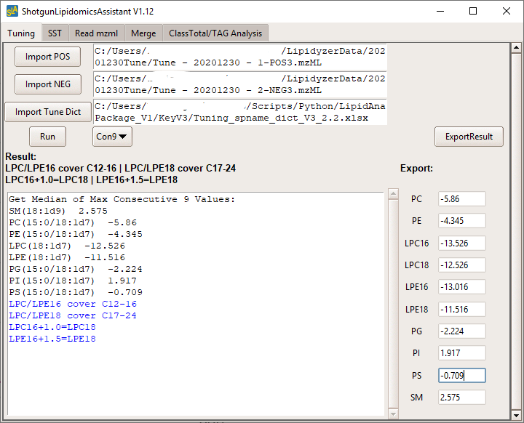

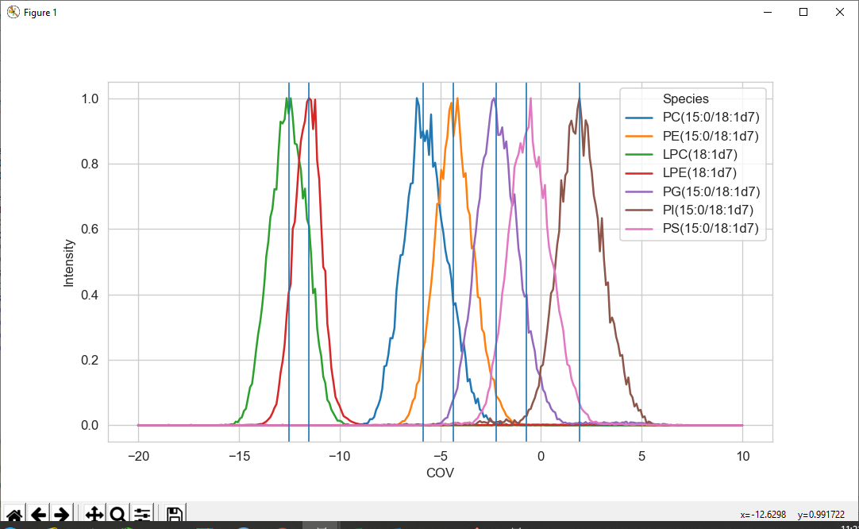

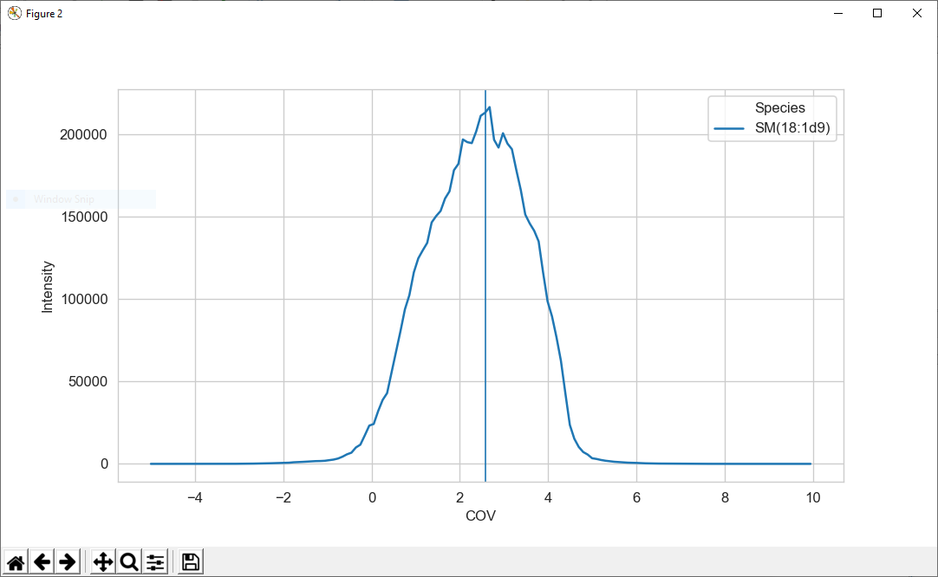

1. Fill in COV values in the Export area. You can also use your mouse to point at a different peak. The x shown on the bottom right corner is the COV value. Note that most tuning mixes have a single LPC and LPE species and yet these subclasses have two different COV values for shorter and longer chain species. The calculation for the offset between these is provided on the tab. Copy the one COV value and calculate the other COV from the first. Hit ExportResult button when finished. Result will be saved to a xlsx file under the same directory with Mzml files. (The excel file will be open automatically. A command prompt may pop-up. You can close it after the excel file is open.)
2. Copy paste the **volt** column to the corresponding Analyst method COV column. The “POS” and “NEG” tabs correspond to the respective experiments in “Method 1”. The SST tab contains COV values for both positive and negative experiments in the SST method. Save the respective files after this modification.

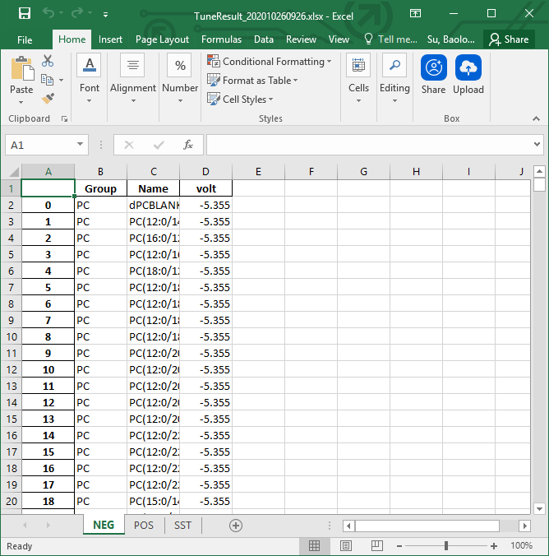

Suitability Test – Setup:

(Note: The Suitability Test is not required but is recommended to ensure that the instrument is in good working order and that the previous tuning step was carried out properly. The Suitability Test mix should be prepared fresh on a regular basis. Baseline results for the suitability test should be established and significant decreases should be troubleshot appropriately.)

1. The suitability test mix is prepared from two working stocks: the Lipidyzer System Suitability Kit (Sciex 5040407) and the PG/PI/PS mix from Avanti (described below).
2. The PG/PI/PS mix is prepared from 17:0-18:1 PI-d5, 17:0-18:1 PG-d5 and 17:0-18:1 PS-d5 (Avanti 850111L-500ug, 858133L-1mg, 858151L-1mg). A 100ug/mL stock of these three compounds should be prepared by diluting in 50/50 DCM/Methanol. Several mLs can be prepared at once and aliquoted into vials or ampules. As an example, the following formulation makes 1mL (100uL PG, 200uL PI, 100uL PS, 300uL Methanol, 300uL DCM).
3. The Suitability Test mix is prepared by combining 10ul of Lipidyzer System Suitability Mix with 10ul of PG/PI/PS mix in 980ul of running buffer.
4. Prepare Suitability Test mix in a robovial and place in the 105 position in the sample rack. Make sure there is sufficient volume of running buffer in the position 1 vial.
5. Reconnect the autosampler output to the source.

Suitability Test – Running:

1. If instrument was set to standby, a modifier purge and 30 minute warm up will be required before starting. If instrument remained ready, you may proceed immediately to the suitability test.
2. Build batch using the “SST v3” method under the batch name “SST – *Date* - 1”. Create 2 samples in the batch: a “buffer” in vial 1 and a “LOD” in vial 105.
3. Submit and Run batch.

Suitability Test – Running:

1. Find and copy .WIFF files to a working folder. Extract to Mzml format with MSConverterGUI.
2. Read the Suitability Test results with the SLA using the SST tab.
3. Import the Mzml file with the SST result (the “LOD” file above).
4. Import the Tuning_spname_dict_xxx.xlsx file
5. Hit Run and the result will be saved to an xlsx file under the same directory with the Mzml file
6. Compare results with previous suitability tests.

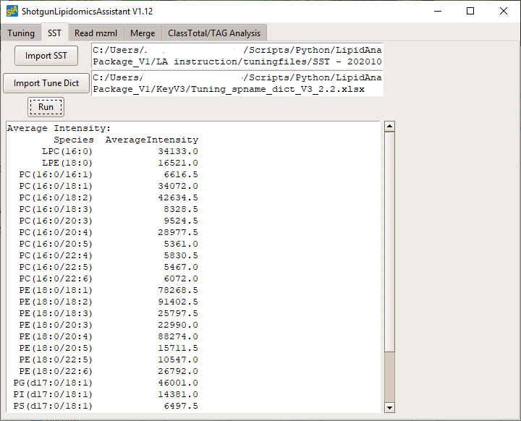

Sample Run Setup:

(Note: This protocol does not describe the sample extraction. There are a number of protocols that detail extraction. The addition of standards prior to extraction is key to good quantitative measurements. Check the “Standard Info” tab on Standard Dictionary Excel. This document details the recommended standard formulation. This formulation can be optimized to the samples you are analyzing. The 5 products that make up the v3 standard are Lipidyzer Standard Kit (Sciex 5040156), PG Internal Standard Mixture - UltimateSPLASH™ (Avanti 330827), PI Internal Standard Mixture - UltimateSPLASH™ (Avanti 330830), PS Internal Standard Mixture - UltimateSPLASH™ (Avanti 330828), and 15:0-18:1-d7-PA (Avanti 791642).)

1. Lipid extracts are dried down, resuspended in 275ul and transferred to a robovial. Samples should be assigned numbers that are utilized in the batch setup. These numbers should be filled into the Sample Map along with sample information.
2. These samples should be placed in the autosampler sample rack in appropriate order.
3. Prior to starting the run, make sure all solvents and running buffer are topped off.

Sample Run:

1. If the instrument has been on standby before starting the sample run, a modifier purge and 30 minute warm up will be needed.
2. If you are performing a large experiment (60+ samples), it may be worthwhile to run Method 1 and Method 2 batches separately. This allows you to check over the samples and correct any plumbing problems before doing a second injection of precious samples.
3. Each batch should be created with the sample numbers assigned above and the correct vial positions. Note that all samples to be analyzed must be assigned numbers as IDs. The SLA denotes sample IDs containing letters or symbols as controls (i.e. “buffer”, “QC”, “QCSpike”, etc.). These numbered IDs are then assigned sample information in the map file. Submit and run these two batches.
4. After completing both Method batches, proceed with data analysis.

Data Analysis Setup:

1. You will need a Species Name Dictionary (spname_dict_xxx) and a Standard Dictionary (standard_dict_xxx.xlsx) to perform the data analysis step. Make sure these match the Analyst methods utilized in your sample run. You will also need the Sample Map you filled out while setting up the samples. Follow the example on the Sample Map. Make sure that each sample is appropriately demarcated into experiments and groups, and that the normalization values for each sample are correct.
2. There is a **Mute** column in spname_dict_xxx. You can mute a species from the output by setting the value to TRUE. (Internal Standards and species end with “_2” are always muted from output.)

|  |  |  |  |
| --- | --- | --- | --- |
| Q1 | Q3 | Mute | Name |
| -700 | 200 | FALSE | dPCBLANK |
| -706.5 | 225.2 | FALSE | PC(12:0/14:1) |
| -736.5 | 255.2 | FALSE | PC(16:0/12:0) |
| -734.5 | 253.2 | FALSE | PC(12:0/16:1) |

1. To update internal standard information, open the “standard_dict_xxx.xlsx” file. Make sure that the appropriate standards are listed, that the concentrations match the lot of standards you are using, and that the volumes used reflect what the amounts you actually spiked into each sample.

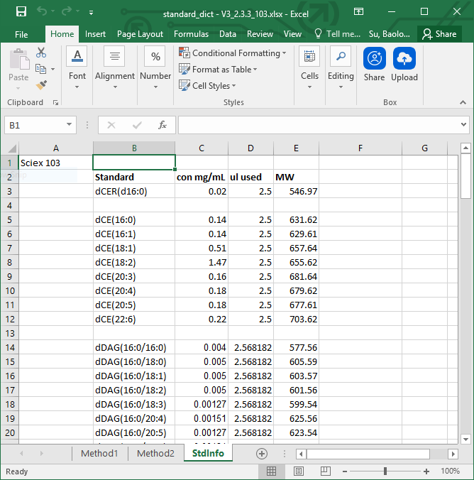

Read MZML:

1. Find and copy .WIFF files to an appropriate working folder. Convert to mzml format with MSconvertGUI. *(Note: the program will read all mzml files in the folder. Please only keep the relevant mzml files there.)*
2. Perform analysis using the Read mzml tab on the SLA
3. Set Directory to the folder of mzml files.
4. Import Standard_dict and spname_dict files.
5. Import isotope correction list if you want to do isotope correction.
6. Select the version of raw data file. (wiff file generated from LWM run or Analyst run)
7. If you want to mute species which you labeled as TRUE in the spname_dict file, chose Yes for Mute Species.
8. Put in your project name. You can also leave it blank.
9. Hit Read MZML. Results will be saved under the same folder with the mzml files

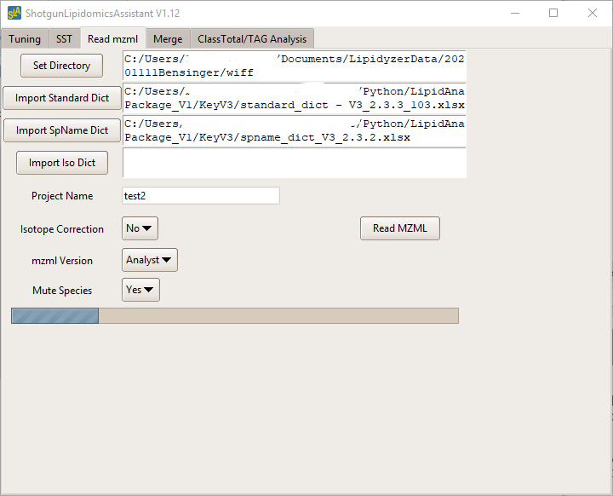

Merge data with sample map:

1. Select **Merge** tab.
2. Set directory to where you want to keep the outputs.
3. Import sample map. (Note: GroupNum will be used to sort x ticks in plots. You can change it to rearrange them.)

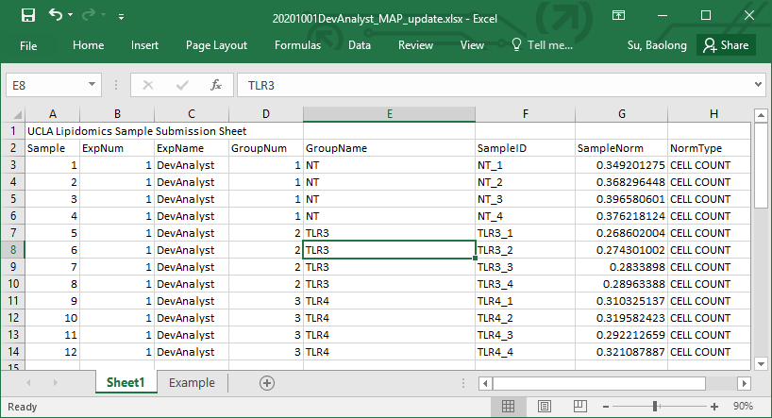

1. Select output excel files m1&m2 from **Read mzml** session. (if your experiment has only 1 method, then load it to m1 and leave m2 blank.)



1. Put in your project name or leave it blank.
2. Select if you want to export a csv file which can be uploaded to ClustVis for analysis.
3. Hit Run Merge. Results will be saved in the directory you selected.

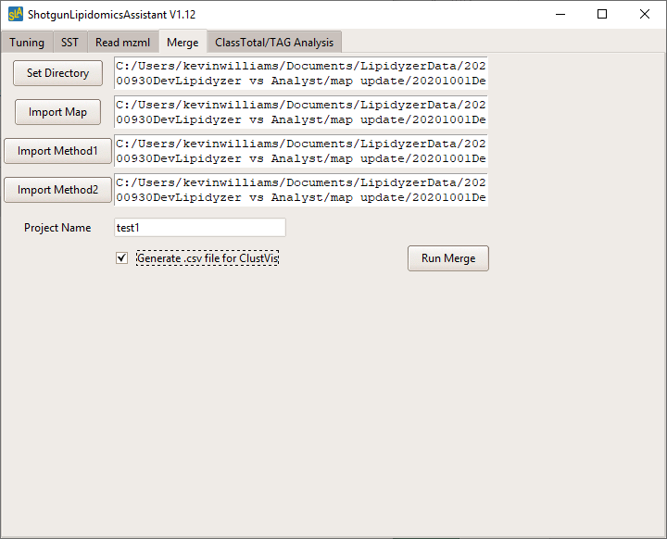

Further Analysis:

1. Prior to performing the ClassTotal/TAG Analysis, you may want to move the primary data file to a new subfolder (especially if there are multiple data files from multiple demarcated experiments in the batch).
2. Select **ClassTotal/TAG Analysis** tab.
3. Load the _Exp_ file from the Merge session



1. Select if you want to add error bar and data points to the TAG analysis bar plots.
2. Hit Run TAG. Results will be saved under the same folder with your _Exp_ file.

