 .ort

**Tutorial: Git with Eclipse**

If you aren't currently using a version control system or are exploring one, check out how to use Git with Eclipse using the EGit plugin.

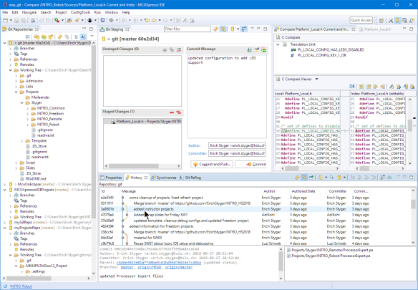

*EGit with Eclipse*

**VCS In a Nutshell**

In a nutshell, a VCS is a database or a system which allows me to store and retrieve files. It keeps a history and I can go back in time to retrieve an earlier state or compare different states. It "versions" items or files in a kind of database. In most cases, such a database is used by multiple users or developers, and with this, the system is able to "merge" changes of different developers; it keeps an audit track and backup of all the changes. Not using a VCS for any medium or larger scale project especially with multiple developers collaborating sounds like suicide to me. If you never have used a version control system, you probably want to start using one. I have used different VCSs (CVS, SVN, [Git](https://git-scm.com/" \t "_blank)), and while I still keep projects for historical reasons in CVS and SVN, I’m using Git for all my new stuff.

If a VCS or Git is new to you, I recommend you have a look at this tutorial video: <https://git-scm.com/video/what-is-version-control>

**Git – Quick Start**

The [Git project](https://en.wikipedia.org/wiki/Git) has been started by the famous Linus Torvalds. It is a modern and distributed version control system. To install Git, follow the links and [tutorial](https://git-scm.com/downloads).

With Git there are several basic actions:

* **add**: adding files to the list of changes
* **commit**: enter the change into the (local) repository
* **push**: transfer the changes in the local repository to the remote one
* **pull**: get the changes from the remote repository

By default, there is always a local repository. A remote repository is needed to share something, e.g. on GitHub.

In the Git Bash shell, configure first your username and default email address:

git config --global user.name "John Doe"

git config --global user.email "john.doe@company.com"

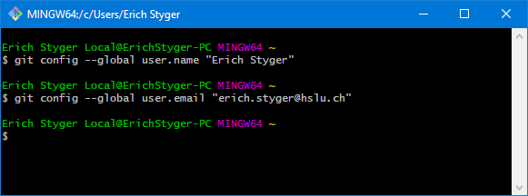

*Git configuration*

That all that we need for configuration.

To create a new Git repository I use:

git init myGitRepo

which creates the repository with that name after the "init".

Next, I create a readme.txt in that folder created (I’m using nano below, you can use any text editor):

cd myGitRepo

nano readme.txt

To add that file to the repository I use:

git add readme.txt

and then commit it to the repository with:

git commit -m"initial version of readme"

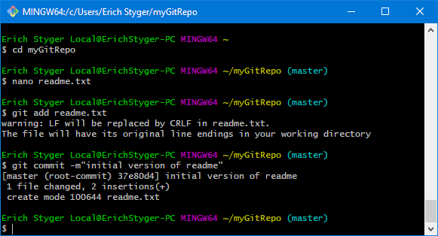

*Added file to the repository*

Instead of doing things on the command line, you are free to use [graphical clients](https://git-scm.com/downloads/guis).

**EGit Client for Eclipse**

I’m always having a GUI client installed beside of the command line version and the Eclipse plugin. Each client has its pros and cons, and I’m using [SourceTree](https://www.sourcetreeapp.com/" \t "_blank) which is free-of-charge. My model is:

1. Using a GUI client like SourceTree for normal working with Git
2. Using the command line version for more advanced things or for automation
3. Using the Eclipse plugin for working with Eclipse projects

My preference for an Eclipse plugin is "[EGit](http://www.eclipse.org/egit/)," for which I wrote [an article how to install into CodeWarrior](https://mcuoneclipse.com/2013/08/13/installing-egit-in-eclipse-and-codewarrior-for-mcu10-4/). Many Eclipse distributions already come with a Git client pre-installed, and the NXP MCUXpresso IDE comes with EGit, too.

Otherwise, use (or update) from the following Eclipse Update site (Help > Install New Software):

http://download.eclipse.org/egit/updates

Going forward, I will show how to use Eclipse (NXP MCUXpresso IDE 10.2) with EGit.

**Git Perspective and Repository Setup in Eclipse**

In Eclipse I switch to the Git perspective:

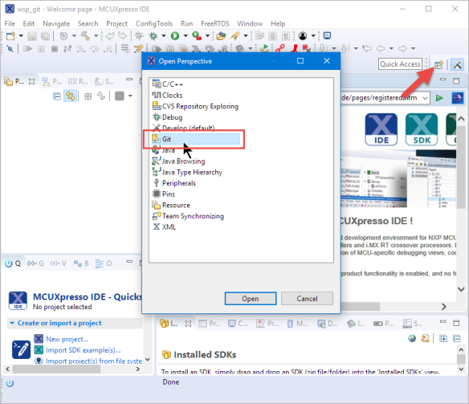

*Open Git Perspective*

From the Git perspective, I can add an existing repository (e.g. the one I have created above with the shell):

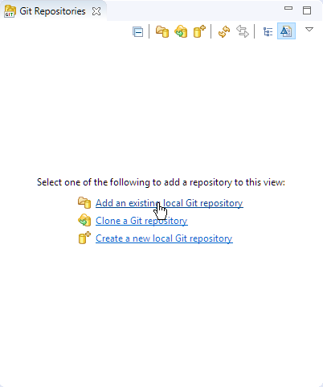

*Add existing repository*

Then browse to the repository folder and add it:

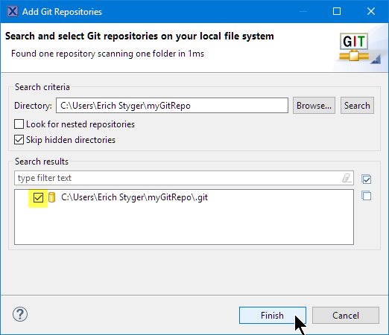

*Adding existing repo*

Instead of using the shell, I can use it to create a new repository, too:

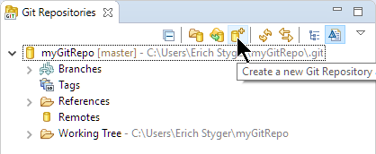

*Create a new repository*

Then it asks me for the repository folder name:

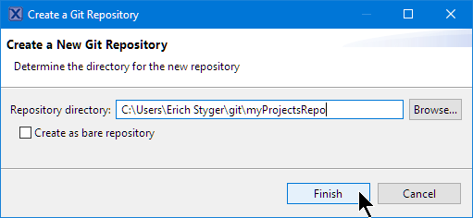

*New Eclipse Git repository*

and it adds it to the available repositories:

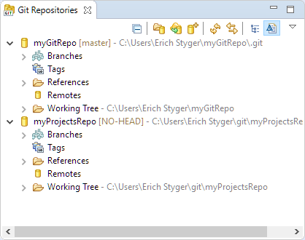

*List of repos*

Or I can clone from an existing repository, e.g. from GitHub. For this I use "clone":

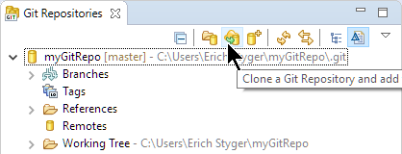

*Clone a Repository*

For example, I can clone and use the McuOnEclipse repository on GitHub:

https://github.com/ErichStyger/mcuoneclipse.git

**You won’t have access rights to push to that repository on GitHub. If you want to make changes to a GitHub repository, clone it on [GitHub](https://github.com/)to your own list of repository and use your repository URL.**

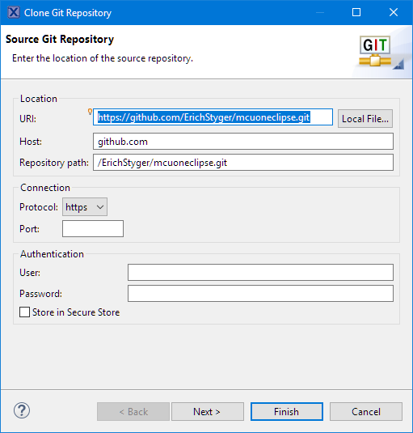

*Cloning McuOnEclipse*

Press next and select the desired branch (if any).

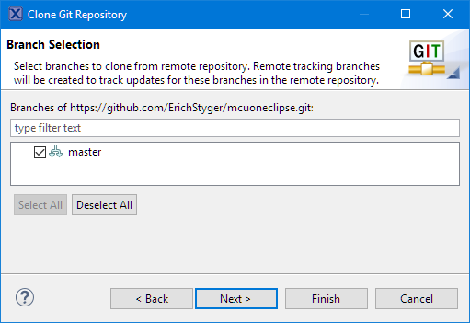

*Select branch*

Then specify the (new/empty) directory name where to clone the repository:

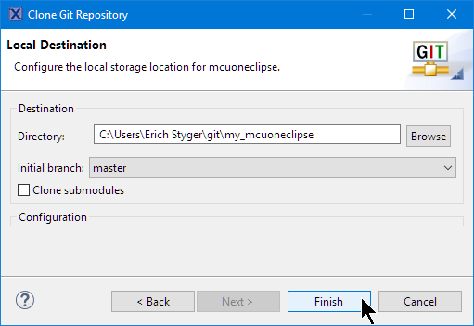

*Local Destination*

Press Finish and it will download repository content which might take a while depending on the data in the repository.

**Adding Projects to Repository**

With the repository configured, I can add an existing project to a repository. Right-Click on the project and select *Team > Share Project…*

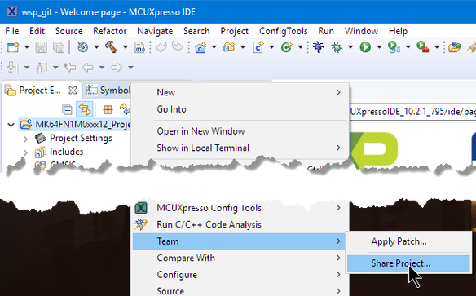

*Sharing Project*

Select the VCS to use:

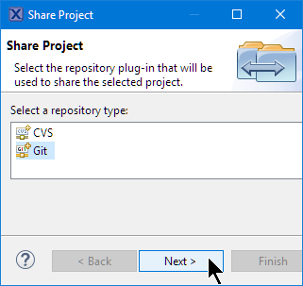

*Select VCS*

Select the repository to use and press Finish:

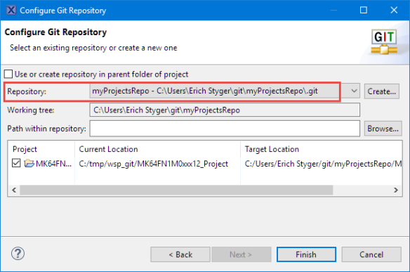

*Selected Repository*

**Ignore File**

Git uses the file **.gitignore** to filter (hide) files or folders which should not end up in the repository.

Git stores the list of files and folders to be ignored into a file named **.gitignore**. By default, the Project Explorer view hides all files starting with a dot. To show them, use the "Filters and Customization" menu:

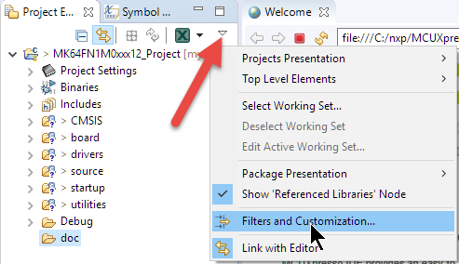

*Filters and Customization*

And then uncheck the \*.resources setting:

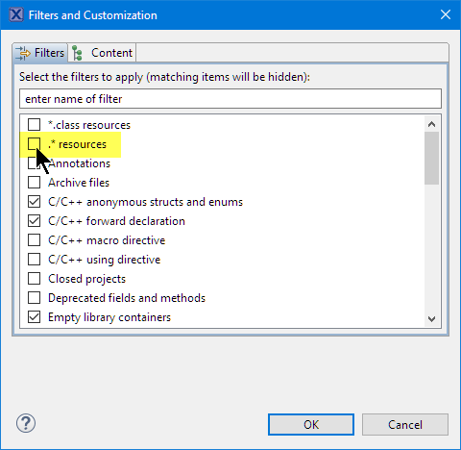

*Filters*

With this I can edit the .gitignore file inside Eclipse:

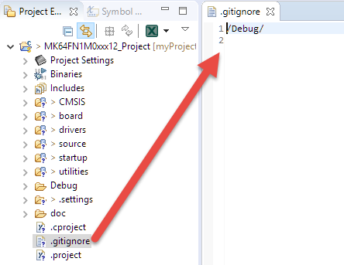

*Default .gitignore file*

The file is processed from the top to the bottom, with # used to start a comment line.

As a general rule: ignore everything which is derived or generated as it would easily create conflicts in the repository.

**For a list of things to be ignored for CodeWarrior and Processor Expert see**[**here.**](https://mcuoneclipse.com/2013/03/29/version-control-with-processor-expert-projects/)

**Update**: It is recommended to ignore the **.settings** folder of the project (see discussions in the comments section of this article). The .settings folder contains XML files with local plugin settings and are specific to the user. So do not put that folder into the version control system.

For MCUXpresso IDE and SDK projects it is very simple: only the output folder with the generated make and object files needs to be ignored which is usually named "Debug" and/or "Release." As seen from the above **.gitignore**, Eclipse already added this to the list, so we are fine.

**Commit**

In the previous step I have added the project to the list of changes. But it is not yet stored in the repository. For this I need to do a commit. With the project added I have now many more actions available in the Team menu:

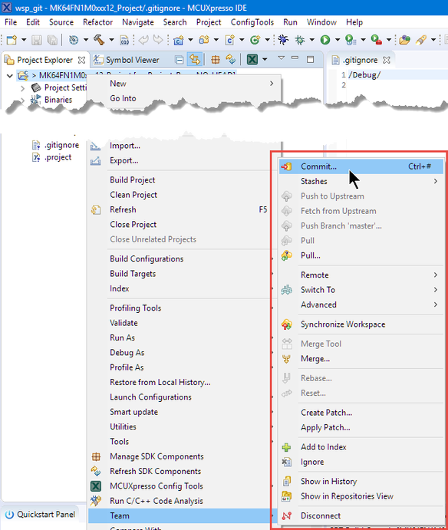

*Extended Team Menu*

With the "Commit…" menu item I get a Git Staging view:

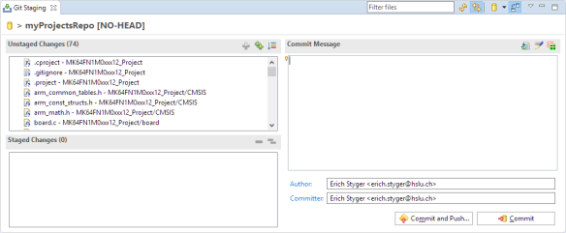

*Git Staging*

The left upper area shows all the changes. I have to stage them into the lower left area using drag&drop or using the "+" and "++" icons in that toolbar and add a commit message:

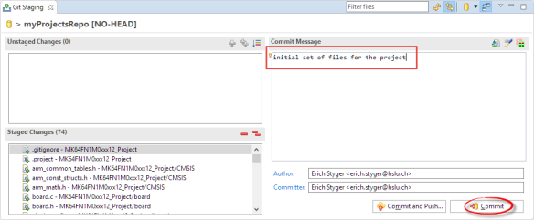

*Ready to commit*

Then I can commit (make the change in the local repository and push later) or do a commit with a push to the remote repository.

**I prefer to make smaller commits and then push them later. With a local (not shared) repository a push is not needed/possible as the push is to the remote repository.**

**Push, Pull and Compare**

The push action is available in the Team menu:

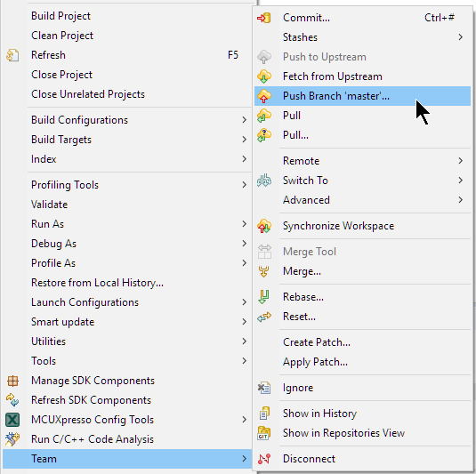

*Push*

In the same menu, I find the pull actions (to get the changes from the repository).

To compare the changes, double-click on the file and it opens the Eclipse diff view:

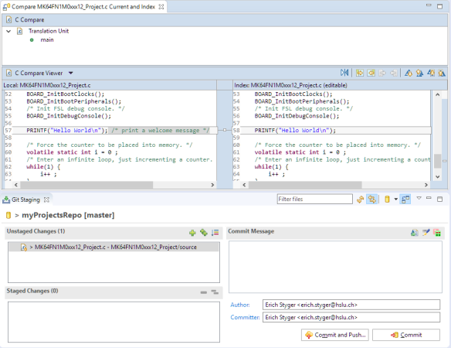

*Compare Changes*

**Import from Git**

Another cool thing is that I can import projects from Git into my workspace. I use the Import item from the File menu:

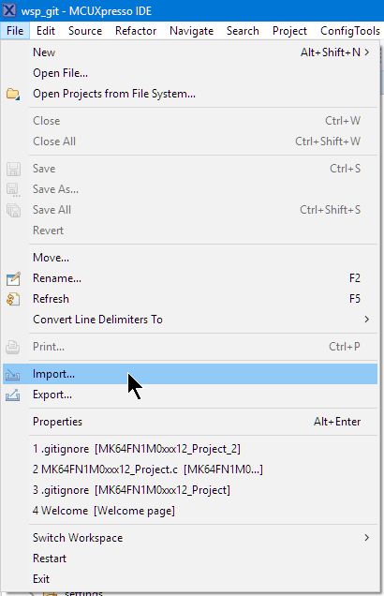

*Import*

Then select import from Git:

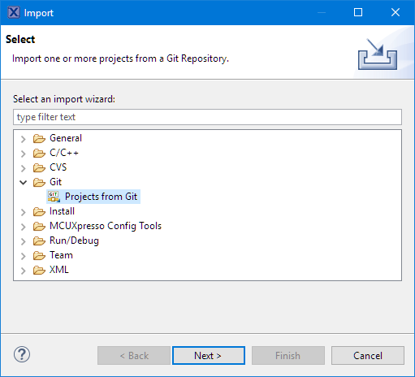

*Import Projects from Git*

Select the repository source:

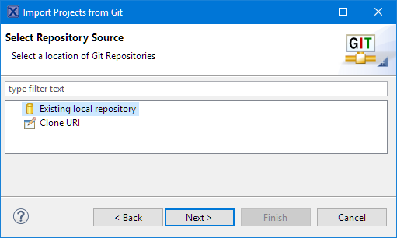

*Select Repository Source*

If you have cloned the McuOnEclipse repository, you can select that one or any of your repositories:

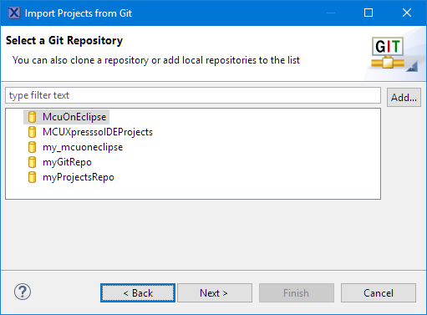

*Select Git Repository*

Then select the folder with the project(s) to import:

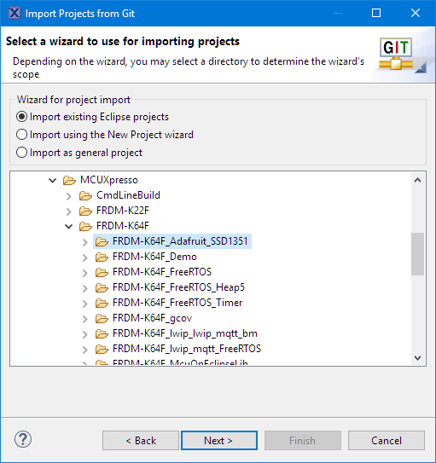

*Select Project to Import*

That way I can easily import projects from any repository.

As always with Eclipse, there are many ways to do one thing. Another way to import projects is from the Git Repositories view:

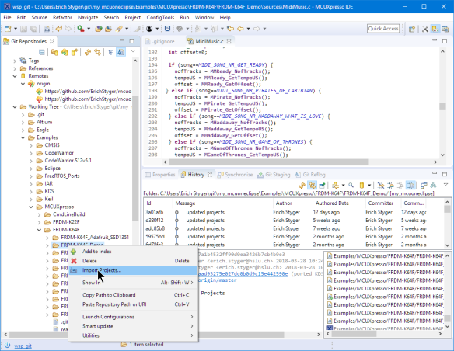

*Importing Git Projects*

**More Features**

Be free to explore more of the EGit features in Eclipse. I recommend going through the Git perspective default views. For example, the History view:

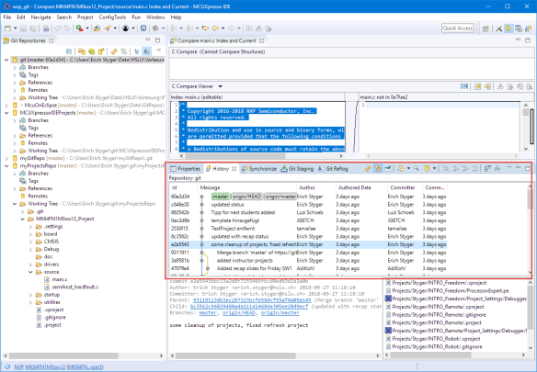

*Git History View*

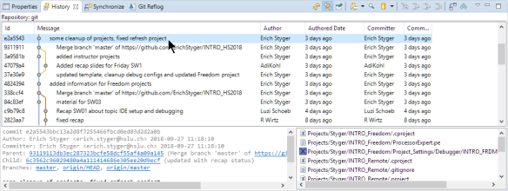

*Git History*

**Summary**

Eclipse with the EGit plugin makes it easy to work with the Git version control system. It takes a bit practice if not familiar with version control systems, but things are easy to learn and the internet is full of more tutorials and videos. Keep learning

.