Exploit embedded in HTTP POST request

url decoded malicious command:



Russia.sh



辙苈ɠ‡̠ᠡ辙臈 one of many Chinese characters found (even though it says russia.sh)

Strings in Malware:

Possible network attack features

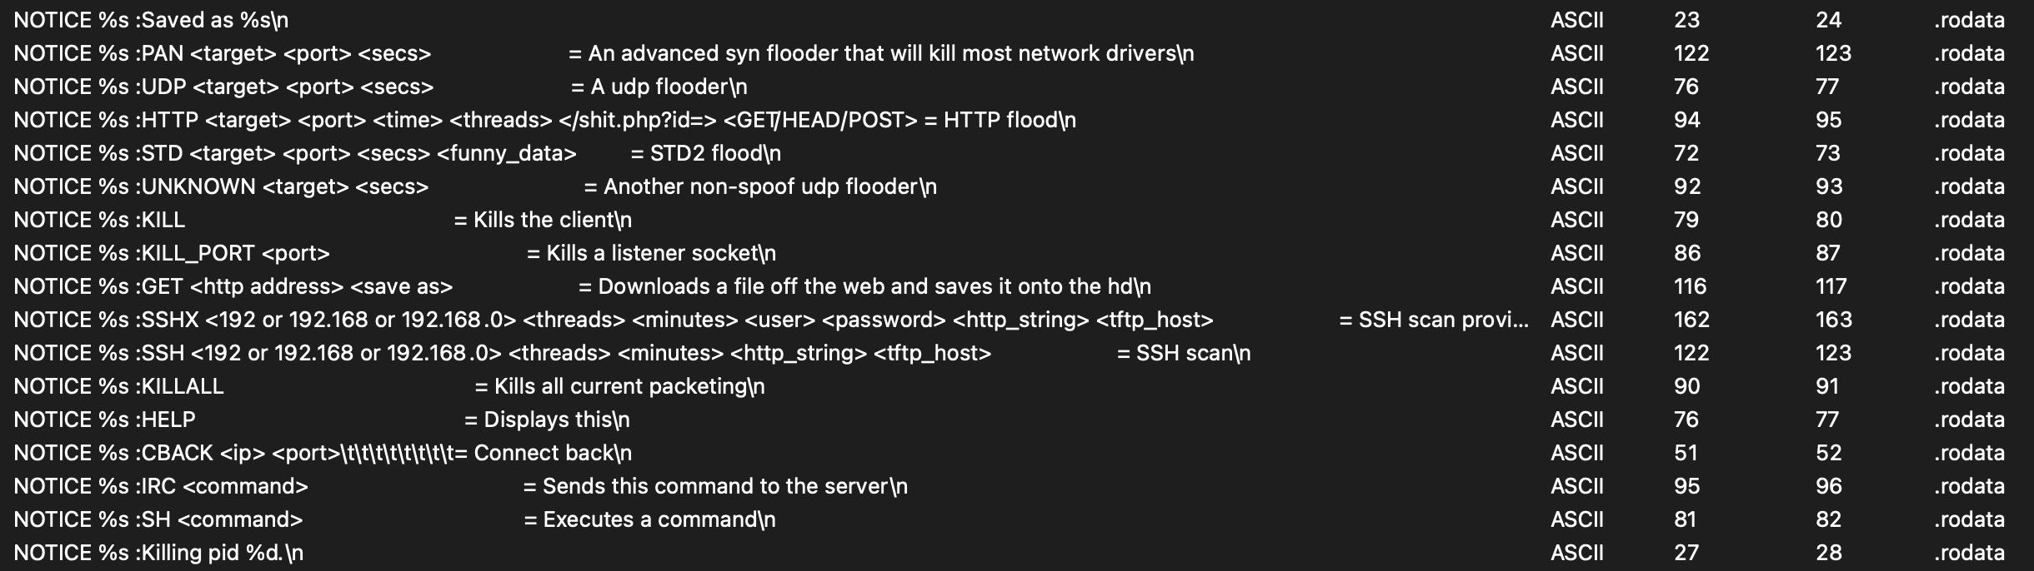

User Agent Strings it uses to blend into the network traffic:

