Lab10Lab21

The related codes are in the package. I have completed all methods required as follow:

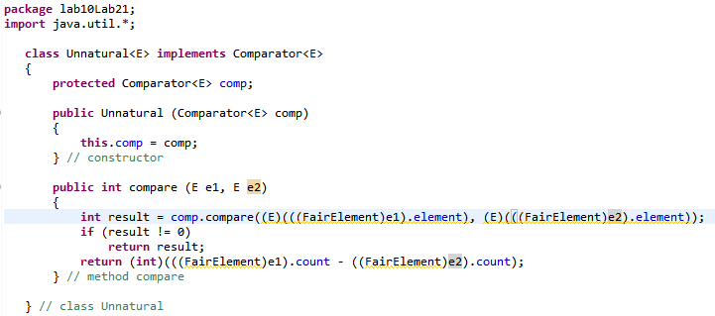

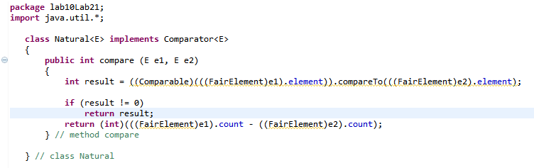

Then I come up with a series of relevant tests which are in the “FairPQTest.class” and all of them have passed as follow:

