Lab11

The related codes are in the package lab11. All running time of the three methods have been calculated out as follow:

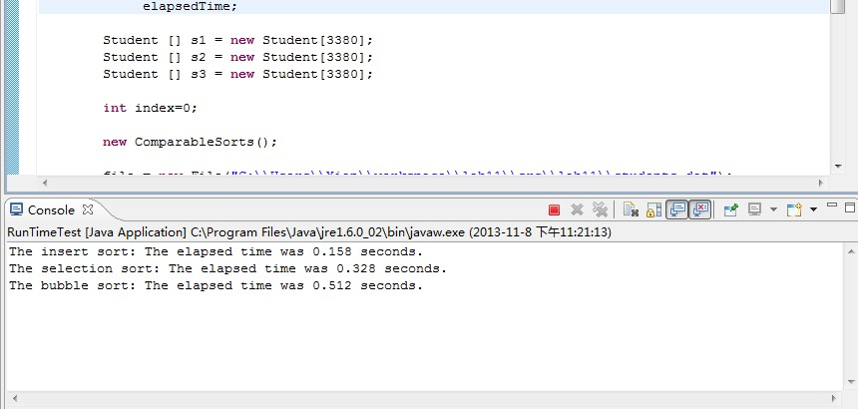

From the result, we can conclude that the insertion sort performs better than the selection sort and both of the two methods are superior to the bubble sort. As expected, the conclusion corresponds to what the professor showed in the previous course.