Lab12

The related codes are in the package lab12. All running time of the threes methods have been calculated as follow:

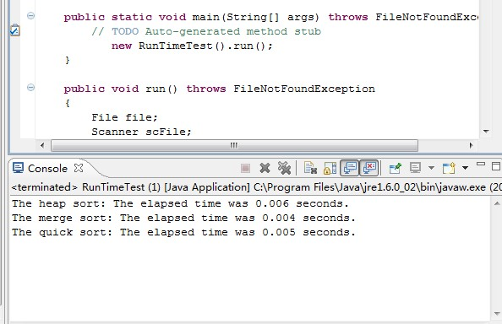

In my test, we can see that the heap sort performs a little worse than the other two and the merge sort works best among them.