Lab13

All codes are in the package lab13. For starting vertex A, the **breadth-first traversal** went through the graph as follow:

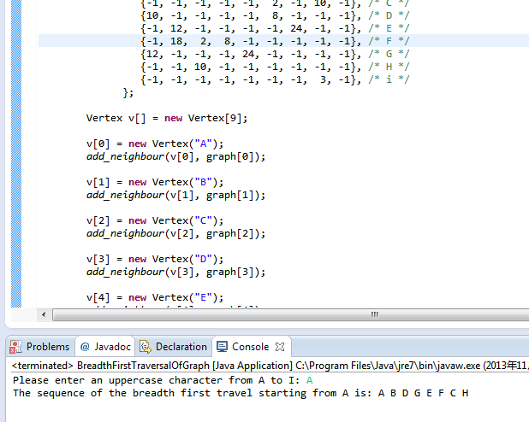

For starting vertex F, the **breadth-first traversal** went through the graph as follow:

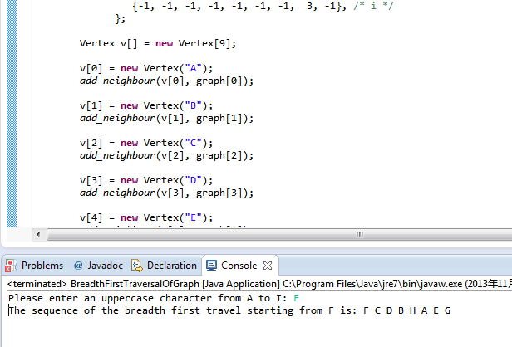

For starting vertex I, the **breadth-first traversal** went through the graph as follow:

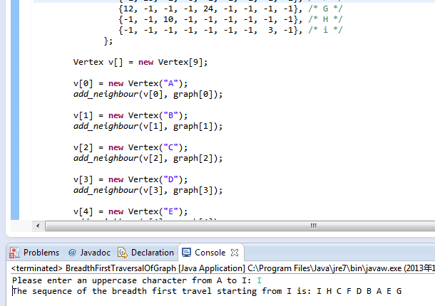

For starting vertex A, the **depth-first traversal** went through the graph as follow:

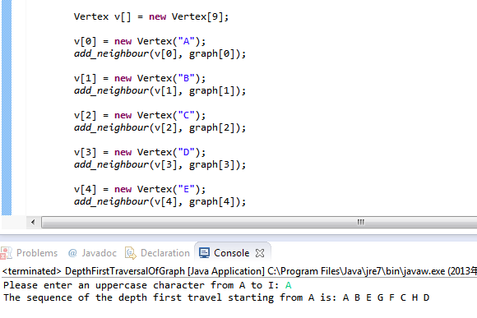

For starting vertex F, **the depth-first traversal** went through the graph as follow:

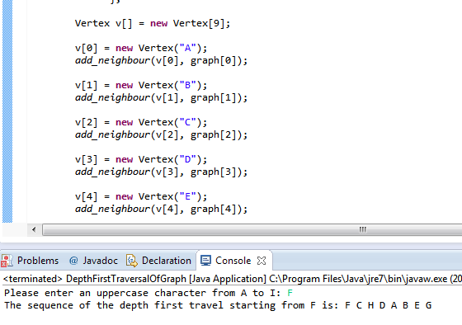

For starting vertex I, **the depth-first traversal** went through the graph as follow:

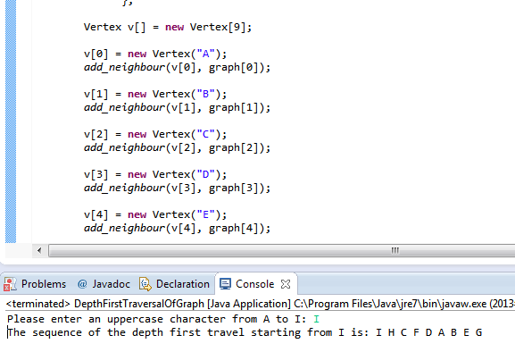

The graph which was discussed in the class is captured as follow:

