Lab6 in Lab3

The codes of the test classes are in the “.zip” file, under lab3Lab6 package. The ArrayCollectionTest1 class is to test the ArrayCollection class. The ArrayCollectionUserTest class is to test the ArrayCollectionUser class.

As you can see in the following picture, the ArrayCollectionTest1 class ran successfully, including the remove method and the equals method.

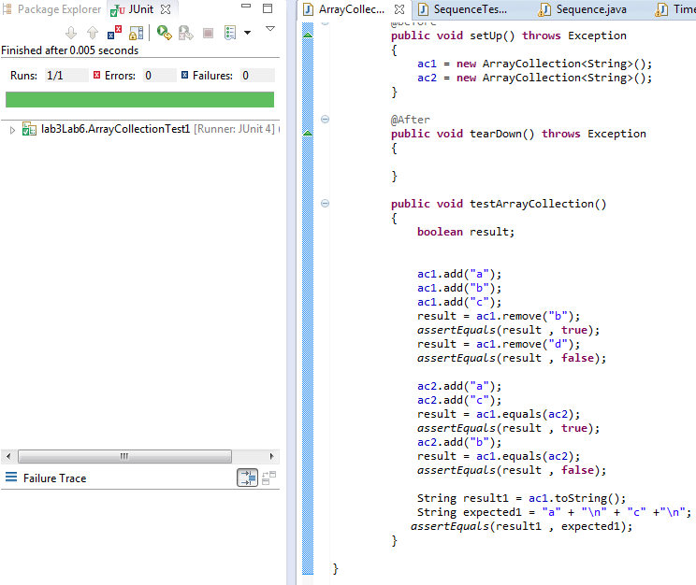

And the ArrayCollectionUserTest class also ran well. I checked what the “user” object contained after those methods had been called. The screenshot is as follow:

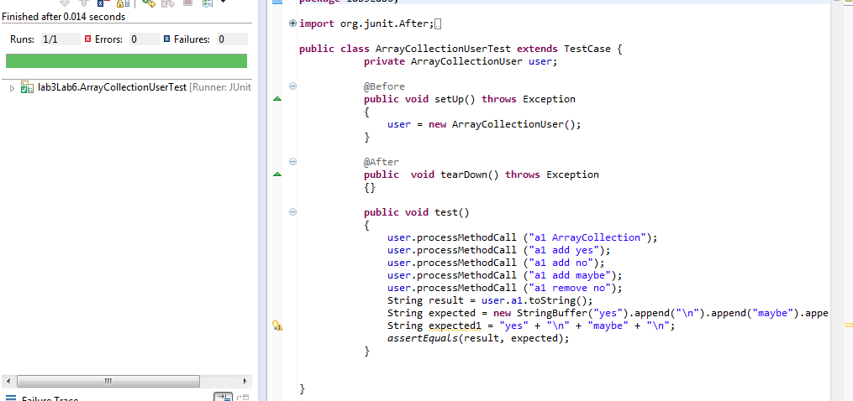

Project 4.1 of lab 3

The class files of this part are in the lab3Project4_1 package.

All methods have been defined in the “Sequence.java”.

The test class ran without failures or errors as follow:

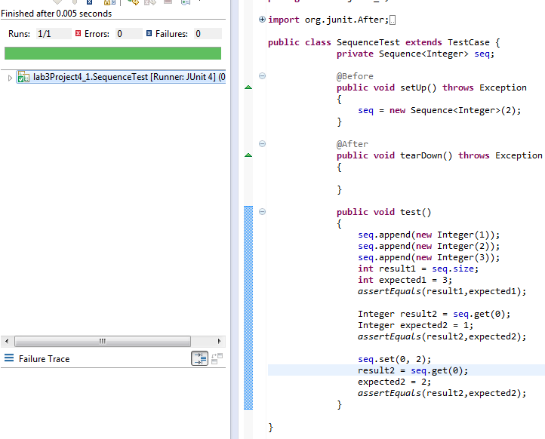

Lab7 in Lab3

The class files of this part are in the lab3Lab7 package.

My recursive Fibonacci method is developed in the “Fibonacci.java”. And the test class for it ran successfully:

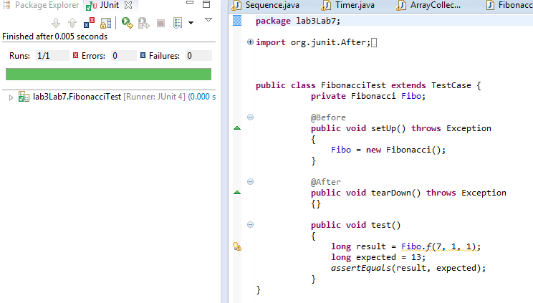

The results of the timing test to the four methods have been calculated out, as the following screenshot in the next page shows (the Timer class in package):

There are four results. The first one is the [original recursive version](http://www.cs.lafayette.edu/~collinsw/cs103/lab/lab07/code/fib1.java), and the following three are the [formula version](http://www.cs.lafayette.edu/~collinsw/cs103/lab/lab07/code/fib3.java), the [iterative version](http://www.cs.lafayette.edu/~collinsw/cs103/lab/lab07/code/fib2.java), and my recursive version in turn.

To conclude, the iterative versions always have better performances than the recursive ones. As my method are combination of the iterative version and the recursive version, its efficiency also lies between the two methods.

