**Lab5_lab12**

The modified “SingleLinkedList” and “SingleLinkedTest” files are included in the lab5Lab12 package. I took HourlyEmployee class as an input and test the method by many comparisons. And all test passed with the snapshot as follow:

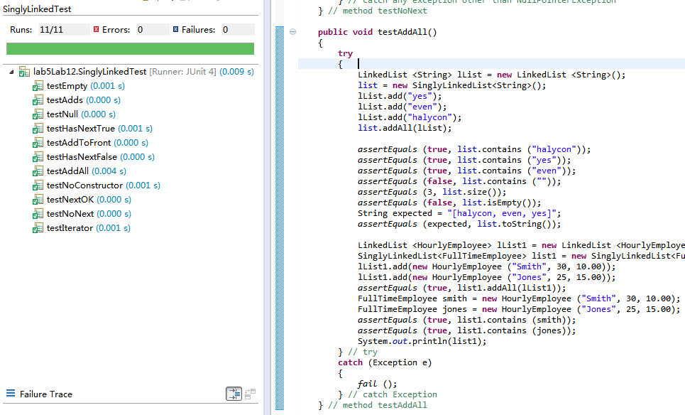

Then I have developed a new test method to check if the addAll method is able to throw NullPointerException correctly. Eventually, the test succeeded.

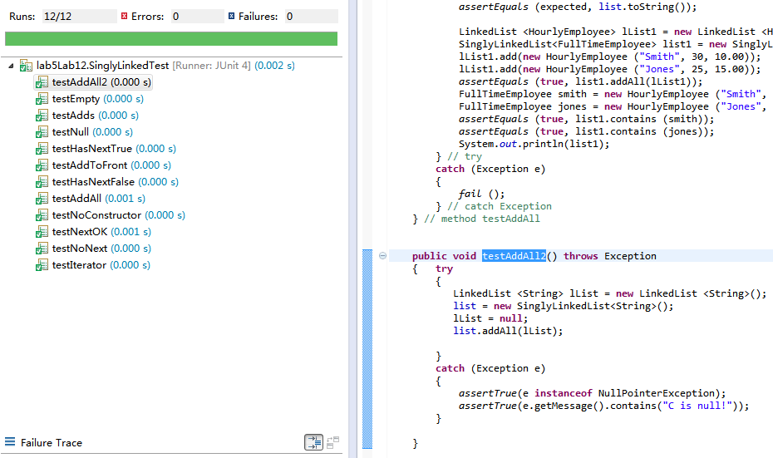

**Lab5_Exercise7.2**

The program is in the lab5Exercise7_2 package.

My hypothesis is the output would be “p,e,r,f,e,c,t”.

The snapshot is as follow:

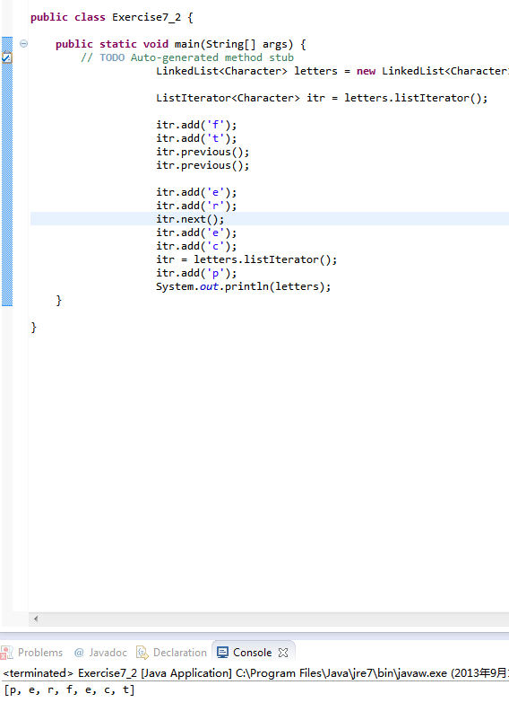

**Lab5_Exercise7.6**

The program is in the lab5Exercise7_6 package.

1. My hypothesis is the sequences would be legal.
2. My hypothesis is the sequences would be illegal, because there is no recent call to the next() method.
3. My hypothesis is the sequences would be illegal, because an add() has been called since the most recent call to next() method.
4. My hypothesis is the sequences would be legal.
5. My hypothesis is the sequences would be illegal, because there is no recent call to the next() method.
6. My hypothesis is the sequences would be illegal, because there is no recent call to the next() method.

The snapshot is captured as follow:

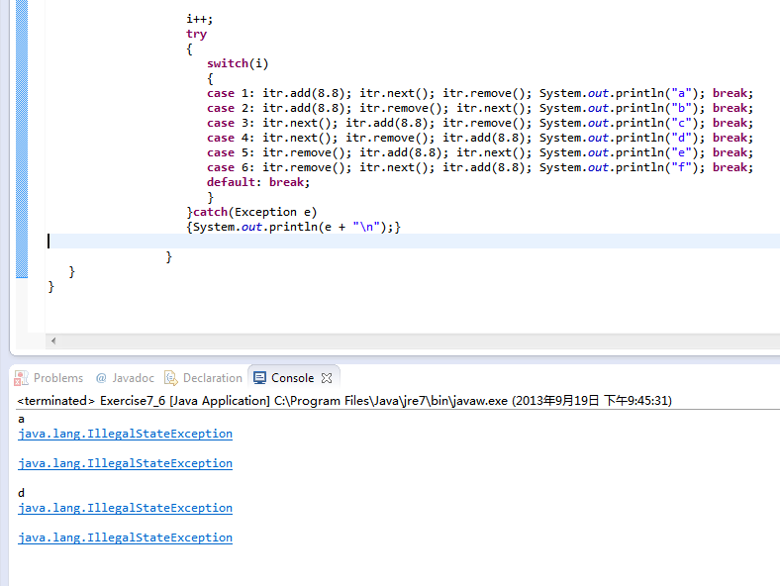

**Lab5_Part3**

The programs are in the lab5Part3 package. I have modified the add methods and the CS401LinkedListIterator inner class to meet the requirements. Also, I have developed a new class for test. All tests have passed shown in the following snapshot:

