Lab6Part1

The codes are in the package “lab6Part1”. I have added the required “remove()” method into the “CS401LinkedListImpl<E>” class. And the related tests are in the “TestForRemove” class. All tests required in this lab have passed as the following picture shows:

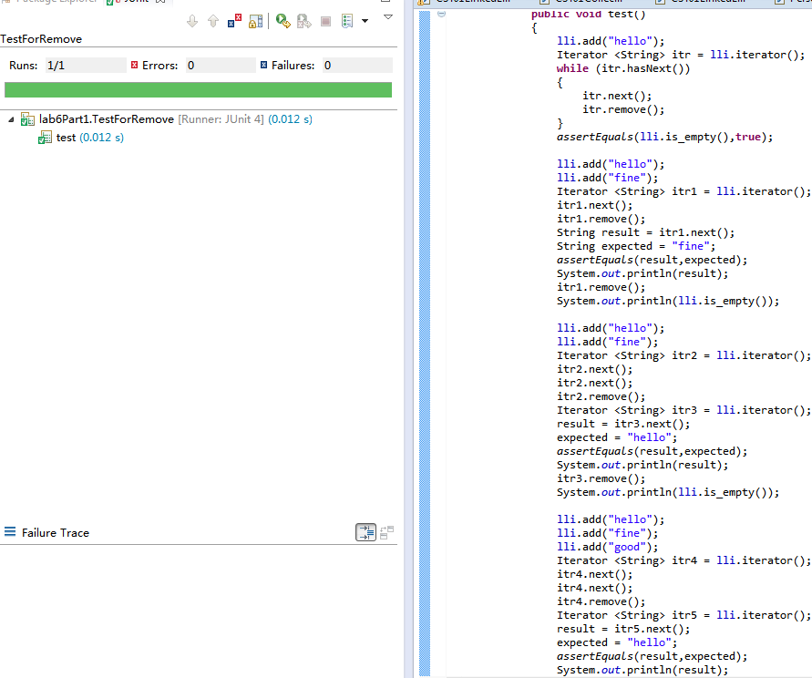

Lab6Part2

The codes for this part in the package “lab6Part2”. All missing parts have been filled in the “CS401DblLinkedListImpl<E>” class. And the relevant results of testing my methods are in the “RunningMyMethods” class. All five required results have been printed out successfully. Here is the snapshot:

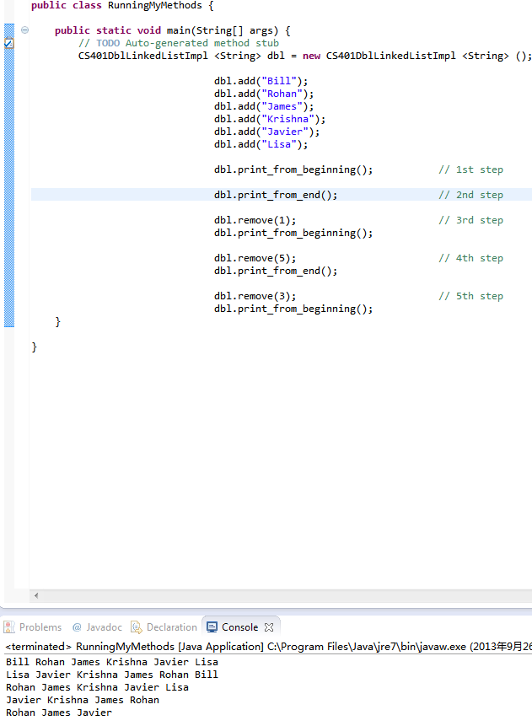

Lab6Part3

The programs are in the package “lab6Part3”. I have developed all methods in the “CS401StackLinkedListImpl<E>” class in order to implement a stack. And the related tests that are in the “TestForStack” class have passed as follow:

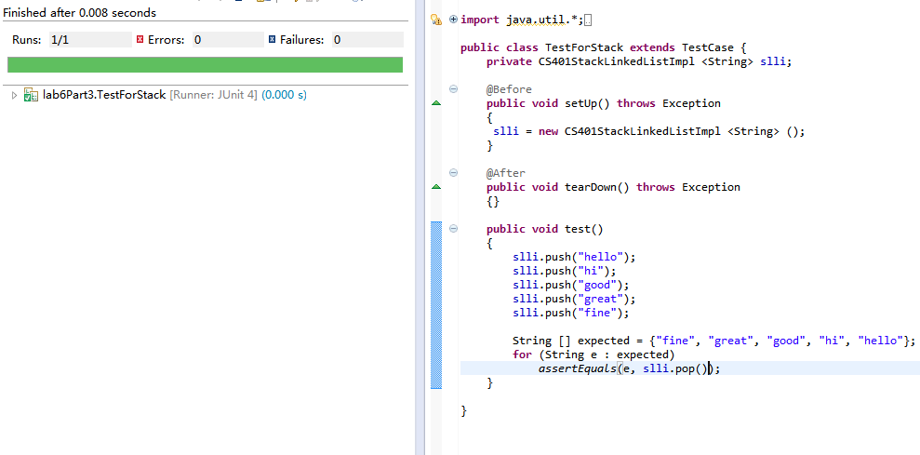

Lab6Part4

The codes are in the “Lab6Part4” package. All postfix expressions have been calculated out successfully. The snapshot is as follow:

