Lab7Part1

The related codes are in the package lab7Part1. I have come up with a test class for each of the queue class I designed. The snapshots for those test classes are as follow.

A queue implemented with array having fixed head:

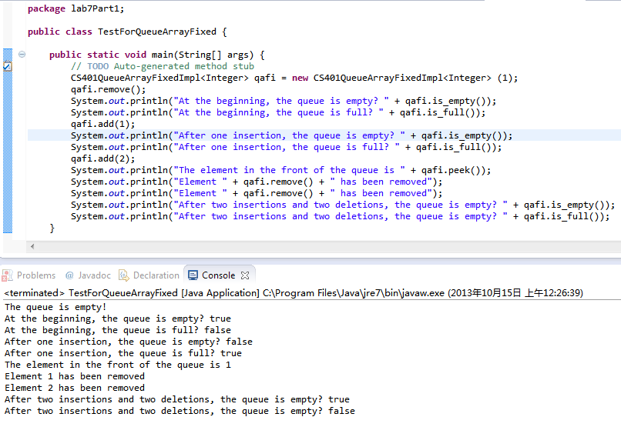

A queue implemented with array having floating head:

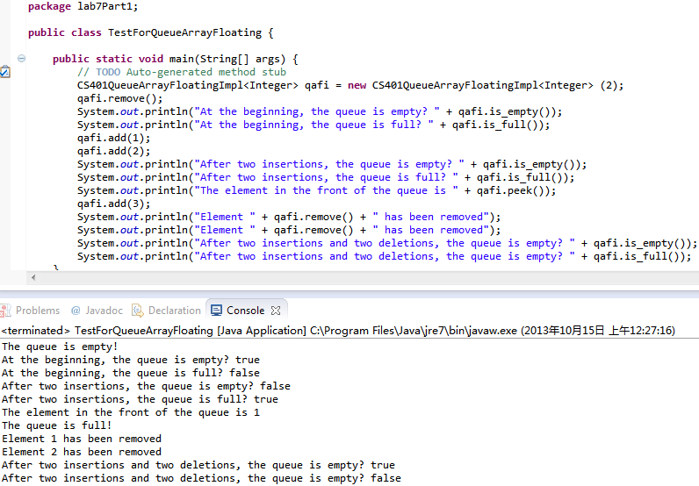

A queue implemented with a linked list:

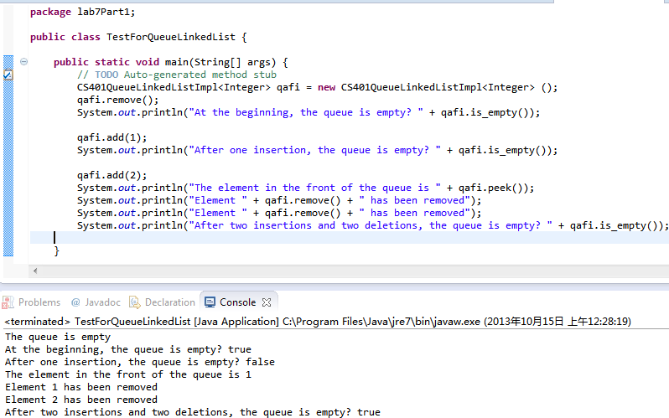

Lab7Part2

The related codes are in the package lab7Part2. The requirements demanded have been achieved. The data is same as what is given in the textbook. The snapshots are as follow:

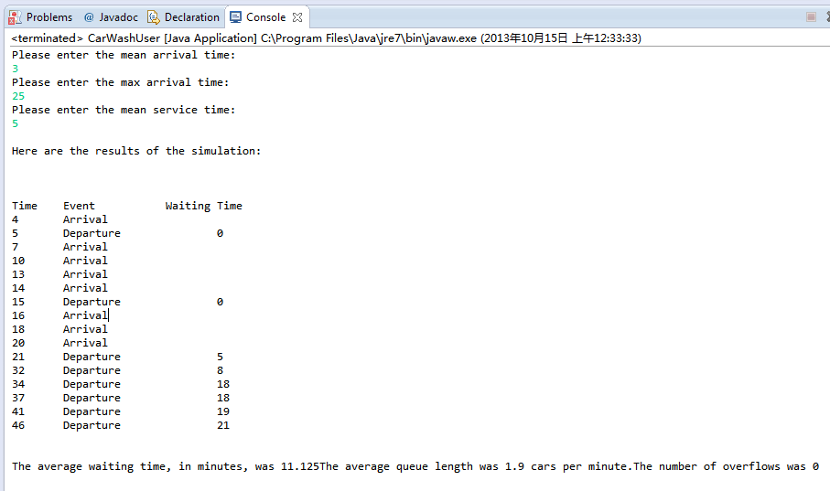

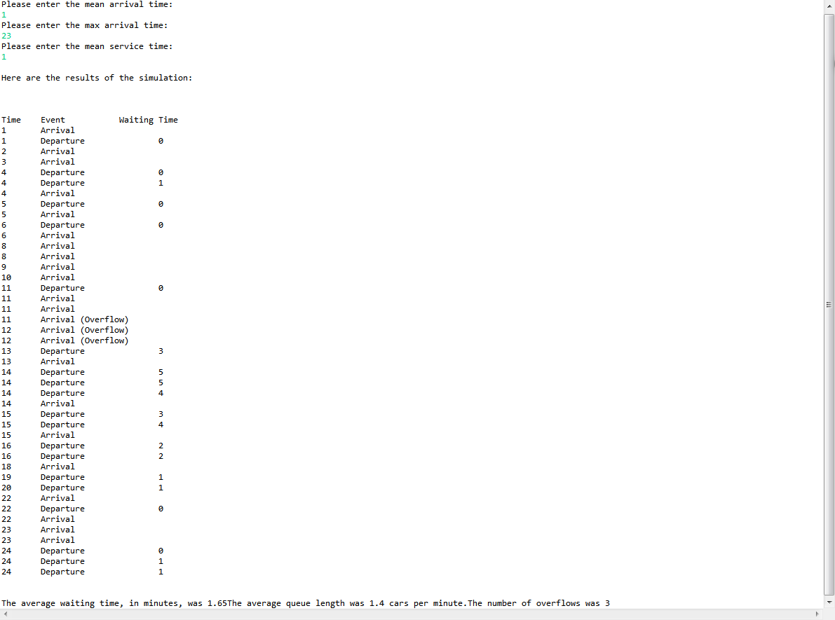

Lab7Part3

The related codes are in the package lab7Part3. The tests are as follow:

