Lab9Lab17

All codes are in the package lab9Lab17. First, I tested my “height()” method, and it has been proved to be correct as follow:

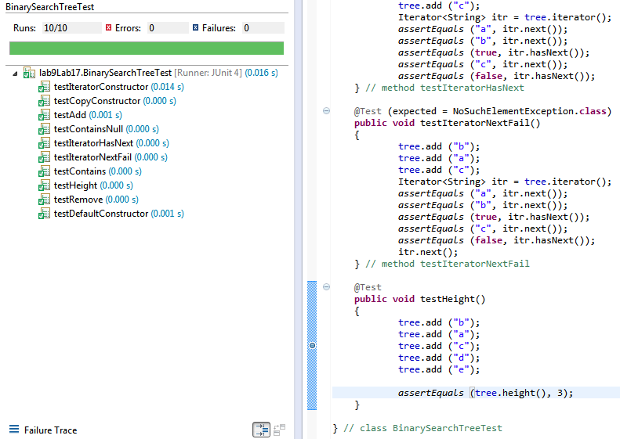

Then I ran the HeightEstimator program as required. The snapshot is as follow:

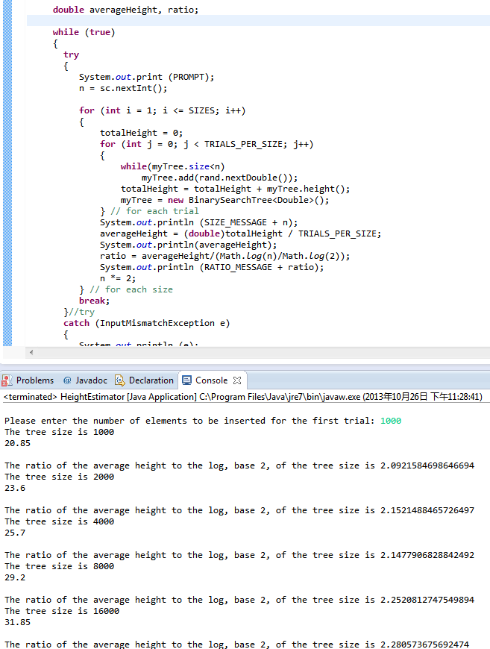

As is shown in the picture, when the number of elements increases exponentially, the tree size grows up in a linear way. Therefore, the complexity will be concluded as logarithmic in n.

Lab9Part2

The related codes are in the package lab9ProgrammingProject10_1. All tests required by the professor have passed as follow:

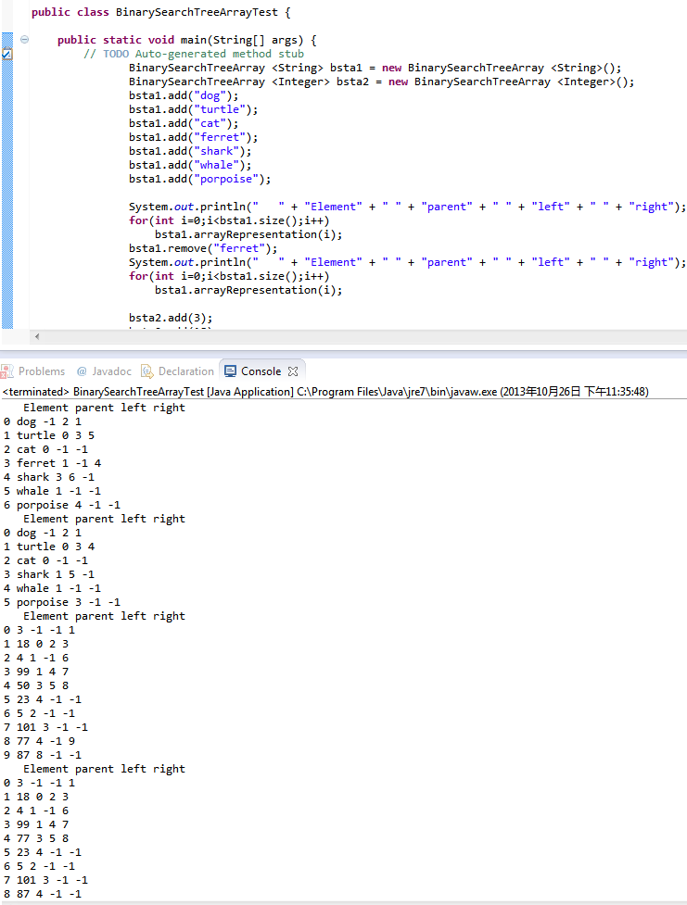

Lab9Part3

All relevant codes are in the package lab9ProgrammingExercises10_4. I replaced the previous “add()” method with my recursive “add()” method in the “BinarySearchTree.java” file. And then I ran the tests and all of them have passed. The snapshot is as shown as follow:

