西 安 邮 电 大 学

毕 业 设 计（外文翻译）

题 目：Design and Integration of Inventory Management System in E-Commerce Website for B2C Shopping Mall Based on Framework Technology

学 院： 计算机学院
专 业： 软件工程
班 级： 1604
学生姓名： 刘志远
导师姓名： 曾艳 职称： 讲师

Design and Integration of Inventory Management System in E-Commerce Website for B2C Shopping Mall Based on Framework Technology
Abstract: With the rapid development of network technology, the Web applications are used more widely, and the higher requirements on the Web system has been pursued by many people. The web applications should become more simple and convenient; also it requires some new internal adjustments in the Enterprise. The techniques of struts2, spring and the Hibernate are used in this paper, and these three kinds of lightweight frames are very popular at present, also the Ajax technology is introduced in our work to implement the development. According to the practical demands of the Back-state management of the B2C Shopping Mall and Inventory management system, this two systems are integrated, and these three framework technologies and Ajax technique are integrated which can in accordance with J2EE three-tier structure as well, finally the framework for Ajax+SSH (Struts+Spring+Hibernate) is realized.
Keywords: Struts2; Spring; Hibernate; Ajax; Back-state management; Inventory management system
1 Introduction
With the impulse of advancement for network technique and the rapid development of electronic commerce, online shopping has become the latest consumptive mode for consumers, particular for our younger generations who are more accept new concept and tend to pay more attention to it.
In consequence, more and more businessmen establish online malls and make this novel shopping concept accepted by consumers.
However, as for these online malls evolved from traditional malls, there are some redundant, even conflict issues existed in online and offline data management and its process. Especially, it is quite important for the adjustments between the former purchase-sell-stock management system and the latter Back-state management of the online shops, which has higher requirements for the output of the enterprise workload, the integrity and timeliness of the data.
In the past, the client/server architectures are adopted by the purchase-sell-stock management information system, which divides application into two parts. One is the server which is responsible for data management, and the other one is the Client which engages in the interaction with manager. A1s we known, the client/server architecture is has reflected the superiority, the Inventory management system's upgrade also has been put on the agenda. The improved model and the Back-state management of online mall are very similar, and this will give us opportunities on the integration or mutual expansion between them. The purpose of this paper is to design an online store Back-state management system with the Inventory management system in order to reduce unnecessary data's duplication for input and output and ensure timeconsistency between the two systems described above.
2 Related techniques
The purpose of this paper is to construct online mall inventory management integrated system using the concept of purchase-sell-stock management system.
The current three open-source frameworks and Ajax technique are used in our research. Struts serves as a MVC pattern of framework, which separates business logic and data performance effectively, optimizes the system structure, and improves the system extensibility as well. Spring is a lightweight J2EE application framework, and it reduces coupling degree between systems effectively through the reverse control characteristic. Hibernate is an open-source persistence layer framework, and it reduces the complexity of database development and improve the portability of the system with the use of JDBC package. Finally, Ajax combines several technologies, it promotes the user experience through asynchronous refresh and optimizes data transfer between the browser and the web server, more importantly, and it also efficiently reduces the unnecessary data round trip and bandwidth consumption.
These three frameworks and Ajax technology are integrated in accordance with J2EE three-tier structure, it forms the framework of Ajax + SSH (Struts + Spring + Hibernate) and the framework is used in the development of online mall back-stage management system. Spring is responsible for the work of business logic layer, which implements the application system with the business logic for the transaction and other functions. The presentation layer can be implemented in the technique of Struts, such as page displaying, responding to users’ requests etc. The mainly task of Hibernate is in the data persistence layer, such as completes the interactive function with database. In addition, we will use technology of Ajax to optimize the JSP page in the framework, and with the helping of the local refresh technology to manage the objects in one page, so as to avoid the frequent jump between more pages and make the system run more smoothly.
3 The Integration between Struts and Spring Techniques
There are various methods to integrate Struts and Spring, three of them are very popular, which are Spring’s ActionSupport, Spring's DelegatingRequestProcessor and Action's full authority Agency used in Struts. The last one is considered the best of the three.
The Struts’ Action can be entrusted to the Spring framework so as to decouple the code, therefore the struts’ application can take advantage of the features used in Spring. Moreover, once Spring controls the Struts Action, it can be used to add more vitality to the Struts Action. The control of the procedure is as follows: Firstly, registered plug-in of the Spring in the struts-config.xml file. Then, set type attributes of the action as org.springframework.web.struts.DelegatingActionProxy, the action is delegated to the Spring. Finally, a path attribute of the action tag corresponding to a bean are configured in configuration file applicationContext.xml of Spring.
4 The Integration between Spring and Hibernate
The file hibernate.cfg.xml is the most important configuration file of Hibernate. The classes which need persistency and some related global properties are defined in this file, Spring does some encapsulation and interface conversion to Hibernate through the class of LocalSessionFactoryBean, in this way, and then we can use unified method to deal with Spring and Hibernate. At the same time, it also provides a global SessionFactory. In this paper, we will adopt the methods of putting SessionFactory into HibernateTemplate to make the integration between Spring and Hibernate.
The key is that the basic resources which Hibernate needs are provided and injected by Spring. Hibernate creates the DataSource required by SessionFactory, the Session which is necessary for executive persistence and the affairs control which is essential for accessing to the persistence layer access are also created by the Hibernate. These logics which are controlled by the code originally had to be controlled by Spring as a Spring bean container now. Spring manages SessionFactory by applicationContext.xml, and does configuration management of the connection between the SessionFactory and the database by using applicationContext.xml .
According to the description above, the structure of Struts, Hibernate and Spring is displayed in Fig 1. The frames are divided into three layers which are the Presentation Layer (web layer), Business Layer and Persistence Layer. Each frame is responsible for the realization of one layer: The Presentation Layer uses Struts, Spring is used in the Business Layer, and Hibernate is used in the Persistence Layer. Each layer in the application has a clear responsibility, each application layer is independent, but it keeps consistency with each other. These frame levels in a loose coupling effect of each other and do not take the low-level technical details into consideration.
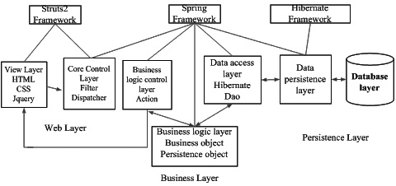
Fig 1. The framework of Struts，Hibernate and Spring
Due to the fact is subjected to HTML, the B/S application cannot use abundant effects to display the data just like the C/S application, any interaction operation with the server are all required to refresh the page, this means that it needs 2 to 5 seconds delay, which leads to poor users' experience, however, introducing AJAX technique in the web applications based on J2EE can well solve these problems. In this mode, the data which was sent directly to the user performance layer was change to return the available data to Ajax Engine. These data includes plaintext, xml and other formats, the only requirement is that Ajax engine can understand and parse the data, the details is displayed in Fig 2.
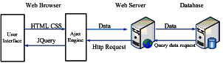
Fig 2. The application model of the Ajax web
5 Analyses and Design
After researching the current disconnection between the existing website backstage and purchase-sale-exist management system, the following defects are discovered as follows, Inefficiency, low speed of processing, data transmit not in time, inaccurate, duplication of labor and causing data inconsistencies and so on. The defects have constrained the managers' creativity, and it is difficulty to keep up with the changes of modernization market. However, through the integration of the applications between the techniques of Ajax and SSH framework, we can combine the characteristics of B2C online mall, make some improvement in system design. The conception is described as follows.
First, because the web mall's foreground and background has a very close relationship, there are some important modules in the mall’s foreground, which are web news bulletin, the part of merchandise display, website shopping module, web users’ module and website commodity comments module etc. The detailed modules are described in Fig 3.
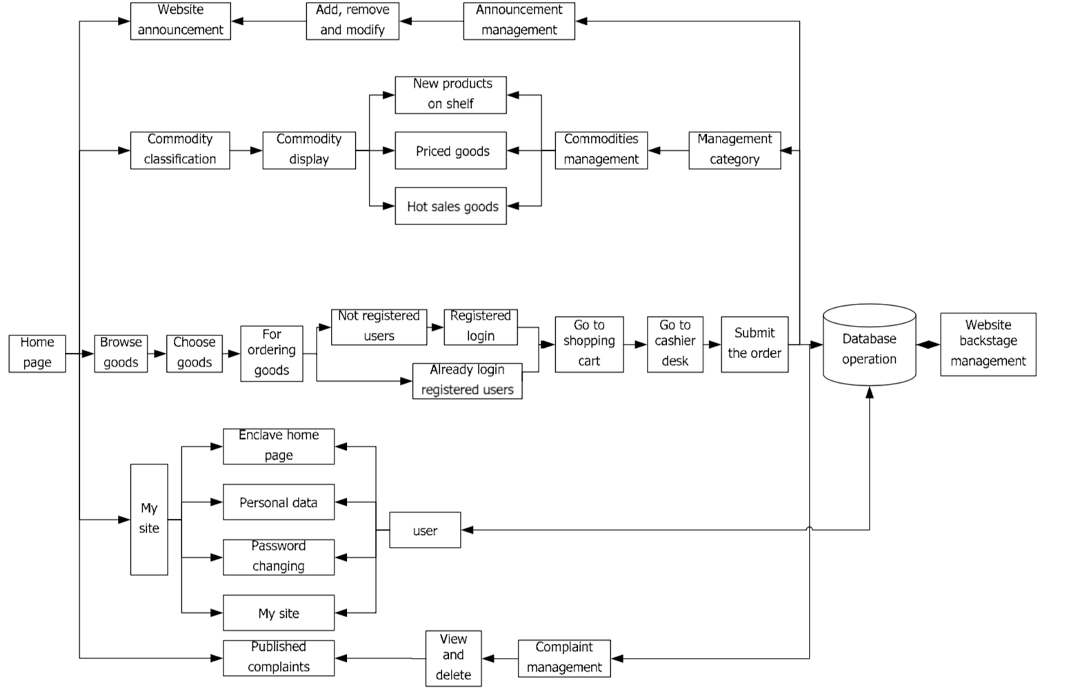
Fig 3. The detailed modules
As shown in Fig 3, these five parts are closely related with the background, and will be reflected in the background one by one, they are news bulletin management, merchandise management, sales management, membership management and commodity comments management. Among them, the shopping module and commodity display module are the most crucial parts of the purchasesell-stock management system, and also the relation is the closest of all. It is difficult to integrate back-state management and purchase-sell-stock management system. The following will focus on this part and introduce in detail.
The relationship between back-state management and purchase-sell-stock management system includes six parts. Firstly, when the registered members complete the shopping process, the data will enter into the sales management module and order management module, and the best sellers list is worked out. Secondly, after registered member confirms the receiving information, then the data will enter into the order management module and inventory management module. Thirdly, after registered member collect merchandise, then the data will enter into the sales management module, and generate preference list. Then, after registered member comments merchandise, then the data will enter into the sales management module, the management module analyses information and improves commodity procurement and sales plan. Again, when procurement department have new commodity, sales management will put commodities on the shelf, and generate latest products. Finally, if some goods is in a large inventory, after approval by related department, the sale department generate Special sale list.
There are four parts in business models, which are purchasing management, sales management, inventory management and financial management. The analyses of their relationships are as follows.
There are three relationships between inventory management and sales management. Firstly, sales management apply to put the goods on the shelves, compare selling quantity and inventory quantity, then according to the difference value and the stock warning level to determine further action. When the difference value is higher than the stock warning level, execute sales outbound operation, at the same time reduce warehouse inventory, at last salesmen put the commodities on the shelves; when the difference value is lower than the stock warning level, by implementing the above strategy and the purchasing information was sent to the purchasing department, and the information content is drew up by the sales department and inventory management departments together. Secondly, the sales department put the goods off shelves, off-theshelf products will be returned to the inventory department, and they will do in-stockroom operation according to the commodity attribute (such as period, product category). Thirdly, the inventory department put forward outbound sales application to the sales department under a certain conditions (such as near the validity or other outbound cordon).
There are three relationships between inventory management and purchasing management. Firstly, the inventory department put forward purchasing application, the purchasing department and the financial department executes procurement operation according to the order information. Secondly, the purchasing department issues the purchase notice, and the inventory department executes commodity input operation. Thirdly, the inventory department issues a return outbound notice and executes goods delivery operation, and then purchasing department will negotiate with suppliers.
There are two relationships between order management and inventory management. Firstly, after the customer complete the payment process, order department take orders operation according to order information and the follow-up logistics is carry on also, and then inventory departments carry out goods delivery processing. Secondly, after the customer receives the goods, if problem appears and the sales department agrees to return, and then the inventory management executes the handling of return goods.
After the above analysis, simple purchase-sell-stock management system was joined into online background management system as an expansion, and a new website backstage management system is created. The summary of each module is displayed in Fig 4.
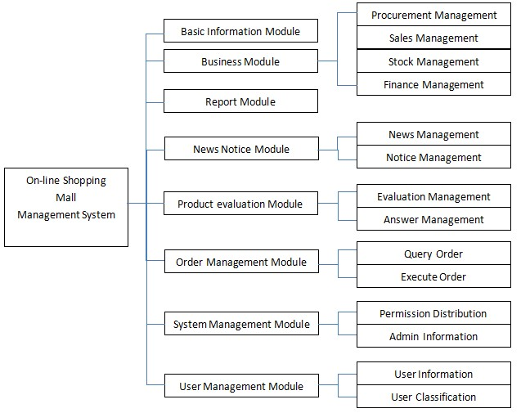

The following portions are the briefly extension to the above, basic information module is mainly responsible for data backup, recovery and browse the system log. The main functions of the financial management are statistical sales revenue, expenditure, the budget, profit distribution and funds occupy, the treatment of providers paid, accounts payable and the capital turnover control are also done in this module. In addition, the financial statistics about online sales, sales calculation within day, month and season are also completed in this module. Sales management is an indispensable part of the daily operation, which fully embodies the advantages of automation, compatible with all the features of commodity management.
There are also some module functions which are described as follows, inquiries about the mall sales situation; the statistical analysis about sales and gross profit, inquires the commodity quotes, and other special treatment and discount, controlling on the sale of goods and printing the form, the inquiry about the details of the sales, new products on selves and old products off selves, and the management of commodity price and other functions.
Inventory management is mainly responsible for incoming goods, inventories revision and query, carrying out the inventory reports and so on. The functions of this module are as follows, providing timely inventory goods type, stock, quality, price, storage location and other information. According to the inventory loss, overflow and inventory management, effectively reduce the inventory loss, enhance the effective inventory, support receptionist sales, and obtains reasonable merchandise ordering cycle and quantity. Purchasing management can input, modify, query and analyze in real time, and print a variety of documents according to purchase orders, indent and returned purchase invoice. According to replenishment orders and sales situation to draw up purchasing plan and cooperate with order management department to finish distribution management and return money management.
6 Conclusions
J2EE three-tier structure and the current popular web application development framework are analyzed and studied, Ajax + SSH (Struts + Spring + Hibernate) framework is formed based on the techniques described above, in this paper this Ajax + SSH (Struts + Spring + Hibernate) framework is applied to B2C website background management, it has effectively changed the condition that client code is redundant, reduced the burden and later maintenance on the client, and the difficulty about expansion issues is resolved as well. In addition, it also greatly enhances the efficiency of the staff and avoids the cumbersome, messy and long cycle of In-out warehouse, and it makes that the system can quickly respond to market changes.
[1] (America) Marty Hall, Larry Brown. Core Servlet and JavaServer Pages: Volume 1: Core Technologies 2nd Edition [M]. PEARSON Prentice Hall, 2004.
[2] LI Gang. the actual practice of Lightweight Java EE enterprise application--Integration and development using Struts 2, Spring and Hibernate [M]. BeiJing: Electronic industry press, 2007.
[3] YANG Shaobo. J2EE Project training-Hibernate frame technology [M]. BeiJing: Tsinghua university press, 2008.
[4] YUAN Shuai. The introduce of the business module in purchasesell-stock management system based on Java (in Chinese) [J]. China science and technology exhibition, 2008.8 .
[5] ZHAO Xiaoxia. Invoicing Management System Design and Implementation (in Chinese) [J]. Coal Technology, 129(101), Jan, 2010.
[6] LIU Bin. Proficient in Java Web integration and development: JSP+AJAX+Strust+Hibernate[M]. Electronic industry press, 2007.11.
[7] SHA Shixuan, WANG Shan. An introduction to database system (3rd Edition) [M]. Higher education press, 2000.
[8] KE Baicong. Ajax Development—conception, Case and the framework [M]. Electronic industry press, 2006.5.
[9] LI Xiaojun. The design and implementation in Electronic commerce system. BeiJing: Mechanical industry press, 2007.8.
[10] YANG Shulin, HU Jieping. The latest Java language practical case tutorial. BeiJing: Tsinghua university press, 2006.
[11] Rob Harrop, Jon Machacek. development guidelines for Spring ( slation team translation). BeiJing: Mechanical industry press, 2006.8.
[12] William Crawford, Jonathan Kaplan. J2EE Design Patterns[M]. o’Reilly. 2003.9 .
[13] Bruce Eckel. Thinking in Java. 3rd Edition[M]. Prentice Hall， Inc, 2003.

基于框架技术的B2C购物中心电子商务网站库存管理系统的设计与集成
摘要:随着网络技术的飞速发展，Web应用的应用越来越广泛，许多人对Web系统提出了更高的要求。网络应用程序应该变得更简单和方便;这也需要企业内部进行一些新的调整。本文使用了struts2、spring和Hibernate技术，这三种轻量级框架是目前比较流行的，并在工作中引入了Ajax技术来实现开发。根据实际的要求Back-state B2C购物中心的管理和库存管理系统,这两个系统集成,和这三个框架技术和Ajax技术集成,可以按照J2EE三层结构,最后对Ajax框架+ SSH (Struts + Spring + Hibernate)实现。

Keywords: Struts2; Spring; Hibernate; Ajax; Back-state管理; 库存管理系统

1介绍
随着网络技术进步的推动和电子商务的迅猛发展，网上购物已经成为消费者最新的消费方式，特别是我们年轻的一代，他们更容易接受和关注新概念。
因此，越来越多的商家建立了网上商城，使这种新奇的购物理念得到了消费者的认可。
然而，这些由传统商城发展而来的网上商城，在数据管理和管理过程中存在着一些冗余甚至冲突。其中，前购销管理系统与后网上商店的后台管理之间的调整尤为重要，这对企业工作量的输出、数据的完整性和实时性提出了更高的要求。
以往的购销管理信息系统采用的是客户端/服务器架构，将应用程序分为两部分。一个是负责数据管理的服务器，另一个是与manager交互的客户端。据我们所知，客户/服务器架构是其优势的体现，库存管理系统的升级也提上了日程。改进后的模式与网上商城的后台管理非常相似，这将给我们提供整合或相互扩展的机会。本文的目的是设计一个在线商店的后台管理系统和库存管理系统，以减少输入和输出不必要的数据重复，保证两个系统之间的时间一致性。

2相关技术
本文的目的是利用进销存管理系统的概念来构建网上商城的在线管理集成系统。
我们的研究采用了现有的三种开源框架和Ajax技术。Struts作为一种MVC模式的框架，有效地分离了业务逻辑和数据性能，优化了系统结构，提高了系统的可扩展性。Spring是一个轻量级的J2EE应用程序框架，它通过反向控制特性有效地降低了系统之间的耦合程度。Hibernate是一个开放源码的持久层框架，它减少了数据库开发的复杂性，并通过使用JDBC package提高了系统的可移植性。最后，Ajax结合了多种技术，通过异步刷新实现了用户体验，优化了浏览器和web服务器之间的数据传输，更重要的是有效地减少了不必要的数据往返和带宽消耗。
这三种框架与Ajax技术按照J2EE的三层结构进行融合，形成了Ajax + SSH (Struts + Spring +)的框架,并利用该框架开发了网上商城后台管理系统。Spring负责业务逻辑层的工作，业务逻辑层通过事务的业务逻辑等功能实现应用系统。表示层可以用Struts技术实现，如页面显示、响应用户请求等。Hibernate的主要任务是在数据持久层，如完成与数据库的交互功能。此外，我们将使用Ajax技术对框架中的JSP页面进行优化，并借助本地刷新技术对一个页面中的对象进行管理，从而避免在更多pages之间频繁跳转，使系统运行更加顺畅。

3.Struts和Spring技术的集成
有多种方法可以集成Struts和Spring，其中有三种非常流行，分别是Spring的ActionSupport、Spring的DelegatingRequestProcessor和Struts中使用的Action的全权代理。最后一个被认为是三个中最好的。
Struts的动作可以委托给Spring框架来解耦代码，因此Struts的应用程序可以利用Spring使用的特性。此外，一旦Spring控制了Struts，就可以使用它为Struts添加更多的活力。该过程的控制如下:首先，在struts-config.xml文件中注册Spring的插件。然后，将动作的类型属性设置为org.springframework.web.struts。委托actionproxy，操作被委托给Spring。最后，在Spring的配置文件applicationContext.xml中配置与bean对应的操作标记的路径属性。

4.Spring和Hibernate之间的集成
xml文件是Hibernate最重要的配置文件。该文件定义了需要persistency和一些相关全局属性的类，Spring通过LocalSessionFactoryBean类对Hibernate进行了一些封装和接口转换，这样我们就可以使用统一的方法来处理Spring和Hibernate。同时，它还提供了一个全局的SessionFactory。在本文中，我们将采用将SessionFactory放入HibernateTemplate的方法来实现Spring与Hibernate的集成。
关键是Hibernate需要的基本资源是由Spring提供和注入的。Hibernate创建SessionFactory所需的数据源，该会话是执行持久性和对于访问持久层访问至关重要的事务控制也由Hibernate创建。这些逻辑最初由代码控制，现在必须由Spring作为Spring bean容器来控制。Spring通过applicationContext管理SessionFactory。并使用applicationContext.xml对SessionFactory和数据库之间的连接进行配置管理。

根据以上描述，Struts、Hibernate和Spring的结构如图1所示。该框架分为表示层(web层)、业务层和持久层。每一帧都负责一个层的实现:表示层使用Struts，业务层使用Spring，业务层使用Hibernate。应用程序中的每一层都有明确的可重用性，每一层都是独立的，但彼此保持一致。这些框架级别之间存在松散耦合效应，并且没有考虑到底层的技术细节。
图1.Struts、Hibernate和Spring的框架

由于受到HTML, B / S应用程序不能使用丰富的效果来显示数据和C / S应用程序一样,任何与服务器交互操作都需要刷新页面,这意味着它需要2到5秒的延迟,这导致了糟糕的用户体验,但是,引入AJAX技术在基于J2EE的web应用程序可以解决这些问题。在此模式下，将直接发送给用户性能层的数据更改为返回给Ajax引擎的可用数据。这些数据包括明文、xml和其他格式，唯一的要求是Ajax引擎能够理解和解析这些数据，详细信息如图2所示。
图2.Ajax web的应用程序模型
5.分析与设计
通过对现有网站后台与购销管理系统目前断开的研究，发现存在以下缺陷:效率低、处理速度慢、数据传输不及时、不准确、重复劳动、造成数据不一致等。这些缺陷制约了管理者的创造力，使其难以跟上现代化市场的变化。但是，通过Ajax技术与SSH框架的应用集成，可以结合B2C网上商城的特点，在系统设计上做一些改进。概念描述如下。
首先，由于网络商城的前台和后台有着非常密切的关系，所以在商城的前台有一些重要的模块，分别是网络新闻发布、商品展示部分、网站购物模块、网站用户模块和网站商品评论模块等。具体模块如图3所示。
图3.详细的模块
如图3所示，这五个部分与背景紧密相关，将会一一体现在背景中，它们是新闻公告管理、商品管理、销售管理、会员管理和商品评论管理。其中，购物模块和商品展示模块是进销存管理系统中最关键的部分，也是关系最密切的部分。摘要后台管理和进销存管理系统的集成是一个难点。下面将围绕这一部分进行详细介绍。
后台管理与进销存管理系统的关系包括六个部分。首先，当注册会员完成购物流程后，数据将进入销售管理模块和订单管理模块，并生成畅销书列表。其次，注册会员确认接收信息后，数据将进入订单管理模块和库存管理模块。第三，注册会员收集商品后，数据将进入销售管理模块，生成偏好列表。然后，注册会员评论商品后，再将数据进入销售管理模块，进行管理模块分析信息，完善商品采购和销售计划。再次，当采购部门有新的商品时，销售管理部门会将商品上架，并生成最新的产品。最后，如果有些商品库存较大，经相关部门批准后，销售部门生成专用销售清单。
商业模式分为采购管理、销售管理、库存管理和财务管理四个部分。对其关系的分析如下。
在库存管理和销售管理之间有三种关系。首先，销售管理应用商品上架，比较销售数量和库存数量，然后根据差值和库存预警等级来决定下一步的行动。当差值高于库存预警水平时，执行销售出库操作，同时减少库存，最终销售人员将商品上架;当差值低于库存预警水平时，通过实施上述策略，将采购信息发送给采购部门，信息内容由销售部门和库存管理部门共同制定。其次，销售部门将货物下架，下架产品返回到库存部门，根据商品属性(如周期、产品类别)进行入库操作。第三，库存部门在一定条件下(如接近有效期限或其他出库限制)向销售部门提出出库申请。
在库存管理和采购管理之间有三种关系。首先，库存部门提出采购申请，采购部门和财务部门根据订单信息进行采购操作。其次，由采购部发出采购通知单，由库存部执行商品输入操作。第三，由库存部门发出退货出库通知并执行发货操作，然后由采购部门与供应商进行谈判。
订单管理和库存管理之间有两种关系。首先，在客户完成付款流程后，订单部门根据订单信息进行订单操作，并进行后续物流，然后库存部门进行发货处理。其次，客户收到货物后，出现问题，销售部门同意退货，由库存管理部门对退货进行处理。
通过以上分析，将简单的进销存管理系统作为扩展加入到在线后台管理系统中，创建了一个新的网站后台管理系统。各模块的摘要如图4所示。
以下部分是对上述模块的简单扩展，基本信息模块主要负责数据备份、恢复和浏览系统日志。财务管理的主要功能有销售收入统计、支出统计、预算统计、利润分配、资金占用统计、供应商支付处理、应付账款处理、资金周转控制。另外，网上销售的财务统计，日、月、季的销售计算也在这个模块中完成。销售管理是日常经营中不可缺少的一部分，充分体现了自动化的优点，符合商品管理的所有特点。
还有一些模块功能，描述如下:查询商场销售情况;统计分析销售和毛利,查询商品报价,和其他特殊治疗和折扣,控制商品的出售和印刷形式,调查关于销售的细节,对自我和旧产品的新产品的自我,和管理的大宗商品价格和其他功能。
库存管理主要负责进料、库存修订与查询、执行库存报表等。该模块的功能如下，及时提供库存商品类型、库存、质量、价格、库位等信息。根据库存损失、溢货和库存管理，有效减少库存损失，提高有效库存，支持前台销售，获得合理的订货周期和数量。采购管理可以实时输入、修改、查询和分析，并根据采购订单、订货和退货发票打印各种单据。根据补货订单和销售情况制定采购计划，配合订单管理部门完成配送管理和退货管理。
6.结论
J2EE三层结构和当前流行的web应用程序开发框架进行了分析和研究,Ajax + SSH (Struts + Spring + Hibernate)框架形成基于上述技术,本文Ajax + SSH (Struts + Spring + Hibernate)框架应用于B2C网站后台管理,有效地改变了状态,客户机代码冗余,减少了负担,以后维护客户,同时也解决了扩容的难题。此外，也大大提高了工作人员的工作效率，避免了进出仓库繁琐、凌乱、周期长，使系统能够快速响应市场变化。

[1] (America) Marty Hall, Larry Brown. Core Servlet and JavaServer Pages: Volume 1: Core Technologies 2nd Edition [M]. PEARSON Prentice Hall, 2004.
[2] LI Gang. the actual practice of Lightweight Java EE enterprise application--Integration and development using Struts 2, Spring and Hibernate [M]. BeiJing: Electronic industry press, 2007.
[3] YANG Shaobo. J2EE Project training-Hibernate frame technology [M]. BeiJing: Tsinghua university press, 2008.
[4] YUAN Shuai. The introduce of the business module in purchase-sell-stock management system based on Java (in Chinese) [J]. China science and technology exhibition, 2008.8 .
[5] ZHAO Xiaoxia. Invoicing Management System Design and Implementation (in Chinese) [J]. Coal Technology, 129(101), Jan, 2010.
[6] LIU Bin. Proficient in Java Web integration and development: JSP+AJAX+Strust+Hibernate[M]. Electronic industry press, 2007.11.
[7] SHA Shixuan, WANG Shan. An introduction to database system (3rd Edition) [M]. Higher education press, 2000.
[8] KE Baicong. Ajax Development—conception, Case and the framework [M]. Electronic industry press, 2006.5.
[9] LI Xiaojun. The design and implementation in Electronic commerce system. BeiJing: Mechanical industry press, 2007.8.
[10] YANG Shulin, HU Jieping. The latest Java language practical case tutorial. BeiJing: Tsinghua university press, 2006.
[11] Rob Harrop, Jon Machacek. Professional development guidelines for Spring (Redsaga translation team translation). BeiJing: Mechanical industry press, 2006.8.
[12] William Crawford, Jonathan Kaplan. J2EE Design Patterns[M]. o’Reilly. 2003.9 .

[13] Bruce Eckel. Thinking in Java. 3rd Edition[M]. Prentice Hall， Inc, 2003.

