${title}诊断报告

诊断结果：${result}

|  |  |  |  |
| --- | --- | --- | --- |
| 姓名 | 性别 | 年龄 | 职业 |
| ${name} | ${sex} | ${nianling} | ${zhiye} |
| ${name1} |  |  |  |

# 寿命曲线

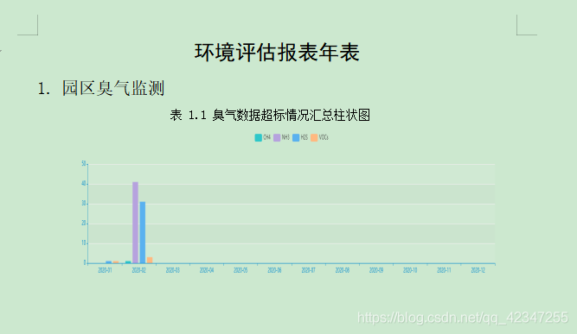

# 诊断结论:

${jielun}

# 参与分析指标:

|  |  |  |  |  |
| --- | --- | --- | --- | --- |
| 名称 | 2 |  |  |  |

# 效能直方图指标：

|  |  |  |  |  |
| --- | --- | --- | --- | --- |
| 名称 | 3 |  |  |  |

# 机器直方图指标：

|  |  |  |  |  |  |
| --- | --- | --- | --- | --- | --- |
| 名称 | 4 |  |  |  |  |

# 其他指标展示：