* Chart Builder.
GGRAPH
/GRAPHDATASET NAME="graphdataset" VARIABLES=INDFMPIR MISSING=LISTWISE REPORTMISSING=NO
/GRAPHSPEC SOURCE=INLINE.
BEGIN GPL
SOURCE: s=userSource(id("graphdataset"))
DATA: INDFMPIR=col(source(s), name("INDFMPIR"))
GUIDE: axis(dim(1), label("Ratio of family income to poverty"))
GUIDE: axis(dim(2), label("Frequency"))
GUIDE: text.title(label("Simple Histogram of Ratio of family income to poverty"))
ELEMENT: interval(position(summary.count(bin.rect(INDFMPIR))), shape.interior(shape.square))
END GPL.

GGraph

Notes
Output Created |  | 01-NOV-2026 21:45:37
Comments
Input | Data | C:\Users\aSUS\Downloads\Statics\FilteredData.sav
Input | Active Dataset | DataSet3
Input | Filter | RIAGENDR = 2 AND RIDAGEYR >= 20AND RHQ010 >= 6 AND RHQ010 <= 19AND INDFMPIR >= 0 (FILTER)
Input | Weight | <none>
Input | Split File | <none>
Input | N of Rows in Working Data File | 2512
Syntax |  | GGRAPH  /GRAPHDATASET NAME="graphdataset" VARIABLES=INDFMPIR MISSING=LISTWISE REPORTMISSING=NO  /GRAPHSPEC SOURCE=INLINE.  BEGIN GPL  SOURCE: s=userSource(id("graphdataset"))  DATA: INDFMPIR=col(source(s), name("INDFMPIR"))  GUIDE: axis(dim(1), label("Ratio of family income to poverty"))  GUIDE: axis(dim(2), label("Frequency"))  GUIDE: text.title(label("Simple Histogram of Ratio of family income to poverty"))  ELEMENT: interval(position(summary.count(bin.rect(INDFMPIR))), shape.interior(shape.square))  END GPL.
Resources | Processor Time | 00:00:00.17
Resources | Elapsed Time | 00:00:00.11

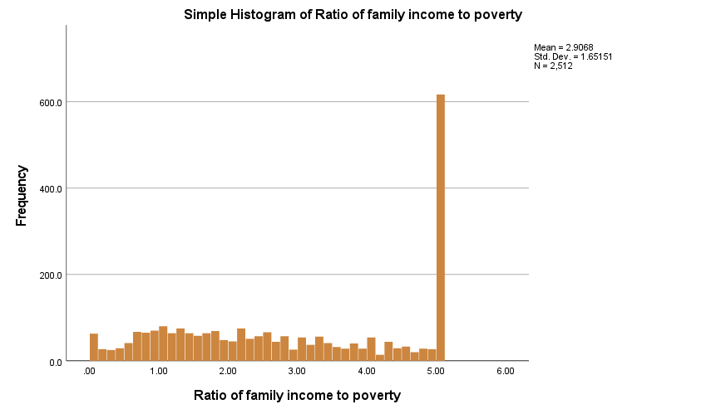

* Chart Builder.
GGRAPH
/GRAPHDATASET NAME="graphdataset" VARIABLES=INDFMPIR PHQ9_Total MISSING=LISTWISE REPORTMISSING=NO
/GRAPHSPEC SOURCE=INLINE
/FITLINE TOTAL=NO SUBGROUP=NO.
BEGIN GPL
SOURCE: s=userSource(id("graphdataset"))
DATA: INDFMPIR=col(source(s), name("INDFMPIR"))
DATA: PHQ9_Total=col(source(s), name("PHQ9_Total"))
GUIDE: axis(dim(1), label("Ratio of family income to poverty"))
GUIDE: axis(dim(2), label("PHQ9_Total"))
GUIDE: text.title(label("Scatter Plot of PHQ9_Total by Ratio of family income to poverty"))
ELEMENT: point(position(INDFMPIR*PHQ9_Total))
END GPL.

GGraph

Notes
Output Created |  | 01-NOV-2026 21:47:24
Comments
Input | Data | C:\Users\aSUS\Downloads\Statics\FilteredData.sav
Input | Active Dataset | DataSet3
Input | Filter | RIAGENDR = 2 AND RIDAGEYR >= 20AND RHQ010 >= 6 AND RHQ010 <= 19AND INDFMPIR >= 0 (FILTER)
Input | Weight | <none>
Input | Split File | <none>
Input | N of Rows in Working Data File | 2512
Syntax |  | GGRAPH  /GRAPHDATASET NAME="graphdataset" VARIABLES=INDFMPIR PHQ9_Total MISSING=LISTWISE REPORTMISSING=NO  /GRAPHSPEC SOURCE=INLINE  /FITLINE TOTAL=NO SUBGROUP=NO.  BEGIN GPL  SOURCE: s=userSource(id("graphdataset"))  DATA: INDFMPIR=col(source(s), name("INDFMPIR"))  DATA: PHQ9_Total=col(source(s), name("PHQ9_Total"))  GUIDE: axis(dim(1), label("Ratio of family income to poverty"))  GUIDE: axis(dim(2), label("PHQ9_Total"))  GUIDE: text.title(label("Scatter Plot of PHQ9_Total by Ratio of family income to poverty"))  ELEMENT: point(position(INDFMPIR*PHQ9_Total))  END GPL.
Resources | Processor Time | 00:00:00.13
Resources | Elapsed Time | 00:00:00.10

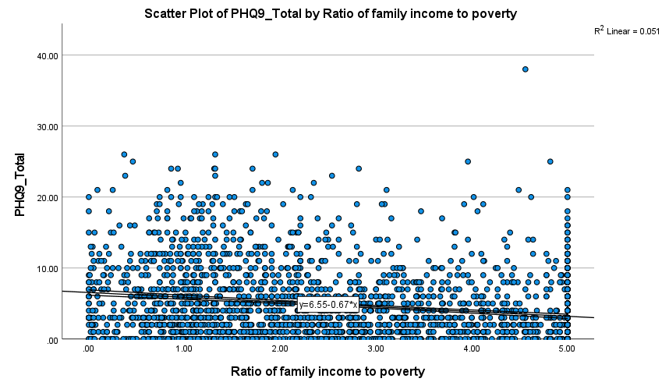

* Chart Builder.
GGRAPH
/GRAPHDATASET NAME="graphdataset" VARIABLES=INDFMPIR MISSING=LISTWISE REPORTMISSING=NO
/GRAPHSPEC SOURCE=INLINE.
BEGIN GPL
SOURCE: s=userSource(id("graphdataset"))
DATA: INDFMPIR=col(source(s), name("INDFMPIR"))
DATA: id=col(source(s), name("$CASENUM"), unit.category())
GUIDE: axis(dim(2), label("Ratio of family income to poverty"))
GUIDE: text.title(label("Simple Boxplot of Ratio of family income to poverty"))
ELEMENT: schema(position(bin.quantile.letter(1*INDFMPIR)), label(id))
END GPL.

GGraph

Notes
Output Created |  | 01-NOV-2026 22:02:11
Comments
Input | Data | C:\Users\aSUS\Downloads\Statics\FilteredData.sav
Input | Active Dataset | DataSet3
Input | Filter | RIAGENDR = 2 AND RIDAGEYR >= 20AND RHQ010 >= 6 AND RHQ010 <= 19AND INDFMPIR >= 0 (FILTER)
Input | Weight | <none>
Input | Split File | <none>
Input | N of Rows in Working Data File | 2512
Syntax |  | GGRAPH  /GRAPHDATASET NAME="graphdataset" VARIABLES=INDFMPIR MISSING=LISTWISE REPORTMISSING=NO  /GRAPHSPEC SOURCE=INLINE.  BEGIN GPL  SOURCE: s=userSource(id("graphdataset"))  DATA: INDFMPIR=col(source(s), name("INDFMPIR"))  DATA: id=col(source(s), name("$CASENUM"), unit.category())  GUIDE: axis(dim(2), label("Ratio of family income to poverty"))  GUIDE: text.title(label("Simple Boxplot of Ratio of family income to poverty"))  ELEMENT: schema(position(bin.quantile.letter(1*INDFMPIR)), label(id))  END GPL.
Resources | Processor Time | 00:00:00.14
Resources | Elapsed Time | 00:00:00.11

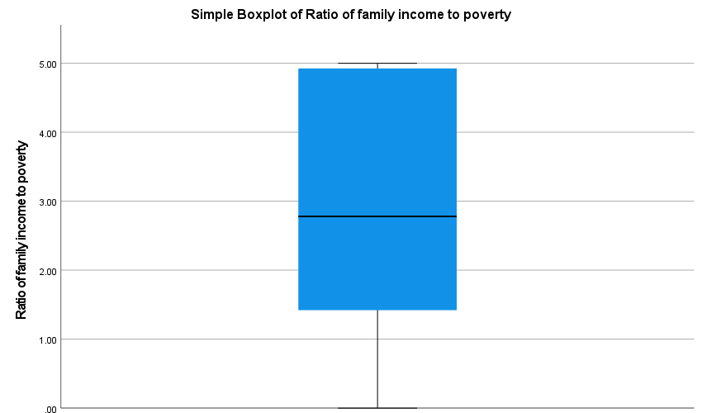

* Chart Builder.
GGRAPH
/GRAPHDATASET NAME="graphdataset" VARIABLES=RHQ010 INDFMPIR MISSING=LISTWISE REPORTMISSING=NO
/GRAPHSPEC SOURCE=INLINE.
BEGIN GPL
SOURCE: s=userSource(id("graphdataset"))
DATA: RHQ010=col(source(s), name("RHQ010"), unit.category())
DATA: INDFMPIR=col(source(s), name("INDFMPIR"))
DATA: id=col(source(s), name("$CASENUM"), unit.category())
GUIDE: axis(dim(1), label("Age when first menstrual period occurred"))
GUIDE: axis(dim(2), label("Ratio of family income to poverty"))
GUIDE: text.title(label("Simple Boxplot of Ratio of family income to poverty by Age when first ",
"menstrual period occurred"))
SCALE: linear(dim(2), include(0))
ELEMENT: schema(position(bin.quantile.letter(RHQ010*INDFMPIR)), label(id))
END GPL.

GGraph

Notes
Output Created |  | 01-NOV-2026 22:02:50
Comments
Input | Data | C:\Users\aSUS\Downloads\Statics\FilteredData.sav
Input | Active Dataset | DataSet3
Input | Filter | RIAGENDR = 2 AND RIDAGEYR >= 20AND RHQ010 >= 6 AND RHQ010 <= 19AND INDFMPIR >= 0 (FILTER)
Input | Weight | <none>
Input | Split File | <none>
Input | N of Rows in Working Data File | 2512
Syntax |  | GGRAPH  /GRAPHDATASET NAME="graphdataset" VARIABLES=RHQ010 INDFMPIR MISSING=LISTWISE REPORTMISSING=NO  /GRAPHSPEC SOURCE=INLINE.  BEGIN GPL  SOURCE: s=userSource(id("graphdataset"))  DATA: RHQ010=col(source(s), name("RHQ010"), unit.category())  DATA: INDFMPIR=col(source(s), name("INDFMPIR"))  DATA: id=col(source(s), name("$CASENUM"), unit.category())  GUIDE: axis(dim(1), label("Age when first menstrual period occurred"))  GUIDE: axis(dim(2), label("Ratio of family income to poverty"))  GUIDE: text.title(label("Simple Boxplot of Ratio of family income to poverty by Age when first ",  "menstrual period occurred"))  SCALE: linear(dim(2), include(0))  ELEMENT: schema(position(bin.quantile.letter(RHQ010*INDFMPIR)), label(id))  END GPL.
Resources | Processor Time | 00:00:00.13
Resources | Elapsed Time | 00:00:00.11

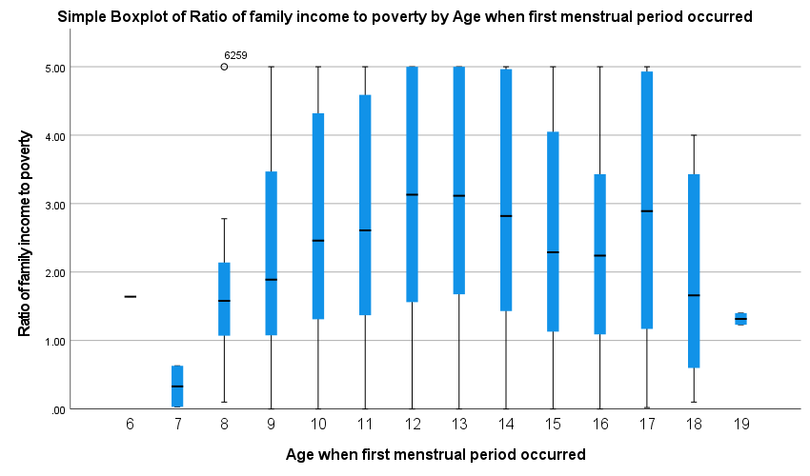

* Chart Builder.
GGRAPH
/GRAPHDATASET NAME="graphdataset" VARIABLES=DMDEDUC2 INDFMPIR MISSING=LISTWISE REPORTMISSING=NO
/GRAPHSPEC SOURCE=INLINE.
BEGIN GPL
SOURCE: s=userSource(id("graphdataset"))
DATA: DMDEDUC2=col(source(s), name("DMDEDUC2"), unit.category())
DATA: INDFMPIR=col(source(s), name("INDFMPIR"))
DATA: id=col(source(s), name("$CASENUM"), unit.category())
GUIDE: axis(dim(1), label("Education level - Adults 20+"))
GUIDE: axis(dim(2), label("Ratio of family income to poverty"))
GUIDE: text.title(label("Simple Boxplot of Ratio of family income to poverty by Education ",
"level - Adults 20+"))
SCALE: linear(dim(2), include(0))
ELEMENT: schema(position(bin.quantile.letter(DMDEDUC2*INDFMPIR)), label(id))
END GPL.

GGraph

Notes
Output Created |  | 01-NOV-2026 22:04:30
Comments
Input | Data | C:\Users\aSUS\Downloads\Statics\FilteredData.sav
Input | Active Dataset | DataSet3
Input | Filter | RIAGENDR = 2 AND RIDAGEYR >= 20AND RHQ010 >= 6 AND RHQ010 <= 19AND INDFMPIR >= 0 (FILTER)
Input | Weight | <none>
Input | Split File | <none>
Input | N of Rows in Working Data File | 2512
Syntax |  | GGRAPH  /GRAPHDATASET NAME="graphdataset" VARIABLES=DMDEDUC2 INDFMPIR MISSING=LISTWISE REPORTMISSING=NO  /GRAPHSPEC SOURCE=INLINE.  BEGIN GPL  SOURCE: s=userSource(id("graphdataset"))  DATA: DMDEDUC2=col(source(s), name("DMDEDUC2"), unit.category())  DATA: INDFMPIR=col(source(s), name("INDFMPIR"))  DATA: id=col(source(s), name("$CASENUM"), unit.category())  GUIDE: axis(dim(1), label("Education level - Adults 20+"))  GUIDE: axis(dim(2), label("Ratio of family income to poverty"))  GUIDE: text.title(label("Simple Boxplot of Ratio of family income to poverty by Education ",  "level - Adults 20+"))  SCALE: linear(dim(2), include(0))  ELEMENT: schema(position(bin.quantile.letter(DMDEDUC2*INDFMPIR)), label(id))  END GPL.
Resources | Processor Time | 00:00:00.13
Resources | Elapsed Time | 00:00:00.10

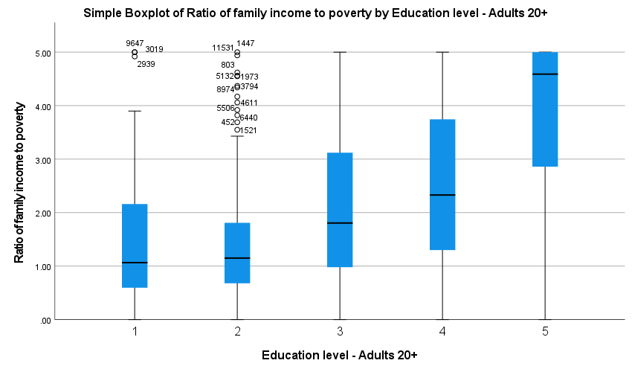

FREQUENCIES VARIABLES=INDFMPIR
/ORDER=ANALYSIS.

Frequencies

Notes
Output Created |  | 02-NOV-2026 08:04:35
Comments
Input | Data | C:\Users\aSUS\Downloads\Statics\FilteredData.sav
Input | Active Dataset | DataSet3
Input | Filter | RIAGENDR = 2 AND RIDAGEYR >= 20AND RHQ010 >= 6 AND RHQ010 <= 19AND INDFMPIR >= 0 (FILTER)
Input | Weight | <none>
Input | Split File | <none>
Input | N of Rows in Working Data File | 2512
Missing Value Handling | Definition of Missing | User-defined missing values are treated as missing.
Missing Value Handling | Cases Used | Statistics are based on all cases with valid data.
Syntax |  | FREQUENCIES VARIABLES=INDFMPIR  /ORDER=ANALYSIS.
Resources | Processor Time | 00:00:00.02
Resources | Elapsed Time | 00:00:00.01

Statistics
Ratio of family income to poverty
N | Valid | 2512
N | Missing | 0

Ratio of family income to poverty
 |  | Frequency | Percent | Valid Percent | Cumulative Percent
Valid | .00 | 22 | .9 | .9 | .9
Valid | .01 | 1 | .0 | .0 | .9
Valid | .02 | 7 | .3 | .3 | 1.2
Valid | .03 | 5 | .2 | .2 | 1.4
Valid | .04 | 7 | .3 | .3 | 1.7
Valid | .05 | 7 | .3 | .3 | 2.0
Valid | .06 | 3 | .1 | .1 | 2.1
Valid | .07 | 2 | .1 | .1 | 2.1
Valid | .08 | 1 | .0 | .0 | 2.2
Valid | .09 | 2 | .1 | .1 | 2.3
Valid | .10 | 3 | .1 | .1 | 2.4
Valid | .11 | 3 | .1 | .1 | 2.5
Valid | .13 | 2 | .1 | .1 | 2.6
Valid | .14 | 3 | .1 | .1 | 2.7
Valid | .15 | 4 | .2 | .2 | 2.9
Valid | .16 | 3 | .1 | .1 | 3.0
Valid | .17 | 1 | .0 | .0 | 3.0
Valid | .18 | 1 | .0 | .0 | 3.1
Valid | .19 | 4 | .2 | .2 | 3.2
Valid | .20 | 3 | .1 | .1 | 3.3
Valid | .21 | 2 | .1 | .1 | 3.4
Valid | .22 | 1 | .0 | .0 | 3.5
Valid | .23 | 3 | .1 | .1 | 3.6
Valid | .25 | 4 | .2 | .2 | 3.7
Valid | .26 | 4 | .2 | .2 | 3.9
Valid | .27 | 2 | .1 | .1 | 4.0
Valid | .29 | 2 | .1 | .1 | 4.1
Valid | .30 | 2 | .1 | .1 | 4.1
Valid | .31 | 1 | .0 | .0 | 4.2
Valid | .32 | 2 | .1 | .1 | 4.3
Valid | .34 | 3 | .1 | .1 | 4.4
Valid | .36 | 3 | .1 | .1 | 4.5
Valid | .37 | 2 | .1 | .1 | 4.6
Valid | .38 | 1 | .0 | .0 | 4.6
Valid | .39 | 2 | .1 | .1 | 4.7
Valid | .40 | 3 | .1 | .1 | 4.8
Valid | .41 | 2 | .1 | .1 | 4.9
Valid | .42 | 2 | .1 | .1 | 5.0
Valid | .43 | 3 | .1 | .1 | 5.1
Valid | .44 | 3 | .1 | .1 | 5.2
Valid | .45 | 2 | .1 | .1 | 5.3
Valid | .46 | 5 | .2 | .2 | 5.5
Valid | .47 | 1 | .0 | .0 | 5.5
Valid | .48 | 3 | .1 | .1 | 5.7
Valid | .49 | 2 | .1 | .1 | 5.7
Valid | .50 | 2 | .1 | .1 | 5.8
Valid | .51 | 3 | .1 | .1 | 5.9
Valid | .52 | 4 | .2 | .2 | 6.1
Valid | .54 | 1 | .0 | .0 | 6.1
Valid | .55 | 6 | .2 | .2 | 6.4
Valid | .56 | 2 | .1 | .1 | 6.4
Valid | .57 | 3 | .1 | .1 | 6.6
Valid | .58 | 4 | .2 | .2 | 6.7
Valid | .59 | 3 | .1 | .1 | 6.8
Valid | .60 | 3 | .1 | .1 | 7.0
Valid | .61 | 4 | .2 | .2 | 7.1
Valid | .62 | 6 | .2 | .2 | 7.4
Valid | .63 | 8 | .3 | .3 | 7.7
Valid | .65 | 7 | .3 | .3 | 8.0
Valid | .66 | 6 | .2 | .2 | 8.2
Valid | .67 | 1 | .0 | .0 | 8.2
Valid | .68 | 8 | .3 | .3 | 8.6
Valid | .69 | 7 | .3 | .3 | 8.8
Valid | .70 | 2 | .1 | .1 | 8.9
Valid | .71 | 5 | .2 | .2 | 9.1
Valid | .72 | 2 | .1 | .1 | 9.2
Valid | .73 | 5 | .2 | .2 | 9.4
Valid | .74 | 16 | .6 | .6 | 10.0
Valid | .75 | 5 | .2 | .2 | 10.2
Valid | .76 | 4 | .2 | .2 | 10.4
Valid | .77 | 6 | .2 | .2 | 10.6
Valid | .78 | 1 | .0 | .0 | 10.7
Valid | .79 | 7 | .3 | .3 | 10.9
Valid | .80 | 3 | .1 | .1 | 11.1
Valid | .81 | 1 | .0 | .0 | 11.1
Valid | .82 | 10 | .4 | .4 | 11.5
Valid | .83 | 5 | .2 | .2 | 11.7
Valid | .84 | 4 | .2 | .2 | 11.9
Valid | .85 | 5 | .2 | .2 | 12.1
Valid | .86 | 6 | .2 | .2 | 12.3
Valid | .87 | 8 | .3 | .3 | 12.6
Valid | .88 | 12 | .5 | .5 | 13.1
Valid | .89 | 2 | .1 | .1 | 13.2
Valid | .90 | 2 | .1 | .1 | 13.3
Valid | .91 | 5 | .2 | .2 | 13.5
Valid | .92 | 4 | .2 | .2 | 13.6
Valid | .93 | 6 | .2 | .2 | 13.9
Valid | .94 | 3 | .1 | .1 | 14.0
Valid | .95 | 2 | .1 | .1 | 14.1
Valid | .96 | 13 | .5 | .5 | 14.6
Valid | .97 | 8 | .3 | .3 | 14.9
Valid | .98 | 6 | .2 | .2 | 15.1
Valid | .99 | 7 | .3 | .3 | 15.4
Valid | 1.00 | 1 | .0 | .0 | 15.4
Valid | 1.01 | 13 | .5 | .5 | 16.0
Valid | 1.02 | 1 | .0 | .0 | 16.0
Valid | 1.03 | 10 | .4 | .4 | 16.4
Valid | 1.04 | 3 | .1 | .1 | 16.5
Valid | 1.05 | 6 | .2 | .2 | 16.8
Valid | 1.06 | 4 | .2 | .2 | 16.9
Valid | 1.07 | 6 | .2 | .2 | 17.2
Valid | 1.08 | 2 | .1 | .1 | 17.2
Valid | 1.09 | 16 | .6 | .6 | 17.9
Valid | 1.10 | 10 | .4 | .4 | 18.3
Valid | 1.12 | 8 | .3 | .3 | 18.6
Valid | 1.13 | 10 | .4 | .4 | 19.0
Valid | 1.14 | 6 | .2 | .2 | 19.2
Valid | 1.15 | 7 | .3 | .3 | 19.5
Valid | 1.16 | 6 | .2 | .2 | 19.7
Valid | 1.17 | 7 | .3 | .3 | 20.0
Valid | 1.18 | 6 | .2 | .2 | 20.3
Valid | 1.19 | 4 | .2 | .2 | 20.4
Valid | 1.20 | 3 | .1 | .1 | 20.5
Valid | 1.21 | 4 | .2 | .2 | 20.7
Valid | 1.22 | 3 | .1 | .1 | 20.8
Valid | 1.23 | 8 | .3 | .3 | 21.1
Valid | 1.25 | 8 | .3 | .3 | 21.5
Valid | 1.26 | 4 | .2 | .2 | 21.6
Valid | 1.27 | 4 | .2 | .2 | 21.8
Valid | 1.28 | 2 | .1 | .1 | 21.9
Valid | 1.29 | 5 | .2 | .2 | 22.1
Valid | 1.30 | 11 | .4 | .4 | 22.5
Valid | 1.31 | 7 | .3 | .3 | 22.8
Valid | 1.32 | 14 | .6 | .6 | 23.3
Valid | 1.33 | 1 | .0 | .0 | 23.4
Valid | 1.34 | 6 | .2 | .2 | 23.6
Valid | 1.37 | 13 | .5 | .5 | 24.1
Valid | 1.38 | 4 | .2 | .2 | 24.3
Valid | 1.39 | 3 | .1 | .1 | 24.4
Valid | 1.40 | 8 | .3 | .3 | 24.7
Valid | 1.41 | 5 | .2 | .2 | 24.9
Valid | 1.42 | 3 | .1 | .1 | 25.0
Valid | 1.43 | 2 | .1 | .1 | 25.1
Valid | 1.44 | 13 | .5 | .5 | 25.6
Valid | 1.46 | 4 | .2 | .2 | 25.8
Valid | 1.47 | 18 | .7 | .7 | 26.5
Valid | 1.48 | 2 | .1 | .1 | 26.6
Valid | 1.49 | 2 | .1 | .1 | 26.7
Valid | 1.51 | 11 | .4 | .4 | 27.1
Valid | 1.52 | 6 | .2 | .2 | 27.3
Valid | 1.53 | 3 | .1 | .1 | 27.5
Valid | 1.54 | 1 | .0 | .0 | 27.5
Valid | 1.55 | 7 | .3 | .3 | 27.8
Valid | 1.57 | 5 | .2 | .2 | 28.0
Valid | 1.58 | 6 | .2 | .2 | 28.2
Valid | 1.59 | 2 | .1 | .1 | 28.3
Valid | 1.60 | 5 | .2 | .2 | 28.5
Valid | 1.61 | 5 | .2 | .2 | 28.7
Valid | 1.62 | 7 | .3 | .3 | 29.0
Valid | 1.64 | 10 | .4 | .4 | 29.4
Valid | 1.65 | 7 | .3 | .3 | 29.7
Valid | 1.66 | 3 | .1 | .1 | 29.8
Valid | 1.67 | 9 | .4 | .4 | 30.1
Valid | 1.68 | 3 | .1 | .1 | 30.3
Valid | 1.69 | 12 | .5 | .5 | 30.7
Valid | 1.70 | 2 | .1 | .1 | 30.8
Valid | 1.71 | 11 | .4 | .4 | 31.3
Valid | 1.72 | 4 | .2 | .2 | 31.4
Valid | 1.74 | 3 | .1 | .1 | 31.5
Valid | 1.75 | 7 | .3 | .3 | 31.8
Valid | 1.76 | 1 | .0 | .0 | 31.8
Valid | 1.77 | 10 | .4 | .4 | 32.2
Valid | 1.78 | 4 | .2 | .2 | 32.4
Valid | 1.80 | 10 | .4 | .4 | 32.8
Valid | 1.81 | 4 | .2 | .2 | 33.0
Valid | 1.82 | 4 | .2 | .2 | 33.1
Valid | 1.83 | 1 | .0 | .0 | 33.2
Valid | 1.84 | 10 | .4 | .4 | 33.6
Valid | 1.85 | 12 | .5 | .5 | 34.0
Valid | 1.86 | 5 | .2 | .2 | 34.2
Valid | 1.87 | 1 | .0 | .0 | 34.3
Valid | 1.88 | 1 | .0 | .0 | 34.3
Valid | 1.89 | 2 | .1 | .1 | 34.4
Valid | 1.90 | 2 | .1 | .1 | 34.5
Valid | 1.91 | 14 | .6 | .6 | 35.0
Valid | 1.92 | 3 | .1 | .1 | 35.2
Valid | 1.93 | 1 | .0 | .0 | 35.2
Valid | 1.94 | 7 | .3 | .3 | 35.5
Valid | 1.95 | 4 | .2 | .2 | 35.6
Valid | 1.97 | 6 | .2 | .2 | 35.9
Valid | 1.98 | 2 | .1 | .1 | 35.9
Valid | 1.99 | 6 | .2 | .2 | 36.2
Valid | 2.00 | 3 | .1 | .1 | 36.3
Valid | 2.01 | 1 | .0 | .0 | 36.3
Valid | 2.02 | 3 | .1 | .1 | 36.5
Valid | 2.03 | 8 | .3 | .3 | 36.8
Valid | 2.04 | 2 | .1 | .1 | 36.9
Valid | 2.05 | 2 | .1 | .1 | 36.9
Valid | 2.06 | 5 | .2 | .2 | 37.1
Valid | 2.07 | 3 | .1 | .1 | 37.3
Valid | 2.08 | 4 | .2 | .2 | 37.4
Valid | 2.09 | 5 | .2 | .2 | 37.6
Valid | 2.10 | 4 | .2 | .2 | 37.8
Valid | 2.11 | 2 | .1 | .1 | 37.9
Valid | 2.12 | 3 | .1 | .1 | 38.0
Valid | 2.13 | 11 | .4 | .4 | 38.4
Valid | 2.15 | 3 | .1 | .1 | 38.5
Valid | 2.16 | 9 | .4 | .4 | 38.9
Valid | 2.17 | 9 | .4 | .4 | 39.3
Valid | 2.18 | 11 | .4 | .4 | 39.7
Valid | 2.19 | 11 | .4 | .4 | 40.1
Valid | 2.20 | 1 | .0 | .0 | 40.2
Valid | 2.21 | 15 | .6 | .6 | 40.8
Valid | 2.22 | 1 | .0 | .0 | 40.8
Valid | 2.23 | 1 | .0 | .0 | 40.8
Valid | 2.24 | 3 | .1 | .1 | 41.0
Valid | 2.25 | 2 | .1 | .1 | 41.0
Valid | 2.26 | 2 | .1 | .1 | 41.1
Valid | 2.28 | 9 | .4 | .4 | 41.5
Valid | 2.29 | 6 | .2 | .2 | 41.7
Valid | 2.30 | 5 | .2 | .2 | 41.9
Valid | 2.31 | 4 | .2 | .2 | 42.1
Valid | 2.32 | 5 | .2 | .2 | 42.3
Valid | 2.33 | 11 | .4 | .4 | 42.7
Valid | 2.34 | 3 | .1 | .1 | 42.8
Valid | 2.35 | 2 | .1 | .1 | 42.9
Valid | 2.36 | 2 | .1 | .1 | 43.0
Valid | 2.38 | 1 | .0 | .0 | 43.0
Valid | 2.39 | 8 | .3 | .3 | 43.4
Valid | 2.40 | 10 | .4 | .4 | 43.8
Valid | 2.41 | 4 | .2 | .2 | 43.9
Valid | 2.42 | 1 | .0 | .0 | 43.9
Valid | 2.43 | 10 | .4 | .4 | 44.3
Valid | 2.44 | 2 | .1 | .1 | 44.4
Valid | 2.45 | 1 | .0 | .0 | 44.5
Valid | 2.46 | 9 | .4 | .4 | 44.8
Valid | 2.47 | 3 | .1 | .1 | 44.9
Valid | 2.48 | 6 | .2 | .2 | 45.2
Valid | 2.49 | 2 | .1 | .1 | 45.3
Valid | 2.50 | 7 | .3 | .3 | 45.5
Valid | 2.51 | 3 | .1 | .1 | 45.7
Valid | 2.52 | 3 | .1 | .1 | 45.8
Valid | 2.53 | 2 | .1 | .1 | 45.9
Valid | 2.54 | 10 | .4 | .4 | 46.3
Valid | 2.55 | 2 | .1 | .1 | 46.3
Valid | 2.56 | 3 | .1 | .1 | 46.5
Valid | 2.57 | 3 | .1 | .1 | 46.6
Valid | 2.58 | 11 | .4 | .4 | 47.0
Valid | 2.59 | 1 | .0 | .0 | 47.1
Valid | 2.61 | 16 | .6 | .6 | 47.7
Valid | 2.62 | 5 | .2 | .2 | 47.9
Valid | 2.64 | 2 | .1 | .1 | 48.0
Valid | 2.65 | 3 | .1 | .1 | 48.1
Valid | 2.66 | 1 | .0 | .0 | 48.1
Valid | 2.67 | 1 | .0 | .0 | 48.2
Valid | 2.68 | 1 | .0 | .0 | 48.2
Valid | 2.69 | 1 | .0 | .0 | 48.2
Valid | 2.70 | 2 | .1 | .1 | 48.3
Valid | 2.71 | 3 | .1 | .1 | 48.4
Valid | 2.72 | 5 | .2 | .2 | 48.6
Valid | 2.73 | 15 | .6 | .6 | 49.2
Valid | 2.74 | 10 | .4 | .4 | 49.6
Valid | 2.75 | 2 | .1 | .1 | 49.7
Valid | 2.76 | 1 | .0 | .0 | 49.8
Valid | 2.77 | 3 | .1 | .1 | 49.9
Valid | 2.78 | 6 | .2 | .2 | 50.1
Valid | 2.79 | 8 | .3 | .3 | 50.4
Valid | 2.80 | 3 | .1 | .1 | 50.6
Valid | 2.81 | 1 | .0 | .0 | 50.6
Valid | 2.82 | 5 | .2 | .2 | 50.8
Valid | 2.83 | 5 | .2 | .2 | 51.0
Valid | 2.84 | 3 | .1 | .1 | 51.1
Valid | 2.85 | 5 | .2 | .2 | 51.3
Valid | 2.86 | 3 | .1 | .1 | 51.4
Valid | 2.87 | 12 | .5 | .5 | 51.9
Valid | 2.88 | 5 | .2 | .2 | 52.1
Valid | 2.89 | 1 | .0 | .0 | 52.1
Valid | 2.91 | 1 | .0 | .0 | 52.2
Valid | 2.92 | 5 | .2 | .2 | 52.4
Valid | 2.94 | 8 | .3 | .3 | 52.7
Valid | 2.95 | 4 | .2 | .2 | 52.9
Valid | 2.96 | 1 | .0 | .0 | 52.9
Valid | 2.98 | 1 | .0 | .0 | 52.9
Valid | 3.00 | 9 | .4 | .4 | 53.3
Valid | 3.02 | 8 | .3 | .3 | 53.6
Valid | 3.03 | 2 | .1 | .1 | 53.7
Valid | 3.04 | 13 | .5 | .5 | 54.2
Valid | 3.06 | 2 | .1 | .1 | 54.3
Valid | 3.08 | 6 | .2 | .2 | 54.5
Valid | 3.09 | 9 | .4 | .4 | 54.9
Valid | 3.10 | 1 | .0 | .0 | 54.9
Valid | 3.11 | 3 | .1 | .1 | 55.1
Valid | 3.12 | 1 | .0 | .0 | 55.1
Valid | 3.13 | 7 | .3 | .3 | 55.4
Valid | 3.14 | 4 | .2 | .2 | 55.5
Valid | 3.15 | 1 | .0 | .0 | 55.6
Valid | 3.16 | 5 | .2 | .2 | 55.8
Valid | 3.17 | 5 | .2 | .2 | 56.0
Valid | 3.18 | 1 | .0 | .0 | 56.0
Valid | 3.19 | 3 | .1 | .1 | 56.1
Valid | 3.22 | 6 | .2 | .2 | 56.4
Valid | 3.23 | 1 | .0 | .0 | 56.4
Valid | 3.24 | 4 | .2 | .2 | 56.6
Valid | 3.25 | 2 | .1 | .1 | 56.6
Valid | 3.26 | 2 | .1 | .1 | 56.7
Valid | 3.27 | 1 | .0 | .0 | 56.8
Valid | 3.28 | 20 | .8 | .8 | 57.6
Valid | 3.29 | 4 | .2 | .2 | 57.7
Valid | 3.30 | 9 | .4 | .4 | 58.1
Valid | 3.31 | 5 | .2 | .2 | 58.3
Valid | 3.32 | 1 | .0 | .0 | 58.3
Valid | 3.33 | 8 | .3 | .3 | 58.6
Valid | 3.34 | 1 | .0 | .0 | 58.7
Valid | 3.35 | 2 | .1 | .1 | 58.8
Valid | 3.36 | 1 | .0 | .0 | 58.8
Valid | 3.38 | 3 | .1 | .1 | 58.9
Valid | 3.39 | 2 | .1 | .1 | 59.0
Valid | 3.41 | 2 | .1 | .1 | 59.1
Valid | 3.42 | 10 | .4 | .4 | 59.5
Valid | 3.43 | 6 | .2 | .2 | 59.7
Valid | 3.44 | 4 | .2 | .2 | 59.9
Valid | 3.45 | 2 | .1 | .1 | 60.0
Valid | 3.46 | 2 | .1 | .1 | 60.0
Valid | 3.47 | 7 | .3 | .3 | 60.3
Valid | 3.49 | 3 | .1 | .1 | 60.4
Valid | 3.50 | 1 | .0 | .0 | 60.5
Valid | 3.52 | 1 | .0 | .0 | 60.5
Valid | 3.53 | 1 | .0 | .0 | 60.5
Valid | 3.55 | 11 | .4 | .4 | 61.0
Valid | 3.57 | 4 | .2 | .2 | 61.1
Valid | 3.58 | 3 | .1 | .1 | 61.3
Valid | 3.60 | 8 | .3 | .3 | 61.6
Valid | 3.62 | 3 | .1 | .1 | 61.7
Valid | 3.64 | 1 | .0 | .0 | 61.7
Valid | 3.65 | 1 | .0 | .0 | 61.8
Valid | 3.67 | 1 | .0 | .0 | 61.8
Valid | 3.68 | 7 | .3 | .3 | 62.1
Valid | 3.69 | 12 | .5 | .5 | 62.6
Valid | 3.70 | 2 | .1 | .1 | 62.7
Valid | 3.71 | 1 | .0 | .0 | 62.7
Valid | 3.73 | 2 | .1 | .1 | 62.8
Valid | 3.74 | 1 | .0 | .0 | 62.8
Valid | 3.75 | 2 | .1 | .1 | 62.9
Valid | 3.76 | 2 | .1 | .1 | 63.0
Valid | 3.77 | 8 | .3 | .3 | 63.3
Valid | 3.78 | 1 | .0 | .0 | 63.3
Valid | 3.80 | 8 | .3 | .3 | 63.7
Valid | 3.82 | 10 | .4 | .4 | 64.1
Valid | 3.83 | 3 | .1 | .1 | 64.2
Valid | 3.84 | 2 | .1 | .1 | 64.3
Valid | 3.85 | 1 | .0 | .0 | 64.3
Valid | 3.86 | 1 | .0 | .0 | 64.3
Valid | 3.87 | 2 | .1 | .1 | 64.4
Valid | 3.88 | 4 | .2 | .2 | 64.6
Valid | 3.90 | 4 | .2 | .2 | 64.7
Valid | 3.91 | 2 | .1 | .1 | 64.8
Valid | 3.92 | 3 | .1 | .1 | 64.9
Valid | 3.93 | 2 | .1 | .1 | 65.0
Valid | 3.94 | 2 | .1 | .1 | 65.1
Valid | 3.96 | 7 | .3 | .3 | 65.4
Valid | 3.97 | 3 | .1 | .1 | 65.5
Valid | 3.99 | 1 | .0 | .0 | 65.5
Valid | 4.00 | 5 | .2 | .2 | 65.7
Valid | 4.01 | 1 | .0 | .0 | 65.8
Valid | 4.02 | 6 | .2 | .2 | 66.0
Valid | 4.04 | 1 | .0 | .0 | 66.0
Valid | 4.05 | 5 | .2 | .2 | 66.2
Valid | 4.06 | 8 | .3 | .3 | 66.6
Valid | 4.08 | 1 | .0 | .0 | 66.6
Valid | 4.10 | 13 | .5 | .5 | 67.1
Valid | 4.12 | 14 | .6 | .6 | 67.7
Valid | 4.13 | 1 | .0 | .0 | 67.7
Valid | 4.14 | 2 | .1 | .1 | 67.8
Valid | 4.15 | 1 | .0 | .0 | 67.8
Valid | 4.16 | 1 | .0 | .0 | 67.9
Valid | 4.17 | 3 | .1 | .1 | 68.0
Valid | 4.19 | 3 | .1 | .1 | 68.1
Valid | 4.21 | 1 | .0 | .0 | 68.2
Valid | 4.22 | 1 | .0 | .0 | 68.2
Valid | 4.23 | 1 | .0 | .0 | 68.2
Valid | 4.25 | 2 | .1 | .1 | 68.3
Valid | 4.26 | 1 | .0 | .0 | 68.4
Valid | 4.27 | 4 | .2 | .2 | 68.5
Valid | 4.29 | 1 | .0 | .0 | 68.6
Valid | 4.31 | 6 | .2 | .2 | 68.8
Valid | 4.32 | 6 | .2 | .2 | 69.0
Valid | 4.33 | 4 | .2 | .2 | 69.2
Valid | 4.34 | 7 | .3 | .3 | 69.5
Valid | 4.36 | 1 | .0 | .0 | 69.5
Valid | 4.37 | 12 | .5 | .5 | 70.0
Valid | 4.40 | 1 | .0 | .0 | 70.0
Valid | 4.41 | 2 | .1 | .1 | 70.1
Valid | 4.42 | 12 | .5 | .5 | 70.6
Valid | 4.43 | 2 | .1 | .1 | 70.7
Valid | 4.44 | 4 | .2 | .2 | 70.8
Valid | 4.45 | 1 | .0 | .0 | 70.9
Valid | 4.46 | 5 | .2 | .2 | 71.1
Valid | 4.48 | 1 | .0 | .0 | 71.1
Valid | 4.49 | 1 | .0 | .0 | 71.1
Valid | 4.50 | 2 | .1 | .1 | 71.2
Valid | 4.51 | 1 | .0 | .0 | 71.3
Valid | 4.53 | 2 | .1 | .1 | 71.3
Valid | 4.54 | 2 | .1 | .1 | 71.4
Valid | 4.55 | 4 | .2 | .2 | 71.6
Valid | 4.56 | 11 | .4 | .4 | 72.0
Valid | 4.57 | 1 | .0 | .0 | 72.1
Valid | 4.59 | 7 | .3 | .3 | 72.3
Valid | 4.61 | 2 | .1 | .1 | 72.4
Valid | 4.62 | 1 | .0 | .0 | 72.5
Valid | 4.63 | 1 | .0 | .0 | 72.5
Valid | 4.64 | 7 | .3 | .3 | 72.8
Valid | 4.66 | 2 | .1 | .1 | 72.9
Valid | 4.67 | 4 | .2 | .2 | 73.0
Valid | 4.68 | 3 | .1 | .1 | 73.1
Valid | 4.69 | 2 | .1 | .1 | 73.2
Valid | 4.72 | 1 | .0 | .0 | 73.2
Valid | 4.78 | 8 | .3 | .3 | 73.6
Valid | 4.80 | 3 | .1 | .1 | 73.7
Valid | 4.81 | 1 | .0 | .0 | 73.7
Valid | 4.82 | 9 | .4 | .4 | 74.1
Valid | 4.83 | 4 | .2 | .2 | 74.2
Valid | 4.86 | 3 | .1 | .1 | 74.4
Valid | 4.88 | 4 | .2 | .2 | 74.5
Valid | 4.89 | 2 | .1 | .1 | 74.6
Valid | 4.92 | 10 | .4 | .4 | 75.0
Valid | 4.93 | 2 | .1 | .1 | 75.1
Valid | 4.94 | 5 | .2 | .2 | 75.3
Valid | 4.95 | 1 | .0 | .0 | 75.3
Valid | 4.97 | 3 | .1 | .1 | 75.4
Valid | 5.00 | 617 | 24.6 | 24.6 | 100.0
Valid | Total | 2512 | 100.0 | 100.0

FREQUENCIES VARIABLES=PHQ9_Total
/ORDER=ANALYSIS.

Frequencies

Notes
Output Created |  | 02-NOV-2026 08:07:33
Comments
Input | Data | C:\Users\aSUS\Downloads\Statics\FilteredData.sav
Input | Active Dataset | DataSet3
Input | Filter | RIAGENDR = 2 AND RIDAGEYR >= 20AND RHQ010 >= 6 AND RHQ010 <= 19AND INDFMPIR >= 0 (FILTER)
Input | Weight | <none>
Input | Split File | <none>
Input | N of Rows in Working Data File | 2512
Missing Value Handling | Definition of Missing | User-defined missing values are treated as missing.
Missing Value Handling | Cases Used | Statistics are based on all cases with valid data.
Syntax |  | FREQUENCIES VARIABLES=PHQ9_Total  /ORDER=ANALYSIS.
Resources | Processor Time | 00:00:00.02
Resources | Elapsed Time | 00:00:00.01

Statistics
PHQ9_Total
N | Valid | 2512
N | Missing | 0

PHQ9_Total
 |  | Frequency | Percent | Valid Percent | Cumulative Percent
Valid | .00 | 478 | 19.0 | 19.0 | 19.0
Valid | 1.00 | 322 | 12.8 | 12.8 | 31.8
Valid | 2.00 | 324 | 12.9 | 12.9 | 44.7
Valid | 3.00 | 268 | 10.7 | 10.7 | 55.4
Valid | 4.00 | 178 | 7.1 | 7.1 | 62.5
Valid | 5.00 | 155 | 6.2 | 6.2 | 68.7
Valid | 6.00 | 134 | 5.3 | 5.3 | 74.0
Valid | 7.00 | 107 | 4.3 | 4.3 | 78.3
Valid | 8.00 | 96 | 3.8 | 3.8 | 82.1
Valid | 9.00 | 68 | 2.7 | 2.7 | 84.8
Valid | 10.00 | 71 | 2.8 | 2.8 | 87.6
Valid | 11.00 | 57 | 2.3 | 2.3 | 89.9
Valid | 12.00 | 53 | 2.1 | 2.1 | 92.0
Valid | 13.00 | 34 | 1.4 | 1.4 | 93.4
Valid | 14.00 | 30 | 1.2 | 1.2 | 94.5
Valid | 15.00 | 31 | 1.2 | 1.2 | 95.8
Valid | 16.00 | 13 | .5 | .5 | 96.3
Valid | 17.00 | 19 | .8 | .8 | 97.1
Valid | 18.00 | 16 | .6 | .6 | 97.7
Valid | 19.00 | 15 | .6 | .6 | 98.3
Valid | 20.00 | 15 | .6 | .6 | 98.9
Valid | 21.00 | 8 | .3 | .3 | 99.2
Valid | 22.00 | 4 | .2 | .2 | 99.4
Valid | 23.00 | 3 | .1 | .1 | 99.5
Valid | 24.00 | 6 | .2 | .2 | 99.7
Valid | 25.00 | 3 | .1 | .1 | 99.8
Valid | 26.00 | 3 | .1 | .1 | 100.0
Valid | 38.00 | 1 | .0 | .0 | 100.0
Valid | Total | 2512 | 100.0 | 100.0

DATASET ACTIVATE DataSet3.

SAVE OUTFILE='C:\Users\aSUS\Downloads\Statics\FilteredData.sav'
/COMPRESSED.
FREQUENCIES VARIABLES=DMDEDUC2
/ORDER=ANALYSIS.

Frequencies

Notes
Output Created |  | 02-NOV-2026 08:30:39
Comments
Input | Data | C:\Users\aSUS\Downloads\Statics\FilteredData.sav
Input | Active Dataset | DataSet3
Input | Filter | RIAGENDR = 2 AND RIDAGEYR >= 20AND RHQ010 >= 6 AND RHQ010 <= 19AND INDFMPIR >= 0 (FILTER)
Input | Weight | <none>
Input | Split File | <none>
Input | N of Rows in Working Data File | 2512
Missing Value Handling | Definition of Missing | User-defined missing values are treated as missing.
Missing Value Handling | Cases Used | Statistics are based on all cases with valid data.
Syntax |  | FREQUENCIES VARIABLES=DMDEDUC2  /ORDER=ANALYSIS.
Resources | Processor Time | 00:00:00.00
Resources | Elapsed Time | 00:00:00.00

Statistics
Education level - Adults 20+
N | Valid | 2512
N | Missing | 0

Education level - Adults 20+
 |  | Frequency | Percent | Valid Percent | Cumulative Percent
Valid | 1 | 72 | 2.9 | 2.9 | 2.9
Valid | 2 | 161 | 6.4 | 6.4 | 9.3
Valid | 3 | 466 | 18.6 | 18.6 | 27.8
Valid | 4 | 839 | 33.4 | 33.4 | 61.2
Valid | 5 | 974 | 38.8 | 38.8 | 100.0
Valid | Total | 2512 | 100.0 | 100.0

FREQUENCIES VARIABLES=RHQ010
/ORDER=ANALYSIS.

Frequencies

Notes
Output Created |  | 02-NOV-2026 08:31:54
Comments
Input | Data | C:\Users\aSUS\Downloads\Statics\FilteredData.sav
Input | Active Dataset | DataSet3
Input | Filter | RIAGENDR = 2 AND RIDAGEYR >= 20AND RHQ010 >= 6 AND RHQ010 <= 19AND INDFMPIR >= 0 (FILTER)
Input | Weight | <none>
Input | Split File | <none>
Input | N of Rows in Working Data File | 2512
Missing Value Handling | Definition of Missing | User-defined missing values are treated as missing.
Missing Value Handling | Cases Used | Statistics are based on all cases with valid data.
Syntax |  | FREQUENCIES VARIABLES=RHQ010  /ORDER=ANALYSIS.
Resources | Processor Time | 00:00:00.00
Resources | Elapsed Time | 00:00:00.01

Statistics
Age when first menstrual period occurred
N | Valid | 2512
N | Missing | 0

Age when first menstrual period occurred
 |  | Frequency | Percent | Valid Percent | Cumulative Percent
Valid | 6 | 1 | .0 | .0 | .0
Valid | 7 | 2 | .1 | .1 | .1
Valid | 8 | 15 | .6 | .6 | .7
Valid | 9 | 100 | 4.0 | 4.0 | 4.7
Valid | 10 | 173 | 6.9 | 6.9 | 11.6
Valid | 11 | 374 | 14.9 | 14.9 | 26.5
Valid | 12 | 704 | 28.0 | 28.0 | 54.5
Valid | 13 | 580 | 23.1 | 23.1 | 77.6
Valid | 14 | 283 | 11.3 | 11.3 | 88.9
Valid | 15 | 154 | 6.1 | 6.1 | 95.0
Valid | 16 | 89 | 3.5 | 3.5 | 98.5
Valid | 17 | 29 | 1.2 | 1.2 | 99.7
Valid | 18 | 6 | .2 | .2 | 99.9
Valid | 19 | 2 | .1 | .1 | 100.0
Valid | Total | 2512 | 100.0 | 100.0

EXAMINE VARIABLES=PHQ9_Total RHQ010 DMDEDUC2 INDFMPIR
/PLOT BOXPLOT STEMLEAF HISTOGRAM
/COMPARE GROUPS
/STATISTICS DESCRIPTIVES
/CINTERVAL 95
/MISSING LISTWISE
/NOTOTAL.

Explore

Notes
Output Created |  | 02-NOV-2026 08:38:01
Comments
Input | Data | C:\Users\aSUS\Downloads\Statics\FilteredData.sav
Input | Active Dataset | DataSet3
Input | Filter | RIAGENDR = 2 AND RIDAGEYR >= 20AND RHQ010 >= 6 AND RHQ010 <= 19AND INDFMPIR >= 0 (FILTER)
Input | Weight | <none>
Input | Split File | <none>
Input | N of Rows in Working Data File | 2512
Missing Value Handling | Definition of Missing | User-defined missing values for dependent variables are treated as missing.
Missing Value Handling | Cases Used | Statistics are based on cases with no missing values for any dependent variable or factor used.
Syntax |  | EXAMINE VARIABLES=PHQ9_Total RHQ010 DMDEDUC2 INDFMPIR  /PLOT BOXPLOT STEMLEAF HISTOGRAM  /COMPARE GROUPS  /STATISTICS DESCRIPTIVES  /CINTERVAL 95  /MISSING LISTWISE  /NOTOTAL.
Resources | Processor Time | 00:00:01.44
Resources | Elapsed Time | 00:00:00.97

Case Processing Summary
 | Cases
 | Valid |  | Missing |  | Total
 | N | Percent | N | Percent | N | Percent
PHQ9_Total | 2512 | 100.0% | 0 | 0.0% | 2512 | 100.0%
Age when first menstrual period occurred | 2512 | 100.0% | 0 | 0.0% | 2512 | 100.0%
Education level - Adults 20+ | 2512 | 100.0% | 0 | 0.0% | 2512 | 100.0%
Ratio of family income to poverty | 2512 | 100.0% | 0 | 0.0% | 2512 | 100.0%

Descriptives
 |  |  | Statistic | Std. Error
PHQ9_Total | Mean |  | 4.6011 | .09817
PHQ9_Total | 95% Confidence Interval for Mean | Lower Bound | 4.4086
PHQ9_Total | 95% Confidence Interval for Mean | Upper Bound | 4.7936
PHQ9_Total | 5% Trimmed Mean |  | 4.0694
PHQ9_Total | Median |  | 3.0000
PHQ9_Total | Variance |  | 24.211
PHQ9_Total | Std. Deviation |  | 4.92049
PHQ9_Total | Minimum |  | .00
PHQ9_Total | Maximum |  | 38.00
PHQ9_Total | Range |  | 38.00
PHQ9_Total | Interquartile Range |  | 6.00
PHQ9_Total | Skewness |  | 1.589 | .049
PHQ9_Total | Kurtosis |  | 2.861 | .098
Age when first menstrual period occurred | Mean |  | 12.42 | .034
Age when first menstrual period occurred | 95% Confidence Interval for Mean | Lower Bound | 12.36
Age when first menstrual period occurred | 95% Confidence Interval for Mean | Upper Bound | 12.49
Age when first menstrual period occurred | 5% Trimmed Mean |  | 12.40
Age when first menstrual period occurred | Median |  | 12.00
Age when first menstrual period occurred | Variance |  | 2.948
Age when first menstrual period occurred | Std. Deviation |  | 1.717
Age when first menstrual period occurred | Minimum |  | 6
Age when first menstrual period occurred | Maximum |  | 19
Age when first menstrual period occurred | Range |  | 13
Age when first menstrual period occurred | Interquartile Range |  | 2
Age when first menstrual period occurred | Skewness |  | .223 | .049
Age when first menstrual period occurred | Kurtosis |  | .481 | .098
Education level - Adults 20+ | Mean |  | 3.99 | .021
Education level - Adults 20+ | 95% Confidence Interval for Mean | Lower Bound | 3.95
Education level - Adults 20+ | 95% Confidence Interval for Mean | Upper Bound | 4.03
Education level - Adults 20+ | 5% Trimmed Mean |  | 4.07
Education level - Adults 20+ | Median |  | 4.00
Education level - Adults 20+ | Variance |  | 1.088
Education level - Adults 20+ | Std. Deviation |  | 1.043
Education level - Adults 20+ | Minimum |  | 1
Education level - Adults 20+ | Maximum |  | 5
Education level - Adults 20+ | Range |  | 4
Education level - Adults 20+ | Interquartile Range |  | 2
Education level - Adults 20+ | Skewness |  | -.922 | .049
Education level - Adults 20+ | Kurtosis |  | .275 | .098
Ratio of family income to poverty | Mean |  | 2.9068 | .03295
Ratio of family income to poverty | 95% Confidence Interval for Mean | Lower Bound | 2.8422
Ratio of family income to poverty | 95% Confidence Interval for Mean | Upper Bound | 2.9714
Ratio of family income to poverty | 5% Trimmed Mean |  | 2.9437
Ratio of family income to poverty | Median |  | 2.7800
Ratio of family income to poverty | Variance |  | 2.727
Ratio of family income to poverty | Std. Deviation |  | 1.65151
Ratio of family income to poverty | Minimum |  | .00
Ratio of family income to poverty | Maximum |  | 5.00
Ratio of family income to poverty | Range |  | 5.00
Ratio of family income to poverty | Interquartile Range |  | 3.51
Ratio of family income to poverty | Skewness |  | -.031 | .049
Ratio of family income to poverty | Kurtosis |  | -1.413 | .098

PHQ9_Total

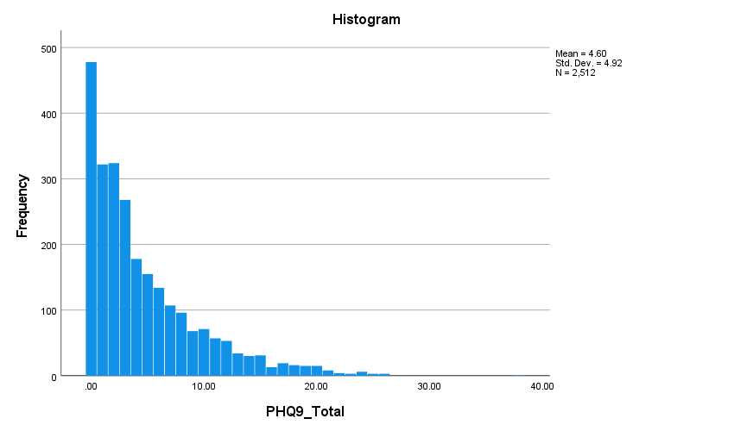

PHQ9_Total Stem-and-Leaf Plot

Frequency Stem & Leaf

478.00 0 . 000000000000000000000000000000000000000000000000000000000000000000000000000000000000000000000000
322.00 1 . 0000000000000000000000000000000000000000000000000000000000000000
324.00 2 . 00000000000000000000000000000000000000000000000000000000000000000
268.00 3 . 000000000000000000000000000000000000000000000000000000
178.00 4 . 000000000000000000000000000000000000
155.00 5 . 0000000000000000000000000000000
134.00 6 . 000000000000000000000000000
107.00 7 . 000000000000000000000
96.00 8 . 0000000000000000000
68.00 9 . 00000000000000
71.00 10 . 00000000000000
57.00 11 . 00000000000
53.00 12 . 00000000000
34.00 13 . 0000000
30.00 14 . 000000
31.00 15 . 000000
13.00 16 . 000
93.00 Extremes (>=17.0)

Stem width: 1.00
Each leaf: 5 case(s)

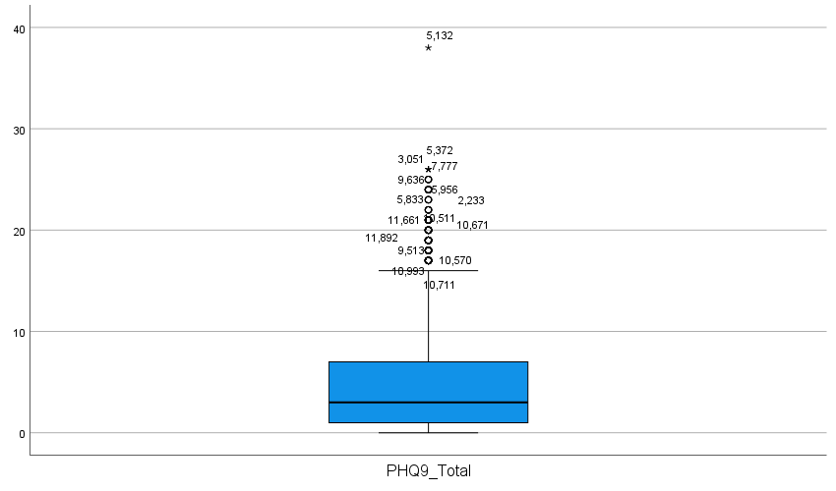

Age when first menstrual period occurred

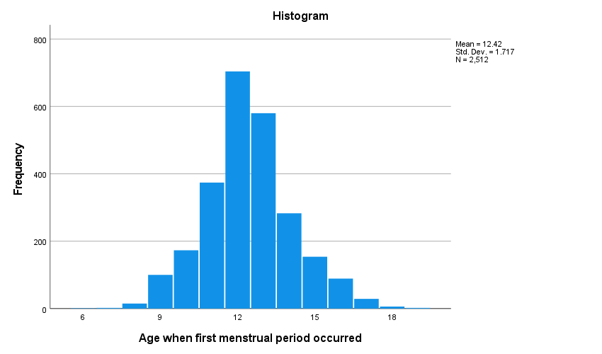

Age when first menstrual period occurred Stem-and-Leaf Plot

Frequency Stem & Leaf

3.00 Extremes (=<7.0)
15.00 8 . 00
.00 8 .
100.00 9 . 00000000000000
.00 9 .
173.00 10 . 0000000000000000000000000
.00 10 .
374.00 11 . 00000000000000000000000000000000000000000000000000000
.00 11 .
704.00 12 . 00000000000000000000000000000000000000000000000000000000000000000000000000000000000000000000000000000
.00 12 .
580.00 13 . 00000000000000000000000000000000000000000000000000000000000000000000000000000000000
.00 13 .
283.00 14 . 0000000000000000000000000000000000000000
.00 14 .
154.00 15 . 0000000000000000000000
.00 15 .
89.00 16 . 0000000000000
37.00 Extremes (>=17.0)

Stem width: 1
Each leaf: 7 case(s)

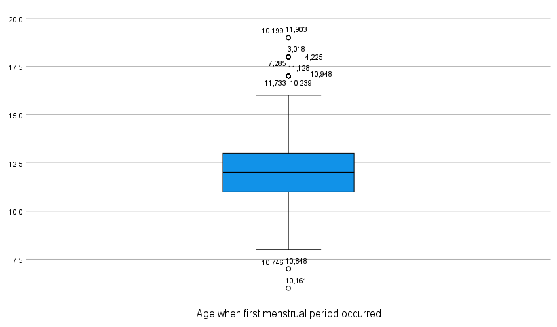

Education level - Adults 20+

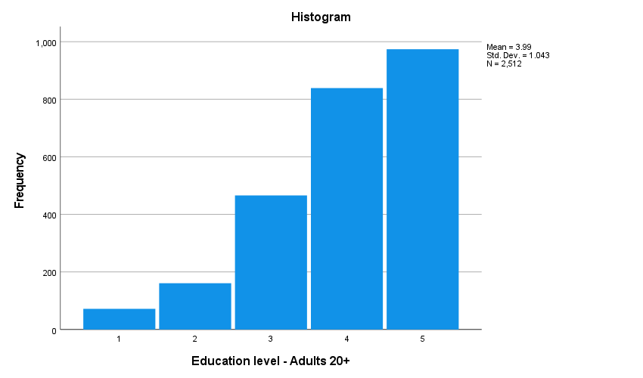

Education level - Adults 20+ Stem-and-Leaf Plot

Frequency Stem & Leaf

72.00 1 . 0000000
.00 1 .
.00 1 .
.00 1 .
.00 1 .
161.00 2 . 0000000000000000
.00 2 .
.00 2 .
.00 2 .
.00 2 .
466.00 3 . 00000000000000000000000000000000000000000000000
.00 3 .
.00 3 .
.00 3 .
.00 3 .
839.00 4 . 000000000000000000000000000000000000000000000000000000000000000000000000000000000000
.00 4 .
.00 4 .
.00 4 .
.00 4 .
974.00 5 . 0000000000000000000000000000000000000000000000000000000000000000000000000000000000000000000000000

Stem width: 1
Each leaf: 10 case(s)

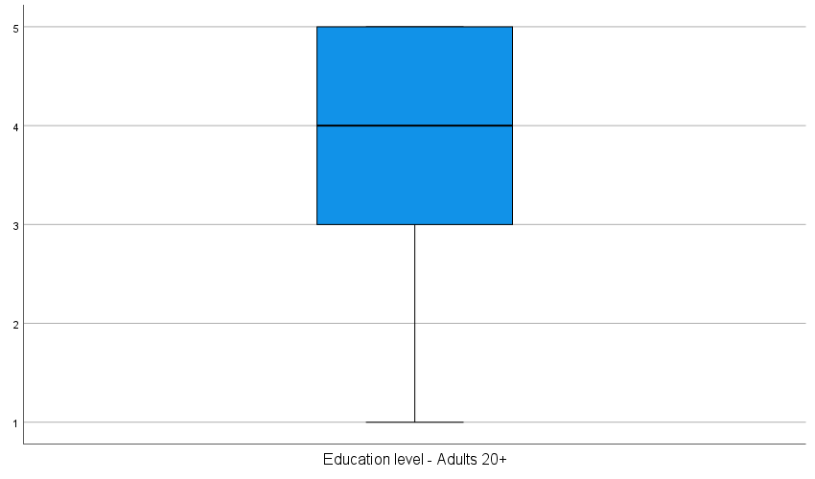

Ratio of family income to poverty

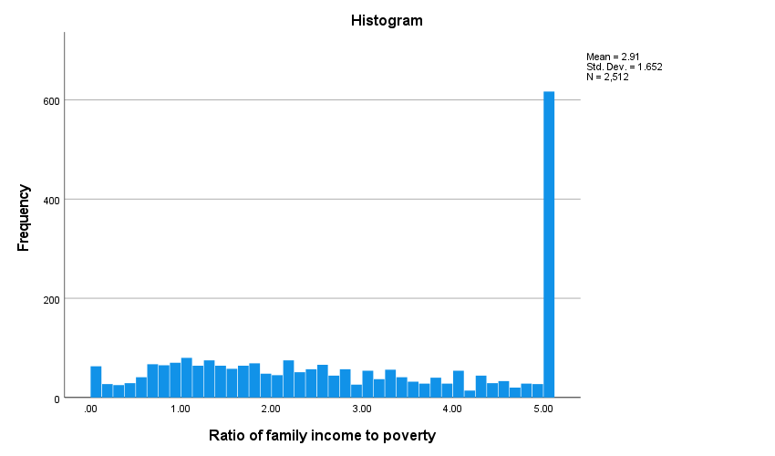

Ratio of family income to poverty Stem-and-Leaf Plot

Frequency Stem & Leaf

81.00 0 . 00000000111
37.00 0 . 22233
54.00 0 . 44445555
103.00 0 . 666666677777777
112.00 0 . 8888888899999999
126.00 1 . 000000000111111111
100.00 1 . 22222233333333
98.00 1 . 44444444555555
103.00 1 . 666666666777777
95.00 1 . 8888888999999
99.00 2 . 00000111111111
81.00 2 . 222222333333
93.00 2 . 4444444555555
85.00 2 . 666677777777
63.00 2 . 888888999
80.00 3 . 00000001111
72.00 3 . 22222233333
57.00 3 . 44444555
52.00 3 . 66666777
55.00 3 . 8888999
65.00 4 . 000011111
47.00 4 . 2233333
59.00 4 . 44445555
31.00 4 . 6667
47.00 4 . 8888999
617.00 5 . 0000000000000000000000000000000000000000000000000000000000000000000000000000000000000000

Stem width: 1.00
Each leaf: 7 case(s)

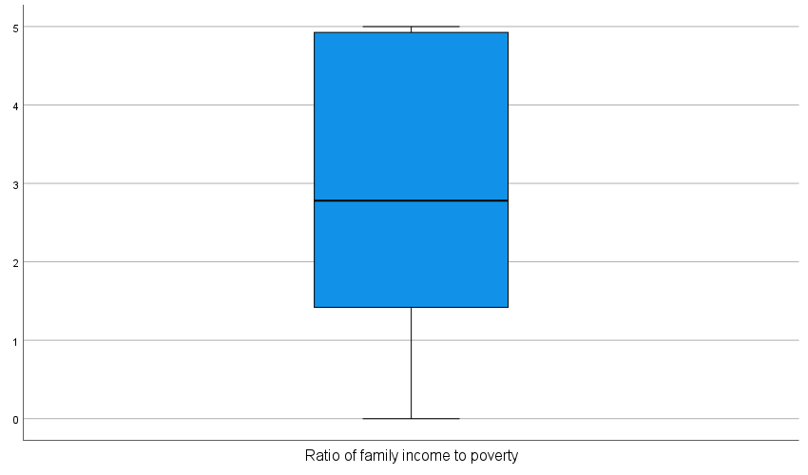

Frequencies

Notes
Output Created |  | 02-NOV-2026 08:47:41
Comments
Input | Active Dataset | DataSet1
Input | Filter | <none>
Input | Weight | <none>
Input | Split File | <none>
Input | N of Rows in Working Data File | 11933
Missing Value Handling | Definition of Missing | User-defined missing values are treated as missing.
Missing Value Handling | Cases Used | Statistics are based on all cases with valid data.
Syntax |  | FREQUENCIES VARIABLES=RIDAGEYR  /ORDER=ANALYSIS.
Resources | Processor Time | 00:00:00.00
Resources | Elapsed Time | 00:00:00.01

DATASET ACTIVATE DataSet3.
EXAMINE VARIABLES=RIDAGEYR
/PLOT BOXPLOT STEMLEAF HISTOGRAM
/COMPARE GROUPS
/STATISTICS DESCRIPTIVES
/CINTERVAL 95
/MISSING LISTWISE
/NOTOTAL.

Explore

Notes
Output Created |  | 02-NOV-2026 08:49:19
Comments
Input | Data | C:\Users\aSUS\Downloads\Statics\FilteredData.sav
Input | Active Dataset | DataSet3
Input | Filter | RIAGENDR = 2 AND RIDAGEYR >= 20AND RHQ010 >= 6 AND RHQ010 <= 19AND INDFMPIR >= 0 (FILTER)
Input | Weight | <none>
Input | Split File | <none>
Input | N of Rows in Working Data File | 2512
Missing Value Handling | Definition of Missing | User-defined missing values for dependent variables are treated as missing.
Missing Value Handling | Cases Used | Statistics are based on cases with no missing values for any dependent variable or factor used.
Syntax |  | EXAMINE VARIABLES=RIDAGEYR  /PLOT BOXPLOT STEMLEAF HISTOGRAM  /COMPARE GROUPS  /STATISTICS DESCRIPTIVES  /CINTERVAL 95  /MISSING LISTWISE  /NOTOTAL.
Resources | Processor Time | 00:00:00.25
Resources | Elapsed Time | 00:00:00.24

[DataSet3] C:\Users\aSUS\Downloads\Statics\FilteredData.sav

Case Processing Summary
 | Cases
 | Valid |  | Missing |  | Total
 | N | Percent | N | Percent | N | Percent
Age in years at screening | 2512 | 100.0% | 0 | 0.0% | 2512 | 100.0%

Descriptives
 |  |  | Statistic | Std. Error
Age in years at screening | Mean |  | 53.65 | .334
Age in years at screening | 95% Confidence Interval for Mean | Lower Bound | 52.99
Age in years at screening | 95% Confidence Interval for Mean | Upper Bound | 54.31
Age in years at screening | 5% Trimmed Mean |  | 53.94
Age in years at screening | Median |  | 57.00
Age in years at screening | Variance |  | 280.955
Age in years at screening | Std. Deviation |  | 16.762
Age in years at screening | Minimum |  | 20
Age in years at screening | Maximum |  | 80
Age in years at screening | Range |  | 60
Age in years at screening | Interquartile Range |  | 28
Age in years at screening | Skewness |  | -.297 | .049
Age in years at screening | Kurtosis |  | -1.058 | .098

Age in years at screening

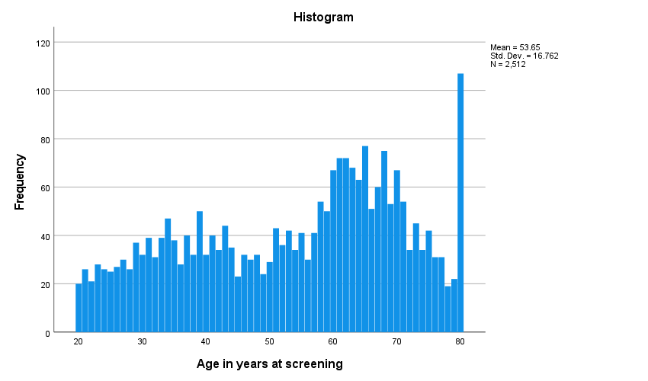

Age in years at screening Stem-and-Leaf Plot

Frequency Stem & Leaf

121.00 2 . 00000111111222223333333444444
145.00 2 . 55555566666667777777888888999999999
188.00 3 . 000000001111111111222222223333333333444444444444
188.00 3 . 5555555556666666777777777788888888999999999999
185.00 4 . 0000000011111111112222222233333333333444444444
141.00 4 . 55555566666666777777788888888999999
184.00 5 . 000000011111111111222222222333333333344444444
216.00 5 . 5555555555666666677777777778888888888888999999999999
342.00 6 . 00000000000000000111111111111111111222222222222222222333333333333333334444444444444444
316.00 6 . 5555555555555555555666666666666677777777777777788888888888888888889999999999999
234.00 7 . 000000000000000001111111111111222222223333333333344444444
145.00 7 . 555555555566666666777777778888899999
107.00 8 . 000000000000000000000000000

Stem width: 10
Each leaf: 4 case(s)

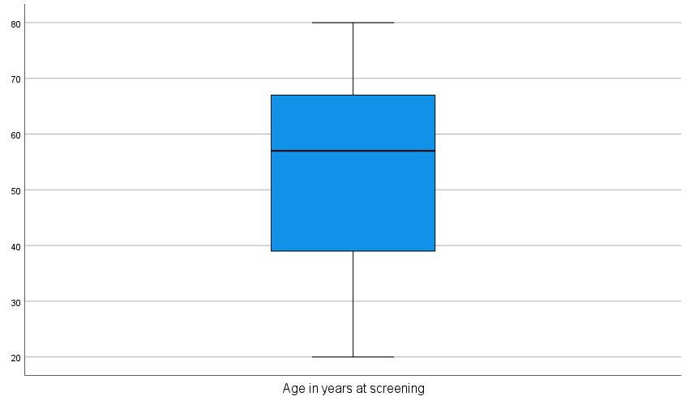

EXAMINE VARIABLES=PHQ9_Total BY DMDEDUC2
/PLOT BOXPLOT STEMLEAF HISTOGRAM
/COMPARE GROUPS
/STATISTICS DESCRIPTIVES
/CINTERVAL 95
/MISSING LISTWISE
/NOTOTAL.

Explore

Notes
Output Created |  | 02-NOV-2026 08:56:17
Comments
Input | Data | C:\Users\aSUS\Downloads\Statics\FilteredData.sav
Input | Active Dataset | DataSet3
Input | Filter | RIAGENDR = 2 AND RIDAGEYR >= 20AND RHQ010 >= 6 AND RHQ010 <= 19AND INDFMPIR >= 0 (FILTER)
Input | Weight | <none>
Input | Split File | <none>
Input | N of Rows in Working Data File | 2512
Missing Value Handling | Definition of Missing | User-defined missing values for dependent variables are treated as missing.
Missing Value Handling | Cases Used | Statistics are based on cases with no missing values for any dependent variable or factor used.
Syntax |  | EXAMINE VARIABLES=PHQ9_Total BY DMDEDUC2  /PLOT BOXPLOT STEMLEAF HISTOGRAM  /COMPARE GROUPS  /STATISTICS DESCRIPTIVES  /CINTERVAL 95  /MISSING LISTWISE  /NOTOTAL.
Resources | Processor Time | 00:00:00.64
Resources | Elapsed Time | 00:00:00.56

Education level - Adults 20+

Case Processing Summary
 | Education level - Adults 20+ | Cases
 | Education level - Adults 20+ | Valid |  | Missing |  | Total
 | Education level - Adults 20+ | N | Percent | N | Percent | N
PHQ9_Total | 1 | 72 | 100.0% | 0 | 0.0% | 72
PHQ9_Total | 2 | 161 | 100.0% | 0 | 0.0% | 161
PHQ9_Total | 3 | 466 | 100.0% | 0 | 0.0% | 466
PHQ9_Total | 4 | 839 | 100.0% | 0 | 0.0% | 839
PHQ9_Total | 5 | 974 | 100.0% | 0 | 0.0% | 974

Case Processing Summary
 | Education level - Adults 20+ | Cases
 | Education level - Adults 20+ | Total
 | Education level - Adults 20+ | Percent
PHQ9_Total | 1 | 100.0%
PHQ9_Total | 2 | 100.0%
PHQ9_Total | 3 | 100.0%
PHQ9_Total | 4 | 100.0%
PHQ9_Total | 5 | 100.0%

Descriptives
 | Education level - Adults 20+ |  |  | Statistic | Std. Error
PHQ9_Total | 1 | Mean |  | 5.0278 | .67192
PHQ9_Total | 1 | 95% Confidence Interval for Mean | Lower Bound | 3.6880
PHQ9_Total | 1 | 95% Confidence Interval for Mean | Upper Bound | 6.3675
PHQ9_Total | 1 | 5% Trimmed Mean |  | 4.3704
PHQ9_Total | 1 | Median |  | 3.0000
PHQ9_Total | 1 | Variance |  | 32.506
PHQ9_Total | 1 | Std. Deviation |  | 5.70143
PHQ9_Total | 1 | Minimum |  | .00
PHQ9_Total | 1 | Maximum |  | 26.00
PHQ9_Total | 1 | Range |  | 26.00
PHQ9_Total | 1 | Interquartile Range |  | 6.00
PHQ9_Total | 1 | Skewness |  | 1.664 | .283
PHQ9_Total | 1 | Kurtosis |  | 2.756 | .559
PHQ9_Total | 2 | Mean |  | 6.8199 | .52970
PHQ9_Total | 2 | 95% Confidence Interval for Mean | Lower Bound | 5.7738
PHQ9_Total | 2 | 95% Confidence Interval for Mean | Upper Bound | 7.8660
PHQ9_Total | 2 | 5% Trimmed Mean |  | 6.2805
PHQ9_Total | 2 | Median |  | 4.0000
PHQ9_Total | 2 | Variance |  | 45.174
PHQ9_Total | 2 | Std. Deviation |  | 6.72113
PHQ9_Total | 2 | Minimum |  | .00
PHQ9_Total | 2 | Maximum |  | 38.00
PHQ9_Total | 2 | Range |  | 38.00
PHQ9_Total | 2 | Interquartile Range |  | 8.50
PHQ9_Total | 2 | Skewness |  | 1.314 | .191
PHQ9_Total | 2 | Kurtosis |  | 2.053 | .380
PHQ9_Total | 3 | Mean |  | 4.9721 | .24137
PHQ9_Total | 3 | 95% Confidence Interval for Mean | Lower Bound | 4.4978
PHQ9_Total | 3 | 95% Confidence Interval for Mean | Upper Bound | 5.4464
PHQ9_Total | 3 | 5% Trimmed Mean |  | 4.4599
PHQ9_Total | 3 | Median |  | 3.0000
PHQ9_Total | 3 | Variance |  | 27.150
PHQ9_Total | 3 | Std. Deviation |  | 5.21054
PHQ9_Total | 3 | Minimum |  | .00
PHQ9_Total | 3 | Maximum |  | 26.00
PHQ9_Total | 3 | Range |  | 26.00
PHQ9_Total | 3 | Interquartile Range |  | 7.00
PHQ9_Total | 3 | Skewness |  | 1.332 | .113
PHQ9_Total | 3 | Kurtosis |  | 1.443 | .226
PHQ9_Total | 4 | Mean |  | 5.0262 | .17645
PHQ9_Total | 4 | 95% Confidence Interval for Mean | Lower Bound | 4.6799
PHQ9_Total | 4 | 95% Confidence Interval for Mean | Upper Bound | 5.3726
PHQ9_Total | 4 | 5% Trimmed Mean |  | 4.5249
PHQ9_Total | 4 | Median |  | 3.0000
PHQ9_Total | 4 | Variance |  | 26.121
PHQ9_Total | 4 | Std. Deviation |  | 5.11087
PHQ9_Total | 4 | Minimum |  | .00
PHQ9_Total | 4 | Maximum |  | 26.00
PHQ9_Total | 4 | Range |  | 26.00
PHQ9_Total | 4 | Interquartile Range |  | 7.00
PHQ9_Total | 4 | Skewness |  | 1.332 | .084
PHQ9_Total | 4 | Kurtosis |  | 1.525 | .169
PHQ9_Total | 5 | Mean |  | 3.6591 | .12522
PHQ9_Total | 5 | 95% Confidence Interval for Mean | Lower Bound | 3.4134
PHQ9_Total | 5 | 95% Confidence Interval for Mean | Upper Bound | 3.9049
PHQ9_Total | 5 | 5% Trimmed Mean |  | 3.2230
PHQ9_Total | 5 | Median |  | 2.0000
PHQ9_Total | 5 | Variance |  | 15.271
PHQ9_Total | 5 | Std. Deviation |  | 3.90783
PHQ9_Total | 5 | Minimum |  | .00
PHQ9_Total | 5 | Maximum |  | 25.00
PHQ9_Total | 5 | Range |  | 25.00
PHQ9_Total | 5 | Interquartile Range |  | 4.00
PHQ9_Total | 5 | Skewness |  | 1.771 | .078
PHQ9_Total | 5 | Kurtosis |  | 4.036 | .157

PHQ9_Total

Histograms

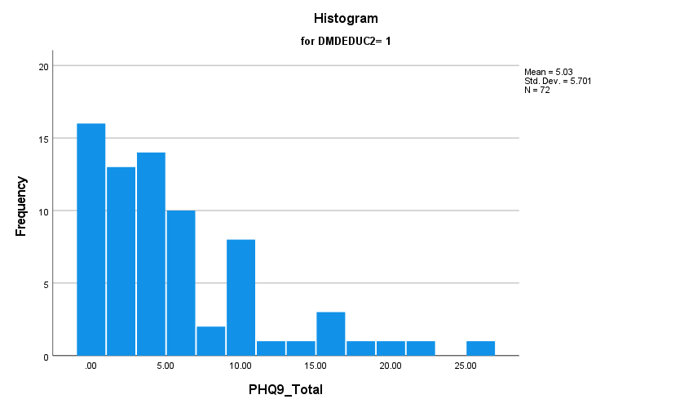

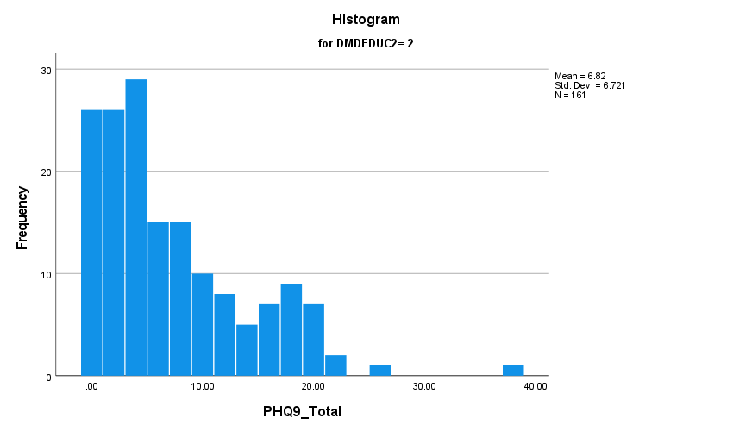

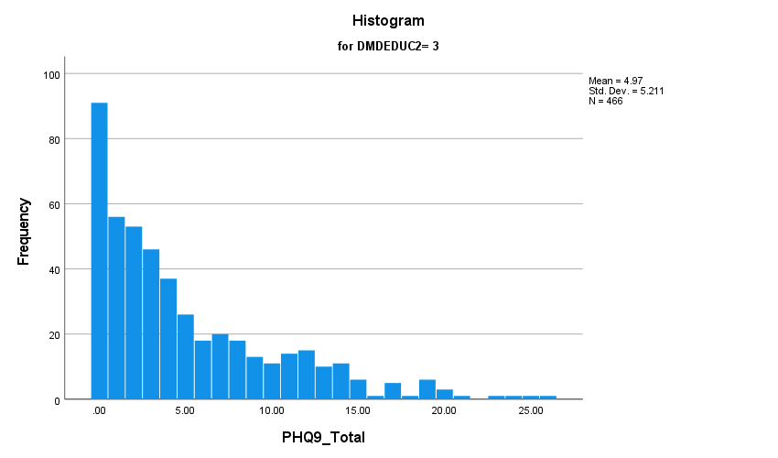

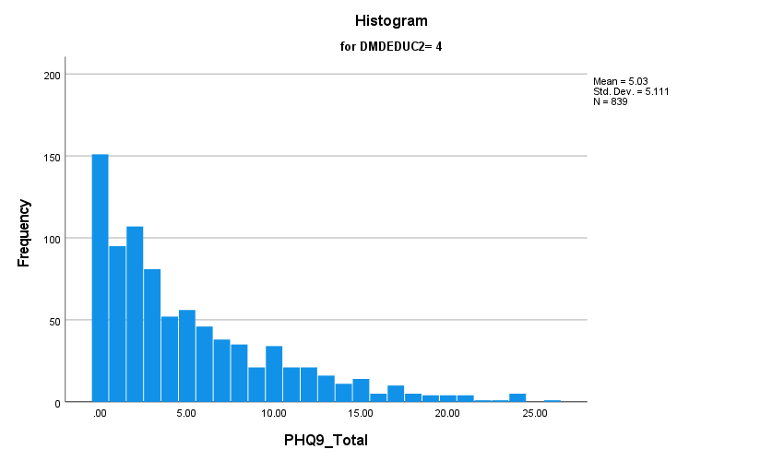

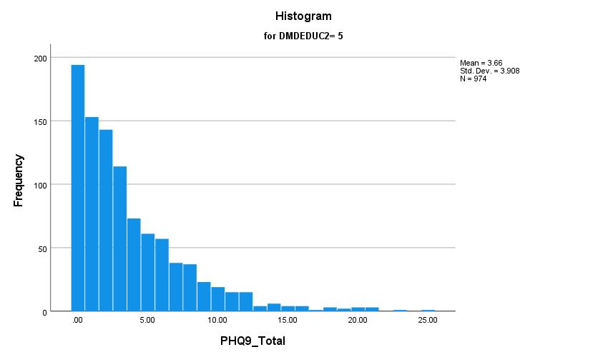

Stem-and-Leaf Plots

PHQ9_Total Stem-and-Leaf Plot for
DMDEDUC2= 1

Frequency Stem & Leaf

23.00 0 . 00000000000000001111111
18.00 0 . 222222333333333333
7.00 0 . 4455555
7.00 0 . 6666677
5.00 0 . 99999
4.00 1 . 0001
1.00 1 . 3
3.00 1 . 555
4.00 Extremes (>=18)

Stem width: 10.00
Each leaf: 1 case(s)

PHQ9_Total Stem-and-Leaf Plot for
DMDEDUC2= 2

Frequency Stem & Leaf

37.00 0 . 0000000000000000000000000011111111111
30.00 0 . 222222222222222333333333333333
21.00 0 . 444444444444445555555
17.00 0 . 66666666777777777
12.00 0 . 888888999999
10.00 1 . 0000111111
5.00 1 . 22333
6.00 1 . 445555
6.00 1 . 666777
9.00 1 . 888888999
4.00 2 . 0000
2.00 2 . 22
2.00 Extremes (>=25)

Stem width: 10.00
Each leaf: 1 case(s)

PHQ9_Total Stem-and-Leaf Plot for
DMDEDUC2= 3

Frequency Stem & Leaf

91.00 0 . 0000000000000000000000000000000000000000000000000000000000000000000000000000000000000000000
56.00 1 . 00000000000000000000000000000000000000000000000000000000
53.00 2 . 00000000000000000000000000000000000000000000000000000
46.00 3 . 0000000000000000000000000000000000000000000000
37.00 4 . 0000000000000000000000000000000000000
26.00 5 . 00000000000000000000000000
18.00 6 . 000000000000000000
20.00 7 . 00000000000000000000
18.00 8 . 000000000000000000
13.00 9 . 0000000000000
11.00 10 . 00000000000
14.00 11 . 00000000000000
15.00 12 . 000000000000000
10.00 13 . 0000000000
11.00 14 . 00000000000
6.00 15 . 000000
1.00 16 . 0
5.00 17 . 00000
1.00 18 . 0
14.00 Extremes (>=19.0)

Stem width: 1.00
Each leaf: 1 case(s)

PHQ9_Total Stem-and-Leaf Plot for
DMDEDUC2= 4

Frequency Stem & Leaf

151.00 0 . 000000000000000000000000000000000000000000000000000000000000000000000000000
95.00 1 . 00000000000000000000000000000000000000000000000
107.00 2 . 00000000000000000000000000000000000000000000000000000
81.00 3 . 0000000000000000000000000000000000000000
52.00 4 . 00000000000000000000000000
56.00 5 . 0000000000000000000000000000
46.00 6 . 00000000000000000000000
38.00 7 . 0000000000000000000
35.00 8 . 00000000000000000
21.00 9 . 0000000000
34.00 10 . 00000000000000000
21.00 11 . 0000000000
21.00 12 . 0000000000
16.00 13 . 00000000
11.00 14 . 00000
14.00 15 . 0000000
5.00 16 . 00
10.00 17 . 00000
5.00 18 . 00
20.00 Extremes (>=19.0)

Stem width: 1.00
Each leaf: 2 case(s)

PHQ9_Total Stem-and-Leaf Plot for
DMDEDUC2= 5

Frequency Stem & Leaf

194.00 0 . 0000000000000000000000000000000000000000000000000000000000000000000000000000000000000000000000000
153.00 1 . 0000000000000000000000000000000000000000000000000000000000000000000000000000
143.00 2 . 00000000000000000000000000000000000000000000000000000000000000000000000
114.00 3 . 000000000000000000000000000000000000000000000000000000000
73.00 4 . 000000000000000000000000000000000000
61.00 5 . 000000000000000000000000000000
57.00 6 . 0000000000000000000000000000
38.00 7 . 0000000000000000000
37.00 8 . 000000000000000000
23.00 9 . 00000000000
19.00 10 . 000000000
15.00 11 . 0000000
47.00 Extremes (>=12.0)

Stem width: 1.00
Each leaf: 2 case(s)

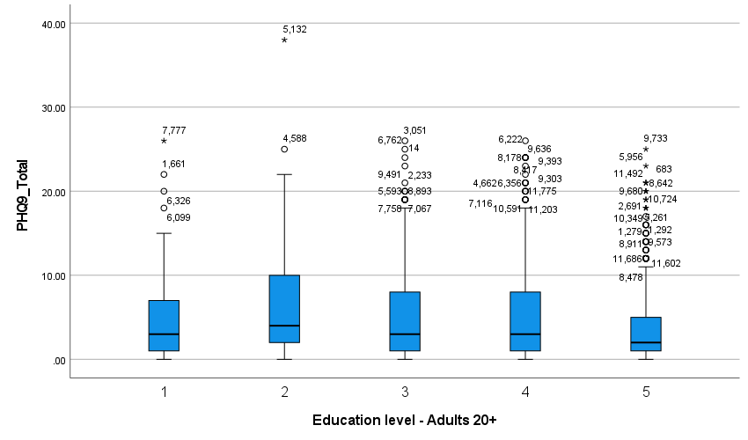

DATASET ACTIVATE DataSet2.
GET
FILE='C:\Users\aSUS\Downloads\Statics\DPQ.sav'.

Warning # 67. Command name: GET FILE
The document is already in use by another user or process. If you make
changes to the document they may overwrite changes made by others or your
changes may be overwritten by others.
File opened C:\Users\aSUS\Downloads\Statics\DPQ.sav
DATASET NAME DataSet5 WINDOW=FRONT.
DATASET ACTIVATE DataSet3.
EXAMINE VARIABLES=PHQ9_Total DMDEDUC2 INDFMPIR RHQ010
/PLOT BOXPLOT STEMLEAF HISTOGRAM
/COMPARE GROUPS
/PERCENTILES(5,10,25,50,75,90,95) HAVERAGE
/STATISTICS DESCRIPTIVES
/CINTERVAL 95
/MISSING LISTWISE
/NOTOTAL.

Explore

Notes
Output Created |  | 02-NOV-2026 11:11:55
Comments
Input | Data | C:\Users\aSUS\Downloads\Statics\FilteredData.sav
Input | Active Dataset | DataSet3
Input | Filter | RIAGENDR = 2 AND RIDAGEYR >= 20AND RHQ010 >= 6 AND RHQ010 <= 19AND INDFMPIR >= 0 (FILTER)
Input | Weight | <none>
Input | Split File | <none>
Input | N of Rows in Working Data File | 2512
Missing Value Handling | Definition of Missing | User-defined missing values for dependent variables are treated as missing.
Missing Value Handling | Cases Used | Statistics are based on cases with no missing values for any dependent variable or factor used.
Syntax |  | EXAMINE VARIABLES=PHQ9_Total DMDEDUC2 INDFMPIR RHQ010  /PLOT BOXPLOT STEMLEAF HISTOGRAM  /COMPARE GROUPS  /PERCENTILES(5,10,25,50,75,90,95) HAVERAGE  /STATISTICS DESCRIPTIVES  /CINTERVAL 95  /MISSING LISTWISE  /NOTOTAL.
Resources | Processor Time | 00:00:00.94
Resources | Elapsed Time | 00:00:00.90

Case Processing Summary
 | Cases
 | Valid |  | Missing |  | Total
 | N | Percent | N | Percent | N | Percent
PHQ9_Total | 2512 | 100.0% | 0 | 0.0% | 2512 | 100.0%
Education level - Adults 20+ | 2512 | 100.0% | 0 | 0.0% | 2512 | 100.0%
Ratio of family income to poverty | 2512 | 100.0% | 0 | 0.0% | 2512 | 100.0%
Age when first menstrual period occurred | 2512 | 100.0% | 0 | 0.0% | 2512 | 100.0%

Descriptives
 |  |  | Statistic | Std. Error
PHQ9_Total | Mean |  | 4.6011 | .09817
PHQ9_Total | 95% Confidence Interval for Mean | Lower Bound | 4.4086
PHQ9_Total | 95% Confidence Interval for Mean | Upper Bound | 4.7936
PHQ9_Total | 5% Trimmed Mean |  | 4.0694
PHQ9_Total | Median |  | 3.0000
PHQ9_Total | Variance |  | 24.211
PHQ9_Total | Std. Deviation |  | 4.92049
PHQ9_Total | Minimum |  | .00
PHQ9_Total | Maximum |  | 38.00
PHQ9_Total | Range |  | 38.00
PHQ9_Total | Interquartile Range |  | 6.00
PHQ9_Total | Skewness |  | 1.589 | .049
PHQ9_Total | Kurtosis |  | 2.861 | .098
Education level - Adults 20+ | Mean |  | 3.99 | .021
Education level - Adults 20+ | 95% Confidence Interval for Mean | Lower Bound | 3.95
Education level - Adults 20+ | 95% Confidence Interval for Mean | Upper Bound | 4.03
Education level - Adults 20+ | 5% Trimmed Mean |  | 4.07
Education level - Adults 20+ | Median |  | 4.00
Education level - Adults 20+ | Variance |  | 1.088
Education level - Adults 20+ | Std. Deviation |  | 1.043
Education level - Adults 20+ | Minimum |  | 1
Education level - Adults 20+ | Maximum |  | 5
Education level - Adults 20+ | Range |  | 4
Education level - Adults 20+ | Interquartile Range |  | 2
Education level - Adults 20+ | Skewness |  | -.922 | .049
Education level - Adults 20+ | Kurtosis |  | .275 | .098
Ratio of family income to poverty | Mean |  | 2.9068 | .03295
Ratio of family income to poverty | 95% Confidence Interval for Mean | Lower Bound | 2.8422
Ratio of family income to poverty | 95% Confidence Interval for Mean | Upper Bound | 2.9714
Ratio of family income to poverty | 5% Trimmed Mean |  | 2.9437
Ratio of family income to poverty | Median |  | 2.7800
Ratio of family income to poverty | Variance |  | 2.727
Ratio of family income to poverty | Std. Deviation |  | 1.65151
Ratio of family income to poverty | Minimum |  | .00
Ratio of family income to poverty | Maximum |  | 5.00
Ratio of family income to poverty | Range |  | 5.00
Ratio of family income to poverty | Interquartile Range |  | 3.51
Ratio of family income to poverty | Skewness |  | -.031 | .049
Ratio of family income to poverty | Kurtosis |  | -1.413 | .098
Age when first menstrual period occurred | Mean |  | 12.42 | .034
Age when first menstrual period occurred | 95% Confidence Interval for Mean | Lower Bound | 12.36
Age when first menstrual period occurred | 95% Confidence Interval for Mean | Upper Bound | 12.49
Age when first menstrual period occurred | 5% Trimmed Mean |  | 12.40
Age when first menstrual period occurred | Median |  | 12.00
Age when first menstrual period occurred | Variance |  | 2.948
Age when first menstrual period occurred | Std. Deviation |  | 1.717
Age when first menstrual period occurred | Minimum |  | 6
Age when first menstrual period occurred | Maximum |  | 19
Age when first menstrual period occurred | Range |  | 13
Age when first menstrual period occurred | Interquartile Range |  | 2
Age when first menstrual period occurred | Skewness |  | .223 | .049
Age when first menstrual period occurred | Kurtosis |  | .481 | .098

Percentiles
 |  | Percentiles
 |  | 5 | 10 | 25 | 50
Weighted Average(Definition 1) | PHQ9_Total | .0000 | .0000 | 1.0000 | 3.0000
Weighted Average(Definition 1) | Education level - Adults 20+ | 2.00 | 3.00 | 3.00 | 4.00
Weighted Average(Definition 1) | Ratio of family income to poverty | .4265 | .7400 | 1.4200 | 2.7800
Weighted Average(Definition 1) | Age when first menstrual period occurred | 10.00 | 10.00 | 11.00 | 12.00
Tukey's Hinges | PHQ9_Total |  |  | 1.0000 | 3.0000
Tukey's Hinges | Education level - Adults 20+ |  |  | 3.00 | 4.00
Tukey's Hinges | Ratio of family income to poverty |  |  | 1.4200 | 2.7800
Tukey's Hinges | Age when first menstrual period occurred |  |  | 11.00 | 12.00

Percentiles
 |  | Percentiles
 |  | 75 | 90 | 95
Weighted Average(Definition 1) | PHQ9_Total | 7.0000 | 12.0000 | 15.0000
Weighted Average(Definition 1) | Education level - Adults 20+ | 5.00 | 5.00 | 5.00
Weighted Average(Definition 1) | Ratio of family income to poverty | 4.9275 | 5.0000 | 5.0000
Weighted Average(Definition 1) | Age when first menstrual period occurred | 13.00 | 15.00 | 16.00
Tukey's Hinges | PHQ9_Total | 7.0000
Tukey's Hinges | Education level - Adults 20+ | 5.00
Tukey's Hinges | Ratio of family income to poverty | 4.9250
Tukey's Hinges | Age when first menstrual period occurred | 13.00

PHQ9_Total

PHQ9_Total Stem-and-Leaf Plot

Frequency Stem & Leaf

478.00 0 . 000000000000000000000000000000000000000000000000000000000000000000000000000000000000000000000000
322.00 1 . 0000000000000000000000000000000000000000000000000000000000000000
324.00 2 . 00000000000000000000000000000000000000000000000000000000000000000
268.00 3 . 000000000000000000000000000000000000000000000000000000
178.00 4 . 000000000000000000000000000000000000
155.00 5 . 0000000000000000000000000000000
134.00 6 . 000000000000000000000000000
107.00 7 . 000000000000000000000
96.00 8 . 0000000000000000000
68.00 9 . 00000000000000
71.00 10 . 00000000000000
57.00 11 . 00000000000
53.00 12 . 00000000000
34.00 13 . 0000000
30.00 14 . 000000
31.00 15 . 000000
13.00 16 . 000
93.00 Extremes (>=17.0)

Stem width: 1.00
Each leaf: 5 case(s)

Education level - Adults 20+

Education level - Adults 20+ Stem-and-Leaf Plot

Frequency Stem & Leaf

72.00 1 . 0000000
.00 1 .
.00 1 .
.00 1 .
.00 1 .
161.00 2 . 0000000000000000
.00 2 .
.00 2 .
.00 2 .
.00 2 .
466.00 3 . 00000000000000000000000000000000000000000000000
.00 3 .
.00 3 .
.00 3 .
.00 3 .
839.00 4 . 000000000000000000000000000000000000000000000000000000000000000000000000000000000000
.00 4 .
.00 4 .
.00 4 .
.00 4 .
974.00 5 . 0000000000000000000000000000000000000000000000000000000000000000000000000000000000000000000000000

Stem width: 1
Each leaf: 10 case(s)

Ratio of family income to poverty

Ratio of family income to poverty Stem-and-Leaf Plot

Frequency Stem & Leaf

81.00 0 . 00000000111
37.00 0 . 22233
54.00 0 . 44445555
103.00 0 . 666666677777777
112.00 0 . 8888888899999999
126.00 1 . 000000000111111111
100.00 1 . 22222233333333
98.00 1 . 44444444555555
103.00 1 . 666666666777777
95.00 1 . 8888888999999
99.00 2 . 00000111111111
81.00 2 . 222222333333
93.00 2 . 4444444555555
85.00 2 . 666677777777
63.00 2 . 888888999
80.00 3 . 00000001111
72.00 3 . 22222233333
57.00 3 . 44444555
52.00 3 . 66666777
55.00 3 . 8888999
65.00 4 . 000011111
47.00 4 . 2233333
59.00 4 . 44445555
31.00 4 . 6667
47.00 4 . 8888999
617.00 5 . 0000000000000000000000000000000000000000000000000000000000000000000000000000000000000000

Stem width: 1.00
Each leaf: 7 case(s)

Age when first menstrual period occurred

Age when first menstrual period occurred Stem-and-Leaf Plot

Frequency Stem & Leaf

3.00 Extremes (=<7.0)
15.00 8 . 00
.00 8 .
100.00 9 . 00000000000000
.00 9 .
173.00 10 . 0000000000000000000000000
.00 10 .
374.00 11 . 00000000000000000000000000000000000000000000000000000
.00 11 .
704.00 12 . 00000000000000000000000000000000000000000000000000000000000000000000000000000000000000000000000000000
.00 12 .
580.00 13 . 00000000000000000000000000000000000000000000000000000000000000000000000000000000000
.00 13 .
283.00 14 . 0000000000000000000000000000000000000000
.00 14 .
154.00 15 . 0000000000000000000000
.00 15 .
89.00 16 . 0000000000000
37.00 Extremes (>=17.0)

Stem width: 1
Each leaf: 7 case(s)

